Bromley IRIS Service (Identification and Referral to Improve Safety)
Market Engagement Questionnaire
June 2023

Contents
Introduction 3
Clarification Questions 3
Indicative Timeline 3
Expression of Interest 4
Overview of Service 5
Introduction 5
Background 5
Market Engagement Questionnaire 7
Section 1: Organisation Details 7
Section 2: Bidding / Commercial Model 8
Section 3: Procurement Process and Timelines 9
Section 4: The Services 10
Section 5: General Feedback 11

Introduction
NHS South East London Integrated Care Board (Bromley) (“the ICB”) is seeking feedback to inform the procurement of the Bromley IRIS.
In order to assist the ICB with testing its assumptions and proposed service requirements, your responses to the questions listed below will explore the following areas:
- the draft Service Specification
- timescales for procurement and mobilisation of the contract/service
- proposed contract duration and financial envelope
We ask that interested organisations submit responses to the questionnaire using the template provided. Respondents are requested to address the questions specifically rather than attaching extensive technical or promotional information or materials, as such information will not be considered.
Please complete the template and return this via the ProContract messaging facility by 30th June 2023, 14:00.
Questionnaire responses submitted will remain confidential and information gathered will be used for the sole purpose of informing the ICB of the future procurement exercise.
Please refer to Appendix A for the Service Specification, available for download via the ProContract e-tendering portal.

Clarification Questions
Please direct any questions via the ProContract messaging facility. A clarification question and answer process will NOT be operated during this market engagement; however a Frequently Asked Questions document will be sent to questionnaire respondents following the close of market engagement.
Anonymised questions and ICB responses will be published via the portal messaging facility as a public message. Interested organisations must indicate if a query is of a commercially sensitive or confidential nature. Where disclosure of such a query and the answer would, or would be likely to, prejudice its commercial interests, respondents must set out to the ICB the reason(s) for non-disclosure to other organisations.
However, if the ICB does not consider the query to be of a commercially sensitive or confidential nature, or considers it to represent a query relevant to all organisations, in terms of both the query and the response, it will, at its sole discretion, retain the right to refuse such a request and inform the requesting organisation of any such decision. The organisation will have the opportunity of revoking the question (leaving it unanswered) or the question and response being published publicly.

Indicative Timeline
The indicative timeline is as follows:
Milestones and Key actions | Indicative Dates
Expression of Interest and Market Engagement Questionnaire Response Period (ends 14:00 GMT) | 30th June 2023
EoI and MEQ Response Analysis and requirements finalisation | 3rd – 18th July 2023
Invitation to Tender (ITT) published, subject to ICB decision to proceed with procurement | 19th July 2023
Deadline for receipt of Bidder clarification questions | 14th August 2023
ITT Submission Deadline (5 weeks) | 24th August 2023
Compliance Checks, Evaluation, Moderation for Consensus & Approval to Award (4 weeks) | September 2023
Outcome Letters to Bidders and Standstill Period | 2nd October 2023
Earliest Mobilisation Commencement | 13th October 2023
Contract Commences | 1st February 2024

Expression of Interest
This market engagement exercise will be used to inform final procurement documentation and service requirements to be published with the Invitation to Tender, subject to ICB decision to proceed with procurement.
In this case ICB will publish a contract notice in Find a tender and Contract finder inviting expressions of interest and tender.
Any interested organisations, including those who have expressed an interest in this market engagement exercise, have to also express an interest in the invitation to tender notice to participate in the procurement process.

Thank you for taking the time to provide your feedback.

Overview of Service

Introduction
This Service relates to the delivery of Domestic Abuse (DA) training and support for all GP practices and Primary Care Network (PCN) staff in Bromley in accordance with the IRIS (Identification and Referral to Improve Safety) model of DA Training delivery to Primary Care, for the 3 years from 01/02/2024 to 31/01/2027.

The previous Bromley IRIS service was in place from April 2018 to March 2023, delivering education and training to Bromley GP practices on identification and appropriate referral of victims of Domestic abuse (DA). The new service provider will inherit a good legacy of approximately 41 of the 43 Bromley GP practices being IRIS accredited at 31/03/23.

Background

“Health settings are trusted environments; they are places we can reach those subject to DA from every background and walk of life, including those who may not feel confident seeking help from other professionals. Awareness of, and the expected response to, DA should be embedded in the policy and practices of all health settings.”

The IRIS programme is an evidence-based, effective and cost-effective intervention to improve the general practice response to domestic abuse and is nationally recognised. It has been cited as best practice in general practice for responding to domestic violence and abuse by the Department of Health and Social Care (2010, 2011, 2017), and has also informed the NICE guidance and standards on domestic violence and abuse.
IRIS has been evaluated in a randomised controlled trial which found it to be a very successful programme for addressing domestic abuse in general practice. IRISi’s most recent national report (data to 31/03/2019) has highlighted that the IRIS programmes across England and Wales have consistently brought about substantial increased referrals into specialist services as well as improved the safety and quality of life for patients
The Service Specification (available to download via ProContract) is in line with the NICE public health guidance on domestic violence and abuse (PH50) which recommends offering specialist advice, advocacy and support in settings where people may be identified or may disclose that domestic violence and abuse is occurring https://www.nice.org.uk/guidance/ph50.
SEL ICB Bromley additionally, and separately, commissions a GP IRIS Clinical Lead to support local GP practices by promoting IRIS services and to attend appropriate steering groups, and professional DA forums, including the Bromley MARAC meetings. The GP Clinical Lead also provides ongoing support to nominated practices in conjunction with the Bromley IRIS service, and thus provides an important link between the Bromley IRIS service and Bromley GP practices.
Please download the full Service Specification from ProContract e-tendering portal.
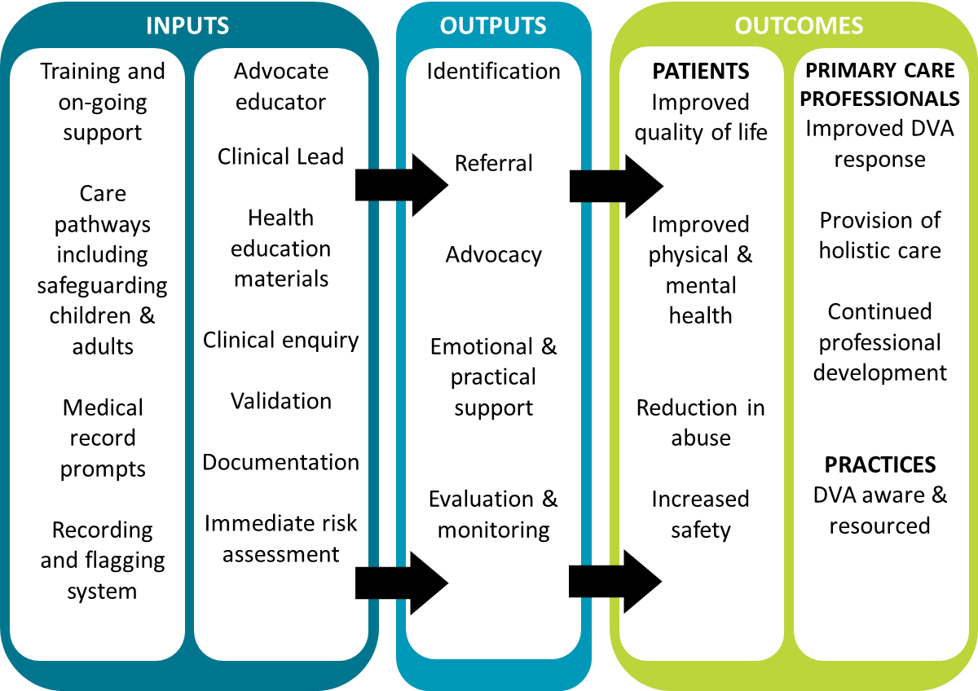
Figure 1: The IRIS Model

Market Engagement Questionnaire

Below are a series of questions based on the service requirements, draft specification and the expectations of this service. The ICB is seeking feedback through this market engagement exercise to shape the requirements of this service and to inform future procurement exercises.

Section 1: Organisation Details

1.1 | Organisation name
1.2 | Registered address
1.3 | Named contact for response  (name and position)
1.4 | Contact details

Section 2: Bidding / Commercial Model

2.1 | Lotting Structure: it is proposed that service is commissioned as a single lot.
2.1a | Please provide your view on the lotting structure
2.1b | If you believe the lotting structure should be different, please provide your view on the split options and your rationale for this.
2.1c | Is there a maximum and/or minimum lot size for safe/effective/efficient service delivery or any other risks you feel should be considered in determining the Lot structure?
2.1d | Please describe how the lotting structure would affect your interest/ability to bid (if at all).
2.2 | Contract Duration: it is proposed to procure a contract of 3 years (36 months) followed by an optional extension of up to 2 years (24 months) at the discretion of the ICB.
2.2a | Please confirm whether you feel this contract duration would cause any issues which may prevent you from bidding or which may lead to adverse implications on commercials or other service aspects?
2.2b | Is the contract length sufficient to fully mobilise, embed and deliver the services as set out in the specification?
2.3 | The proposed annual contract value for the service is £115,000.00.
2.3a | Please provide feedback on the contract financial value provided. The proposed value is fully inclusive of all costs required to mobilise (transition) and deliver the specified services.

Section 3: Procurement Process and Timelines

3 | Procurement timeline: the indicative timeline has a tender publication date 19/07/2023 and a tender submission date 24/08/2023.
3.1a | Would the procurement timelines as stated present any risks that would prevent you from bidding? If yes, what are these and what would help to mitigate these?
3.2 | Mobilisation timeline: the indicative timeline has a mobilisation period of approximately 3.5 months.
3.2a | Please confirm whether the proposed mobilisation period presents any risks or would prevent you from bidding? If yes, what are these and what would help to mitigate these?
3.3 | ICB information: please describe what information you would need from the ICB as part of the tender documentation in order to allow you to provide your best quality bid?
3.4 | ICB support: please describe what support you would need from the ICB during the mobilisation phase to support successful service mobilisation (if any).

Section 4: The Services

4.1 | Staffing: please refer to the service specification for an outline of staffing expectations in line with the IRIS model.  IRIS is not currently being delivered in Bromley and therefore no TUPE will apply; the successful bidder will be required to recruit staff during the mobilisation period.  Please provide feedback on this requirement, including any risks or issues associated with recruiting to the required staffing level in line with the IRIS model.
4.2 | For GP practice training and any support provided to victim/survivors, the draft specification (section 3.3) requires that a choice is offered regarding face-to-face or remote delivery. Please provide your feedback on this requirement, including any risks or issues you might anticipate in meeting this requirement.
4.3 | Please provide any other feedback you may have on the draft service specification.

Section 5: General Feedback

5.1 | Barriers to bidding: please confirm if there are any other barriers to prevent you from bidding which have not already been described above
5.2 | Risks: are there any other risks associated with the service or the procurement which have not been described above which you feel the ICB should consider and how these could be mitigated.
5.3 | Any other feedback

Domestic Abuse as defined by the Domestic Abuse Act 2021
Nicole Jacobs Designate Domestic Abuse Commissioner for England and Wales. Foreword to Pathfinder toolkit June 2020

