Appendix 8

Step by Step
Supplier Guide
to the
NWUPC
e-Tendering System

Introduction

This Step-By-Step Guide is provided to assist you in using the (In-tend) e-tendering system. Once you have registered, you will be able to maintain your company information, return tender submissions and maintain company/contract documentation in a secure area via the internet.

If you encounter any difficulties whilst using the system you can contact out Support team by phoning 0844 2728810 or emailing support@in-tend.co.uk

Registering on the e-Tendering system

Visit https://in-tendhost.co.uk/nwupc to access the (In-tend) supplier portal.

From the homepage click on Register

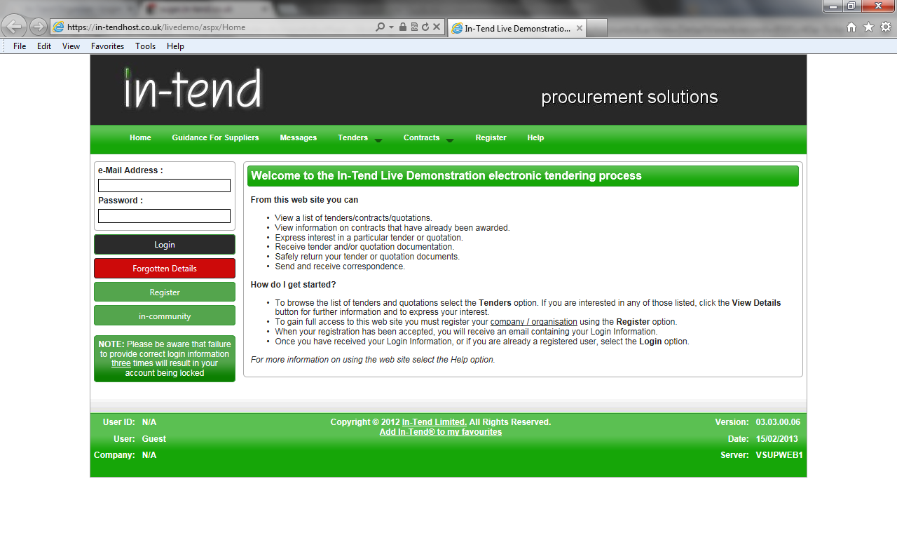

Registration Process
As part of the simple registration form you will be asked to complete your Company Details, Company Contact Details and Primary User Details. Email alerts and actions will be sent to the email addresses you provide, so if possible it is useful to enter a general company email address in the Primary User Details section such as info@ *****.co.uk.
For cases where this person or inbox may be unavailable, we strongly recommended you add an Additional User (located at the bottom of the screen) so they can gain access to the site and also receive a copy of the emails. All Yellow fields are mandatory
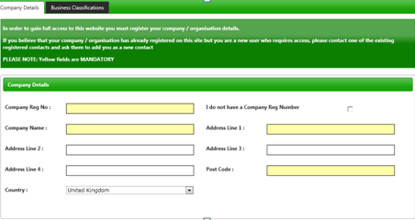
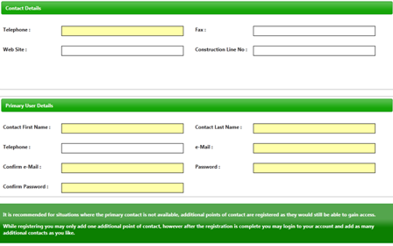

Whilst registering you may only add one additional point of contact, however after the registration is complete you may login to your account and add as many additional contacts as you like.
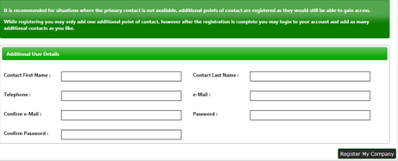
In the Business Classifications tab you are able to add the business category codes relevant to your company. Enter a keyword or click on the search button to see the full list of available categories. Click the blue + symbol to add a category you require. You can add multiple categories.
Once you are happy with the details click on Register My Company
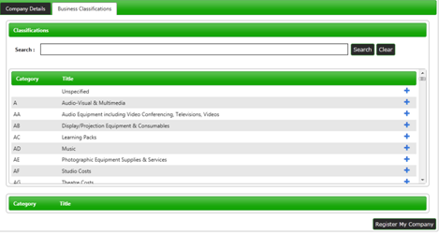

You should not register your company more than once, unless they are under a separate company registration number. If your company has several locations, register the company against the head office and add contact details for individuals at the different locations. You can add one additional user at the time of registration. Once registered, you can add several contacts in the Company Details section.

Once registration is complete, the system will then thank you for registering and inform you that your details are being processed. You will then shortly receive an email with confirmation of your email and password.

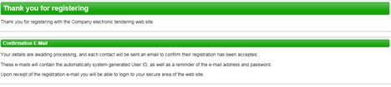

Managing your Company Details
If you need to update your company information you can do this from the Company Details section on the top menu bar. From here you can edit/add information regarding the company, contact details, company documents and business classifications.

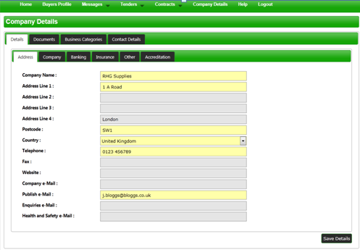
Please note that it is important that you do keep your details up to date, particularly your contact email addresses as you may miss out on tender opportunities which may be of interest.

Tender Opportunities
To access tender opportunities hover over the Tenders section at the top menu bar and then click on Current, this will provide you with a full list of current tender opportunities. For a tender that you are interested in you should click View Details

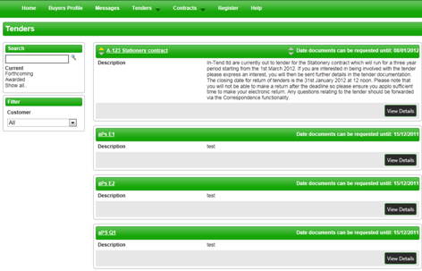
From the Tender Management screen you are able to Express Interest in the tender.
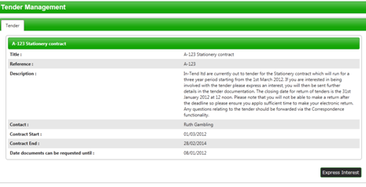

You will then be asked to either log into an existing account or register a new one.
Once you have expressed your interest you will instantly see an update as to your status in the tender process and it will tell you that your expression of interest is being processed.
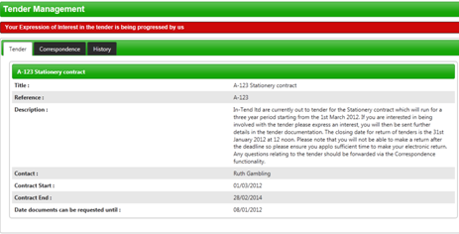
Once your expression of interest is received and accepted by the organisation (this may not happen straight away) you should receive an email saying that you have received tender documents and you should login to the secure area of the website to access them. If documents are immediately available, you will be taken straight to the latest tender stage screen.
If you are not currently logged in, from the homepage you should enter your email address and password then click Login.

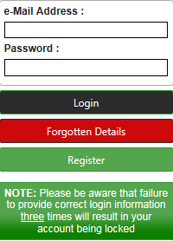

*Please note that you are given three attempts to enter your email address and password. Please ensure you click the Forgotten your Password button if you cannot remember your details otherwise your account will be locked!

Once you are logged in, go to the Tenders section at the top menu bar and click on My Tenders, find the tender that you are dealing with and click View Details. From the Tender Management section, you can easily see what your status is within the tender process. You will be able to see tabs running across the top. The tab which is RED is the current stage of the tender process (eg. Pre Qualification Stage, Invitation to Tender stage).

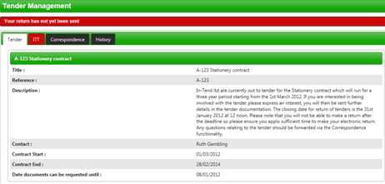

Submit Tender Return
If you click on this tab (e.g. ‘ITT’) you will go into the section where you can access the tender documents. At the top of this section you will see instructions as to how to attach and submit documents which you should read carefully as they talk you through step by step.

In this section you will see the follow headings:
- Tender Documents Received: View and/or download tender documents received
- My Tender Return: If any mandatory documents have been requested, they will be shown in the My Tender Return section against a Red button. You will need to attach them using the Attach Documents button within the My Tender Return section at the bottom of this screen.
If a Questionnaire is required to be completed, it will be shown in Red and marked Not Started in the My Tender Return section. It is mandatory that any Questionnaire’s must be completed.
- Attach Documents (if available): Attach any additional documents you wish to return as part of your tender submission; these will upload to the My Tender Return section.
- Submit Return: Click the Submit Return button only when you are completely happy that you have all the documents uploaded that you need to submit. 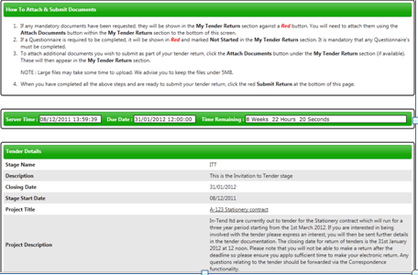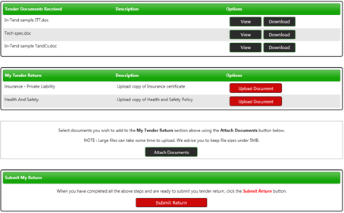

Once you have submitted your return you will be able to view a Return Receipt which confirms all the details of your submission. This will always be available to view within the History tab.
₊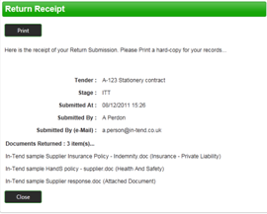
If for any reason you wish to amend your return you may be able to do so by going into the stage tab again. The screen visible will show you all the documents that you returned as part of your original submission. If you want to remove any documents or add additional documents you can do this now.
Please note you should ensure that ALL the documents which you wish to be evaluated as part of your tender return are included in the My Tender Return section before you click on Modify Return as you are overiding the first return!

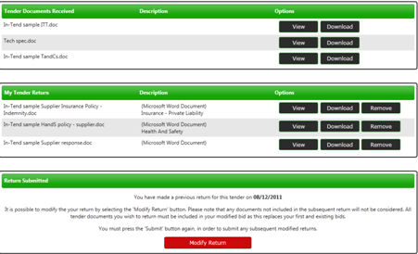

Correspondence
This procedure is used to receive and send a communication regarding a tender/contract via the website.
If you receive Correspondence you will firstly receive an email alert informing you of this. You will need to login to the secure area of the system to view it. When you first login you will see on the homepage in red a prompt to say that there are unread correspondence. If you click on the link it will take you straight through to the message.
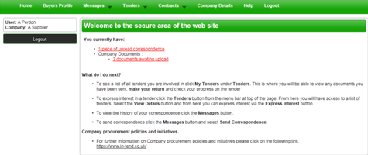
Alternatively, you can view the message through the Tender Management screen where it will tell you in brackets how many correspondence there are in the Correspondence tab. You can view the message, view any attachments and also make a reply.
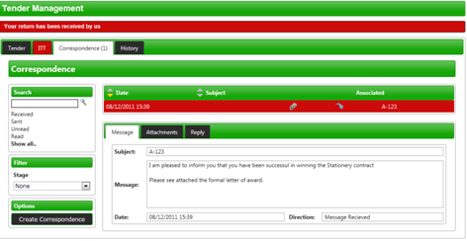
You can also view Correspondence through the Messages tab at the top of the screen
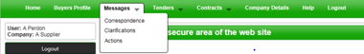

Clarifications
If there are any Clarifications made against the tender you can access them by viewing the tender details and a new tab will appear. It will tell you how many clarifications there are in brackets. Click on the Clarifications tab to view.
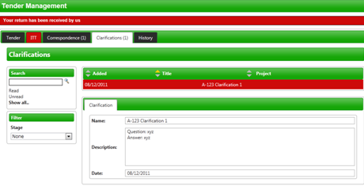
NB. If you require clarification regarding the tender you should send your clarification request via Correspondence

Actions
This procedure is used to send you tasks which should be completed by a certain date. The system will send out automatic reminders for you to complete Actions.
If you receive an Action email, log in to your homepage and a red link will appear on screen.
Click on the red link or hover over Messages at the top menu bar and then click Actions.
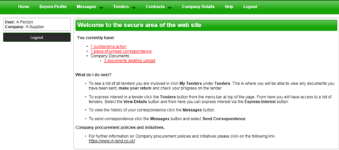

You will be taken you to this screen where you can view details of the action placed against you.
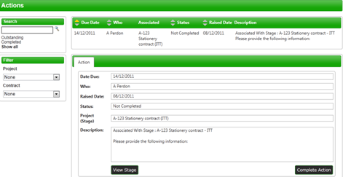
Read through the Action and make sure everything requested is completed then click COMPLETE ACTION.

Tender History
Within the My Tenders section you will see the History tab where there is a log of your involvement of the tender, right from your expression of interest to the current status.

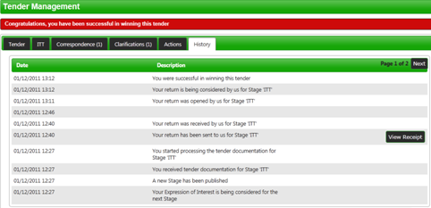

Contracts
You can view a summary of what Contracts the Institution has running from the Contracts heading at the top menu bar (may not be available with some institutions).
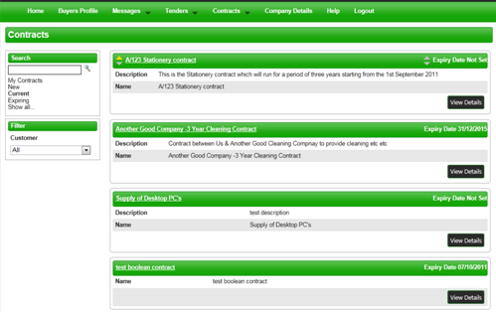
If you are the contracted supplier you should log into the secure area of the website to be able to view specific contract information/documentation.
You can view this information by hovering over Contracts on the top menu bar and then clicking on My Contracts and then View Details for the relevant contract.
From this screen you can view contract details, see contract documents and send correspondence relating to the contract.

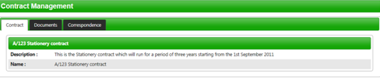

Contract Documents
Contract Documents can be viewed in the Documents tab within the Contract Management section.
Some documents may have viewing rights only which you cannot replace eg. official contract, agreed terms and conditions etc.
Other documents may be for you to manage and keep updated eg: insurances, policies etc...
If you are required to upload a new revision of a document that has expired you will receive an email alert. You should login to the secure area of the website where you will see a prompt in red that contract documents require upload.

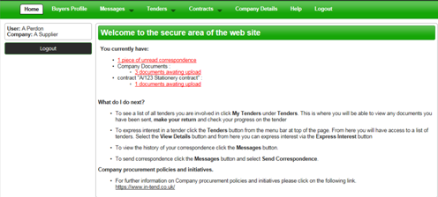

To upload these documents you should click on the red prompt or go into My Contracts, click View Details of the relevant contract and then click the Documents tab.

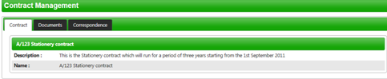

Managing Contract Documents
From the documents tab you can view contract documents and replace/upload documents that you are responsible for maintaining.
You will be able to see a Replace button for the documents that may have expired (eg. Insurances) or that can be updated as and when (eg policies). You will also see a red Upload Document button for documents that have been requested by the contracting institution. If there is an expiry date in place you will be reminded until you upload the required document.

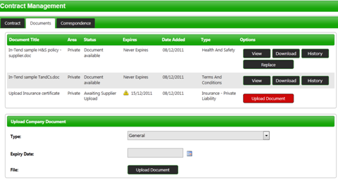

If you require any additional information or help, please contact the In-tend Support Desk.
In-tend Support
Tel: 0844 2728810
Email: support@in-tend.co.uk

