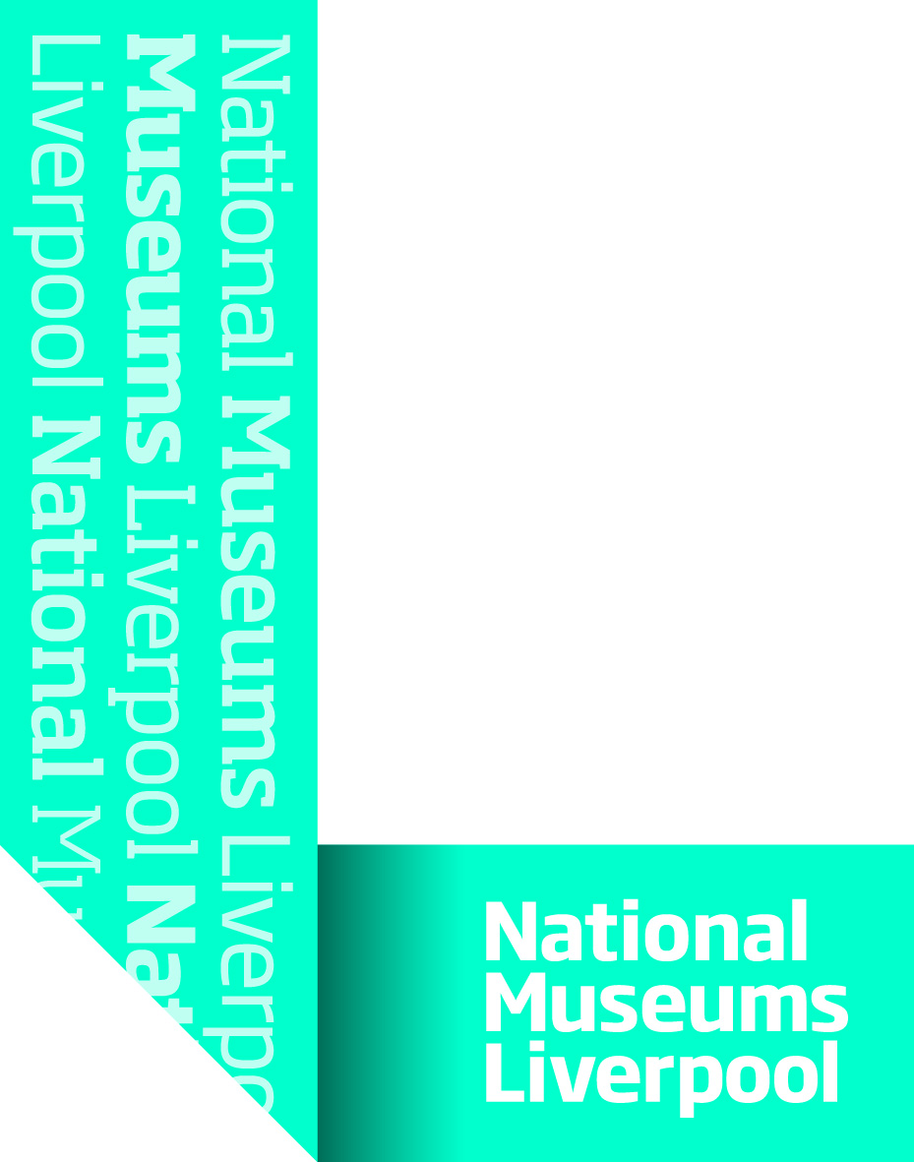
NML Procurement Protocol

The procurement of all works, goods and services by National Museums Liverpool (NML) will be based on value for money, having due regard for propriety and regularity, and in doing so, it will support the strategic objectives of NML – in particular to maximise and make best use of the resources available.

We will strive to improve our commitment to best practise procurement by:
- Procedures covering the procurement of goods, services and works (i.e. all non pay expenditure) will be designed to obtain best value for money, whilst reducing risk, and ensuring legal compliance. Value for money takes financial (particularly whole life costs) and qualitative factors, and fitness for purpose into consideration. Therefore, purchases are made based on the best value in terms of technical and commercial merit and NOT just cost alone.

- Procurement activities will be undertaken in a transparent, professional and ethical manner.

- Whole life costs will be considered when procuring goods and services. In addition to the upfront cost of buying the goods, the cost of installation, operating, maintenance, decommissioning and disposal should be taken into account.

- All relevant legal requirements, including UK and EU legislation, will be complied with in all procurement activities.

- The Head of Procurement has overall responsibility for the operation of efficient and effective procurement processes.

- All procurement activity must be carried out with honesty and integrity, avoiding even the appearance of impropriety, maintaining consistency in all processes and actions.

- Goods and services will be procured by competition unless there are compelling reasons to the contrary. The minimum competitive requirements for expenditure will be set out in the NML internal Financial guidelines. NML publishes its tender opportunities on Contracts Finder, in compliance with the changes introduced within the Public Procurement Regulations 2015. (Contracts Finder is the Government’s single platform providing access to public sector procurement related information and documentation, including the facility to publish both tender and contract documents in a single place.)

- Single tender action, where only one supplier is asked to respond to a procurement need, should only be used in exceptional circumstances and must be justified in advance in accordance with internal Financial guidelines

- NML will strive to procure via aggregation of requirements across NML in order to establish central contracts to ensure economies of scale. It will be compulsory to use such contracts unless otherwise agreed with the Head of Procurement.

- NML will strive to use frameworks, such as CCS, ESPO and CPC, where it can be shown that benefits are delivered.

- The procurement of works, goods and services over certain financial thresholds will be in accordance with the European Community Procurement Rules i.e. the publishing of notices in the Official Journal of the European Union.

- All staff (including externally grant funded) and any party who may commit expenditure directly on behalf of the Museum have a responsibility to familiarise themselves and comply with the Procurement Protocol. In doing so they will support and maintain the integrity of the procurement process, and seek to ensure value for money procurement processes and for overseeing the procurement of all goods, services and works.

- NML is committed to adopting full e-procurement, with the use of electronic tendering, electronic ordering of goods and payment to our suppliers, resulting in improved efficiency and a reduction in costs for us and those who do business with us.

- NML will treat all suppliers fairly and equally and with upmost integrity. Supplier’s confidential information must not be disclosed to any third party or used in any way without the consent of the supplier.

- Any material personal interest which may affect, or be seen to affect, impartiality or judgement should be declared by any staff member involved in the procurement process.

- We will report quarterly on the performance of NML’s procurement activity.

- Sustainable Procurement - Our sustainability objective is to ensure a continuous improvement in procurement decisions measured against delivering sustainable trading. More specifically, we seek to avoid adverse social and environmental impact in the supply-chain, the reduction of environmental impact from service operations and the purchase of products that meet recognised environmental standards. (See Sustainable Procurement statement)

- Ethical Procurement - Our ethical objective is to ensure that people in the supply-chain are treated with respect and have rights with regard to employment including the rights to freely choose employment, freedom of association, payment of a national living wage, working hours that comply with national laws, equal opportunities, recognised employment relationship, freedom from intimidation and to a safe and healthy working environment. (See Ethical Procurement statement)

- NML expects its suppliers to make similar commitments with regard to sustainability and ethical practises and to confirm this during its dealings with NML. Acceptance of this will be asked during the tender process and as part of the Terms and Conditions of business.

- We will strive to make NML a beacon of best practice for procurement.

Ethical Procurement Statement

Procurement has a role to play in minimising any risk of social exploitation within the supply chain. This statement addresses the expectation that our staff and suppliers have a natural respect for our ethical standards in the context of their own particular culture and that relationships with our suppliers are based on the principle of fair and honest dealings at all times.
The same principle of fair and honest dealings must be extended to all others with whom our suppliers do business, including employees, sub-contractors and other third parties and their local communities.

As an organisation, NML staff should ensure that we behave ethically not only in the direct impact of our activities, but also indirectly through our supplier relationships. Hence, NML requires that goods and services purchased will be sourced ethically and bought from supply sources which maintain ethical standards throughout their supply chains

In all procurement activities, NML staff must consider the suppliers they deal with, ensuring compliance with the following key elements:

- Procurement Practice - NML staff will always act professionally and selflessly by:
- maintaining the highest possible standard of integrity in all their business relationships both inside and outside the organisations where they work;
- rejecting any business practice which might reasonably be deemed improper and never using their authority for personal gain;
- declaring any material personal interest which may affect, or be seen to affect, their impartiality, or judgement, in respect of their procurement duties. The declaration of interest may be in connection to a supplier, colleague or third party, and would be deemed to impinge on their impartiality

- Fairtrade – to seriously consider Fairtrade products where applicable.

- Ethical Procurement Labour Framework (Child Labour) - It is recognised that the use of child labour continues to be a significant problem across world-wide supply chains particularly in sub-contracted manufacturing within the developing world. It is unacceptable to NML that any goods or services procured use Child Labour in any part of the associated supply chain.

- Minimise our environmental impact by seeking to:
- Use renewable energy and manage our energy efficiently
- Reduce our reliance on fossil fuels
- Reduce our reliance on chemicals that persist in the environment and have the potential to harm health.
- Embrace natural products and services.
- Minimise waste through recycling and other sustainable waste management practices.

- Modern Slavery Act 2015 –we will comply with the modern slavery act. Modern slavery is a crime and a violation of fundamental human rights. It takes various forms, such as slavery, servitude, forced and compulsory labour and human trafficking, all of which have in common the deprivation of a person's liberty by another in order to exploit them for personal or commercial gain. As part of our tendering process we will insist that responders provide assurances that they have undertaken appropriate due diligence in ensuring that there is no slavery or human trafficking within the supply chains that serve their contract with NML. We will also add appropriate clauses to our standard contracts.

Standards expected of our Suppliers
We expect our suppliers to comply with legal requirements and to adopt the following moral principles:

- Regulatory compliance - Suppliers shall comply with all national and other applicable law and regulations. Where the national law and this Standard are in conflict, the highest standards consistent with national law should be applied.

- Elimination of child labour - Suppliers should develop or participate in and contribute to policies and programmes that provide for the transition of any child found to be performing child labour to enable her or him to attend and remain in quality education until no longer a child.

- Right to a national living wage - Wages paid for a standard working week meet or exceed national (or, where applicable, local) legal standards.

- Avoidance of excessive working hours - Standard working hours must comply with national laws and national benchmark industry standards; whichever affords greater protection to the employee.

- No discrimination - A policy of equality for all should be in place and there should be no discrimination in hiring, compensation, access to training, promotion, termination or retirement based on race, caste, national origin, religion, age, disability, gender, marital status, sexual orientation, religious beliefs, union membership or political affiliation.

- No harsh or inhumane treatment - Physical abuse or discipline, the threat of physical abuse, sexual or other harassment and verbal abuse of other forms of intimidation shall be prohibited.

- Safe and Healthy Working Conditions - To provide a safe and healthy working environment bearing in mind international standards, the prevailing knowledge of the industry and of any specific hazards.

- Environment - To comply with all environmental legislation, regulations and all local laws which relate to the organisations environmental aspects to facilitate the protection of the environment.

Summary - Suppliers must uphold basic human rights. No organisation within the supply chain should be linked to an oppressive regime, or be involved in a business that may damage the reputation of or is unacceptable to the principles of NML .

Sustainable Procurement Statement

NML is committed to sustainable procurement. Sustainable procurement is often described as the purchase of works, goods or services in a way that achieves value for money on a whole life basis. This means that purchases are considered in terms of the associated positive or negative impacts on the community, both local and global, the economy and the environment.

NML recognises its responsibilities to carry out its Procurement activities in an environmentally responsible and sustainable manner. NML will therefore strive to:

- Comply with all relevant environmental legislation.

- Ensure that all procurement decisions are taken in the spirit of the NML Sustainability Policy

- Ensure that suppliers environmental credentials are, as far as legally practicable, considered in the supplier appraisal process.

- Sustainability requirements will be considered and where appropriate will be specified in initial tender documentation for both suppliers and contractors, to ensure suppliers and contractors are aware of our environmental and social criteria at an early stage in the tender process.

- Where practicable, we will purchase goods that have a minimal impact upon the environment, both local and global. Factors taken into consideration will include sustainability of resource production, transportation, full life energy/raw material consumption and waste production and percentage recycled content.

- Environmental and social factors shall be considered in the purchasing process. Specifically this includes considering what the product is made from, the product durability, where it is made and by whom, the efficiency of the product during use and the processes involved in its production and distribution, what the disposal requirements are and if it can be reused or recycled.

