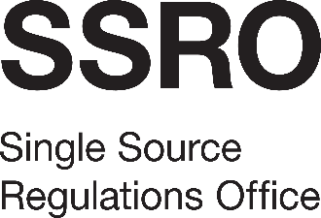
Single Source Regulations Office
100 Parliament Street
London
SW1A 2BQ

5 October 2023  ABANDONMENT NOTICE  SSRO-C-131 Stakeholder Survey | T  E | 0203 774 4780  tenders@ssro.gov.uk
 | www.gov.uk/ssro

The SSRO’s requirement for commissioning a stakeholder survey in early 2024 has been reconsidered, including in light of the resource draw on the organisation at this time. A decision has been taken to not proceed with the current procurement exercise, but to re-visit our requirements in the autumn of 2024.

