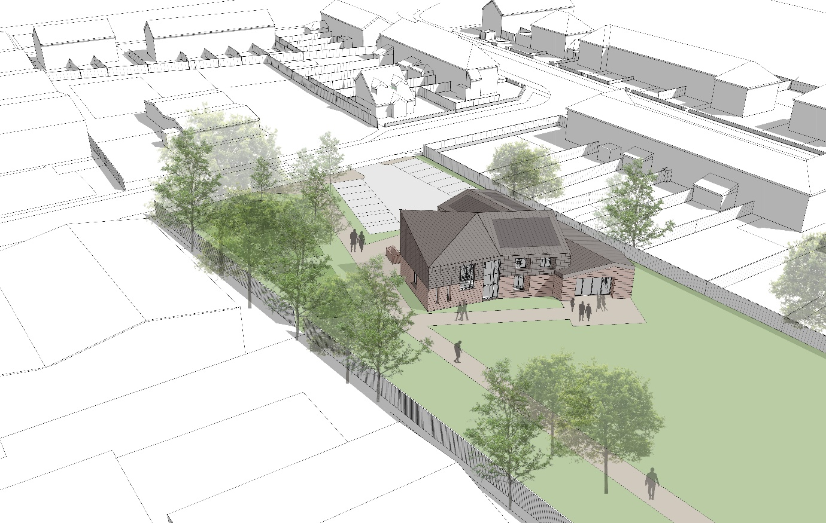

New Youth Centre
Eldon Way
Wick
Littlehampton
Tender to:

Act as Employers Agent on behalf of Littlehampton Town Council on the Keystone Project.
Contents:

- Background
- Scope and Specification
- Employees Agent Specification
- Health and Safety
- Evidence
- Contract
- Project Timescales
- Cost
- Tender Submissions
- Tender compliance
- Confidentiality
- Bidder Clarification
- Site Visits
- Interface Strategies
- Payments
- Appendix

Tender Information Pack

Definition

LTC – Littlehampton Town Council
HDA – Heyler Davies Architects
ADC – Arun District Council
EA – Employers Agent
Bidders – Defined as the company/persons submitting tender.

Description

1.0 Background

1.1 The strategic aims and objectives of this Council are to deliver a youth facility to replace the Keystone Centre. The current Keystone Centre in Eldon Way is dated, has a footprint of c.300m² and is set within an enclosed open space between a residential area and industrial estate in the north-west of Littlehampton. Throughout 2018 the Town Council held exploratory discussions with the District Council and community groups to identify proposals for a youth hub in Wick. The District Council has agreed to provide land opposite to the existing Centre for this purpose by way of a lease for the footprint of the new building and has been working with the Town Council on the project brief which will also deliver improvements to the existing outdoor play facilities.

1.2 A community engagement exercise was undertaken in February and March 2019 to gather views regarding what the priorities should be and at the same time to generate ideas for the shape of future provision that would inform a feasibility study. In March 2019, the feedback from this exercise, which was positive and included comments from the Keystone Centre Management Committee who welcomed the investment in a new facility, was considered by Council who supported commissioning a feasibility study. Authority was delegated to the Town Clerk, in consultation with the Chair of the Property and Personnel Committee to take this work forward.

1.3 In February 2020, following a tender exercise that was conducted in accordance with the Town Council’s Financial Regulations, Heyler Davies Architects (HDA) were appointed to produce the feasibility study for the project. The brief called for a design concept for a building sited on the open space on the opposite side of the road to the existing Centre, with a footprint of circa 500m2 , not exceeding two storeys that would be predominantly used by young people and would also cater for other community groups. The capital budget for the project was set at circa £1,250,000 to include fees and a timescale of three months given for completion of the study.

1.4 The outline design concept produced by HDA is innovative and includes the requirements within the specification set down by the Town Council. It also incorporates the capacity for improvements to the existing outdoor play facilities that will be delivered by the District Council. The design envisages a two-storey building with a footprint of approximately 431m2, that contains a large flexible interior hall space, provision for small meeting rooms, a kitchen, and associated facilities.
Parking will be positioned at the entrance to the building and there is space at the rear for outdoor play facilities. A small amount of preparatory work has been undertaken to determine the positioning of amenity facilities and informal discussions have also been held with the District Council Parks Team and Planners.
The existing Keystone centre is to remain open until project handover and following this will be included within the scope of this project for demolition.

On 18/06/20 HDA have been appointed to take the project forward to build plans to formally go to planning and specifications to enable a tender process for a contractor to undertake the works.

Appendix1: HDA presentation – This document offers further info on design and concept.

2.0 Scope/Specification:

2.1 - Outline Specification given at project outset:

2.2 A summary of the specifications that were included is set out below:

• The building should be fully accessible, of innovative design and should not intrude on what is partly a residential landscape.

• Main hall with a room divider to enable flexible use. The interior shall be designed to be a suitable environment for a range of indoor sports uses, with lighting that can be adapted to suit different activities

• A fully fitted kitchen linked to both the foyer/lobby area and main hall to enable the serving of refreshments.

• Offices /small meeting/activity/training rooms – with 1 to be suitable for confidential meetings o Toilets and parking

• Energy efficient in all aspects of its delivery with consideration given to the inclusion of solar panels as a minimum. Store(s) area – with flexibility to accommodate significant, and above the normal standard, secure storage. o Access to the existing public open space and Keystone Centre and parking to be maintained during construction.

3.0 Employer’s Agent Specification
3.1 Act on LTC behalf to inform on all aspects in relation to RIBA . Inform on risks throughout project in terms of budget/timescale/H&S and ensure guidance is adhered to in terms of Covid-19 restrictions.
3.2 Act on LTC behalf in relation to client obligations as outlined with CDM regulations 2015. Give specialist advice to ensure contractors are delivering on required contractual arrangements and in line with CDM regulation.

3.3 Offer specialist advice on all aspects of construction (technical advice) to ensure LTC offer best value and efficiency within the building. This advice will also ensure project outline is met and building fits the requirements outlined as a youth facility.
3.4 Review designs and comment regarding the need to avoid foreseeable risks and combat at source risks to the health and safety of those carrying out construction work or cleaning work and those who might be affected by such work.
3.5 Review the designs and comment on the adequacy of the Health and Safety information provided by the Designers.
3.6 Advise the Client in connection with the need for any specialist surveys, investigations and studies as necessary to enable him to discharge his duties in relation to the pre-construction Health and Safety information.
3.7 Advise on the implications of value engineering exercises involving the Client, the Project Team and, when appointed, the Principal Contractor.
3.8 Develop specification for principal contractor tender and manage tender process dealing with all enquiries. LTC will maintain responsibility for final appointment in line with LTC policy and procedure.
3.9 Preparing a cash flow forecast and monitoring actual progress against it and prepare recommendations for interim payments on account to the Contractor.
3.10 Preparing monthly assessments of anticipated final cost and reporting thereon and prepare and negotiate the Final Account with the Contractor.
3.11 Act as principal contact to ensure communication is maintained throughout the project and lead on project management committee to inform on progress with the project. It is anticipated biweekly meetings will be required and in light of Covid-19 this will adapt either remotely or at LTC main office – Manor House, Littlehampton.
3.12 Agreeing with the Contractor any variations to the contract. Certifying Contractor’s valuations in conjunction agreed contract instructions.
3.13 Ensure H&S obligations are met and health and safety file is in place. Act on LTC behalf to ensure any accidents falling under RIDDOR are processed within legal requirement.
3.14 Arranging for commencement of the works and checking the Contractor’s programme. Inform HSE if required and complete required documentation.
3.15 Monitoring the progress of the Project by periodic site visits and monitoring the quality of workmanship of the construction work. Be flexible and adaptable through out the project to meet the needs of the client.
3.16 Manage handover of building and ensure all O&Ms are issued to client and training is delivered on any site specifics.
3.17 Manage year one defect period and co-ordinate the handover of the Project, make all reasonable endeavours to ensure that time, cost and quality criteria are met.
3.18 Manage demolition of current Keystone centre for handover back to ADC.
Core Aims and Objectives:
Best value , Energy efficiency , Project delivered on time, Project delivered on budget, Communication streams maintained throughout ,H&S and CDM obligations met

4.0 Health and Safety

- The contractor will provide an adequate risk assessment relating to the above tasks to the Town Council.
- The contractor will hold sufficient (£10 million pounds) Public Liability and Employers Liability Insurance policies.
- The contractor to hold the correct qualifications to act on LTC behalf as Employers Agent.
- Employers Agent must make reference to Covid-19 and adapt to government requirements if changes occur.
- A copy of the company’s written Health & Safety Policy.
- Evidence of membership of professional bodies.

5.0 Evidence

Contractors will need to provide:

- Evidence of carrying out similar work - At least two projects
- A minimum of two references
- Copies of certificate of public liability insurance (cover £10m)
- Evidence of capacity to carry out the work

6.0 Contract

Any contract will be between the designated contractor and Littlehampton Town Council.
The tender should be based on the contract lasting until the end of the defect period.
The tender costs should be split:
- Contract requirements leading to planning submission
- Contract requirements leading to appointment of contractor
- Contract requirements leading to completion of project and end of year one defects.
LTC reserve the right to not progress to the next stage.

7.0 Project Timescales
Please find below and indicative timetable:

Keystone Project | Date:
Issue of tender documents | 07/07/20
Deadline of bidders Questions | 28/07/20
LTC response to questions | 30/07/20
Tender return deadline date | 31/07/20 at 16:30
Award of contract | 07/08/20
Contract formation | 14/08/20
Contract Commencement | 17/08/20

8.0 Cost

Your tender should include estimated costs as follows: (all to be costed separately)

1. Contract requirements leading to planning submission offering technical advice
2. Contract requirements leading to appointment of contractor
3. Contract requirements leading to completion of project and end of year one defects.

The project total value inclusive of all fee’s is anticipated between £1,200,000 and £1,400,000.

Please complete Appendix 5 Cost Split

9.0 Tender Submissions

Please note no tenders will be accepted electronically.
Please return your submission by Friday 31st July 2020 at 16:30pm.
Please refer to Appendix 3 – Sealed Tender Document.

Return address –
Littlehampton Town Council
The Manor House
Church Street
Littlehampton
West Sussex
BN17 5EW
10 Tender compliance
You are requested to submit separate prices for the three areas of work as detailed above - please use the form Appendix 5 – cost split. Any additional information that might help Littlehampton Town Council to reach a decision are welcomed as part of the bid.
The successful company will be required to enter into a contract with Littlehampton Town Council and this will require the production of all relevant certification including Risk Assessment of the work to be carried out and copies of Public and Employee Liability Insurance. You may wish to submit these documents with your tender.
In participating in this tender process, it will be implied that you accept and will be bound by all provisions within the tender documents. Accordingly, tenders should be on the basis of strict compliance with the requirements outlined within.
Third Party Verifications
Your tender is submitted on the basis that you consent to LTC carrying out all necessary actions to verify the information that you have provided, and the analysis of your tender being undertaken by one or more third parties commissioned by LTC for such purposes.
Information provided to potential bidders
Information that is supplied to potential bidders as part of this tender process is supplied in good faith. The information contained within the Tender documents and all supporting documentation related written or oral communication is believed to be correct at the time of issue but LTC will not accept any liability for its accuracy, adequacy or completeness and no warranty is given as such. This exclusion does not extend to any fraudulent misrepresentations made by or on behalf of LTC.

Potential bidders to make their own enquiries
You are responsible for analysing and reviewing all information provided to you as part of this tender process and forming your own opinions and seeking advice as you consider appropriate. You should notify LTC promptly of any perceived ambiguity, inconsistency or omission in the tender documentation and/or associated supporting documentation provided as part of this process.
Amendments to Tender documents
At any time prior to the tender return deadline, LTC may amend the tender documentation. Any such amendment shall be issued to all potential bidders, and if appropriate to ensure potential bidders have reasonable time in which to take such amendment into account, the tender return deadline shall, at the discretion of LTC, be extended. Your tender must comply with any amendment made by LTC in accordance with this paragraph or it may be rejected.
Declarations as to conduct of Tenderer
In connection with submissions of tenders for the execution of works or supply of goods and materials, declaration shall be obtained from each tender in the following form:- Please read and sign Appendix 3 Declaration as to conduct of Tenderer.
Compliance of tender submissions
Persons or organisations submitting a tender are advised that the canvassing of Councillors or the members of a committee or sub-committee either directly or indirectly shall disqualify them from the tendering process.
Tenders will be scored on the below criteria:
TENDER QUALITY WEIGHTING: 60% TENDER PRICE WEIGHTING: 40%
Please refer to Appendix 2 - Tender evaluation criteria
Any additional questions or for further information, please contact:
(To note currently officers are working remotely so will respond in due course to enquires)

Michael Grier
Community Resources Officer
Littlehampton Town Council
The Manor House
Church Street
Littlehampton
West Sussex
BN17 5EW
Tel: 07834700958
Email: mgrier@littlehampton-tc.gov.uk

All submissions are to be sent by post. All tender submissions should be sent in a plain sealed envelope which should bear the word “Tender” followed by the subject to which it relates but shall not bear any name or mark indicating the sender. The envelopes will remain the custody of the Town Clerk until the appointed time of opening on Monday 3rd August 2020 at 09:00am.

Please refer to Appendix 4 Sealed tender

Disqualification

LTC reserve the right to disqualify if:

- the terms and conditions are breached
- there are any errors, omissions or material adverse changes relating to any information supplied by you at any stage in this tender process
- any other circumstances set out in this tender document, and/or in any supporting documents entitle LTC to reject tender application.

Tender Costs

Bidders are responsible for obtaining all information necessary for preparation of your tender and for all costs and expenses incurred in preparation of the tender. By participation in the tender process the bidder excepts they will not be entitled to claim from LTC any costs , expenses or liabilities whatsoever that are incurred in this tender process , irrespective of whether or not your tender is successful.

Rights to cancel or vary this tender process

By issuing this tender , entering into clarification communications with potential bidders or by having any other form of communication with potential bidders, LTC is not bound in any way to enter into any contractual or other arrangement with you or any other potential bidder.
It is intended that the remainder of this tender process will take place in accordance with articles within this and associated documentation but LTC reserve the right to terminate, suspend, amend or vary this tender process by notice to all bidders in writing. LTC will have no liability for any losses, costs, expenses or liabilities whatsoever that maybe incurred as a result of such termination, suspension, amendment or variation.

11 Confidentiality

Bidders shall use the tender documentation and any other information furnished to them under the tender documentation for the purposes of responding to the tender exercise. All such documents and information bidders received shall remain the property of LTC, Shall be kept confidential and shall be returned to LTC on request.
Reproduction of any parts of the tender documentation is authorised only for the preparation of the response. Bidders shall ensure that all such copies are destroyed when no longer required in connection with tender documentation.

Bidders shall not issue any form of publicity or advertisement regarding this process without prior written consent of LTC.

Bidders shall not transfer, assign or distribute this tender documentation to any other company or person without written permission from LTC Town Clerk. A failure to gain the required authority will prevent consideration for tender.

Freedom of Information

In accordance with obligations and duties placed upon public authorities by the Freedom of Information act 2000 and the Environmental Information Regulations 2004 all information submitted to LTC may be disclosed in response to a request made pursuant to the Information Laws.

In respect of any information submitted by a bidder that the bidder considers to be commercially sensitive the bidder should set out the following information:

- Clearly identify which information is considered commercially sensitive
- Explain the potential implications of disclosure of such information
- Provide an estimate of the period of time during which the bidder believes that such information will remain commercially sensitive.

Where a bidder identifies information as commercially sensitive, LTC will endeavour to maintain confidentiality. Bidders should note, however, that even where information is identified as commercially sensitive, LTC might be required to disclose such information in accordance with the information laws. Accordingly, LTC cannot guarantee that any information marked ‘commercially sensitive’ will not be disclosed.

Anti-Bribery

Bidders must ensure during this tender process no breach to all articles outlined within the Bribery Act 2010.

12 Bidder clarification

All clarification is to be processed through contract finder and will be shared with all prospective bidders to ensure an open and transparent process.

13 Site Visits

All site visits must conform to Current Coivd-19 conditions. The site itself is a large open space so distancing is easily achievable.

Site visits are to be arranged by appointment with Listed contact (shown under Compliance of tender submissions)

14 Strategies

- LTC Neighbourhood Plan
- Greenspace works – Delivery of MUGA and play area within green space.
- Greenspace Management Contract 2017 – 2027
- ADC play area strategy

15 Payments

In line with LTC policy and procedure any requested payment will be authorised by appointed LTC personnel and paid by cheque.

16 Appendix

Appendix 1 – HDA presentation
Appendix 2 – Tender Evaluation
Appendix 3 – Declarations as to conduct of tenderer
Appendix 4 - Sealed Tender info
Appendix 5 - Cost Split

