

Attachment 2b – Lot 3 Certificate of Technical and Professional Ability
Residential
RM6184 – Offsite Construction Solutions

Instructions
We require you to demonstrate that you have delivered Works and Services within the scope of Lot 3. To do so, you are required to submit one (1) Certificate of Technical and Professional Ability (COTPA).
You are required to complete section A within the COTPA (highlighted yellow).
The customer must verify that the information you have provided in section A is true and accurate by completing and signing Section B within the COTPA (highlighted blue).
The form of COTPA is set out below.
You must submit the completed COTPA for Lot 3 by uploading this file to question 1.34 within the online selection questionnaire (qualification envelope) as a ZIP file.
Name your ZIP file in the following format: organisation name_Lot 3 COTPA
Please note that we reserve the right to contact the customers listed in the certificates to verify the information provided. You must notify the customer that they may be contacted by us.
PMV (Pre Manufactured Value)
PMV is calculated as a percentage of a project that was completed “offsite”, as the determining factor as to whether the project is considered to be an “offsite” project or traditional construction project.

For the purposes of this certificate, the PMV of a specific project is to be completed by the bidding entity as follows:

(PMV contact value £ / Gross Construction contract value £) x 100 = PMV%

Mandatory requirements
- The certificate must be for a project for which a completion certificate has been provided within the 5 years prior to the publication of the contract notice for this competition.
- The contract can be from the public or private sector but must have used NEC, JCT, PC2000 or TAC-1 terms for the capital works packages, i.e. Groundworks, Delivery, Installation works.
- Examples of call-off contracts awarded under framework contracts will be considered valid, but framework contracts themselves will not be valid.
- No attachments other than the certificates are permitted. Any additional documents submitted will be disregarded.
- The certificate must cover a project where your organisation was acting in the role of Principal Contractor (as defined by the Construction (Design and Management) Regulations 2015) and were contracted as the manufacturer, installer and commissioner of the main works on this project
- The project must have demonstrated 55% PMV
- The project must demonstrate delivery of a turnkey solution
- Customer contacts provided must not have been employed or appointed by your organisation, or from within your associated group of companies, within the past 18 months prior to the publication of the contract notice.
- Section B must be completed in full. If a customer wishes to remain anonymous or you have a non-disclosure agreement with them please do not use this as or your certificate
- Electronic/DocuSign signatures will be accepted for Section B but typed signatures will not.

Lot 3
- A bidder can submit an example project for either an MMC Category 1 (3D) or a Category 2 (2D) solution depending on their manufacturing system. Should they wish to provide both systems, they must provide an example project for each system.
- Examples must clearly and unambiguously fall within the scope of a design and construction residential or mixed-use (including residential) project, or a design and construction project of comparable complexity, utilising either MMC Categories 1 or 2. Comparable complexity is defined by way of a project that meets all the following criteria:
1) Elicitation of client requirements
2) Design and Manufacture, Deliver & Construction, Commissioning & Handover
3) Project PMV equal to or greater than 55%
4) Satisfies either BOPAS or NHBC Accepts, or similar approved, requirements
5) Delivers a minimum of 20 individual dwellings

Certificates of Technical and Professional Ability will be marked PASS/FAIL
You may fail Part 11 – Technical and Professional Capability of the selection questionnaire and be excluded from the competition if:
- Your COTPA does not meet all the mandatory requirements set out above.
- You do not provide calculative evidence demonstrating your example project meets a minimum 55% PMV qualifying criteria
- You have not completed all of the information requested in the Certificate of Technical and Professional Ability.
- Your customer has not provided the required certification information in section B of the Certificate of Technical and Professional Ability.
- We contact the customer to verify the information provided and they cannot or will not verify the information. It is vital that you select a customer that is prepared to verify the information you have provided and be contactable in the event that clarification is required.
If we determine that you have failed Part 11 – Technical and Professional Capability of the selection questionnaire we will notify you and tell you the reasons for this.

Certificate of Technical and Professional Ability
RM6184 – Offsite Construction Solutions – Lot 3
Section A - To be completed by the bidder
Lot Title: Lot 3 Residential | 3D Turnkey Solution
Name of bidder: | [bidder’s name]
Certificate of Technical and Professional Ability - details of the contract, to be certified by the customer in Section B.
Name of customer: | [customer name]
Name of supplier: | [supplier name]
Contract title: | [contract title]
Short description of contract (max. 150 words):
PMV: | %
Contract start date: | [dd/mm/yyyy]
Contract completion date: | [dd/mm/yyyy]
Contract Value: | £
FTS Award Notice reference or  Contracts Finder reference:  (for Public Sector Contracts only – enter N/A if not applicable) | FTS Award Notice or Contracts Finder reference:  [e.g. 2011/S 239-387260]
Scope of Work Package
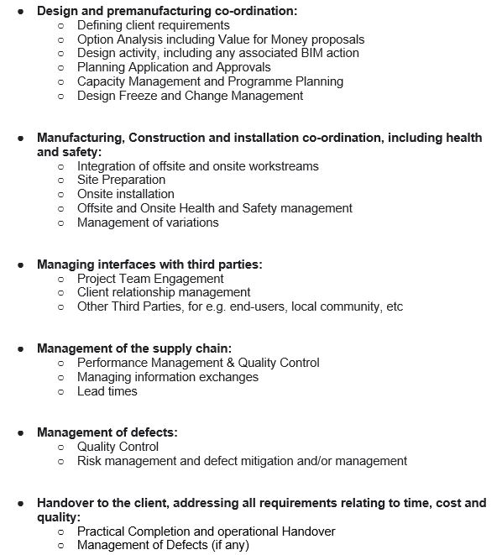

Lot Title: Lot 3 Residential | 2D Turnkey Solution
Name of bidder: | [bidder’s name]
Certificate of Technical and Professional Ability - details of the contract, to be certified by the customer in Section B.
Name of customer: | [customer name]
Name of supplier: | [supplier name]
Contract title: | [contract title]
Short description of contract (max. 150 words):
PMV | %
Contract start date: | [dd/mm/yyyy]
Contract completion date: | [dd/mm/yyyy]
Contract Value: | £
FTS Award Notice reference or  Contracts Finder reference:  (for Public Sector Contracts only – enter N/A if not applicable) | FTS Award Notice or Contracts Finder reference:  [e.g. 2011/S 239-387260]
Scope of Work Package
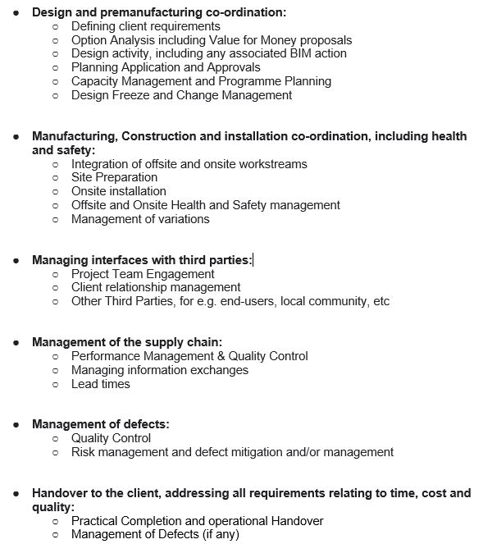

Section B - To be completed by the customer (2D COPTA, if applicable)
Certificate of Technical and Professional Ability - Customer contact details
Customer contact name: | [name of customer contact]
Customer address: | [customer address]
Customer direct line: | [customer telephone number]
Customer email: | [customer email]
Customer confirmation:
We hereby certify that, to the best of our knowledge and belief, the supplier has satisfactorily supplied the services and delivered the deliverables and the outcomes described above at Section A in accordance with the contract. | Authorised signature (either double-click on the signature box below to digitally sign or copy & paste in an image file of your signature):
Liability for customer certifying Certificate of Technical and Professional Ability:
In signing this Certificate of Technical and Professional Ability I confirm that I have the necessary authority to do so on behalf of the organisation for which the works and services were provided.
Whilst the information in this certificate has been provided in good faith in the belief that it is truthful and accurate, the customer does not assume any responsibility or any liability nor make any guarantee, representation or warranty as to the contents of this certificate. The customer shall not be liable for and hereby excludes liability for any loss, damage (including any special, exemplary, indirect, incidental, consequential damages, costs or associated legal fees) that may be suffered as a result of use of the certificate and its content, to the fullest extent permitted by law.
Nothing in this certificate shall affect, or constitute a waiver of, the customer's rights or remedies in relation to the contract.

Section B - To be completed by the customer (3D COPTA, if applicable)
Certificate of Technical and Professional Ability - Customer contact details
Customer contact name: | [name of customer contact]
Customer address: | [customer address]
Customer direct line: | [customer telephone number]
Customer email: | [customer email]
Customer confirmation:
We hereby certify that, to the best of our knowledge and belief, the supplier has satisfactorily supplied the services and delivered the deliverables and the outcomes described above at Section A in accordance with the contract. | Authorised signature (either double-click on the signature box below to digitally sign or copy & paste in an image file of your signature):  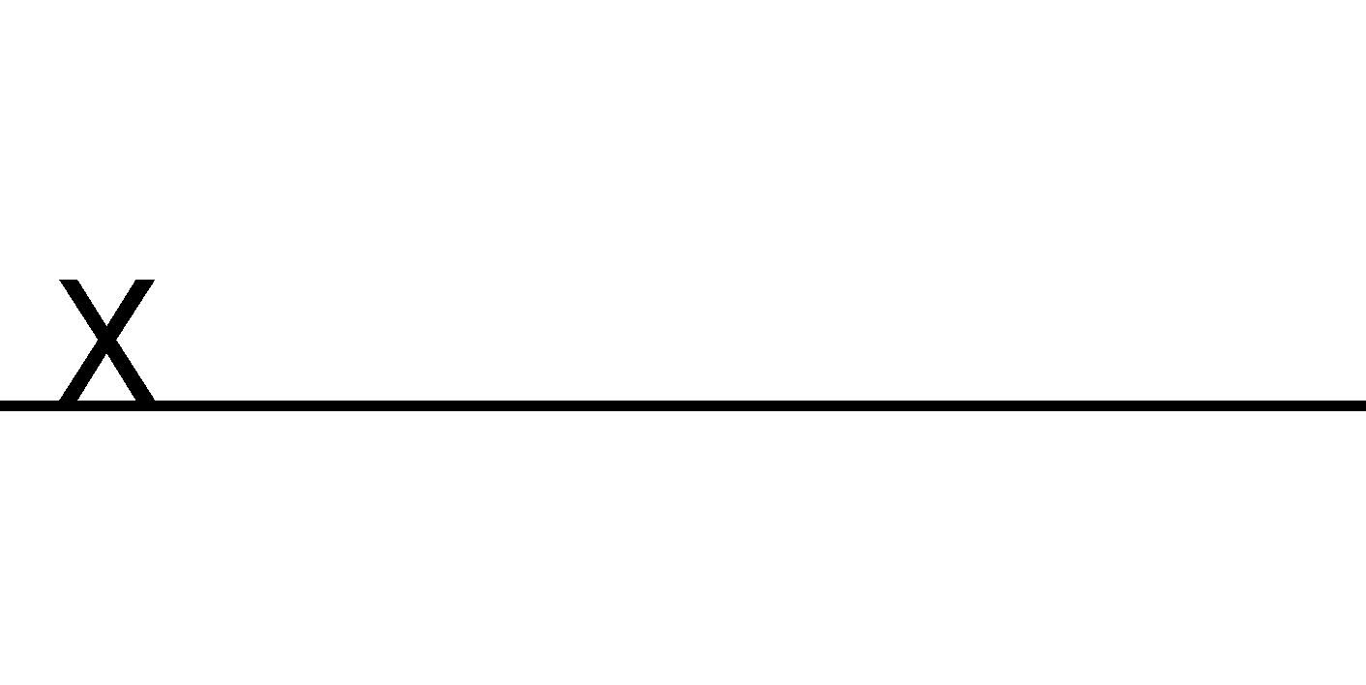
Liability for customer certifying Certificate of Technical and Professional Ability:
In signing this Certificate of Technical and Professional Ability I confirm that I have the necessary authority to do so on behalf of the organisation for which the works and services were provided.
Whilst the information in this certificate has been provided in good faith in the belief that it is truthful and accurate, the customer does not assume any responsibility or any liability nor make any guarantee, representation or warranty as to the contents of this certificate. The customer shall not be liable for and hereby excludes liability for any loss, damage (including any special, exemplary, indirect, incidental, consequential damages, costs or associated legal fees) that may be suffered as a result of use of the certificate and its content, to the fullest extent permitted by law.
Nothing in this certificate shall affect, or constitute a waiver of, the customer's rights or remedies in relation to the contract.

