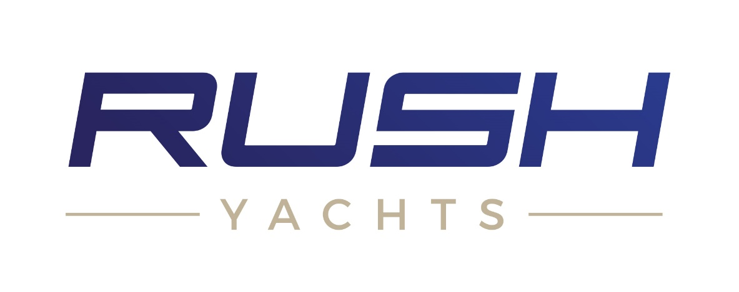

**Invitation to Tender**

**Rush 39 Construction Moulds**

**Ref: BIGTP116/10000893**

Contents

1 Rush Yachts Overview & Description 1

2 Project Specification 1

3 ITT Timeline 2

3.1 Manufacturing Timeline 3

4 Conflicts of Interest 3

4.1 Exclusions 3

5 Consortium or Sub-Contracting 4

6 Tender Application Requirements 4

7 Tender Scoring Criteria 4

8 Tender Returns 4

9 Clarification 5

10 Disclaimer 6

# Rush Yachts Overview & Description

Rush Yachts are builders of the most practically green superyacht tenders/day boats for the marine industry making use of the latest in green materials, processes, and technologies. After the release of the design and engineering concept at the end of 2020, Rush Yachts are looking to get the first range of vessels into construction during 2021. To achieve the project brief and capitalise on the intended market, Rush Yachts require a set of high-quality hull, deck and hatch moulds to enable the ongoing build in the most efficient, high quality and sustainable manner.

The purchase of the moulds is part of a grant funded application process and therefore procurement will be subject to grant approval of the project as a whole. Rush Yachts will compare tenders received on a compliance basis only.

# Project Specification

The following details the overall project specification:

Manufacture and supply of moulds for the hull, deck and engine room hatch for the Rush 39. The project should be built around creating plugs (male tooling) which in turn are used to create the final hull, deck and engine room hatch moulds.

* X 1 Hull Mould (centreline split with alignment method and silicon seal)
  + Approximately 110m2
  + 1200gr finish above waterline (67m2)
  + 1200gr finishing below waterline (43m2)
* X 1 Deck Mould
  + Approximately 60m2
  + 1200gr finish on exposed surfaces (42m2)
  + 320gr finish on areas covered by timber (18m2)
* X 1 Engine Hatch
  + Approximately 6.5m2
  + 1200gr finish on exposed surfaces
  + 320gr finish on areas covered by timber
* Include a designated warranty period of no less than two years from delivery

Additional tooling requirements:

* Moulds should be built so that they are suitable for resin infusion
* The moulds should be supplied on a strong steel framework with suitable heavy-duty wheels

Where possible, proposals should include ways to increase the overall environmental impact of the processes and materials used within the manufacture of the end moulds. This can include items such as using recycled EPS within the plug construction or using Balsa or recycled plastics within the mould frames. If there are any changes in cost related to the use of green materials/processes then these should be detailed and costed separately.

Notes:

* Final surface areas will be released to the chosen supplier on completion of detailed naval architecture by Rush Yachts and their design team. These documents will be in Rhino file format
* The current 3D file format can be found in the tender documentation
* Additional works should be listed with separate hourly rates and general manufacturing costs for a desired finish (including additional costs to increase surface finish on areas less than 1200gr)
* Weekly reports on progress and planned visits for quality control sign offs should be included within the quote
* Rush Yachts will be the owner of the production mould after final payment is fulfilled
* Rush Yachts to make final quality sign off inspection prior to final payment and shipping
* Transport to Rush Yachts facilities to be included as a separate line item (please refer to the companies address on page 5 of this document)
* All mould construction drawings including reinforcement will be done by the supplier and approved by Rush Yachts prior to manufacture
* All mould structural design and lamination schedule to be created by supplier

# ITT Timeline

The anticipated timetable for submission of the tender and commission milestones are set out below:

|  |  |
| --- | --- |
| Activity | Date |
| Date ITT available on Contracts Finder | 22/02/2021 (Day 1) |
| Last date for raising queries | 08/03/2021 (Day 14) |
| Last date for clarifications to queries | 12/03/2021 (Day 18) |
| Deadline to return ITT | 15/03/2021 (Day 21) |
| Evaluation of ITT | 15/03/2021 (Day 21+) |
| Award of Contract | This is subject to successfully obtaining grant funding and will normally be no later than 90 days from contract evaluation |

## Manufacturing Timeline

The expected timeline from signing the contract to delivery is to be 14 – 15 weeks. This includes final design work from Rush Yachts. If there are any clear issues with this timeline then they should be stated by the supplier.

# Conflicts of Interest

A Declaration that to your knowledge there is no conflict of interest between your company and Rush Yachts that is likely to influence the outcome of this procurement either directly or indirectly through financial, economic or other personal interest which might be perceived to compromise their impartiality and independence in the contexts of this procurement procedure.

This will permit that in the event of a conflict of interest, appropriate steps are taken to ensure that the evaluation of any submission will be undertaken by an independent and impartial party.

## Exclusions

Rush Yachts shall exclude applicants from participation in this procurement procedure where they have established or are otherwise aware that the applicant, to include administrative, management or supervisory staff that have powers of representation, decision or control of the applicants company, has been the subject of a conviction by final judgment of one of the following reasons:-

* Participation in a criminal organisation
* Corruption
* Fraud
* Terrorist offences or offences linked to terrorist activities
* Money laundering or terrorist financing
* Child labour and other forms of trafficking in human beings

# Consortium or Sub-Contracting

Where a consortium or sub-contracting approach is proposed, all information requested should be given in respect of the proposed prime contractor or consortium leader. Relevant information should also be provided in respect of consortium members or sub-contractors who will play a significant (greater than 25%) role in the delivery of the services under any ensuing Contract.

# Tender Application Requirements

Please provide paper copies of your application which should include:

1. Confirmation that you the supplier can meet the requirements outlined in the brief above.
2. Dated your response, used our company’s full postal address (albeit your submission might be by email) and included the Reference: BIGTP116/ 10000893
3. Details of who to contact in your company in relation to this tender
4. Company registration Number and VAT number (if appropriate)
5. Total cost of providing the goods/services requested in the format required with a breakdown to include:
   1. Costs for additional costs related to labour and materials
   2. Delivery to Rush Yachts address

# Tender Scoring Criteria

The tender will be scored only on their compliance to the specification as detailed in Section 2 and awarded to the lower compliant tender.

# Tender Returns

Tenders may be returned by email or post.

Tenders should be returned by 17:00 of 22/02/2021

If submitted by email, tenders should be sent electronically to [info@rushyachts.uk](mailto:info@rushyachts.uk) with the following message noted in the Subject Box; “Rush Yachts Rush 39 Construction Moulds BIGTP116/ 10000893”

Tenders are advised to request a read receipt when submitting by email.

If submitting by post, the tender must be enclosed in a sealed envelope, only marked as follows:

Tender – Strictly Confidential – “Rush Yachts Rush 30 Construction Moulds BIGTP116/ 10000893”

Addressed to:

Rush Yachts

Trethewey House

Tregony

Truro

Cornwall

TR2 5TH

United Kingdom

# Clarification

There will not be any negotiations of any of the substantive terms of the Tender Documents. Only clarification queries will be answered. Any clarification queries arising from the Tender Documents which may have a bearing on the offer should be raised as soon as possible in writing. The deadline for clarification questions is 7 days before the submission date. All e-mailed queries should be sent to: -

Name: Michael Rusbridge

E-mail: info@rushyachts.uk

No representation by way of explanation or otherwise to persons or corporations tendering or desirous of tendering as to the meaning of the tender, Contract or other Tender Documents or as to any other matter or thing to be done under the proposed contract shall bind us unless such representation is in writing and duly signed by Michael Rusbridge of Rush Yachts. All such correspondence shall be returned with the Tender Documents and shall form part of the Contract.

Tenderers must provide a single point of contact in their organisation for all contact between the Tenderer and Rush Yachts.

Responses to any queries will be shared through the Contracts Finder website.

# Disclaimer

The issue of this documentation does not commit Rush Yachts to award any contract pursuant to the bid process or enter into a contractual relationship with any provider of the service. Nothing in the documentation or in any other communications made between Rush Yachts or its agents and any other party, or any part thereof, shall be taken as constituting a contract, agreement or representation between Rush Yachts and any other party (save for a formal award of contract made in writing by or on behalf of Rush Yachts).

Bidders must obtain for themselves, at their own responsibility and expense, all information necessary for the preparation of their tender responses. Information supplied to bidders by Rush Yachts or any information contained in Rush Yacht’s publications are supplied only for general guidance in the preparation of the tender response. Bidders must satisfy themselves by their own investigations as to the accuracy of any such information and no responsibility is accepted by Rush Yachts for any loss or damage of whatever kind and howsoever caused arising from the use by bidders of such information.

Bidders shall be responsible for their own costs and expenses in connection with or arising out of their response. Rush Yachts reserves the right to vary or change all or any part of the basis of the procedures for the procurement process at any time or not to proceed with the proposed procurement at all.

Cancellation of the procurement process (at any time) under any circumstances will not render Rush Yachts liable for any costs or expenses incurred by bidders during the procurement process.