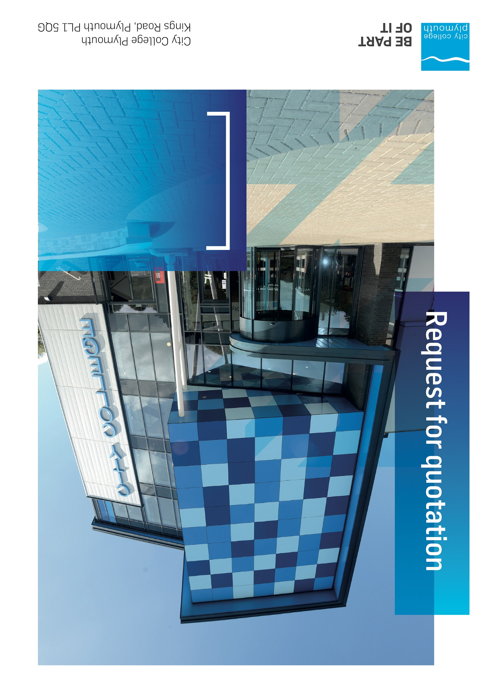

**Request for Quotation**

**RFQ200**

**Security Services**

**Issued 23st March 2023**

# Table of Contents

Table of Contents 2

Confidentiality Statement 3

Open Procedure 3

Submission Details 4

Submission Deadlines 4

Submission Delivery Address 4

Submission Questions and Clarifications 4

Electronic Submissions 4

Introduction and Executive Summary 5

Business Overview & Background 5

Our Vision … is where our future lies 5

Our Mission … is what we focus on each and every day 6

Background 6

Detailed Requirement 6

Timescales 7

Required Affiliations 8

Security and DBS arrangements 8

Written Submission 8

Pricing 8

Terms and Conditions 9

Validity 9

Selection Criteria 9

Award Price 10

Written submission 10

Assessment of Quotations 11

Freedom of Information Act 2000 11

General Data Protection Regulation (GDPR) 2018 11

Agreement Conditions Acceptance and Declaration 11

Supporting Documentation 11

# Confidentiality Statement

This document, and any attachments thereto, regardless of form or medium, is intended only for use by the addressee(s) and may contain legally privileged and/or confidential, copyrighted, trademarked, patented or otherwise restricted information viewable by the intended recipient only. If you are not the intended recipient of this document (or the person responsible for delivering this document to the intended recipient), you are hereby notified that any dissemination, distribution, printing or copying of this document, and any attachment thereto, is strictly prohibited and violation of this condition may infringe upon copyright, trademark, patent, or other laws protecting proprietary and, or, intellectual property. In no event shall this document be delivered to anyone other than the intended recipient or original sender and violation may be considered a breach of law fully punishable by various domestic and international courts. If you have received this document in error, please respond to the originator of this message or email him/her at the address below and permanently delete and/or shred the original and any copies and any electronic form this document, and any attachments thereto and do not disseminate further.

Thank you for your consideration, City College Plymouth.

Where no notice is given, all information contained herein is Copyright 2019 City College Plymouth.

# Open Procedure

The College fully adheres to the requirements of the Public Contracts Regulations 2015, including for opportunities which are under threshold amounts.

Any Contractor who directly or indirectly canvasses any Member or Officer of the Institution, or advisor concerning the award of the contract for the provision of the services, or who directly or indirectly obtains or attempts to obtain information from any such member or Officer concerning any Tender or proposed Tender for the service will be disqualified from having his/her Tender considered.

# Submission Details

## Submission Deadlines

All submissions for responding to this Request for Quote must be submitted via email as stated below, no later than:

**Tuesday 11th April 2023**

**12:00 Noon**

Any submissions received after this date will not be considered.

## Submission Delivery Address

All submissions should be submitted electronically as below

## Submission Questions and Clarifications

You may contact the following person if you have any questions or require clarification on any topics covered in this Request for Quotation: by Friday 31st March.

**Adam Baker**

Procurement Officer

Phone: 01752 855313

Email: tenders@cityplym.ac.uk

All correspondence during the Tender should be channeled via the Procurement Officer using the above details only. Bidders found to have gained an unfair advantage shall be disqualified from the current opportunity and future opportunities with the College for a minimum of four (4) years.

## Electronic Submissions

Electronic submissions in response to this Request for Quotation must meet the following criteria:

Sent via email to: [tenders@cityplym.ac.uk](mailto:tenders@cityplym.ac.uk)

Document standards:

* Text must be in Microsoft Word format;
* Price tables must be in Microsoft Excel format (using pricing schedule in Appendix A);
* Supportive evidence may additionally be submitted in PDF format;
* Images, Designs, and other supporting evidence may be in either JPEG or PDF format
* Completed Appendix C Suitability Assessment & Selection Questionnaire (Including Mandatory & Discretionary Exclusions) Parts 1, 2 and 3. - *Please note this suitability assessment will not be viewed unless you are the winning tenderer. Failure at this stage may prevent the contract from being awarded.*
* Signed Agreement Acceptance and Declaration.

*Please note that the College is able to accept submissions sent in a compressed or “.zip” file format, so long as the files contained meet the standards described above.*

**WARRANTY**:

By submitting your tender bid, you are warrantying to the College that you have not breached our canvassing or soliciting clause.

If any successful tenderer awarded a contract is found to have provided an inaccurate warranty, then the College reserves the right to terminate the awarded contract with immediate effect and re-tender the contract from which the successful tenderer will be excluded from re-bidding and shall be disqualified from any future opportunities for a period of four years.

# Introduction and Executive Summary

The College is looking to purchase an onsite Security Service to carry out various tasks as requested by the premises team.

The anticipated value of the supply contract will exceed £25,000. Therefore, as per the Public contracts Regulations 2015 the opportunity will be advertised on the government portal ‘Contracts Finder’.

# Business Overview & Background

The College operates on two sites within the city, serving 12,533 students and employing over 500 staff. The College operates year round, with opening times from 0800-2100 on some days.

## Our Vision … is where our future lies

We are a College with a national reputation for promoting enterprise, employability and science, technology, engineering and mathematics (STEM).

## Our Mission … is what we focus on each and every day

To be the South West’s leading provider of innovative, technical, professional education and training by supporting partnerships for growth, raising aspirations and fostering wealth creation

## Background

City College Plymouth is one of the largest providers of innovative, technical and professional, education in the South West with a national reputation for promoting enterprise, employability and science, technology, engineering and mathematics (STEM). The College plays a central role in the educational, cultural and economic life of the region and works with strategic partners to facilitate growth, raise aspirations and foster wealth creation.

The College was awarded the Teaching Excellence Framework Gold award for its university-level provision and its most recent Ofsted inspection confirmed that the College continues to be ‘Good’ with outstanding features. The College was rated first in the South West and second nationally for student satisfaction in the latest FE Choices student satisfaction survey.

City College supports the region’s employers with their award-winning Apprenticeship provision, as well as providing a range of courses and bespoke training programmes which enable employees to upskill or retrain to better support their business’ requirements. Their successful partnership working with the local business community resulted in a 99.5% satisfaction rate in the Government’s national ‘FE Choices employer satisfaction survey 2016 to 2017’ - placing them first in the country for general further education colleges.

City College Plymouth offers a wide range of academic and vocational courses in a variety of subjects. The total number of students supported by the College is 12,533 –comprising of: 3,569 full-time students, including 765 higher education students and 179 non EU students; 8,964 part-time students; and 1,599 apprentices. The College also employs over 500 staff.

# Detailed Requirement

City College Plymouth is looking to contract a firm to provide security services to enable us to deliver an enhanced student experience.

The college is looking to engage for an initial annual contract with an option to extend for a further 2 years on a 1+1 basis.

Provision required for term time

2 Guards between the hours of 8:30 and 16:30 - Monday - Friday

1 Guard between the hours of 16:30 and 21:30 Monday - Friday

Provision required for Staff training days and College holidays

1 Guard between the hours of 8:30 and 16:30 Monday - Friday

1 Guard between the hours of 16:30 and 21:30 Monday - Friday

Please note term dates are available from here: https://www.cityplym.ac.uk/information/term-dates/

There may also be a requirement to provide guards outside of the times highlighted above due to additional events etc, please can you provide pricing for this ad-hoc additional cover.

The guard number and hours require is currently and while we don't foresee any change we expect to be able to adjust to the needs of the college with 28 days notice

Below is a summary of the expected duties the security guards would be expected to undertake;

* Regular patrols of the college (Internal and external)
* Lanyard checks at the front entrance from 8:30 and ensures staff/students are wearing them throughout the day.
* Smoking/vaping checks to ensure this activity is undertaken in the designated areas
* Monitoring parking - disabled bays, restricted areas etc and issuing warning notices at the college's discretion
* Emptying pay and display machines (Weekly)
* Dealing with individual incidents as requested by college employees
* Reporting safeguarding concerns to the college safeguarding team
* Use of CCTV
* Locking/unlocking at the request of college management - This is not a requested daily duty

Please note this is not an exhaustive list and the appointed guards would be expected to carry out any other tasks as requested by the premises management

## Timescales

The College would like the initial year of the contract to start w/c 1st May 2023

## Required Affiliations

The contractor will be required to be SIA approved. Documents will need to be available upon request. This is a pass/fail criteria.

## Security and DBS arrangements

The College requires that all contractors, prior to undertaking work on the College site, will have been subject to a (DBS) English Disclosure Barring and Services check.

All staff on site will be required to comply with health and safety requirements at all times and to wear appropriate identification.

All staff will be required to sign in and sign out when on College premises.

# Written Submission

We require a written document which details your company offer with particular interest to the following areas. This submitted document will be scored as per the table on page 10

.

* Contract management and reporting.
* Outline capabilities to carry out tasks outlined above
* Experience of working in an education setting
* Confirmation that you are SIA approved and details of the various accreditations that you hold. **Please note failure to provide this information will mean your bid will not progress to the assessment stage.**
* Confirmation that security officers will hold a valid English DBS certificate. **Bidders who are unable to provide this confirmation will be unable to progress to the assessment stage.**

# Pricing

Bidders should provide their pricing using Appendix A.

Prices should be firm and valid for at least the initial contract period (12 months) and not subject to increase or escalation of any kind throughout the contract.

The data provided in Appendix A **should not** be considered a commitment to purchase, and services will be ordered via a formal purchase order. However the successful supplier will benefit exclusively from the College’s annual spend on these services.

# Terms and Conditions

The College’s normal business terms are 1-2 months from the date of invoice. Payment will become due subject to the above upon the College’s full acceptance of the goods/services. This Request for Quotation and any resulting purchase order will be subject to the College’s General Terms and Conditions of Purchase of Goods/Services – see appendix B.

The College reserves the right to request a formal contract for all contracts over 1 year duration in supplement to the terms and conditions and contract acceptance documents.

# Validity

Bidder’s offers should be open and valid for acceptance for a period of no less than ninety [90] days from the date of submission.

# Selection Criteria

The successful supplier will have provided the Most Economically Advantageous Tender (MEAT) to the college. It should be noted that the bidder with the lowest submitted prices will not necessarily be down-selected. All bidders will be notified via email of the results of the outcome no later than 90 days from the date of submission. The date of contract award will be provided within that email.

The marking criteria is as follows:

|  |  |
| --- | --- |
| Category | Weight |
| Price | 70% |
| Understanding of the requirement and ability to carry out tasks | 10% |
| Contract management including incident reporting | 10% |
| Experience of working in an educational setting | 10% |
| Pass / Fail Criteria |  |
| SIA approved contractor | Pass/ Fail |
| DBS confirmation | Pass/Fail |

Please see table below for more details on the scoring method.

## Award Price

Lowest quote price divided by quote price multiplied by 100

## Written submission

|  |  |  |
| --- | --- | --- |
| **Assessment** | **Score** | **Interpretation** |
| **Excellent** | 4 | *Comprehensive response supported by examples*  *Description fully supported by details that demonstrate the applicant’s ability to provide the required services.* |
| **Good** | 3 | *Broad response supported by relevant examples.*  *Description well supported by details that demonstrate the applicant’s ability to provide the required services.* |
| **Satisfactory** | 2 | *Reasonable response supported by some evidence.*  *Description adequately supported by details that demonstrate the applicant’s ability to provide the required services.* |
| **Poor** | 1 | *Limited response not well supported by evidence.*  *Description inadequately supported by details that demonstrate the applicant’s ability to provide the required services.* |
| **Unacceptable** | 0 | *No response or insufficient information provided.* |

# Assessment of Quotations

Bidders must ensure that their quotation fully addresses all information requested within this RFQ document. Bidders must ensure that any quotation fully meets the specification required. The College reserves the right to discount any quotation which does not fully meet the specification.

The College reserves the right to seek clarification with bidders upon receipt of quotations.

# Freedom of Information Act 2000

Under the Freedom of Information Act 2000 the College cannot guarantee that information provided by bidders during the course of this RFQ procedure or any resulting contract will be held a confidential. The College will not routinely release information to interested parties unless required to do so in order to meet our statutory obligations.

# General Data Protection Regulation (GDPR) 2018

All bidders must comply with the General Data Protection Regulation (GDPR) 2018 in respect of using and processing personal information. Bidders must have in place technical and organisational safeguards to protect personal data from unauthorised use, disclosure or loss.

The College reserves the right to request a copy of your privacy statement if you are the successful bidder.

# Agreement Conditions Acceptance and Declaration

Bidders are required to sign and return the attached Agreement Conditions Acceptance and Declaration. Appendix D

# Supporting Documentation

Appendix A: Pricing Schedule

Appendix B: City College Plymouth Standard Terms & Conditions

Appendix C: Suitability Assessment & Selection Questionnaire

Appendix D: Agreement Conditions Acceptance and Declaration