Notification of Supplier Day and Request for Expressions of Interest

RSSB research into pantograph and OLEinteraction

RSSB, on behalf of the rail industry, are seeking to understand ideas and capability to undertake research into current industry challenges regarding the Pantograph and OLE

Purpose

This notification is to invite potential suppliers to provide information through an Expression of Interest (EoI) about potential research to be procured by RSSB challenges related to the pantograph, the OLE and the interface between the two.

This EoI is intended to provide the supplier community with insight into the current thinking and provide the opportunity for suppliers to influence the prioritisation and focus of future research. As such this EOI seeks to enable suppliers to:

* understand the research ideas identified;
* provide information regarding any pre-existing work suppliers may be aware of to inform project development;
* support the understanding on the impact the research may provide to industry; and
* register their interest and capability for a specific research area should RSSB decide to commission it for delivery.

To feed into the process, EoIs should be received by COP **13 August 2018**.

Background

The Vehicle/Train Energy System Interface Committee (V/TE SIC) assists the rail industry in evaluating and managing the key power supply system interfaces. It also identifies losses, and likely remedies, in the energy transmission system; promotes more efficient energy use; and develops longer-term, sustainable energy strategies.

V/TE SIC has identified a series of knowledge gaps and has engaged with RSSB to look at options for addressing these gaps through research.

Scope of work

Specific scopes of work will be defined and this engagement activity is expected to influence the approach. The ideas currently under consideration are displayed on the diagram on the following page which was developed by V/TE SIC.

To be taken forward projects will need to be identified and developed which have the following characteristics:

* Identifies and targets a significant knowledge gap for the industry
* Requires cross industry collaboration for the research and the likely implementation
* Has a high likelihood of implementation by the affected stakeholders
* Is expected to have a significant and positive impact on the rail sector

We welcome support and ideas from the supplier community on what projects could be scoped to best meet these requirements.

Timeframes

At the point of developing this EoI, no specific project is agreed for development and delivery, but this process is expected to support the decision on the definition of projects to take forward. The first of the projects to come out of this initiative, assuming suitable projects are identified, would be expected to be tendered in **late 2018**.

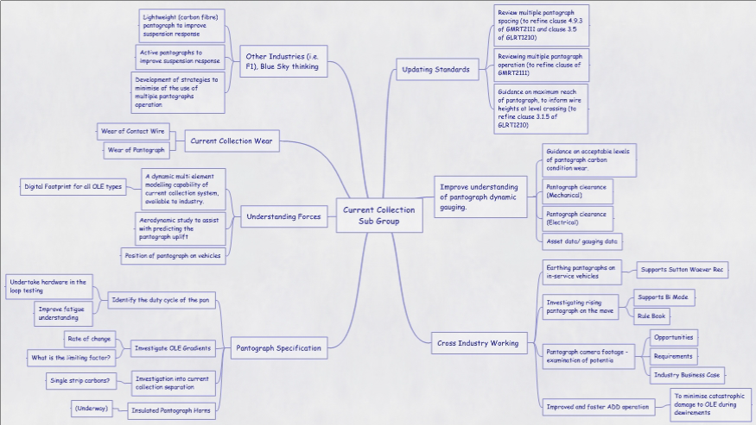

Expressions of interest

We are inviting suppliers to provide a short summary of their capabilities and experience in this subject area to help us deliver a successful project. Taking into account the envisaged scope of work, we would be pleased to receive a summary response (**Max 4 pages**) by **13 August 2018** setting out your interest.

Based on experience of similar projects, we would welcome any additional thoughts (**no page limit**), and we would be keen for suppliers to specifically consider:

* If there is any pre-existing research or evidence for the challenges identified?
* How might some of the research ideas be combined to make projects?
* Which research ideas are expected to have the most positive impact?
* Which areas of research would you as a supplier be interested in being involved in?
* What can RSSB and the industry do to enable you to be able to deliver against these research challenges?
* Can you provide data to support the development of projects for tendering or delivery of these projects?
* Which key stakeholders should be considered?
* What key industry insertion points for the research would you identify?

Any information provided through the EOI will potentially be used to develop the RSSB approach for the work and will not be shared in the original format. Should any information be confidential and not utilised in this way, the suppliers should clearly mark it as such.

Supplier Day

Following the receipt of EOIs we expect to consolidate the industry contributions and subsequently host a supplier day (targeting **September 2018**) to communicate more information on planned activity and enable a live discussion to further develop and firm up the planned approach.

Next steps

Please email any responses to Shareditt@rssb.co.uk