|  |  |
| --- | --- |
| **Gayle Webster**  ORR Procurement Manager  Telephone 020 7282 3944  Email gayle.webster@orr.gov.uk |  |
| Potential Providers |  |

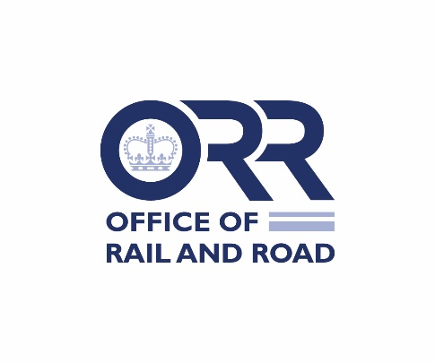

01 November 2021

Dear All

**PR23 Policy, Economics and Project Management support**

**ORR/CT/21-50**

Please find enclosed a set of Invitation to Tender (ITT) documents for the above requirement. This procurement is subject to the Public Contracts Regulations 2015 and is being conducted via an open procurement procedure. The document suite consists of the following:

Selection Questionnaire including:

Part 1 Potential Supplier Information

Part 2 Exclusion Grounds

Part 3 Selection Questionnaire

Invitation to Tender including:

Statement of Requirement

Award Criteria

Procurement Procedures

All interested potential providers are invited to complete both the selection questionnaire and the tender response requirements and submit these via the ORR Bravo Procurement Portal (<http://orr.bravosolution.co.uk/>). Registration Instructions below.

Any clarification questions must be raised via this portal as per the instructions within the ITT.

Yours faithfully

Gayle Webster

**Supplier Guidance Notes**

**How to register details on ORR eTendering portal & express interest in a project**

1. Register your company on the Office of Rail and Road portal (this is only required once)

- Browse to the eTender Portal: http://orr.bravosolution.co.uk

     -Click the “Click here to register” link.

- Accept the terms and conditions and click “continue”.

- Enter your correct business and user details. We advise that wherever possible you register a team email address (e.g. frameworks@xyz.co.uk) rather than an individual’s email address – this ensures that any messages and notifications can still be accessed and picked by a colleague in the event that an individual is out of the office or leaves the organisation.

- Note your chosen username and click “Save” when complete.

     - You will receive an email from BravoSolutions with your unique password (please keep this secure).

**2. Responding to the tender**

* When you have received your unique password re-enter the Portal and click on the name of the tender you wish to respond to and upload your proposal.

**If you are already registered on the portal but have forgotten your login details or if you require any further assistance use the online help, or the BravoSolution help desk is available Mon – Fri (8am – 6pm) on:**

**- eMail:   help@bravosolution.co.uk**

**- Phone: 0800 368 4850/ Fax: 020 7080 0480**