TERMS OF REFERENCE FOR ACTIVITY 3.3 STUDY ON THE IMPLEMENTATION OF COMMON FISHERIES POLICY (CFP) AND BEST PRACTICES.

Fish Forward Project frame
As one of the world´s leading conservation organisations, WWF has a long track record in its advocacy and communication work on sustainable fisheries and seafood.

The EU is the biggest market and importer of seafood in the world, with more consumption of seafood supplied through products imported from non-EU countries rather than through EU catches or aquaculture production. Hence, the choices made by European consumers, corporates and authorities have the ability to influence at a global scale.

WWF and the Environmental Justice Foundation have teamed-up with partners in Europe and the developing world to drive the European market and global fisheries in a more sustainable direction. With the “Fish Forward” Project (Grant Contract EXTERNAL ACTIONS OF THE EUROPEAN UNION CSO-LA/2017/387-131, Title: “Sustainable Seafood for the Benefit of People, Oceans and Climate”, duration 2018-2020) we will raise awareness of sustainable seafood consumption so that target groups in Europe are taking responsibility by choosing sustainable seafood as active contributors to Sustainable Development Goals and to climate change mitigation and adaptation.

As part of a contribution to this project goal a study on the implementation of the external dimension of the CFP and best practices will be undertaken.

Deliverable: Study on the implementation of CFP external dimensions and best practices, max 50 pages. A separate summary of the report detailing the key findings, max 4 pages

Introduction
As well as being the worlds biggest seafood market, the EU is also one of the most important players in international fishery activities in external waters. An estimated 22,000 EU vessels or more contribute to 28% of the EU´s total fish catches internationally. The EU is also an important player in several international fishery management organisations and a global leader in the fight against IUU.

The management of EU fishing vessels both in EU waters and internationally is regulated through the European Commission’s Common Fisheries Policy (CFP). The basic regulation of the reformed CFP has in place Council Regulation (EC) 1005/2008 to combat Illegal, Unreported and Unregulated (IUU) fishing. This Regulation came into force on the 1st January 2010 and stipulates that only marine fisheries products validated as legal by the flag state can be imported/exported to the EU. It also ensures that any EU vessel fishing illegally anywhere in the world faces substantial financial penalties.

The external dimension of the CFP covers the regulation of EU vessels that fish outside the EU in international waters. In 2016 the European Commission, the Parliament and the Council of Fisheries Ministers have agreed on a new legal framework (Regulation 2017/2403) to manage the external fishing fleet, repealing Council Regulation (EC) No 1006/2008. This new regulation sets out rules for issuing and managing fishing authorisations for Union fishing vessels conducting fishing operations in waters under the sovereignty or jurisdiction of a third country, under the auspices of an RFMO to which the Union is a contracting party, in or outside Union waters, or on the high seas. 60 % of the ocean lies beyond national jurisdiction, i.e. the high seas. Management of fishing on the high seas is implemented through the RFMOs according to FAO international guidelines. Management is also informed by the Biodiversity Beyond National Jurisdiction (BBNJ) working group. Other agreements and treaties, such as the Treaty of Lisbon, set out the EUs wider commitments to sustainability and detail internal processes to change or implement any legislation. In order to fish in international waters, the EU holds two different types of fishing agreements with non-EU countries:
- sustainable fisheries partnership agreements (SFPAs) – the EU gives financial and technical support in exchange for fishing rights, generally with southern partner countries
- northern agreements – joint management of shared stocks with Norway, Iceland and the Faroe Islands
In addition to these agreements a major focus of influence for the EU is as a member of Regional Fisheries Management Organisations (RFMOs). The RFMOs are formed of representatives from international countries with either a shared interest in the fisheries within a certain geographical area, or with a shared interest in one specific highly migratory species, most commonly tuna. The EU, is a member of 6 tuna and 11 non-tuna RFMOs. The RFMOs have the power to set catch and effort limits, technical measures and control obligations to ensure the stock or stocks of interest are fished sustainably.

This report will focus on the 10 current tuna and mixed SFPAs, including Madagascar and Morocco which are currently being re-negotiated. Dormant SFPAs will not be covered nor will northern agreements. A list of the active and dormant SFPAs is included in Annex A. The report should also consider the EU contribution to the relevant SDGs through relevant RFMOs, with particular focus on how this influences the achievement of the relevant SDGs in the FF2 project partner countries; Tunisia, Turkey, Philippines, South Africa and India.

The EUs international commitments to sustainable development
As well as adhering to commitments set out by the CFP the EU has a number of internationally agreed commitments to wider sustainable development, including sustainable management of global fisheries. In particular the achievement of the Sustainable Development Goals, (SDGs) set out in the United Nations 2030 Agenda for Sustainable Development.,

Ultimately all interactions between the EU and third countries, whether it is through the work of the various RFMOs or SFPAs, should contribute to the achievement of the relevant SDGs, i.e. in social, environmental, economic terms, in line with the UN 2030 agenda for sustainable development. The EU has also committed itself to gender equality targets detailed in the EU Gender Action Plan 2016 – 2020. These targets compliment the gender equality targets set out in SDG 5 and apply to the EUs associations with third countries through SFPAs. This report should focus on the achievement of the SDGs from a social, economic and environmental standpoint.

Figure 1 shows the links between EU and international obligations focussed on the sustainable development of fisheries

Overall Purpose of the report
The purpose of this study is to take stock of the effectiveness of EU implementation of the rules on ensuring legal, sustainable and equitable fisheries in its fishing activity outside EU waters and thus its contribution to the achievement of relevant SDGs.

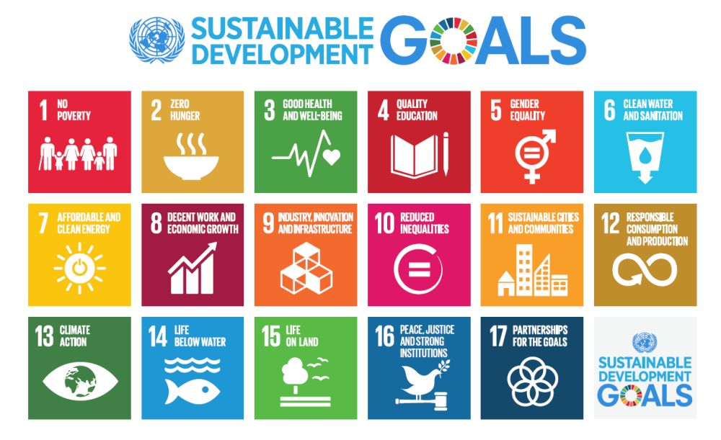
Figure 2 showing the list of 17 UN Sustainable Development Goals – this project will focus on the goals and associated targets relevant to sustainable fisheries

WWF are commissioning a report to expand on a previous study ‘Is Europe ready to lead on international fisheries Governance?’ The report identified strengths and weaknesses in EU delivery of the external dimension of the CFP and provided a number of recommendations with regard to the EUs engagement in SFPAs and RFMOs.

This new report should assess what steps, if any, the EU is taking to implement the previous recommendations and exploring how the EU is contributing to the achievement of the relevant UN Sustainable Development Goals in waters outside of the EU.

This new report should contribute to the wider Fish Forward II project objective:

By 2020, consumers and the corporate sector in Europe are taking responsibility by choosing sustainable seafood as active contributors to the Sustainable Development Goals, climate change mitigation and adaptation.

The report is intended to be read by members of the public and as such it should be written in largely non-technical language and easy to read with communicable case studies that can be used in WWFs European-wide advocacy. Ideally we would like at least one newsworthy top line story of interest European media outlets.

Structure of the report

- Introduction – reflect on the previous report focused on EU international fisheries: Is Europe well placed to lead on international fisheries governance? What were the recommendations and what progress has been made towards implementing improvements?

- Summarise the EUs international commitments to sustainable development (sustainable development relating to social, environmental and economic factors in particular) – in particular sustainable international fisheries through the CFP (External dimension, SFPAs, IUU), ToL, RFMOs, UN SDGs.

- Consider and identify the relevant SDGs including the relevant targets and indicators for fisheries and sustainable development, taking each in turn and linking to the EUs SFPAs in the 10 countries the EU has tuna and mixed agreements with, including Morocco (Annex A). Focus on one or two EU Member States – How are they fulfilling their commitments to the SFPAs/SDGs. Are there examples of good practice or recommendations for improvement?

- Identify the EUs social, economic and environmental contribution to the relevant SDGs through RFMOs and the role of EU Member states, with a particular focus on how this influences the achievement of the relevant SDGs, in particular focus on 5 countries (Tunisia, Turkey, Philippines, South Africa and India).

- Identify at least one case study which provides examples of good practice (strengths) and one which identifies where recommendations should be made (weaknesses) to guide improvements in social, environmental and economic terms, i.e. gender equality could be improved by the EU in xx country by xx etc. List recommendations.

- Conclusions and recommendations

Scope of report: European fishing outside EU waters in the context of the CFP and other relevant legislation and its contribution to sustainable development obligations and commitments.

Methods: Desk based study

Deliverables: The report as outlined above including a separate 2 – 4 A4 page summary leaflet. The report must generate media friendly, communicable case studies as detailed above, identifying opportunities for the collection of visual elements that will resonate with the general public, raising awareness of the EUs role in the achievement of the identified FF2 relevant SDGs and communicating the ‘value of nature’.

The report and associated summary will solely be owned by WWF but attributed to the contractor.

Timeframe:
Response to tender: 1 month from publication (publish 12th November close on the 10th December)
Tender awarded: 4th January
Start date of consultancy: 21st January (following negotiations and agreement on final contract)
Delivery of 1st draft report: April 2019
Delivery of 2nd draft report: June 2019
Delivery of final report: September 2019

Budget: €22,000 including VAT

Tendering Process:
Please provide a written tender for the work described above by midnight 10th December 2018 outlining the approach you would take to deliver the required activities, the relevant experience of the proposed consultant(s), including their current location and the total cost you would invoice for the work.

Please email your responses to Rhona Kent rkent@wwf.org.uk and Simone Niedermueller simone.niedermueller@wwf.at

Tender Evaluation:
An evaluation of responses/tenders will be carried out and a contract award made on the basis of;

Evaluation Criteria |  | Sub-Criteria
Quantitative | 30% | Value for money | 30%
Qualitative – Capability & Competency | 70% | Knowledge of the external dimension of the CFP and the UNs SDGs in particular relation to sustainable development of global fisheries as identified in the TOR | 30%
 |  | Understanding of requirements | 20%
 |  | Previous Experience/Resourcing | 20%

Contact:
Rhona Kent, Fisheries Policy Officer WWF UK, e. rkent@wwf.org.uk, t. 0131 659 9027

ANNEX A: Countries with which the EU holds SFPAs⁴

The EU has currently 9 active SFPAs protocols in force with third countries:

7 tuna agreements

Country | Agreement expiry date
Côte d'Ivoire* | 30/06/2018
Madagascar^{ⱡ} | 31/12/2018
Senegal | 19/11/2019
Liberia | 08/12/2018
Seychelles | 17/01/2020
Cook Islands | 13/10/2020
Mauritius | 01/12/2020
*renewal procedures for Cote d'Ivoire are about to be completed
ⱡ renewal procedures for Madagascar are underway

2 mixed agreements (EU vessels are not restricted to only catching tuna)

Country | Agreement expiry date
Mauritania |  | 15/11/2019
Greenland |  | 31/12/2020

Morocco is under renegotiation and activity will be interrupted until procedures are completed.

The EU has also 10 "dormant" agreements with Mozambique, Micronesia, Solomon Island, Gambia, Gabon, Kiribati, Equatorial Guinea and Guinea-Bissau, Cabo Verde and Sao Tomé e Principe. "Dormant agreements" stand for countries which adopted a fisheries partnership agreement without having a protocol in force. EU vessels are therefore not allowed to fish in waters under the regime of the dormant agreements. Comoros agreement, which was also dormant, is currently being denounced. These dormant SFPAs do not fall under the scope of this study.

Fish Forward II. Webpage. https://www.fishforward.eu/en/ [accessed 03/09/2018]
http://www.eumofa.eu/documents/20178/108446/The+EU+fish+market+2017.pdf
http://www.whofishesfar.org /
https://ec.europa.eu/fisheries/cfp/international_en [accessed 04/10/2018]
European Commission press release http://europa.eu/rapid/press-release_IP-18-6142_en.htm [accessed 08/11/2018]
The Common Fisheries Policy. Webpage. https://ec.europa.eu/fisheries/cfp_en [accessed 07/09/2018}
EC IUU fishing Regulation. Webpage. https://ec.europa.eu/fisheries/cfp/illegal_fishing_en [accessed 03/10/2018]
The external Dimension of the CFP https://ec.europa.eu/fisheries/cfp/international_en [accessed 04/10/2018]
Regulation (EU) 2017/2403 on the sustainable management of external fishing fleets https://eur-lex.europa.eu/legal-content/EN/TXT/?uri=CELEX:32017R2403
The FAO International Guidelines for the Management of Deep-sea Fisheries in the High Seas http://www.fao.org/fishery/topic/166308/en [accessed 25/10/2018]
BBNJ http://dosi-project.org/working-groups/bbnj [accessed 25/10/2018]
Consolidated versions of the Treaty on European Union and the Treaty on the functioning of the European Union https://publications.europa.eu/en/publication-detail/-/publication/3c32722f-0136-4d8f-a03e-bfaf70d16349
Bilateral agreements with countries outside the EU. Webpage. https://ec.europa.eu/fisheries/cfp/international/agreements_en [accessed 28/09/2018]
The UN Sustainable Development Goals https://sustainabledevelopment.un.org/sdgs
Key European action supporting the 2030 Agenda and the Sustainable Development Goals https://ec.europa.eu/europeaid/sites/devco/files/swd-key-european-actions-2030-agenda-sdgs-390-20161122_en.pdf
The UN 2030 agenda for sustainable development https://ec.europa.eu/europeaid/policies/european-development-policy/2030-agenda-sustainable-development_en
UN Charter http://www.un.org/en/charter-united-nations/index.html
EU Gender action plan 2016 – 2020 https://europa.eu/capacity4dev/public-gender/minisite/eu-gender-action-plan-2016-2020
WWF Report Is Europe ready to lead on international fisheries governance?: https://www.wwf.org.uk/sites/default/files/2017-06/Is%20Europe%20Ready%20To%20Lead%20On%20International%20Fisheries%20Governance.pdf

