**Specification**

**1 Natural England**

Natural England’s vision is thriving nature for people and planet. Our Mission is to build partnerships for natures recovery. This reflects the need for us to work with and through a wide range of people and the need for rapid action to rebuild sustainable ecosystems and thereby protect and restore habitats, species and landscapes.

Our work over the next few years will reflect the priorities set out in the government’s  [25 Year Environment Plan](https://www.gov.uk/government/publications/25-year-environment-plan). Work will be focussed around 4 goals:

* Resilient landscapes and seas
* Sustainable development
* Greener farming and fisheries
* Connecting people with nature

Further information can be found at [Natural England](https://www.gov.uk/government/organisations/natural-england)

**2 Background**

**Nature Recovery Network**

Local Nature Recovery Strategies will be the key vehicle to deliver the [Nature Recovery Network](https://www.gov.uk/government/publications/nature-recovery-network/nature-recovery-network). The NRN will increase, improve and join-up wildlife-rich places across the whole of England, helping to tackle three of the greatest challenges we face: biodiversity loss, climate change and health. The NRN is a major commitment in the government’s 25 Year Environment Plan and part of the forthcoming Nature Strategy.

**Local Nature Recovery Strategies**

Local Nature Recovery Strategies (LNRS) are a new duty placed on responsible authorities by the [Environment Bill](https://www.gov.uk/government/publications/environment-bill-2020). The LNRS will identify nature recovery priorities at the county scale using an evidence based, locally led collaborative process. Five pilots have tested a DEFRA defined process to inform Regulations and Statutory Guidance being drafted to enact the Environment Bill. The pilots have identified an essential need to develop the skills and knowledge of NE staff, Arms Length Bodies and external organisations including local authorities and eNGO’s to be prepared for national roll out. The Gant chart below summarises the key milestones for DEFRA and NE throughout 2021-22 to develop the local capacity required which is politically high profile and time sensitive. The development and delivery of a comprehensive LNRS training programme will support effective implementation of this work by NE and partners and drive forward the NRN across the whole of England.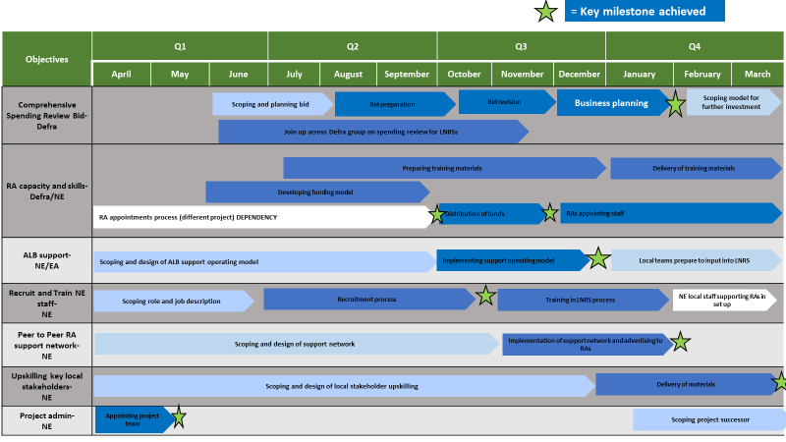

**3 Learning and Development Programme**

**Phase 1 Development and delivery to 100 NE, EA and FC delegates**

Defra has provided new funding to increase the capacity of Natural England across England to prepare for national roll out of the LNRS clauses of the Environment Bill following Royal Assent. This funding includes the recruitment of 25 new staff members at Senior Adviser level. This training will also be offered to Environment Agency and Forestry Commission colleagues working on LNRS which may result in a further 75-100 delegates during 2021-22.

Senior Advisers are expected to perform at the following general levels:

General Profile – Senior Adviser

|  |  |
| --- | --- |
| Factor | Roles at this job family level typically require the individual to: |
| Knowledge, Skills and Expertise | * Apply a broad knowledge of Natural England’s purpose, and the relevant frameworks and practical activities/approaches needed to deliver project results and when contributing to wider Natural England work programmes. * Act as a key reference point and source of detailed expertise and objective advice in a specific professional field or area of operation within the organisation and/or externally. |
| Management of Resources/ Leadership | * Lead, or make a significant contribution in own area of expertise to the delivery or development of Natural England-wide or regional/area: strategy, programmes, projects or operations. * Manage multidisciplinary project teams working in more than one location, monitor and manage assigned budgets and be responsible for securing people resources from line managers and other project teams. * Organise and deploy resources agreed with the Team Leader(s) to drive continuing improvement of outcomes and deliver value for money within a project or area of operation. * Put in place project standards, processes and systems to ensure delivery of high quality outcomes to internal and external customers. * Monitor and review the progress against delivery plans, including budget expenditure and forecasting, in order to explore opportunities for improvements, enhancements or innovation, as well as providing feedback to Manager/Team Leader(s) to support individual performance reviews. |
| Complexity of Problems/ Challenges | * Deal with issues relating to the delivery of significant project or service outcomes which may require integration with other related work areas, activities or specialisms/interdependencies with other projects. * Resolve problems which involve considering new approaches, testing options, judgement and interpretation in making recommendations or determining appropriate action. |
| Relationships & Influencing | * Engage continuously with colleagues and partners to agree outcomes. This might include negotiating to gain resources required to delivery project outcomes; fostering a shared understanding of issues and interests and gaining buy-in to the prioritisation of specific work area or project targets. * Play a lead role in internal and perhaps national networks/communities to exchange information and best practice on the delivery of specific service and project outcomes. |
| Impact | * Influence the delivery of a number of regional/national targets as a senior contributor in a functional group or when leading project teams. * Make decisions that impact on the performance of a number of interdependent work areas and projects and are likely to affect a range of internal and external customers and stakeholders. |

**Phase 2 - Responsible Authorities and eNGOs**

LNRS senior advisers will undertake engagement with responsible authorities and local stakeholders to identify a further tranche of 100 -150 candidates who will undertake the LNRS Learning and Development Programme during 2022-24.

**Overall Approach and Learning Approach**

Coherency

The cohort of senior advisers will include a range of existing NE Senior Advisers on assignment and new recruits to NE. The L and D programme should help to develop this group as a team that learn, think and share their skills and development together.

Time Investment

The focus of this L&D is to prepare the cohort and partners for national roll out from April 2022. The time sensitivity of this work means it is extremely important that learning is done efficiently and in such a way that any skills taught are quickly deployed, reconsidered, and improved as people develop. Large swathes of time spent on courses will not be possible.

Action Learning

As the group develops the trainer should be prepared to offer one to one support in later surgeries and facilitate non-course based learning as part of action learning sets/ groups. The operation of these groups will depend on group requirements and should morph associated with practical issues.

Developing the Person

Experience suggests that the development of lasting partnerships and the formation of relationship will require a significant amount of self-discovery in terms of the staff’s own learning and leadership styles and how they relate to people. An important part of this learning process will include coaching and mutual mentoring to develop the sort of collaborative leaders and active listeners we need.

Adaptable Learning

This learning and development package will need to be agile and use appropriate mechanisms to deliver the learning as effectively as possible to meet the challenges of both the geographical scale of this L&D programme with staff and partners from across the whole of England and any ongoing restrictions imposed by Covid 19.

Core and Optional Modules

As well as the above style or approach to learning, staff will needa core group of skills and knowledge. All staff will need to engage with the core modules which focus on induction and collaborative leadership. In addition to the core modules the training provider will work with Natural England, Environment Agency and Forestry Commission specialists to facilitate a range of optional technical modules essential in the design and planning of the Nature Recovery Network.

Table 1 – List of Core Modules

|  |  |
| --- | --- |
| Induction | |
| 1 | General induction to the programme using a 360 Report |
| 2 | Technical induction to Nature Recovery Networks and LNRS |
| 3 | Aligning to Natural England Values |
| Vision | |
| 4 | Building positive relationships |
| 5 | Building a collective vision |
| Collaboration | |
| 6 | Collaborative leadership |
| 7 | Leading in uncertainty |
| 8 | Influencing |
| Inclusion | |
| 9 | Facilitating and convening |
| 10 | Engaging local communities |

**Learning outcomes**

The training provider would be expected to develop three potential learning outcomes for each core module.

**Module content and pre learning package**

The training provider would be expected to discuss with NE exact content of modules before delivery. They will also work with NE to review relevant in-house training materials and put together pre learning package for delegates.

**4 Timescales**

Implementation of LNRS’s is a high priority work area for DEFRA and Natural England. In order to upskill ALB’s, Responsible Authorities and stakeholders for this significant new way of working it is critical that we develop and deliver this ambitious learning and development programme effectively and within tight timescales. In order for rollout to take place in April 2022 it is essential training is delivered Q3 and Q4 of 2021-22.