Request for Quotation (RFQ)

|  |
| --- |
| Weed Control 2024-25  Reference number: RFQ-002-24 |

|  |
| --- |
| Contents |

**PART A**

Basic Contract Information

Section 1 – Instructions for Completion

1.1 Quote Enquiries

1.2 Quote Format

1.3 Quote Submission Procedure

1.4 Quote Validity Period

Section 2 - Quote Timetable

Section 3 - Evaluation Approach

3.1 Evaluation Criteria

3.2 Selection Criteria

3.3 Award Criteria

3.4 Commercial / Price Evaluation

3.5 Quality Assessment Evaluation

3.6 Negotiations

3.7 Notification of Award

**PART B**

Section 4 - Quote Completion Documentation

4.1 Selection Criteria

4.2 Financial Matters

4.3 Selection Questionnaire

Section 5 - The Specification

Section 6 - The Pricing Document

Section 7 - The Quality Assessment

**PART C**

Schedule 1 - Form of Quotation and Declarations

Schedule 2 – Commercially Sensitive Information

**PART D**

Appendix A - Terms and Conditions of Contract for Services

Appendix B - Defined Terms

PART A - INVITATION TO QUOTE AND INFORMATION FOR APPLICANTS

|  |  |
| --- | --- |
| **Basic Contract Information** | |
| Contract Title | Weed Control |
| Contract Value | £7,000 per annum |
| Contract Length | 1 year with the option to extend for a further year |
| Basic Description of Services | The Authority is looking for quotations for the control of weeds of the highways outlined within the specification. |

Part A: Section 1 – Instructions for Completion

This document consists of four parts –

**Part A**: Instructions, timetable and evaluation criteria. There are no sections for the Applicant to fill in in this section.

**Part B**: Must be returned by the Applicant. There are various sub-sections which must be filled in.

**Part C**: Must be returned by the Applicant. Includes schedules for commercially sensitive information, the form quotation and declarations.

**Part D**: The Appendices include a glossary. There are no sections for the Applicant to fill out in this section.

Any information relating to the Council and supplied by the Council shall be kept by the Applicant in strictest confidence.

Applicants are advised that the Council is not bound to accept the lowest quote submitted, nor to reimburse any expense incurred during the process.

The Council reserves the right to award the business in whole to one Applicant, in part to more than one Applicant or to make no award at all.

1.1 Quote Enquiries

All enquiries and clarifications should be directed to the Authorised Officer shown below and no later than 14 days before the due date for the return of quotes:

|  |  |
| --- | --- |
| **Authorised Officer Details** | |
| Name: | Joe Piwecki |
| Telephone Number: | 01637 878388 |
| E-mail | [joe@newquay.gov.uk](mailto:joe@newquay.gov.uk) |

Applicants are advised that where such enquiries have been made, and it is appropriate to do so, the Council will distribute to all Applicants a copy of the enquiry and the written reply, with anonymity preserved.

1.2 Quote Format

All Quotes must be written in English and costs submitted are to be presented in Pounds Sterling, exclusive of VAT, but inclusive of all other costs where not stated in the Pricing Document.

Where details are provided by the Applicant in literature that they submit in connection with the Quote, they must ensure that clear cross-references are given to the Council.

1.3 Quote Submission Procedure

The Authority requires one hard copy (printed) submission and/or one copy submitted electronically by email. The content of the written and electronic copies must be identical, in the case of any discrepancies the electronic copy shall prevail.

If submitting a hard copy it must be returned to the Authority at the address: Municipal Offices, Marcus Hill, Newquay, TR7 1AF, either by post or by hand.

When submitting the hard copy it must be sealed in a plain envelope/parcel with ‘Quotation’ and the quote reference number written in the title. Any such envelope or parcel shall not bear any name or any other mark by which the applicant can be identified.

The Authority does not accept responsibility for the premature opening or mishandling of quotes that are not submitted in accordance with these instructions.

When you are submitting your response electronically please be aware of the speed of your Internet connection, your system configuration and general web traffic that may impact on the time required to complete the transaction. Loading and submitting of the quote must be completed by the final submission time.

Electronic responses must be emailed to [joe@newquay.gov.uk](mailto:joe@newquay.gov.uk)

All responses must be submitted by 12:00hrs (noon) on the closing date for submissions as set out in Section 2 - Quote Timetable below.

1.4 Quote Validity Period

Quotes must remain valid for acceptance for a period of 30 days from the Quote return date.

Section 2 - Quote Timetable

This procurement will follow a clear, structured and transparent process at all times, to ensure that all Applicants are treated equally. The key dates for this procurement (Timetable) are currently anticipated to be as follows:

|  |  |
| --- | --- |
| **Stage / Action** | **Date** |
| Issue RFQ documents | 06 March 2024 |
| Closing date for submissions in response to this document. | 25 March 2024 |
| Evaluation of submissions | 01 - 18 April 2024 |
| Decision and notification to suppliers | 22 April 2024 |
| Contract start | 01 May 2024 |

Section 3 - Evaluation Approach

3.1 Evaluation Criteria

Bids will be evaluated in two parts:

1. Selection Criteria (if applicable). Some of these sections may not apply to this RFQ, and a note will be made against any of those which do not apply in this instance. This is Section 4.
2. Pricing Document and Quality Assessment (if applicable). These are Sections 6 and 7.

The first element the Council will evaluate is the Selection Criteria (if applicable). Applicants not satisfying the elements of the RFQ will, at the discretion of the Council, be excluded from the remainder of the evaluation process and their bid shall not be considered further.

Applicants who satisfy the Selection Criteria (if applicable) will have the remainder of their bid evaluated in accordance with the remainder of Section 3.

3.2 Selection Criteria

The evaluation methodology for the Selection Criteria’s is as outlined below:

|  |  |
| --- | --- |
| **Selection Questionnaire** | |
| **Section** | **Evaluation Methodology** |
| 1.1 Potential supplier information  1.2 Bidding model  1.3 Contact details and declaration | Information only, this section is not evaluated |
| 2.1 Grounds for mandatory exclusion | Pass/Fail |
| 3.1 Economic and Financial standing | Pass/Fail |
| 4.1 Technical and Professional ability | Pass/Fail |
| 5.1 Insurance | Pass/Fail |
| 6.1 Health & Safety | Pass/Fail |

Pass / Fail Questions

* These criteria will be scored on a pass / fail basis. In the event of an Applicant being awarded a fail against any of these criteria the Applicant may be excluded from the process and the remainder of the Quote may not be evaluated.

**Consortia, Unincorporated Joint Ventures and Subcontracting Applicants**

Where the Applicant has completed the Selection Criteria and that Applicant is made up of a Lead Organisation and Relevant Organisation(s) the following will apply (unless stated otherwise within the relevant section):

* For Pass/Fail modules all Relevant Organisations will be required to pass all modules unless an adequate justification is provided by the Relevant Organisation or the Lead Organisation which is satisfactory to the Council

3.3 Award Criteria

The Award Criteria for this RFQ is:

|  |  |  |
| --- | --- | --- |
| **Evaluation Criteria Breakdown** | **Means of Evaluation** | |
|  | **Sub Criteria** | **Main Criteria** |
| **Criteria: Quality** | | 60% |
| Understanding of the Council’s Brief | 10% |  |
| Experience of the team | 10% |  |
| Evidence of Supplier’s ability to respond to any issues/complaints | 5% |  |
| Health and Safety and Risk Management processes | 10% |  |
| Project Delivery and Programme | 5% |  |
| Promotion and Protection of the Environment | 20% |  |
| **Criteria: Price** | | 40% |

3.4 Commercial / Price Evaluation

The commercial element of the evaluation will be carried out after Applicants have been selected using the Selection Criteria. Only those Applicants satisfying the Selection Criteria’s requirements will have their commercial submission evaluated.

The Pricing Document contains the details and requirements relating to the price element of this RFQ. This may include, but is not limited to, the inclusion of specific instructions, documents, templates, pricing structures, etc. for the Applicants to return as part of their quote submission.

The Applicant’s price will be scored on a comparative basis.

|  |
| --- |
| **Scoring System** |
| Lowest price submitted from all Quotes receives maximum % score (40%). Other Applicants prices are scored in accordance with the following equation:  % Score = Lowest Quoted price x 40  Applicant’s price |

3.5 Quality Assessment Evaluation

Scored Questions

* These modules contain questions relevant to the procurement in question, the responses to which will be evaluated and scored. The module may be assessed and scored as a whole, or each individual question will be evaluated and scored. The sum of those scores will give a total score for that module. Please refer to each module’s introduction for full details. Scores will be awarded from 0-10 as defined by the scoring system set out below:

|  |  |  |  |
| --- | --- | --- | --- |
| **Score 0** | No response | No response |  |
| **Score 1** | Extremely Weak | Very poor proposal/response; does not cover the associated requirements, major deficiencies in thinking or detail, significant detail missing, unrealistic or impossible to implement and manage | **Weak** |
| **Score 2** | Very Weak | Poor proposal/response, only partially covers the requirements, deficiencies in thinking or detail apparent, difficult to implement and manage |
| **Score 3** | Weak | Mediocre proposal/response, moderate coverage of the requirements, minor deficiencies either in thinking or detail, problematic to implement and manage |
| **Score 4** | Fair - Below Average | Proposal/response partially satisfies the requirements, with small deficiencies apparent, needs some work to fully understand it | **Fair - Good** |
| **Score 5** | Fair - Average | Satisfactory proposal/response, would work to deliver all of the Authority's requirements to the minimum level |
| **Score 6** | Fair - Above Average | Satisfactory proposal/response, would work to deliver the majority of the Authority's requirements to the minimum level with some evidence of where the Applicant could exceed the minimum requirements |
| **Score 7** | Good | Good proposal/response that convinces the Authority of its suitability, response slightly exceeds the minimum requirements with a reasonable level of detail |
| **Score 8** | Strong | Robust proposal/response, exceeds minimum requirements, including a level of detail or evidence of original thinking which adds value to the bid and provides a great deal of detail | **Strong - Excellent** |
| **Score 9** | Very Strong | Proposal/response well in excess of expectations, with a comprehensive level of detail given including a full description of techniques and measurements employed |
| **Score 10** | Outstanding/ Excellent | Fully thought through proposal/response, which is innovative and provides the reader with confidence of the suitability of the approach to be adopted due to the complete level of detail provided |

3.6 Negotiations

Following evaluation, the Council reserves the right to enter into negotiations with the Applicants on all or some elements of their Quote.

The Council shall conduct the negotiation for the purposes and with the aim of:

* Identifying the best Quote in order to award the Contract
* Adapting the Quote to the requirements specified in the RFQ Documents

During negotiations the Council shall ensure equal treatment among the Applicants. Negotiations may be conducted by telephone or in a face to face meetings. If a face to face meeting is required then these meetings will be treated as confidential between the Council and the individual Applicant. A formal record will be taken of the meeting.

3.7 Notification of Award

The Council will notify all Applicants of the Council’s award decision.

PART B – QUOTE RETURN

|  |
| --- |
| Weed Control 2024-25  Reference number: RFQ-002-24 |

|  |
| --- |
| Name of Applicant:  Date: |

Section 4 - Quote Completion Documentation

4.1 Selection Criteria

**Explanatory Notes**

Applicants are required to complete all questions in this section which have space for answers. Some sections refer to criteria which are not applicable to this RFQ. This will be clearly marked with “Not Applicable to this RFQ”, and you are not required to answer these sections.

All responses provided must be clearly referenced to the questions to which they relate. Copies of certificates or policies will need to be provided by the successful supplier before any contract or purchase order is placed with them.

All applicable sections of the following Selection Criteria must be completed. Failure to do so may result in your submission being excluded from further evaluation. Where the answer is a statement of fact, it must be accurate and supported by documentary evidence as appropriate. It is the Applicant’s responsibility to ensure that the Council is not misled.

It is the responsibility of the Applicant to inform the Council of any matter that may affect the Applicant’s continued qualification.

4.2 Financial Matters

The Council will carry out a financial check on the Applicant. This will take the form of a review of the Applicant’s accounts available from Companies House. If company accounts are not available, then the Council will carry out a financial check on the information available as identified in Section 3.1. The Council may also need to undertake an Experian Credit Check as part of its financial assessment. The Applicant will be awarded an overall pass or fail mark based on the Council’s professional judgement. This professional judgement will be provided from the Council’s Responsible Finance Officer.

Any additional information provided should be clearly referenced to the question number in your submission.

4.3 Selection Questionnaire

|  |  |  |  |  |  |  |  |  |  |  |  |
| --- | --- | --- | --- | --- | --- | --- | --- | --- | --- | --- | --- |
| NOTE TO APPLICANT: Part 1 must be completed but will not be scored | | | | | | | | | | | |
| **Section 1.1** | | **Potential supplier information** | | | |  | | | | | |
| **Question number** | | **Question** | | | | **Response** | | | | | |
| 1.1(a) | | Full name of the potential supplier  submitting the information | | | |  | | | | | |
| 1.1(b) – (i) | | Registered office address (if applicable) | | | |  | | | | | |
| 1.1(b) – (ii) | | Registered website address (if applicable) | | | |  | | | | | |
| 1.1© | | Please mark ‘X’ in the relevant box to indicate your trading status | | | | 1. a public limited company | | | |  | |
| 1. a limited company | | | |  | |
| 1. a limited liability partnership | | | |  | |
| 1. other partnership | | | |  | |
| 1. sole trader | | | |  | |
| 1. other (please specify) | | | |  | |
| 1.1(d) | | Date of registration in country of origin | | | |  | | | | | |
| 1.1© | | Company registration number (if applicable) | | | |  | | | | | |
| 1.1(f) | | Charity registration number (if applicable) | | | |  | | | | | |
| 1.1(h) | | Registered VAT number | | | |  | | | | | |
| 1.1(k) | | Trading name(s) that will be used if successful in this procurement | | | |  | | | | | |
| 1.1(l) | | Please mark ‘X’ in the relevant box to indicate whether any of the following classifications apply to you | | | | 1. Voluntary, Community and Social Enterprise (VCSE) | | | |  | |
| 1. Small or Medium Enterprise (SME) | | | |  | |
| 1. Sheltered workshop | | | |  | |
| 1. Public service mutual | | | |  | |
| **Section 1.2** | | **Bidding model** | | | |  | | | | | |
| **Question number** | | **Question** | | | | **Response** | | | | | |
| 1.2(a) – (i) | | Are you bidding as the lead contact for a group of economic operators?  If yes, please provide details listed in questions below. | | | | **Please indicate your answer by marking ‘X’ in the relevant box.** | | | | | |
| **Yes** | | | | **No** | |
|  | | | |  | |
| 1.2(a) – (ii) | | Name of group of economic operators (if applicable) | | | |  | | | | | |
| 1.2(a) – (iii) | | Proposed legal structure if the group of economic operators intends to form a named single legal entity prior to signing a contract, if awarded. If you do not propose to form a single legal entity, please explain the legal structure. | | | |  | | | | | |
| 1.2(b) – (i) | | Are you or, if applicable, the group of economic operators proposing to use sub-contractors?  If yes, please provide details listed in questions below. | | | | **Yes** | | | | **No** | |
|  | | | |  | |
| Name of sub-contractors (if applicable) | | | |  | | | | | |
| The role each sub-contractor will take in providing the works and /or supplies e.g. key deliverables: | | | |  | | | | | |
| The approximate % of contractual obligations assigned to each sub-contractor: | | | |  | | | | | |
| Contact details and declaration | | | | | | | | | | | |
| I declare that to the best of my knowledge the answers submitted and information contained in this document are correct and accurate.  I declare that, upon request and without delay I will provide the certificates or documentary evidence referred to in this document.  I understand that the information will be used in the selection process to assess my organisation’s suitability to be invited to participate further in this procurement.  I understand that the authority may reject this submission in its entirety if there is a failure to answer all the relevant questions fully, or if false/misleading information or content is provided in any section.  I am aware of the consequences of serious misrepresentation. | | | | | | | | | | | |
| **Section 1.3** | | **Contact details and declaration** | | | |  | | | | | |
| **Question number** | | **Question** | | | | **Response** | | | | | |
| 1.3(a) | | Contact name | | | |  | | | | | |
| 1.3(b) | | Name of organisation | | | |  | | | | | |
| 1.3(c) | | Role in organisation | | | |  | | | | | |
| 1.3(d) | | Phone number | | | |  | | | | | |
| 1.3(e) | | E-mail address | | | |  | | | | | |
| 1.3(f) | | Postal address | | | |  | | | | | |
| 1.3(g) | | Signature (electronic is acceptable) | | | |  | | | | | |
| 1.3(h) | | Date | | | |  | | | | | |
| **Part 2: Exclusion grounds**  NOTE TO APPLICANT: this section must be completed and will be evaluated as a whole on a Pass or Fail basis. The section will be marked as a ‘Fail’ if “Yes” is answered to question 2.1(a) and 2.2(a) and satisfactory evidence of self-cleaning is not detailed in your response to question 2.1(b) and 2.2(b). | | | | | | | | | | | |
| **Section 2.1** | | **Grounds for mandatory exclusion** | | | |  | | | | | |
| **Question number** | | **Question** | | | | **Response** | | | | | |
| 2.1(a) | | **Regulations 57(1) and (2)**  The detailed grounds for mandatory exclusion of an organisation are set out on this [web page](https://www.gov.uk/government/uploads/system/uploads/attachment_data/file/551130/List_of_Mandatory_and_Discretionary_Exclusions.pdf), which should be referred to before completing these questions.  Please indicate if, within the past five years you, your organisation or any other person who has powers of representation, decision or control in the organisation been convicted anywhere in the world of any of the offences within the summary below and listed on the [webpage](https://www.gov.uk/government/uploads/system/uploads/attachment_data/file/551130/List_of_Mandatory_and_Discretionary_Exclusions.pdf). | | | | | | | | | |
|  | | | | **Please indicate your answer by marking ‘X’ in the relevant box.** | | | | | |
| **Yes** | | | | **No** | |
| Participation in a criminal organisation | | | |  | | | |  | |
| Corruption | | | |  | | | |  | |
| Fraud | | | |  | | | |  | |
| Terrorist offences or offences linked to terrorist activities | | | |  | | | |  | |
| Money laundering or terrorist financing | | | |  | | | |  | |
| Child labour and other forms of trafficking in human beings | | | |  | | | |  | |
| 2.1(b) | | If you have answered yes to question 2.1(a), please provide further details.  Date of conviction, specify which of the grounds listed the conviction was for, and the reasons for conviction,  Identity of who has been convicted  If the relevant documentation is available electronically please provide the web address, issuing authority, precise reference of the documents. | | | |  | | | | | |
| **Part 3: Selection questions** | | | | | | | | | | | |
| **Section 3.1** | | **Economic and financial standing** | | | |  | | | | | |
| **Question number** | | **Question** | | | | **Response** | | | | | |
| 3.1 | |  | | | | **Please indicate your answer by marking ‘X’ in the relevant box.** | | | | | |
| **Yes** | | | **No** | | |
| Are you able to provide a copy of your audited accounts for the last two years, if requested?  If no, can you provide **one** of the following: | | | |  | | | | | |
| (a) A statement of the turnover, Profit and loss Account/income Statement, Balance Sheet/Statement of Financial Position and Statement of Cash Flow for the most recent year of trading for this organisation. | | | |  | | | | | |
| (b) A statement of the cash flow forecast for the current year and a bank letter outlining the current cash and credit position. | | | |  | | | | | |
| (c) Alternative means of demonstrating financial status if any of the above are not available (e.g. forecast of turnover for the current year and a statement of funding provided by the owners and/or the bank, charity accruals accounts or an alternative means of demonstrating financial status). | | | |  | | | | | |
| **Section 4** | | **Technical and professional ability** | | | |  | | | | | |
| 4.1 | | Please provide details of up to three contracts, in any combination from either the public or private sector; voluntary, charity or social enterprise (VCSE) that are relevant to our requirement. VCSEs may include samples of grant-funded work. Contracts for supplies or services should have been performed during the past three years. Works contracts may be from the past five years.  Consortia bids should provide relevant examples of where the consortium has delivered similar requirements. If this is not possible (e.g. the consortium is newly formed or a Special Purpose Vehicle is to be created for this contract) then three separate examples should be provided between the principal member(s) of the proposed consortium or Special Purpose Vehicle (three examples are not required from each member).  If you cannot provide examples see question 4.2 | | | | | | | | | |
|  | | | Contract 1 | Contract 2 | | | Contract 3 | | | | |
| Name of customer organisation | | |  |  | | |  | | | | |
| Point of contact in the organisation | | |  |  | | |  | | | | |
| Position in the organisation | | |  |  | | |  | | | | |
| E-mail address | | |  |  | | |  | | | | |
| Contract Start date | | |  |  | | |  | | | | |
| Contract completion date | | |  |  | | |  | | | | |
| Estimated contract value | | |  |  | | |  | | | | |
| Description of contract 1: | | | | | | | | | | | |
| Description of contract 2: | | | | | | | | | | | |
| Description of contract 3: | | | | | | | | | | | |
| 4.2 | | If you cannot provide at least one example for questions 6.1, in no more than 500 words please provide an explanation for this e.g. your organisation is a new start-up or you have provided services in the past but not under a contract. | | | | | | | | | |
| Response: | | | | | | | | | | | |
| **Section 5** | | **Additional questions** | | | |  | | | | | |
| **5.1** | | **Insurance** | | | |  | | | | | |
| Please self-certify whether you already have, or can commit to obtain, prior to the commencement of the contract, the levels of insurance cover indicated below(Please indicate your answer by marking ‘X’ in the relevant box): | | | | | | **Yes** | | | | **No** | |
| Employer’s (Compulsory) Liability Insurance = £10 Million | | | | | |  | | | |  | |
| Public Liability Insurance = £10 Million | | | | | |  | | | |  | |
| * It is a legal requirement that all companies hold Employer’s (Compulsory) Liability Insurance of £5 million as a minimum. Please note this requirement is not applicable to Sole Traders. | | | | | |  | | | |  | |
| **Section 6** | **Project Specific Questions** | | | | | | | | | |
| **6.1** | **Health & Safety** | | | | **Yes** | | | **No** | | |
| Please self-certify that your organisation has a Health and Safety Policy that complies with current legislative requirements. | | | | |  | | |  | | |
| Has your organisation or any of its Directors or Executive Officers been in receipt of enforcement/remedial orders in relation to the Health and Safety Executive (or equivalent body) in the last 3 years?  If your answer to this question was “Yes”, please provide details in a separate Appendix of any enforcement/remedial orders served and give details of any remedial action or changes to procedures you have made as a result. | | | | |  | | |  | | |

Section 5 The Specification

1. **Location of work within the Parish**

The enclosed maps show the network of roads within the Parish requiring weed control. There is also a Weed Control Schedule available displaying a summary of the roads requiring this control under the contract.

1. **Description of the work**

The work consists of using appropriate weed-killing methods either repellant chemicals, mechanical weeding or a suitable organic alternative and to apply those methods to all the roads identified by Newquay Town Council for the purposes of reducing the number of weeds on said roads. Where access is restricted by vehicles or other obstacles, the contractor must ensure these areas are treated by other means i.e. knapsack/manual weeding or returning to site on alternative date. Where areas cannot be accessed the contractor must contact Newquay Town Council immediately to report what areas were not covered and why. Chemicals used must be environmentally friendly and approved by DEFRA. Newquay Town Council will consider within its evaluation contractors which use alternatives to Glyphosate. The schedule of roads is outlined in a separate document along with associated maps. The total length of roads under this contract is **71.04 km (note including both sides of the road would total 142.08 km).**

1. **Timing of work**

Where spraying is used this must take place on dry days throughout the summer until all the spraying has been completed. 1st Spray must commence during May/June with a 2nd Spray to take place in August/September. If mechanical or organic weed control is used the this should be undertaken in the same months. Further treatment may be required on particular roads and this should be taken into consideration. The Contractor and Newquay Town Council will agree any additions in writing prior to works commencing.

1. **Public Liability and Training Certificates**

The contractor must have:

* *a minimum of £5 million public liability cover.*
* *valid training certificates for the use of any powered tools e.g. brush cutter, sprays or vehicular equipment used (if any)*
* *qualifications and up-to-date licenses obtained for the use of any dangerous chemicals*

These documents must be presented to the Town Clerk to view and for copies to be taken by the Town Clerk before a contract is awarded.

Before submitting a quote the contractor should examine the requirements of this contract through looking at the maps and visiting the sites. The Town Council would expect the contractor to carry out site visits of these areas within a reasonable timeframe to ensure they are fully aware of any workloads.

1. **Site Visit**

Before tendering the contractor should examine the requirements of this contract through looking at the maps and visit the sites. This is of key importance to understand which areas of the contract have on-street parking and require alternative weed control methods.

1. **Works Estimate**

The contractor shall give a quote based on the information contained within this tender document and the information provided by Newquay Town Council. This should be on a price per km basis to allow future additions to the work programme to be costed. Newquay Town Council may, without invalidating the contract, order an addition or omission from the works. Any additional costs will be based on a priced specification which the Contractor should submit with the tender application.

1. **Quote to be Inclusive**

The contractor is to include in their price, all costs in connection with labour, health and safety requirements, plant, materials, tool maintenance, fuel and transport, chemicals, protective wear and all other things necessary for the work to be undertaken. The contractor must be aware that some areas may require different methods of weed control where there are many vehicles on the road.

1. **Agreement of work Programme**

Before starting work the contractor will provide a programme of work to Newquay Town Council’s satisfaction.

1. **Responsible Person**

The contractor shall keep on site at all reasonable times when undertaking work on site as a working foreman or other responsible person to whom Newquay Town Council can give instructions and who can co-ordinate the work of other operatives and sub-contractors. This will include providing a mobile phone number.

1. **Safety and Environmental Protection Issues**

Before starting work the contractor will:

* *Provide and agree method statements illustrating how they will go about the work (e.g. erecting safety signs, tools to be used).*
* *Agree how they will comply with Health & Safety Regulations, COSHH requirements (e.g. use of petrol, herbicides etc.).*
* *Provide public liability insurance documents.*
* *Provide certificates of competency (such as operators licenses for machinery and, if applicable, application of herbicides).*

Before starting work Newquay Town Council will:

* *Provide information concerning any other matter to be brought to the contractor's attention (e.g. archaeological or wildlife issues).*

1. **Site Access**

Newquay Town Council will provide the contractor information concerning access to the sites and landowner details where possible.

The contractor will arrange access with the landowners where necessary, e.g. accessing an area blocked by a vehicle.

1. **Submission of Contractor Work Schedule with Invoice**

The contractor shall agree to fill in the contractor work schedule and submit a copy with each quarterly invoice.

1. **Weed Control Schedule**

|  |  |  |
| --- | --- | --- |
| **AREA** | **STREET** | **MAP REF** |
| **MAYFIELD** | THOMAS RD | WC001 & WC003 |
| BAY VIEW TERR |
| LANHENVOR AVE |
| ROBARTES RD |
| TRENANCE AVE |
| HEADLEIGH RD |
| TRENANCE LANE |
| TRELAWNEY RD |
| AGAR RD |
| CLIFDEN CLOSE |
| LINDEN AVE |
| LINDEN CRESCENT |
| RAWLEY LANE |
| MAYFIELD RD |
| HAWKINS RD |
| HAWKINS DRIVE |
| TREDOUR RD |
| CHEVIOT RD |
| TREMBATH CRES |
| ANTHONY RD |
| CHYVERTON CLOSE |
| TRETHEWEY WAY |
| CHYNANCE DRIVE |
| LISTRY RD |
| TRENARTH RD |
| TREGUNNEL HILL |
| ESTUARY VIEW |
| PENGANNEL CLOSE |
| MAYFIELD CRES |
| VIVIAN CLOSE |
| CLEVEDON RD |
| PENMERRIN COURT |
| TOR RD |
| BERRY RD |
|  |
| MICHELL AVE |
| CARCLEW AVE |

|  |  |  |
| --- | --- | --- |
| **AREA** | **STREET** | **MAP REF** |
| **NEWQUAY CENTRAL**  **NEWQUAY CENTRAL (Cont)** | HEADLAND RD | WC001 & WC003  WC001 & WC003 |
| KING EDWARD CRES |
| BEACON RD |
| BELMONT PLACE |
| DANE ROAD |
| TOWER RD |
| SYDNEY RD |
| HOPE TERR |
| FERNHILL RD |
| TREVENA TERR |
| TREVOSE AVE |
| GOLF TERRACE |
| JUBILEE ST |
| WESLEY YARD |
| CRANTOCK ST |
| ATLANTIC RD |
| HIGHER TOWER RD |
| ST PIRANS RD |
| MOUNT WISE |
| ST JOHNS RD |
| ST CUTHBERTS RD |
| KIMBERLEY CLOSE |
| ST GEORGES RD |
| ST MARYS RD |
| ST MICHAELS RD |
| ENNORS RD |
| SEYMORE AVE |
| BROAD ST |
| OAKLEIGH TERR |
| SPRINGFIELD RD |
| PARGOLLA RD |
| TOR RD |
| FAIRVIEW TERR |
| MICHELL AVE |
| CARCLEW AVE |

|  |  |  |
| --- | --- | --- |
| **AREA** | **STREET** | **MAP REF** |
| **SPORTS CENTRE** | TOLCARNE RD | WC002 & WC003 |
| ALBANY RD |
| TOLCARNE MEWS |
| QUARRY PARK RD |
| EDGECUMBE AVE |
| EDGECUMBE GARDENS |
| ELIOT GARDENS |
| ULALIA RD |
| HILLGROVE RD |
| TRETHERRAS RD |
| TOWAN BLYSTRA RD |
| DUKES WAY |
| COLVREATH RD |
| ST ANNES RD |
| CHESTER RD |
| GLAMIS RD |
| WHITEGATE RD |
| ST AUBEN CRES |
| TRETHERRAS CLOSE |
| PYDAR CLOSE |
| SHACKLETON DRIVE |
| TRERICE DRIVE |
| CARDELL WAY |
| EARLS RISE |
| NATHAN CLOSE |
| KINGSLEY MEAD |

|  |  |  |
| --- | --- | --- |
| **AREA** | **STREET** | **MAP REF** |
| **TOWAN BLYSTRA** | TOWAN BLYSRA ROAD | WC003 |
| BEDOWAN MEADOWS |
| BILLINGS DRIVE |
| CLEMENS CLOSE |
| CARTER CLOSE |

|  |  |  |
| --- | --- | --- |
| **AREA** | **STREET** | **MAP REF** |
| **TRELOGGAN**  **TRELOGGAN (Cont.)** | TREVEMPER ROAD | WC002 & WC003 |
| TRENINNICK HILL |
| TRELOGGAN ROAD |
| TRELOGGAN LANE |
| MEADOWSIDE |
| SWEET BRIAR CRES |
| MOWHAY CLOSE |
| CROWN CLOSE |
| TAMARISKE LANE |
| HIGHER WELL CLOSE |
| BRAMBLE CLOSE |
| WHEATFIELD CRES |
| DOWNSIDE CLOSE |
| MEADOW CLOSE |
| GORSE CLOSE |
| LITTLE DOWN PARK |
| BRIDGE CLOSE |
| POLWHELE ROAD |
| PENDRAGON CRES |
| DALE ROAD |
| DALE CLOSE |
| KEW CLOSE |
| LUXON DRIVE |
| ELM CLOSE |
| MELLANVRANE LANE |
| GOONVREA CLOSE |
| TREFORDA RD |
| CHICHESTER CRES |
| GRESHAM CLOSE |
| PENINA AVE |
| WYCH HAZEL WAY |

|  |  |  |
| --- | --- | --- |
| **AREA** | **STREET** | **MAP REF** |
| **HENVER ROAD** | LUSTY GLAZE ROAD | WC004 |
| BONYTHON ROAD |
| CARMINOW WAY |
| MANEWAS WAY |
| ARUNDEL WAY |
| GODOLPHIN WAY |
| PRAZE RD |
| WELL WAY |
| VEOR ROAD |
| PENHALLOW ROAD |

|  |  |  |
| --- | --- | --- |
| **AREA** | **STREET** | **MAP REF** |
| **PENTIRE** | BEZANT PLACE | WC001 |
| POLVELLA CLOSE |
| CURLEW CLOSE |
| PENMERE DRIVE |
| PENTIRE CRESCENT |
| LAWTON CLOSE |
| PENTIRE AVE |
| FAIRFIELD PLACE |
| RIVERSIDE AVE |
| RIVERSIDE CRES |
| CAMULLAS WAY |
| TREVEAN WAY |
| PARK GODREVY |
| PENTIRE RD |
| TRETHELLEN HILL |
| ESPLANADE RD |

|  |  |  |
| --- | --- | --- |
| **AREA** | **STREET** | **MAP REF** |
| **ST COLUMB MINOR** | PORTH BEAN ROAD | WC004 |
| CROSS CLOSE |
| CORONATION WAY |
| DUCHY AVENUE |
| TOLCROWS COURT |
| TREVIGLAS CLOSE |
| PENWARTHA CLOSE |
| SCHOOL CLOSE |
| LEWARNE CRES |
| GREENANK CRES |
| LEWARNE RD |
| ROMA CLOSE |
| PORTH PARADE |
| PORTH BEACH RD |
| LEADER RD |
| CALSHOT CLOSE |
| PEMBROKE RD |
| FELIXTOWE AVE |
| ALDRITT CLOSE |
| CHURCH STREET |
| MOUNT BATTEN CLOSE |
| RIALTON HEIGHTS |
| PRIORY RD |
| STAFFORD CLOSE |
| STANWAYS RD |
| HENWOOD CRES |
| PARKLANDS CLOSE |
| CHYLAN CRES |
| ALWYN CLOSE |
| STANHARVER CLOSE |

|  |  |  |
| --- | --- | --- |
| **AREA** | **STREET** |  |
| **WHIPSIDERRY** | TREVELGUE ROAD |  |

1. **Weed Control Maps**

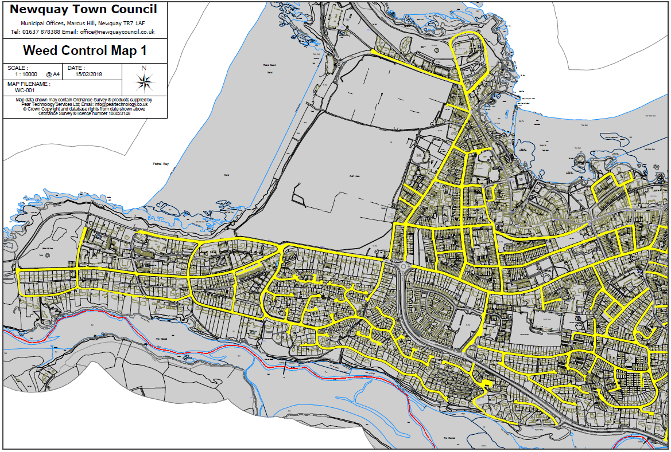

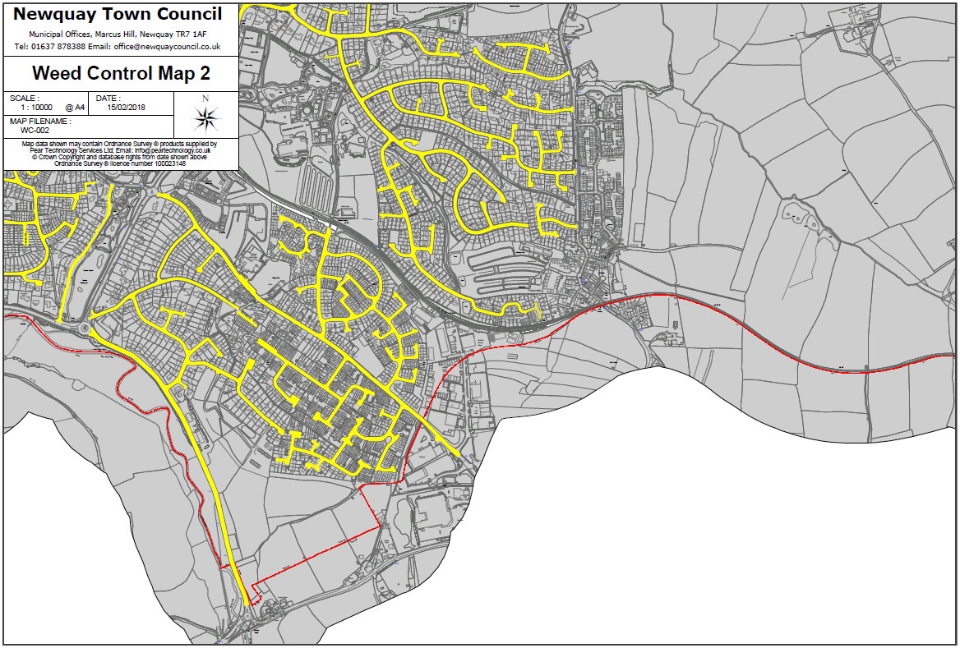

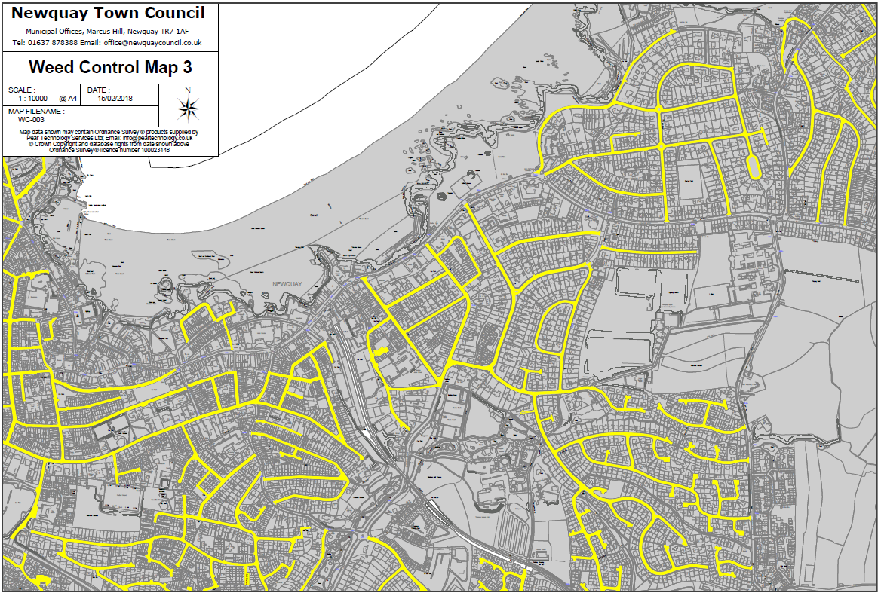

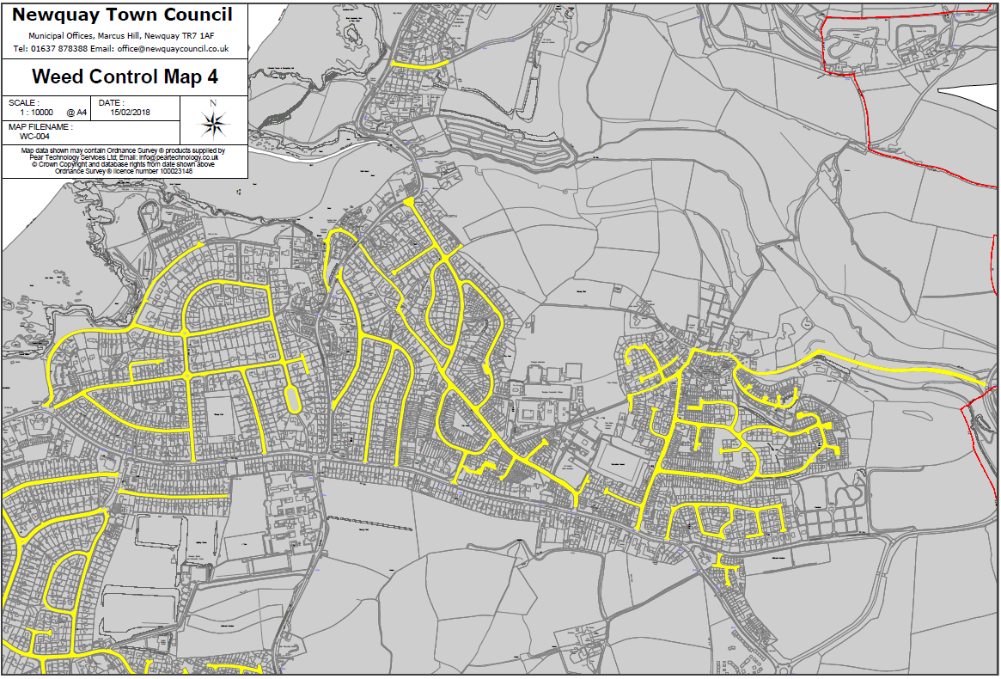

Section 6 The Pricing Document

All prices shall be stated in pounds sterling and exclusive of VAT.

|  |  |
| --- | --- |
| **Activity** | **Cost (£ excl VAT)** |
| **Weeding of Highways as outlined in the Weed Control Schedule (per spray/removal)** | |
|  |  |
| **Other** | |
| Include and describe any other costs not captured above |  |
| **Total (excluding VAT)** |  |
| The following costs are to be provided for information only but will not be scored as part of the evaluation. | |
| Day rate per member of staff |  |
| Daily rate of plant and equipment hire |  |

Section 7 The Quality Assessment

|  |
| --- |
| 1. **Understanding of the Council’s Brief *(10%)***   Please demonstrate your understanding of the Council’s brief outlining proposals on how the project will be managed and delivered. |
|  |
| **2. Experience of the team *(10%)***  Provide details of the team who will be used to deliver the services described in the specification and how their knowledge and experience gained on other projects referenced in section 4 of the questionnaire will be utilised to deliver this contract. |
|  |
| **3. Evidence of Supplier’s ability to respond quickly should problems arise during the display period *(5%)***  Please give information and evidence of the response times expected if any issues should occur during the spraying periods. Please include details of emergency (same day) response processes and non-emergency (next working day) response processes. |
|  |
| **4. Health and Safety and Risk Management processes *(10%)***  Include details of Health and Safety considerations and risk management processes.  Include in your response:   * your methodologies for testing and using all required equipment * Example risk assessment |
|  |
| **5. Project Delivery and Programme *(5%)***  Please demonstrate how you are able to ensure the works are completed on time.  Please include in your response a programme with key milestones. |
|  |
| **6. Promotion and Protection of the Environment *(20%)***  Please demonstrate how the methods you are using are safe in the natural environment. Include in your response:   * Where you use chemicals for weed control, what impact do they have on the Environment (if any). * Have you explored using alternatives to chemical treatment i.e. organic/mechanical weed control? If not, why and outline your reasoning. |
|  |

PART C - SCHEDULES

Schedule 1 - Form of Quotation and Declarations

**Request for Quotation Which Does Not Include a Formal Deed of Agreement**

Having examined the Request for Quotation and its accompanying documents (which I/we shall keep) and being satisfied as to my/our abilities and experience in all respects to satisfy the requirements of the Contract.

Offer to provide or supply upon the terms and conditions of the contract contained in Appendix 1 in its present form the Services for the prices on the quoted Pricing Document as indicated below for the contract period :-

|  |  |
| --- | --- |
| Pricing Document attached | YES / NO |

and/or during the contract period at the price ascertained under the terms and conditions of contract.

I/We understand and agree that your written letter of acceptance of our Quote shall constitute the making of a binding contract between us.

I/We understand that the information provided in this quotation document and any supporting information provided by us will be relied upon and taken to be true and accurate. If it is subsequently determined that any information supplied was inaccurate, I/we understand and accept that Council reserves the right to exclude our offer to supply (if still under evaluation) or if the Contract has been awarded and the information inaccurately supplied had a significant bearing on the award, that Council shall be at liberty to terminate the Contract.

I/We understand that you are not bound to accept the lowest or any Quote you may receive.

Signed……………………………………………………………………………..

Date ……………………………………………………………………………….

in the capacity of ……………………………………………………………….

duly authorised to sign for and on behalf of

(in BLOCK CAPITALS) ………………………………………………………….

Telephone No. ……………………………………………………………………

Postal Address ……………………………………………………………………

Schedule 2 - Commercially Sensitive Information

The Authority may be obliged to disclose information in or relating to this Quotation following a request for information under the Freedom of Information Act (FOIA) or Environmental Information Regulations (EIR). Please outline in the table below items which you consider are confidential and genuinely commercially sensitive and which should not be disclosed in respect of your Quotation.

I declare that I wish the following information to be designated as Commercially Sensitive.

|  |
| --- |
|  |

The reason(s) it is considered that this information should be exempt under Freedom of Information Act FOIA) or Environmental Information Regulations (EIR) is:

|  |
| --- |
|  |

PART D - APPENDICES

Appendix A - Terms and Conditions of Contract for Services

1. **NEWQUAY TOWN COUNCIL**
2. **THE SUPPLIER []**

**AGREEMENT FOR WEED CONTROL OF HIGHWAYS**

Municipal Offices Marcus Hill

Newquay

TR7 1AF

**THIS AGREEMENT** is made [ ]

# BETWEEN

|  |  |
| --- | --- |
| **(1)** | **NEWQUAY TOWN COUNCIL** of Municipal Offices, Marcus Hill, Newquay, TR7 1AF (the **"Council"**); and |
| **(2)** | **[XXX]** (Company Registration No: [XXX]) whose registered office is at [XXX] **(**the **“Supplier”**). |

**BACKGROUND**:

1. In reliance upon the skill, knowledge and experience of the Supplier the Council has appointed the Supplier to provide the Services.
2. The Supplier agrees to accept the appointment in accordance with the terms and conditions of this Agreement.

# IT IS AGREED:

1. **DEFINITIONS AND INTERPRETATION**
   1. In this Agreement unless the context otherwise requires the definitions set out below shall apply.

|  |  |
| --- | --- |
| “Administrator” | the Council officer responsible for the monitoring and management of this Agreement whose details are set out in Schedule 4, or such other person as the Council may otherwise advise in writing; |
| “Agreement” | this agreement, its terms and conditions, schedules and any other document attached; |
| “Bribery Act” | the Bribery Act 2010 and any subordinate legislation made under that Act from time to time together with any guidance or codes of practice issued by the relevant government department concerning the legislation; |
| “Commencement Date” | 01 May 2024; |
| “Commercially Sensitive Information” | the information listed in Schedule 5 comprising the information of a commercially sensitive nature relating to the Supplier, its intellectual property rights or its business or which the Supplier has indicated to the Council that, if disclosed by the Council, would cause the Supplier significant commercial disadvantage or material financial loss; |
| “Confidential Information” | all confidential information (however recorded or preserved) disclosed by a party or its representatives to the other party and that party’s representatives in  connection with this Agreement, including but not limited to: |
|  | 1. any information that would be regarded as confidential by a reasonable business person relating to: (i) the business, affairs, customers, suppliers or plans of the disclosing party; and (ii) the operations, processes, product information, |
|  | 1. know-how, designs, trade secrets or software of the disclosing party; |
|  | 1. any information developed by the parties in the course of carrying out this Agreement; |
| “Data Controller” | the same meaning as set out in the Data Protection Legislation; |
| “Data Processor” | the same meaning as set out in the Data Protection Legislation; |
| “Data Protection Legislation” | the UK Data Protection Legislation and (for so long as and to the extent that the law of the European Union has legal effect in the UK) the GDPR and any other directly applicable European Union regulation relating to privacy; |
| “Data Subject” | the same meaning as set out in the Data Protection Legislation; |
| “Expiry Date” | 30 April 2025; |
| “Fees” | the fees payable to the Supplier by the Council under the Agreement for the full and proper performance by the Supplier of its obligations under this Agreement, as set out in Schedule 3; |
| “Force Majeure Event” | any cause materially affecting the performance of the Services under the Agreement arising from any act, events, omissions, happenings or non-happenings beyond the parties reasonable control including, without limitation, acts of God, war, riot, fire, flood or any disaster affecting either of the parties but will not mean any labour dispute between the Supplier and the Supplier’s employees, agents or sub-contractors; |
| “GDPR” | the General Data Protection Regulation ((EU) 2016/679); |
| “Good Industry Practice” | standards, practices, methods and procedures conforming to the Laws and with all due skill and care, diligence, prudence and foresight which would be expected from a skilled and appropriately experienced, qualified and trained person or body engaged in a similar type of undertaking under the same or similar circumstances; |
| “Initial Term” | the period of 1 year commencing on the Commencement Date and ending on the Expiry Date; |
| “Laws” | any applicable Act of Parliament, subordinate legislation within the meaning of Section 21(1) of the Interpretation Act 1978, exercise of the royal prerogative, enforceable community right within the meaning of Section 2 of the European Communities Act 1972, regulatory policy, guidance or industry code, judgment of a relevant court  of law, or directives or requirements of any regulatory body which the Supplier is bound to comply with; |
| “Personal Data” | the same meaning as set out in the Data Protection Legislation; |
| “Prohibited Act” | 1. offering, promising or agreeing to give to any servant of the Council any gift or consideration of any kind as an inducement or reward: |
|  | 1. for doing or not doing (or for having done or not having done) any act in relation to the obtaining or performance of this Agreement or any other agreement with the Council; or |
|  | 1. for showing favour or disfavour to any person in relation to this Agreement or any other agreement with the Council; |
|  | 1. committing any offence: |
|  | 1. under the Bribery Act and or the UK Data Protection Legislation; or |
|  | 1. under legislation creating offences in respect of fraudulent acts; or |
|  | 1. at common law in respect of fraudulent acts in relation to this Agreement or any other agreement with the Council; or |
|  | 1. defrauding or attempting to defraud or conspiring to defraud the Council; |
|  | 1. any action that may reasonably be considered to be to the detriment of the Council and or its end user’s welfare, either by positive action or by omission. Such action shall include but is not limited to; breach of the law, related to health, safety and or care, safeguarding, abuse, sexual allegations and or misconduct; financial malpractice or business continuity failure; |
| “Regulated Activity” | in relation to children shall have the same meaning as set out in Part 1 of Schedule 4 to the Safeguarding Vulnerable Groups Act 2006 and in relation to vulnerable adults shall have the same meaning as set out in Part 2 of Schedule 4 to the Safeguarding Vulnerable Regulated Activity: Groups Act 2006. |
| “Safety Legislation” | the Health and Safety at Work Act 1974 and the Consumer Protection Act 1987 together with all regulations made under them including, but not limited to, the General Product Safety Regulations 1994, the Control of Substances Hazardous to Health Regulations 1999 and all other legislation, codes of practice and guidance from time to time amended (including subordinate legislation and European Community legislation to the effect that it has direct effect on member states) imposing legal requirements with respect to health and safety at work and/or the safety of any goods and equipment used in the performance of the Services and the health and safety of the users of such equipment; |
| “Schedules” | the schedules attached to this Agreement; |
| “Services” | the services to be provided to the Council by the Supplier and its Staff, as specified in Schedule 1 and 2; |
| “Supplier’s Representative” | the representative appointed by the Supplier in relation to this Agreement, whose details are set out in Schedule 4, or such other person as the Supplier may otherwise advise in writing; |
| “Staff” | all persons employed by the Supplier to perform its obligations under the Agreement together with the Supplier’s servants, agents, suppliers and sub-contractors used in the performance of its obligations under the Agreement; |
| “Term” | the period of the Initial Term as may be varied by:   1. any extensions to this Agreement which are agreed pursuant to clause 2; or   the earlier termination of this Agreement in accordance with its terms; |
| “UK Data Protection Legislation” | any data protection legislation from time to time in force in the UK including the Data Protection Act 1998 or 2018 or any successor legislation including GDPR; |
| “Working Day” | Monday to Friday, excluding public holidays in England and Wales, unless otherwise authorised by the Council. |

* 1. The interpretation and construction of the Agreement shall be subject to the following provisions:
     1. words importing the singular meaning include where the context so admits the plural meaning and vice versa;
     2. words importing the masculine include the feminine and neuter;
     3. reference to a clause is a reference to the whole of that clause unless stated otherwise;
     4. references to any statute, enactment, order, regulation or other similar instrument shall be construed as a reference to the statute, enactment, order, regulation or instrument as amended by any subsequent enactment, modification, order, regulation or instrument as subsequently amended or re-enacted;
     5. references to any party shall include natural persons and partnerships, firms and other incorporated bodies and all other legal persons of whatever kind and however constituted and their successors and permitted assigns or transferees;
     6. the words “include”, “included”, “includes” and “including” are to be construed as if they were immediately followed by the words “without limitation”; and
     7. headings are included in the Agreement for ease of reference only and shall not affect the interpretation or construction of the Agreement.
     8. in cases of conflict the following order of precedence shall apply:
        1. the clauses of this Agreement;
        2. Schedule 1 - The Council’s Requirements;
        3. Schedule 2 and 3;
        4. Any other Schedule.

# TERM

* 1. This Agreement shall take effect on the Commencement Date and shall continue for the Term, subject always to review or such lesser period as a result of the Agreement being terminated earlier in accordance with the provisions of this Agreement.
  2. The Council may extend this Agreement beyond the Initial Term for up to 1 year (the “Extended Period”) if both parties agree in writing to such an extension or extensions. The same terms and conditions as those contained within this Agreement shall apply to any Extended Period*.*

# DUE DILIGENCE, SUPPLIER’S WARRANTY AND THE SERVICE STANDARD

* 1. The Supplier acknowledges and confirms that:
     1. the Council has delivered or made available to the Supplier all of the information and documents that the Supplier considers necessary or relevant for the performance of its obligations under this Agreement;
     2. it has made and shall make its own enquiries to satisfy itself as to the accuracy and adequacy of any information supplied or made available to it by or on behalf of the Council pursuant to clause 3.1(a);
     3. it has satisfied itself (whether by inspection or having raised all relevant due diligence questions with the Council before the Commencement Date) of all relevant details relating to the performance of its obligations under this Agreement; and
     4. it has entered into this Agreement in reliance on its own due diligence.
  2. Save as provided in this Agreement, no representations, warranties or conditions are given or assumed by the Council in respect of any information which is provided to the Supplier by the Council and any such representations, warranties or conditions are excluded, save to the extent that such exclusion is prohibited by law.
  3. The Supplier:
     1. warrants and represents that all information and statements made by the Supplier as a part of the procurement process, including without limitation the Supplier’s quote or response remains true, accurate and not misleading, save as may have been specifically disclosed in writing to the Council prior to execution of the Agreement; and
     2. shall promptly notify the Council in writing if it becomes aware during the performance of this Agreement of any inaccuracies in any information provided to it by the Council during such due diligence which materially and adversely affects its ability to perform the Services or meet any performance target or KPIs.
  4. The Supplier shall not be entitled to recover any additional costs from the Council which arise from, or be relieved from any of its obligations as a result of, any matters or inaccuracies notified to the Council by the Supplier in accordance with clause 3.3(b), save where such additional costs or adverse effect on performance have been caused by the Supplier having been provided with fundamentally misleading information by or on behalf of the Council and the Supplier could not reasonably have known that the information was incorrect or misleading at the time such information was provided. If this exception applies, the Supplier shall be entitled to recover such reasonable additional costs from the Council or shall be relieved from performance of certain obligations as shall be determined by the clause 31 – Variation.
  5. Nothing in this clauses 3.1, 3.2, 3.3 and 3.4 shall limit or exclude the liability of the Authority for fraud or fraudulent misrepresentation.
  6. In performing the Services, the Supplier shall ensure, throughout the Term of this Agreement, that it:
     1. complies with the terms of this Agreement and completes the Services in accordance with the requirements set out in Schedule’s attached in all material respects ensuring that, except with the consent of the Council, the Services are carried out exclusively by the persons named in the Supplier’s quote;
     2. operates in accordance with Good Industry Practice and in compliance and conformance with all applicable Laws;
     3. notifies the Council in writing immediately on learning of any relationship or potential conflict of interest that might influence or be perceived to influence the provision of the Services;
     4. co-operates with the Council in all matters relating to the Services;
     5. co-operates, and procures that its Staff co-operates, with the Council in carrying out any performance monitoring, at no additional charge to the Council; and
     6. uses its best endeavours to promote the interests of the Council.
  7. The Council shall use its reasonable endeavours to:
     1. provide, for the Supplier, its agents, sub-contractors, Suppliers and employees, in a timely manner and at no charge, access to the Council's premises, office accommodation, data if relevant and other facilities as reasonably required by the Supplier or any of them; and
     2. provide, in a timely manner, such information as the Supplier may reasonably require, and ensure that it is accurate in all material respects.

# FEES AND PAYMENT

* 1. In consideration of the performance of the Supplier’s obligation under the Agreement, the Council shall pay the Fees set out in Schedule 3 within thirty (30) days of a correctly rendered invoice. No extra charges shall be effective unless agreed in writing and signed by the Council.
  2. All invoices shall be directed to the Administrator.
  3. The Council shall pay all undisputed invoices submitted to it by the Supplier in accordance with the payment arrangements set out in Schedule 3, to a bank account nominated in writing by the Supplier. Each invoice shall include such supporting information required by the Council to verify the accuracy of the invoice, including but not limited to the relevant purchase order number.
  4. The Council may reduce payment in respect of any Services which the Supplier has either failed to provide or has, in the Council’s reasonable opinion, provided inadequate Services;
  5. All amounts payable by the Council under the Agreement are exclusive of amounts in respect of valued added tax chargeable from time to time (the “VAT”). Where any taxable supply for VAT purposes is made under the Agreement by the Supplier to the Council, the Council shall, on receipt of a valid VAT invoice from the Supplier, pay to the Supplier such additional amounts in respect of VAT as are chargeable on the performance of the Services at the same time as payment is due for the performance of the Services.
  6. If the Council fails to pay any amount properly due and payable by it under the Agreement, the Supplier shall have the right to charge interest on the overdue amount at the rate of two (2) per cent per annum above the base rate for the time being of the Bank of England, accruing on a daily basis from the due date up to the date of actual payment. This clause shall not apply to payments that the Council disputes in good faith.
  7. The Supplier shall maintain complete and accurate records of the time spent and materials used by the Supplier in the performance of the Services, and the Supplier shall allow the Council to inspect such records at all reasonable times on request.
  8. Payment by the Council shall be without prejudice to any claims or rights which the Council may have against the Supplier and shall not constitute any admission by the Council as to the performance by the Supplier of its obligation hereunder.
  9. The Council may at any time, without notice to the Supplier, set off any liability of the Supplier to the Council against any liability of the Council to the Supplier, whether either liability is present or future, liquidated or unliquidated, and whether or not either liability arises under this Agreement. Any exercise by the Council of its rights under this clause shall not limit or affect any other rights or remedies available to it under this Agreement or otherwise.
  10. Where the Supplier enters into a Sub-Contract, the Supplier shall include in that Sub- Contract:

1. Provisions having the same effect as clauses 4.3 – 4.4 of this Agreement; and
2. A provision requiring the counterparty to that Sub-Contract to include in any Sub- Contract which it awards provisions having the same effect as clauses 4.3 – 4.4 of this Agreement.
3. In this clause 4.10, “Sub-Contract” means a contract between two or more suppliers, at any stage of remoteness from the Council in a sub-contracting chain, made wholly or substantially for the purpose of performing (or contributing to the performance of) the whole or any part of this Agreement.
   1. The Supplier shall maintain up-to-date personnel records on its Staff engaged in the provision of the Services and shall provide information to the Council as the Council reasonably requests on the Supplier’s Staff. The Supplier shall ensure at all times that it has the right to provide these records in compliance with the applicable Data Protection Legislation.

# STATUTORY RIGHTS

* 1. Nothing in these conditions shall affect in any way the statutory rights of the Council under the Sale of Goods Act 1979, the Supply of Goods and Services Act 1982 or any subsequent amending or consolidating legislation.
  2. A party who is not a party to this Agreement is not entitled to enforce any of its terms under the Contracts (Rights of Third Parties) Act 1999 except where this Agreement expressly provides otherwise.
  3. The Supplier shall at its own expense, comply in all respects with the Laws and all applicable rules and regulations in all matters arising in the performance of or in connection with the Agreement.

# MONITORING

* 1. The Supplier's performance of the Services shall be monitored by the Administrator, who shall be entitled to make recommendations to the Supplier for improving the standard of the Supplier’s performance in undertaking the Services.
  2. If applicable, the Supplier’s Representative will meet regularly with the Administrator upon receiving a request to do so, to discuss the Services being provided by the Supplier and to provide the Council with progress reports and or information.
  3. At the meetings the Administrator and the Supplier’s Representative will review, among other things, the Supplier’s performance, key performance indicators where applicable, progress- to-date on provision of the Services, and any issues relating to the performance of the Services.
  4. The Administrator shall keep minutes of all meetings in relation to monitoring of the Agreement.
  5. The Administrator shall review the Supplier’s compliance with the Data Protection Legislation, the FOIA, in accordance with clause 10 (Data Protection) and clause 11 (Freedom of Information) and any other Laws applicable to the Services.
  6. The Council may terminate the Agreement by written notice with immediate effect if the Supplier fail to perform the Services in accordance with the Agreement

# ANTI-BRIBERY AND MODERN SLAVERY ACT REQUIRMENTS

* 1. The Supplier shall:
     1. comply with all applicable anti-bribery, anti-corruption and anti-slavery legislation including, without limitation, the Bribery Act and Modern Slavery Act 2015;
     2. maintain and enforce its own policies and procedures, including adequate procedures under the Bribery Act, to ensure compliance with all applicable anti-bribery and anti- corruption legislation;
     3. use reasonable endeavours to ensure that all persons associated with the Supplier (as defined by section 8 of the Bribery Act) including any sub-contractors and suppliers comply with this clause;
     4. implement due diligence procedures for its own suppliers, sub-contractors and other participants in its supply chain, to ensure that there is no slavery or human trafficking in its supply chain;
     5. use reasonable endeavours not to purchase any raw materials, resources or products from any country that has been sourced from producers or manufacturers using forced labour in its operations or practice.

# EQUALITIES

* 1. The Supplier shall (and shall procure that its Staff shall) not unlawfully discriminate within the meaning and scope of any Law, enactment, order or regulation relating to discrimination in employment including but not limited to the Equality Act 2010, and shall (and shall procure that its Staff shall) at all times comply with the provisions of the Human Rights Act 1998 in the performance of the Services.

# SAFEGUARDING

* 1. Where it is clear or otherwise reasonably likely that the performance of the Agreement will require the Supplier (or any of its staff, agents, sub-contractors or advisors) to carry out a Regulated Activity the Supplier shall:

1. comply at all times with the provisions of the Safeguarding Vulnerable Groups Act 2006 (“SVGA 2006);
2. ensure that all individuals engaged in Regulated Activity are subject to a valid enhanced disclosure check for regulated activity undertaken through the Disclosure and Barring Service (DBS); and
3. monitor the level and validity of the checks under this clause 9.4 for each member of staff;
4. not employ or use the services of any person who is barred from, or whose previous conduct or records indicate that he or she would not be suitable to carry out Regulated Activity or who may otherwise present a risk to service users, children or vulnerable adults.
   1. The Supplier warrants that at all times for the purposes of this Agreement it has no reason to believe that any person who is or will be employed or engaged by the Supplier in the provision of the Services is barred from the activity in accordance with the provisions of the Safeguarding Vulnerable Groups Act 2006 and any regulations made thereunder, as amended from time to time.
   2. The Supplier shall immediately notify the Administrator and or the Council of any information that it reasonably requests to enable it to be satisfied that the obligations of this clause 9 have been met.
   3. The Supplier shall refer information about any person carrying out the Services to the DBS where it removes permission for such person to carry out the Services (or would have, if such person had not otherwise ceased to carry out the Services) because, in its opinion, such person has harmed or poses a risk of harm to the service users and or children and or vulnerable adults.

# DATA PROCESSING

* 1. Both parties will comply with all applicable requirements of the Data Protection Legislation and any applicable Laws. This clause 10 is in addition to, and does not relieve, remove or replace, a party’s obligations under the Data Protection Legislation. In this clause 10, applicable Laws means (for so long as and to the extent that they apply to the Provider) the law of the European Union, the law of any member state of the European Union and/or Domestic UK Law; and Domestic UK Law means the UK Data Protection Legislation and any other law that applies in the UK.
  2. The parties acknowledge that for the purposes of the Data Protection Legislation, the Council is the Data Controller and the Supplier is the Data Processor. Schedule 6 sets out the scope, nature and purpose of processing by the Supplier, the duration of the processing and the types of Personal Data and categories of Data Subject.
  3. Without prejudice to the generality of clause 10.1, the Council will ensure that it has all necessary appropriate consents and notices in place to enable lawful transfer of the Personal Data to the Supplier for the duration and purposes of this Agreement.
  4. Without prejudice to the generality of clause 10.1, the Supplier shall, in relation to any Personal Data processed in connection with the performance by the Supplier of its obligations under this Agreement:
     1. process that Personal Data only on the written instructions of the Council (as set out in Schedule 6), unless the Supplier is required by applicable Laws to otherwise process that Personal Data. Where the Supplier is so required, it shall promptly notify the Council before processing the Personal Data, unless prohibited by the applicable Laws;
     2. ensure that it has in place appropriate technical and organisational measures, reviewed and approved by the Council, to protect against unauthorised or unlawful processing of Personal Data and against accidental loss or destruction of, or damage to, Personal Data, appropriate to the harm that might result from the unauthorised or unlawful processing or accidental loss, destruction or damage and the nature of the data to be protected, having regard to the state of technological development and the cost of implementing any measures (those measures may include, where appropriate, pseudonymising and encrypting Personal Data, ensuring confidentiality, integrity, availability and resilience of its systems and services, ensuring that availability of and access to Personal Data can be restored in a timely manner after an incident, and regularly assessing and evaluating the effectiveness of the technical and organisational measures adopted by it);
     3. not transfer any Personal Data outside of the European Economic Area unless the prior written consent of the Council has been obtained and the following conditions are fulfilled:
        1. the Council or the Supplier has provided appropriate safeguards in relation to the transfer;
        2. the Data Subject has enforceable rights and effective remedies;
        3. the Supplier complies with its obligations under the Data Protection Legislation by providing an adequate level of protection to any Personal Data that is transferred; and
        4. the Supplier complies with the reasonable instructions notified to it in advance by the Council with respect to the processing of the Personal Data;
     4. notify the Council immediately if it receives:
        1. a request from a Data Subject to have access to that person’s Personal Data;
        2. a request to rectify, block or erase any Personal Data;
        3. receives any other request, complaint or communication relating to either Party’s obligations under the Data Protection Legislation (including any communication from the Information Commissioner);
     5. assist the Council in responding to any request from a Data Subject and in ensuring compliance with the Council’s obligations under the Data Protection Legislation with respect to security, breach notifications, impact assessments and consultations with supervisory authorities or regulators;
     6. notify the Council immediately and in any event within 24 hours on becoming aware of a Personal Data breach including without limitation any event that results, or may result, in unauthorised access, loss, destruction, or alteration of Personal Data in breach of this Agreement;
     7. at the written direction of the Council, delete or return Personal Data and copies thereof to the individual on termination or expiry of the Agreement unless required by the applicable Laws to store the Personal Data;
     8. maintain complete and accurate records and information to demonstrate its compliance with this clause 10 and allow for audits by the Council or the Council’s designated auditor.
  5. The Supplier shall indemnify the Council against any losses, damages, cost or expenses incurred by the Council arising from, or in connection with, any breach of the Supplier’s obligations under this clause 10.
  6. Where the Supplier intends to engage a Sub-Contractor pursuant to clause 4.10 and intends for that Sub-Contractor to process any Personal Data relating to this agreement, it shall:
     1. notifiy the Council in writing of the intended processing by the Sub-Contractor;
     2. obtain prior written consent to the processing;
     3. ensure that any Sub-Contract imposes obligations on the Sub-Contractor to give effect to the terms set out in this clause 10.
  7. Either party may, at any time on not less than thirty (30) Working Days’ written notice to the other party, revise this clause 10 by replacing it with any applicable controller to processor standard clauses or similar terms forming part of an applicable certification scheme.
  8. The provisions of this clause shall apply during the continuance of the Agreement and indefinitely after its expiry or termination.

# FREEDOM OF INFORMATION

* 1. The Supplier recognises that the Council has information disclosure obligations under the Freedom of Information Act 2010 (“FOIA”) and the Environmental Information Regulations (“EIR”). The Supplier agrees to provide such assistance and support as may be requested from time to time by the Council for the purposes of enabling or assisting the Council to comply with these information disclosure obligations in respect of matters relating to or arising out of this Agreement.
  2. In the event that a request made to the Council for access to information under the FOI or the EIR, or any notice, recommendation or complaint is made to or against the Council in relation to its obligations under the FOIA or EIR, the Supplier will within five (5) Working Days of the date of a request from the Council provide to the Council, any details in its possession relating to this Agreement or to the Supplier as the Council may require to deal with such access request or deal with such notice, recommendation or complaint.
  3. The Supplier acknowledges the Council may be obliged under the FOIA or EIR to disclose information to third parties, including information relating to the appointment of the Supplier to provide the Services under this Agreement, and the terms of this Agreement, subject to certain exemptions. The Supplier further acknowledges and accepts that the decision to disclose information and the application of any such exemptions under the FOIA or EIR will be at the Council’s sole discretion PROVIDED THAT the Council shall act reasonably and proportionately in determining whether any exemptions under the FOIA or EIR may apply to protect the Supplier’s legitimate commercial interests trade secrets.

# TRANSPARENCY

* 1. The Supplier acknowledges that Council has information publication obligations the Local Government Transparency Code 2015, and agrees that this Agreement (including the Schedules), and any documentation including but not limited to requests for quotes, advertisement issued by the Council seeking expressions of interest, the pre-qualification questionnaire and the quote documents (the “Procurement Documents”) issued by the Council in relation to this Agreement are not Confidential Information, and may be published by the Council, save where in the reasonable opinion of the Council the contents of the Agreement or the Procurement Documents are exempt from disclosure under the FOIA or EIR in which case, the Supplier consents to the Agreement or Procurement Documents being redacted by the Council to the extent necessary to remove or obscure the exempt content, and to publication subject to those redactions.

# CONFIDENTIALITY AND COUNCIL’S PROPERTY

* 1. Subject to clause 10 (Data Protection), clause 11 (Freedom of Information) and Clause 12 (Transparency), the Supplier shall not, without the prior written consent of the Council,, publish or disclose to any person, or permit any such disclosure by any of its employees or representatives, any Confidential Information.
  2. The restriction in clause 13.1 does not apply to:
     1. any information required to be disclosed by an order of court or other tribunal or required to be disclosed in accordance with any law, statute, proclamation, by-law, directive, decision, regulation, rule, order, notice, rule of court, delegated or subordinate legislation; or
     2. any information which is already in, or comes into, the public domain otherwise than through unauthorised disclosure by the Supplier; or
     3. any disclosure authorised by the Council.
  3. All documents, manuals, hardware and software provided by the Council to the Supplier, and any data or documents (including copies) produced, maintained or stored on the Council's computer systems or other electronic equipment (including mobile phones, if provided by the Council) in relation to this Agreement, remain the property of the Council.
  4. All intellectual property rights and proprietary rights including copyright and all other rights of a like nature conferred under the laws of the United Kingdom (and all other countries of the World) in any works conceived originated or made by the Supplier pursuant to the Services (“Intellectual Property”) shall automatically vest in the Council and Supplier hereby assigns to the Council by way of future assignment the copyright and all other intellectual property rights in the Intellectual Property for the full term during which the said rights and any renewals or extensions shall subsist.
  5. The Supplier warrants and represents that the Intellectual Property will not infringe any intellectual property rights of which a third party is the proprietor. The Supplier agrees to indemnify the Council against any and all liability, loss, damages, costs and expenses which the Council or a third party may incur or suffer as a result of any dispute or contractual, tortious or other claims or proceedings brought against the Council by a third party alleging infringement of its intellectual property rights by reason of the use or exploitation of the Intellectual Property.

# INDEMNITY

* 1. Without prejudice to any other provision of this Agreement, the Supplier will fully indemnify the Council against any claims made against it as a result of any failure by the Supplier to comply with any statutory provision to be observed or performed in connection with the provision of the Services.
  2. The Supplier’s liability to indemnify the Council arising under clause 14.1 will be without prejudice to any other right or remedy of the Council arising under this Agreement.

# INSURANCE

* 1. Throughout the Term the Supplier shall at its own cost effect and maintain with a reputable insurance company within the UK such policies of insurance as are necessary to cover any liability of the Supplier in respect of loss of or damage to property and personal injury to, or death of, any person arising out of or in the course of or caused by the Supplier carrying out or failing to carry out its obligations under the Agreement or for which it may become liable to the Council under clause 14, including:

1. employers liability insurance in the minimum sum of £10,000,000.00 in respect of one incident and the number of incidents covered shall be unlimited;
2. public liability insurance cover in the minimum sum of £10,000,000.00 in respect of any one incident and the number of incidents covered shall be unlimited and should be adequate to cover all risks in the performance of the Services;
   1. The Supplier shall continue to maintain the above policies of insurance for a 6-year period following the termination of the Agreement.
   2. Upon request, the Supplier will provide the Council with details of the policies of insurance (by way of insurer’s certificate) effected in accordance with clause 15.1, so as to demonstrate that clause 15.1 is being complied with.
   3. The Supplier will immediately inform the Council of any failure or inability to maintain insurance in accordance with clause 15.1 and of any circumstances likely to render such insurance void or voidable in order that the Supplier and the Council can discuss the means of best protecting their respective positions in the absence of such insurance.

# TERMINATION OF AGREEMENT

* 1. In the event of:
     1. the passing by the Supplier of a resolution for its winding-up or the making by a court of competent jurisdiction of an order for the winding-up of the Supplier or the dissolution of the Supplier; or
     2. the making of an administration order in relation to the Supplier or the appointment of a receiver over, or the taking possession or sale by an encumbrancer of, any of the Supplier’s assets; or
     3. the Supplier making an arrangement or composition with its creditors generally or making an application to a court of competent jurisdiction for protection from its creditors generally,

the Council may, without prejudice to any other power of termination or to any rights or remedies it may have, terminate the Agreement forthwith by notice and the Supplier shall indemnify the Council against all costs, expenses and damages for which the Council becomes liable arising from such termination.

* 1. Without prejudice to the Parties other rights and remedies, either party may forthwith terminate the Agreement by notice if the other:
     1. commits or attempts a Prohibited Act;
     2. fails to comply with Good Industry Practice, UK Data Protection Legislation, Safety Legislation and or the Laws;
     3. commits any material breach of the terms of this Agreement and fails to remedy such breach within seven (7) days of being given written notice to do so by the other; or
     4. fails to perform its obligations under the Agreement with due diligence,

the termination shall be at no loss or cost to the Council and the Supplier hereby indemnifies the Council against all costs, expenses and damages for which the Council may suffer as a result of any such termination.

* 1. Notwithstanding the generality of this clause 16 the Council shall have the right to terminate the Agreement or to terminate the provision of any part of the Agreement at any time by giving one month’s written notice to the Supplier.

# ASSIGNMENT AND SUB-CONTRACTING

* 1. The Supplier shall not assign or sub-contract the Services under this Agreement, or any part thereof, without the permission of the Council in writing. Assignment or sub-contracting any part of the Services shall not relieve the Supplier of any obligation or duty attributable to the Supplier under this Agreement.
  2. The Supplier shall be responsible for the acts and omissions of its assignees and sub- contractors as though they were its own. Where the Council has consented to the placing of an assignment or sub-contracts, copies of each contract of assignment or sub-contract shall be provided by the Supplier to the Council within two (2) Working Days of issue.
  3. The Council shall be freely entitled to assign, novate or otherwise transfer its rights and obligations under this Agreement to

1. a government body; or
2. to any body (including any private sector body) which performs or carries on any of the functions and/or activities that previously had been performed and/or carried on by the Council;
3. where the Council is a public authority and any change in the legal status of the Council which means that it ceases to be a public authority;
4. in the event of the establishment of a unitary authority or another legal structure.

# DISPUTES

* 1. If the Council reasonably believes that the Services are deficient, the Supplier shall be formally notified in writing by the Council, inviting the Supplier at the earliest possible opportunity to discuss the matter and giving clear indications as to how the Services have not been satisfactory.
  2. After such discussions, the Supplier shall remedy any agreed faults within an agreed, reasonable timescale. Once the Council has formally notified the Supplier of any such deficiencies, it shall be entitled to withhold payment of any invoices which the Supplier has submitted (or may submit) for the Services, or part pay any such invoices as it sees fit until such time as the agreed faults have been remedied.
  3. If the Supplier is unable or unwilling to remedy the above faults, the Council may terminate this Agreement in accordance with clause 16.2.3; if the Supplier feels that the Services are not deficient or that the Council has been unfair in its judgment of the quality of the Services, and the parties are unable to come to an agreement on the matter amicably between them, the matter may be resolved by reference to an independent mediator who is acceptable to both parties, and whose decision both parties agree shall be final. Both parties shall share the cost of mediation.

# NOTICES

* 1. Any notice, request, demand, consent or approval given under or in connection with this Agreement must be given in writing. Any such notice, request, demand, consent or approval shall in the case of the Council be sent to the Administrator at the Council’s address as set out at the beginning of this Agreement and in the case of the Supplier, to the Supplier’s Representative at the Supplier’s registered office address as set out at the beginning of this Agreement.
  2. Notices may be delivered by hand or sent by post. If sent by post, a notice shall be deemed to have been received on the second Working Day following the date of posting. If sent by registered post or recorded delivery, it shall be deemed to have been received on the date and time receipt was acknowledged.

# NO WAIVER

* 1. No delay, neglect or forbearance on the part of either party in enforcing against the other party any term or condition of the Agreement shall either be or be deemed to be a waiver or in any way prejudice any right of that party under this Agreement.
  2. A waiver of any right or remedy under this Agreement or by Law is only effective if it is given in writing and shall not be deemed a waiver of any subsequent right or remedy.

# FORCE MAJEURE

* 1. Neither party shall be liable for delay in performing or failing to perform its obligations under this Agreement if the delay or failure results from Force Majeure. Such delay or failure shall not constitute a breach of this Agreement and the time for performance shall be extended by a period equivalent to that during which performance is prevented provided that if such delay or failure persists for more than one month nothing in this clause shall be taken to limit or prevent the exercise of the right to terminate under clause 16.

# LIMITATION OF LIABILITY

* 1. Save that this clause 22.1 is not intended to exclude or limit liability for personal injury or death attributable to the Supplier’s negligence, the Supplier’s liability under this Agreement shall be limited to the amount of the Council’s actual loss provided that the Council shall first have taken all reasonable steps to recoup any such loss.

# ACCRUED RIGHTS AND REMEDIES

* 1. The termination of the Agreement will not prejudice or affect any claim, right, action or remedy that will have accrued or will thereafter accrue to either party.

# RIGHTS AND DUTIES RESERVED

* 1. All rights, duties and powers which the Council has as a local authority or which the Council’s officers have as local authority officers are expressly reserved.

# SURVIVAL OF TERMS

* 1. The terms of the Agreement will (except in respect of any obligations fully performed prior to or at the completion of the Services) continue in force and effect after the completion of the Services by the Supplier.

# PUBLICITY AND BRANDING

* 1. The Supplier shall not:
     1. make any press announcements or publicise this Agreement or its contents in any way; or
     2. use the Council’s name or brand in any promotion or marketing or announcement of orders,

without the prior written consent of the Administrator.

# AUTHORITY TO ENTER INTO THE AGREEMENT

* 1. Each of the parties warrants its power to enter into this Agreement and that it has obtained the necessary approvals to do so.

# ENTIRE AGREEMENT

* 1. This Agreement contains the whole agreement between the parties and neither party has relied upon any oral or written representations made to it by the other or the others employees, representatives or agents and and supersedes and extinguishes all previous agreements, promises, assurances, warranties, representations and understandings between them, whether written or oral, relating to its subject matter.
  2. Each party agrees that it shall have no remedies in respect of any statement, representation, assurance or warranty (whether made innocently or negligently) that is not set out in this Agreement. Each party agrees that it shall have no claim for innocent or negligent misrepresentation or negligent misstatement based on any statement in this Agreement.

# COUNTERPARTS

* 1. This Agreement may be executed in any number of counterparts, each of which when executed and delivered shall constitute an original of this Agreement, but all the counterparts shall together constitute the same Agreement.

# NO PARTNERSHIP OR AGENCY

* 1. Nothing in this Agreement is intended to, or shall be deemed to, establish any partnership or joint venture between any of the parties, constitute any party the agent of another party, or authorise any party to bind or make or enter into any commitments for or on behalf of any other party.
  2. Each party confirms it is acting on its own behalf and not for the benefit of any other person.

# VARIATION

* 1. No variation of this Agreement shall be effective unless it is in writing and signed by the parties.
  2. The Supplier shall not be entitled to recover any additional costs from the Council unless agreed in writing.

# GOVERNING LAW

31.1 This Agreement shall be governed by and construed in accordance with English law and the parties submit to the exclusive jurisdiction of the courts of England and Wales.

|  |
| --- |
| IN WITNESS of which this Agreement has been entered into on the date stated at the beginning of it. |
| Signed on behalf of COUNCIL by: |
| ……………………………………………………… |
| Signed on behalf of the SUPPLIER by: |
| ……………………………………………………… Director  ……………………………………………………… Director/ Company Secretary |

**SCHEDULE 1**

**THE COUNCIL’S REQUIREMENTS [AGREEMENT FOR WEED CONTROL]**

**SCHEDULE 2**

**THE SUPPLIER’S RESPONSE [ ]**

**SCHEDULE 3 SUPPLIER’S FEES [ ]**

**SCHEDULE 4**

**DETAILS OF CONTACTS**

Administrator:

Name: [Joe Ashton]

Address: [Municipal Offices, Marcus Hill, Newquay, TR7 1AF]

Telephone number: [01637 878388]

E-mail- address: [joe@newquay.gov.uk]

Supplier’s Representative Name: [ ]

Address: [ ]

Telephone number: [ ] E-mail- address: [ ]

**SCHEDULE 5**

**COMMERCIALLY SENSITIVE INFORMATION**

**[DETAILS OF ANY SUPPLIER INFORMATION TO BE CLASSIFIED AS COMMERCIALLY SENSITIVE]**

**SCHEDULE 6**

**DATA PROCESSING**

**NOT USED**

Appendix B - Defined Terms

|  |  |
| --- | --- |
| **For the purpose of this Quotation the following words and expressions shall have the meanings set out below.** | |
| **Appendix** | The referred Appendix attached to, or supplied with, this RFQ. |
| **Applicant** | Any person or persons, firm or firms, company or companies bidding for the Services, Supplies or Works detailed in this RFQ, or, where there is more than one organisation applying, the lead organisation. |
| **Authorised Officer** | The person(s) detailed in 1.1 of this RFQ. |
| **Award Criteria** | The evaluation criteria that will be applied to all bids satisfying the Selection Criteria (if applicable). |
| **Contract** | The Contract for the provision of the Services, Supplies or Works, which will be awarded to the successful Applicant. |
| **Council** | Newquay Town Council, Municipal Offices, Marcus Hill, Newquay, TR7 1AF |
| **Lead Organisation** | In the case of a consortium Applicant or an Applicant relying on Significant Subcontractors, the organisation responsible for leading the submission. |
| **Quality Assessment/Evaluation** | The quality element of an Applicant’s bid and/or the evaluation relating to that quality aspect. |
| **Quotation/Quote** | Shall mean the Applicant’s offer to the Authority, which shall be submitted as the completed procurement documents |
| **Relevant Organisation** | (a) where the Applicant is a consortium, each consortium member other than the Lead Organisation; and  (b) where the Applicant or consortium member is a prime contractor, each Significant Subcontractor other than the Lead Organisation. |
| **Request for Quotation (RFQ)** | This Request for Quotation documentation for Weed Control 2024-25 |
| **Selection Criteria** | The criteria used to select those Applicants whose bids will be considered for evaluation against the Award Criteria. |
| **Significant Subcontractor** | Where there is a subcontracting arrangement, each proposed subcontractor where that proposed subcontractor will be contributing significantly, either in terms of value or importance to the performance of the Works. |
| **Services** | The Service or Services as described in this RFQ. |