Refurbishment 3, Ennor Close – Specification for works

July 2026

1. List of Drawings and Reference Materials
1a: Kitchen specification
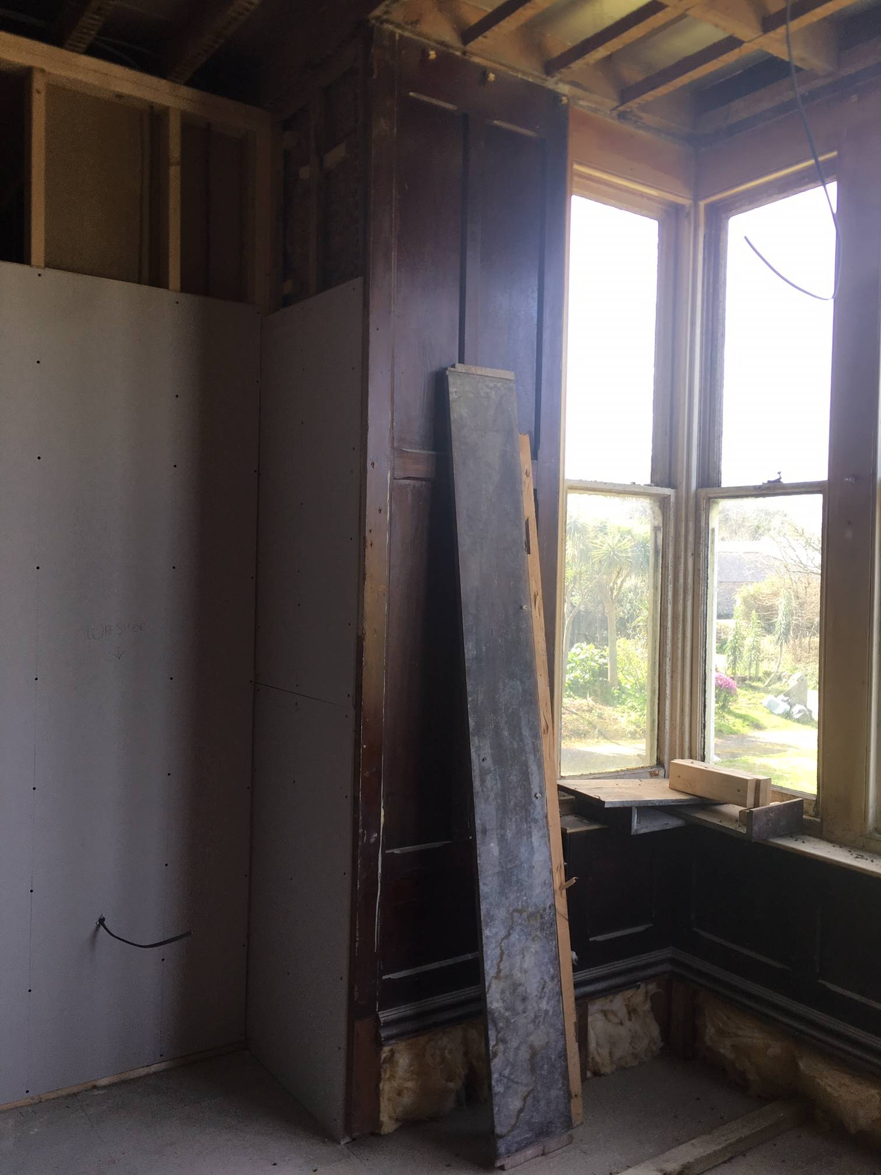

2. Specification
B: As described in xls Spreadsheet detailing works required.

3. Variations from the Specification (Variant Bids)

The Council will not accept variant bids relating to this procurement.

