SCHEDULE 2 – THE SERVICES

- Service Specifications

Service Specification No. | V16 29.10.20
Service | Community Urology Assessment and Treatment Service
Commissioner Lead | Rachel Anthwal, Head of Non Acute Commissioning for Bristol, North Somerset and South Gloucestershire Clinical Commissioning Group
Provider Lead
Period | XXXX
Date of Review | January 2022

1. Population Needs
  - National context
There have been a number of publications promoting more integrated services to be provided in the community, closer to home, these include:-
- NHS Long Term Plan (Department of Health, January 2019)
- Our health, our care, our say- a new direction for community services (D of H, 2006
- Shifting Care Closer to Home Demonstration sites (D of H , 2007)
- Providing care for patients with urological conditions: guidance and resources for commissioners (Primary Care Contracting, 2008)

  - Local context
Bristol, North Somerset and South Gloucestershire Clinical Commissioning Group serves a population of approximately 1,000,000 people. There are 77 member GP practices working from six localities.

Specialist Urology services are provided by:-
- North Bristol NHSTrust
- University Hospitals Bristol and Weston Foundation Trust
- GP Care UK Ltd.
- Royal United Hospitals Trust

The service must be provided in such a way that it supports the BNSSG Primary Care Strategy.

  - Evidence base
An evidence review has been conducted and no high quality evidence was found in the literature to identify if any specialist urology services could be safely and effectively moved from acute trusts into the community. However, many CCGs across the country have commissioned community based specialist urology services, and a number of models are outlined in the review.
2. Outcomes
2.1 NHS Outcomes Framework Domains & Indicators

Domain 1 | Preventing people from dying prematurely
Domain 2 | Enhancing quality of life for people with long-term conditions
Domain 3 | Helping people to recover from episodes of ill-health or following injury
Domain 4 | Ensuring people have a positive experience of care
Domain 5 | Treating and caring for people in a safe environment and protecting them from avoidable harm

2.2 Local defined outcomes
The performance of the service will be monitored using a mixture of key performance indicators (KPI) and service monitoring metrics. These are described in the two tables below:-

    - Key performance indicators

KPI | Service standard | Timeframe
- Number of advice and guidance requests responded to within 3 working days and the number responded to after 3 working days but within 7 calendar days of receipt | 100% within 7 calendar days | Data to be provided on a monthly basis
- Number and percentage of referrals which are clinically triaged with the CCG Referral Service within 3 working days of receipt | 100% | Data to be provided on a monthly basis
- Number and percentage of referrals returned to primary care within 3 working days with a management plan which describes what the GP and patient should do and why | Between 20 and 40% | Data to be provided on a monthly basis
- Number and percentage of patients contacted to arrange an appointment at the Community Urology Assessment and Treatment Service within a maximum of 5 working days of acceptance of the referral once triage is complete | 100% by 5 days | Data to be provided on a monthly basis
- Number and percentage of patients seen by the Community Urology Assessment and Treatment Service within 4 and 5 weeks of receipt of the referral | 90% within 4 weeks and 100% within 5 weeks | Data to be provided on a monthly basis
- Number and percentage of patients who require an onward referral to secondary care, and are referred within 2 working days of their appointment with the service, and reasons for those (< 5%) that weren’t referred within 2 working days | 95% within 2 working days of the patient’s appointment with the service | Data to be provided on a monthly basis
- Number and percentage of discharge reports (report template to be agreed with the CCG) sent to referring GP within 2 and 3 working days of the patient being seen and discharged | 95% within 2 working days and 100% within 3 working days | Data to be provided on a monthly basis
- Number and percentage of patients who have completed treatment within 18 weeks (Please note the clock starts as soon as the service clinically triage the referral) | 100% | Data to be provided on a monthly basis
- A summary of the results of a patient survey (survey questionnaire to be agreed with the CCG) to measure patient satisfaction | Surveys to be given to 90% of consenting patients who received a face to face service, with a target response rate of 40%. | Data to be provided on a quarterly basis
- A summary of the results of collecting patient reported outcome measures (the PROM tool to be agreed with the CCG) to inform our understanding of which procedures are perceived as low and high value by service users | A patient reported outcome measurement tool to be given to 90% of consenting patients who received a face to face service, with a target response rate of 40%. | Data to be provided on a quarterly basis
- A summary of the results of a GP satisfaction survey (survey questionnaire to be agreed with the CCG) | All GPs whose patients have been seen by the service to receive a questionnaire, with a target response rate of 30% | Data to be provided on an annual basis
- The number of education sessions organised by the provider to improve the urology knowledge and skills of those working in primary and community care | Number to be agreed with the six localities and not less than 1 a year | Data to be provided on a quarterly basis

    - Service monitoring metrics

Service monitoring metric | Timeframe
- Number and percentage of patients seen in a one stop clinic and discharged with no follow up appointments | Data to be provided on a monthly basis
- Number and percentage of patients seen in a one stop clinic that require follow up appointments, including number of follow up appointments and the reason why | Data to be provided on a monthly basis
- Number and percentage of patients managed by the service without onward referral to secondary care | Data to be provided on a monthly basis
- Number and percentage of patients referred to a secondary care provider following a face to face consultation and the reason for the onward referral | Data to be provided on a monthly basis
- Average and maximum waiting time (in weeks/days) from referral to the Community Urology Assessment and Treatment Service to attendance at the service | Data to be provided on a monthly basis
- Number and percentage of patients who return to the Community Urology Assessment and Treatment Service service within 3 months following discharge | Data to be provided on a monthly basis
- Number and percentage of patients who do not attend and reasons for non-attendance if known | Data to be provided on a monthly basis
- Number of serious incidents and near misses and a report of the actions taken | Data to be provided on a quarterly basis
- A summary of complaints received, including severity score | Data to be provided on a quarterly basis
- A summary of compliments received | Data to be provided on a quarterly basis
- A summary of the activities that the provider has organised or taken part in to improve integration between secondary, primary and community care, such as virtual clinic webinars with GP localities | Data to be provided on a quarterly basis
- Details of how the provider has encouraged and enabled people to self-manage their condition, such as the use of patient portals. Any information for service users must be compliant with the Accessible Information Standard. | Data to be provided on a quarterly basis
- Details of how the service has used the patient reported outcomes data to reduce low value activity. | Data to be provided on a quarterly basis
- The number of patients referred to the BNSSG Improving Access to Psychological Therapies (IAPT) service VitaMinds. | Data to be provided on a quarterly basis

3. Scope
3.1 Aims and objectives of service
The Community Urology Assessment and Treatment Service will provide a rapid access, one stop assessment and diagnostic service for routine urological conditions, delivered in non-hospital settings linked to the six GP Localities. What can reasonably be provided in the community should be provided in the community. The service will improve the skills of those working in primary and community care to enable them to manage as many patients as possible in the community. The service will work in an integrated way with all other providers of urology services in primary, community and secondary care to provide patients with the most appropriate urology pathway to meets their needs.

The service will be provided in the most efficient way for the population as a whole. The service provider will implement a systematic approach to analysing and planning the way they allocate resources to achieve the best results with the resources available.

The Service will collect patient reported outcome measurements and use this intelligence to review all the procedures it provides to ensure that only services that add value to people are provided.

3.2 Service description
The service will need to facilitate integrated working between primary, community and secondary care. Six GP localities and eighteen Primary Care Networks are developing across BNSSG and the service will need to work closely with these groups of practices and linked community services.

As part of the work to transform outpatient services a new model of care for providing an integrated pathway has been developed with clinicians from primary, community and secondary care, as described in the diagram below:-
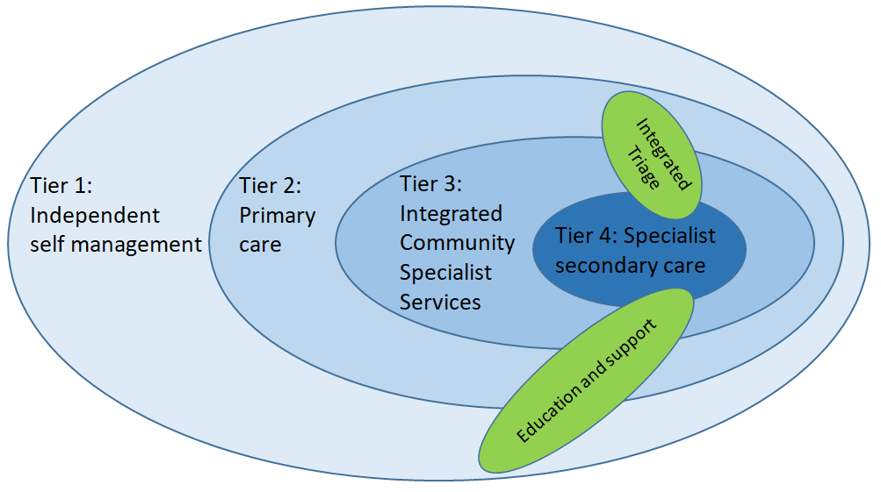
This has been translated into a new pathway for Urology, as described below:-
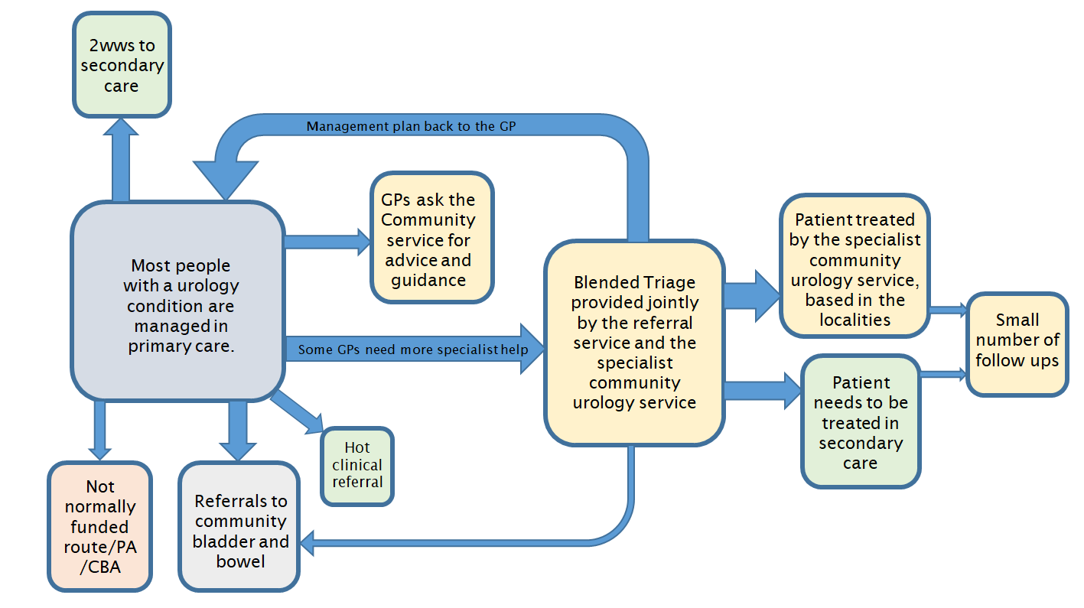

The key elements of the new model are:-

- All 2ww referrals are excluded from the service as they all go to secondary care
- The model anticipates 10% of referrals to be dealt with via advice and guidance
- All non 2ww urology referrals will be clinically triaged jointly by the Referral Service and the specialist community urology service
- The model anticipates 20% of referrals to be dealt with via a management plan back to the GP (based on the learning from the North Somerset commissioned Shire Health service, in which between 20 and 30% of referrals were managed in primary care with a management plan written by a urology expert from October 2015 to March 2019)
- The Community Urology Assessment and Treatment Service will work in an integrated and efficient way with secondary care urology services and the community bladder and bowel service (for example, the new service can take referrals directly from the Bladder and Bowel service without the need to go back to the GP and they will work towards being able to direct list patients for surgery in secondary care)
- The community service will be based in localities around a geographical population
- There will be a lead Urology expert from the community service for every locality and they will skill up the GPs, community staff and service users in that locality
- The model anticipates at least 5% of follow ups from secondary care to be provided by the community urology service
- The providers will implement value based healthcare by collecting patient reported outcomes and using them to ensure only high value activity takes place
- The providers will analyse the way in which the resources are allocated within the service and provide the service in a way which achieves the best results with the resources available.
- The providers will ensure there is movement of information rather than people

The following sections describe in detail how the service will be provided with the key partners:-

3.2.1 Integrated working with GP and Nurse referrers
- The service will provide advice and guidance for GPs in line with the BNSSG Advice and Guidance service agreement
- A Urology Consultant from the service will provide the clinical triage stage with the CCG Referral Service and together they will decide the onward management for all the GP referrals. By having both GP and Urology clinicians responsible for the clinical triage we will ensure the skills from both sets of clinicians inform the decisions made. The service will be expected to develop the skills of those working in the Referral Service and contribute to the information held on Remedy. IT and data sharing agreements will need to be in place to allow access to EMIS. The lessons learnt from the first plan, do, study, act (PDSA) cycle must be used to find the best way to facilitate this blended triage stage in the pathway
- The criteria to be used at triage will be negotiated with all urology service providers in BNSSG and published on Remedy so it is very clear to GPs what should be referred where
- Triage will ensure that the precise requirements for each patient are identified so that appropriate tests can be planned to ensure the smooth running of the future care and to minimise patient waiting time and facilitate the one stop model
- Where clinically appropriate, referrals will be returned to the GP following triage with a clear management plan which describes what should happen next and why, to allow the GP to manage the patient in primary care.
- The service will collate information on common themes/conditions that are appropriate for management in Primary Care based on the triage outcomes, and work with the CCG Referral Service to produce clear advice for GPs for inclusion in Remedy via Frequently Asked Questions
- Comprehensive typed discharge information and treatment plan will be sent to the patients GP and it should include the following items:-
  - Patient’s name, date of birth and NHS number
  - Reason for referral
  - Outcome report, treatment notes and visual observations
  - Recommendations for future management and information to convey to the patient at GP follow up
A template describing the content of the discharge letter will be agreed with GPs at the CCG to ensure it meets their needs.
3.2.2 Integrated working with GP Networks and Localities
- The service is expected to try and develop at least one Lead GP for Urology per locality. This could involve providing educational opportunities such as seminars, observing Consultants run clinics, providing telephone or email advice etc. The Lead GPs for Urology will be help design the primary care locality offer for urology. The service will develop the Lead GPs for Urology as a group across BNSSG.
- Each GP Locality will have a named Urology Consultant or a Specialist Nurse as their link into the Specialist Community Urology Service. That Consultant or Specialist Nurse will offer localities of GP practices a virtual clinic, preferably via webex, at least twice a year. This will be an educational opportunity to discuss the most common conditions referred to the Specialist Urology Community Service and a chance for GPs to ask questions. A recording of the webex will be made available on Remedy for others to listen to.
- The service to investigate being part of Project ECHO which supports hub-and-spoke knowledge-sharing networks, by using videoconferencing to conduct virtual clinics with community providers.
- The service will organise other educational events for the primary care networks and localities with a local focus and should bring all GPs together for an annual conference. These training opportunities should be open to staff working in the community bladder and bowel service. The content of the training to be based on the main areas that have come up in the referrals in the last year.

3.2.3 Integrated working with acute trusts
- Where clinically appropriate referrals will be directed to secondary care at triage. The service not the patients’ GP, will be responsible for ensuring this takes place. The CCG Referral service will ensure the patient is offered choice of all appropriate providers.
- The Community Urology Assessment and Treatment Service with the CCG Referral Service, is expected to agree onward referral pathways with other providers and design them in such a way as to prevent duplication so that patients do not experience delays or repeated assessment and investigations
- IT and data sharing agreements will be put in place for the direct care of patients between providers and to allow access to ICE, etc.
- Where clinically appropriate, in time, the provider will be able to direct list patients onto the list of patients requiring surgery at North Bristol Trust, Emersons Green Treatment Centre and Weston Area Health Trust rather than referring patients to an outpatient appointment. This is the vision, which the service will work towards once relationships and trust is established across the providers. The Clinicians working in the Community Urology Assessment and Treatment Service will need to have a good understanding of the urology pathways which will need to be agreed jointly
- Patients with a suspected cancer are specifically excluded from this service. However, there will be occasions when assessment and diagnostics reveal a high risk patient. The Community Urology Assessment and Treatment Service will need to use the pathway described in the CCG Access Policy to ensure this group of patients are seen urgently in secondary care. Secondary care must be made aware of the potential diagnosis and they should receive all relevant test results and imagining urgently
- The service should provide education and training for specialist junior posts. In addition there should be rotational posts that support the general education and training of both doctors and nurses.

3.2.4 Integrated working with the community services
- People with routine continence problems will be seen by the Community Bladder and Bowel service and people who are housebound will be seen by District Nursing teams.
- When appropriate, the Community Bladder and Bowel service will be able to refer straight to the blended triage provided by the Community Urology Assessment and Treatment Service and the CCG Referral Service without going back to the GP.
- The service will develop good working relationships with the community continence/bladder and bowel service and agree clear pathways between the services including training and development plans for the wider system, and development of opportunities to integrate e.g. rotational posts.
- The provider will need to work with the specialist community continence/bladder and bowel service to engage with and educate community nursing, GPs, care home staff and social care to promote continence and prevent deskilling.
- The provider needs to work closely with the community continence/bladder and bowel service to promote an integrated end to end pathway. Rotational or joint posts between the specialist community urology service and the community continence/bladder and bowel service may support this aim.
- The provider will make available rapid access to the advice and opinion of a urology specialist to the community continence/bladder and bowel service.
- The provider will work with the community continence/bladder and bowel service to develop the skills, confidence and capabilities of the wider health and care workforce with regards to the provision of high quality care and the prevention of incontinence.

3.2.5 Integrated working with service users
- The service will provide an assessment, diagnostic and treatment service for patients with routine and urgent non-cancerous urological conditions. The service will primarily be one stop. However, there may be some occasions when the service needs to see the patient again to complete the treatment. If a second appointment is required patients should be offered phone or email review as an alternative to a face to face appointment.
- At least 5% of follow up outpatient appointments currently provided in hospital should be provided by the specialist urology community based service. Where possible, these appointments should be provided using the agreed BNSSG remote monitoring platform rather than by face to face appointments.
- The service will provide clinics on a weekly basis from a minimum of five locations within the BNSSG area, linked to the six GP Localities. The service is to be provided in areas of high urological need, for example, in geographical areas where large numbers of Black and Minority Ethnic men live

- The service will prescribe medication where necessary, using the BNSSG formulary guidelines, rather than sending patients back to their GP for a prescription. They will prescribe using EMIS to cross check for interactions and will update the patients EMIS record. Further work will be required to explore the feasibility of this within clinic locations to ensure prescriptions from the Community Urology Assessment and Treatment Service are not confused with GP practice prescriptions
- Where possible, all tests (with the exception of CT or MRI) and a clinical diagnosis will be carried out in a single appointment. The provider will offer the following tests as part of the service, when clinically appropriate:
- Flexible cystoscopy
- Ultrasound scan
- Flow rate
- Urine analysis
- The service shall ensure written consent is provided for all flexible cystoscopy procedures carried out, in compliance with GMC or NMC standards
- Those referrals which are likely to require a CT or MRI scan will be sent to secondary care at clinical triage. However, there will be occasions when people being seen by the service will require a CT or MRI scan. In these cases, the service will ensure it can order CT and MRI scans via ICE and will be able to review the results and will be responsible for the patient’s ongoing care
- The service will explain to the patient in advance of the attendance date:
- What to expect during the appointment, including likely appointment length
- The purpose of any planned tests
- Who will perform the tests and where they will take place
- Any preparation required by the patient.
- The service will operate shared decision making with all service users, so the service user makes the decisions about their care
- The service will provide self-care information for patients, such as leaflets, webinars on pelvic floor exercises and bladder drills. They will make these resources available to practices to put on to their websites and direct patients to.
- The service will not be paid for appointments where the service user has failed to attend a booked appointment
- When appropriate, service users will be sign posted to VitaMinds - Bristol, North Somerset and South Gloucestershire (BNSSG), the local Improving Access to Psychological Treatment (IAPT) service to help deal with anxiety and depression
- The service to provide routine surveillance for service users at low risk and to be involved in agreeing the criteria for which service users can be seen in the community
- For those people having routine surveillance the service is to offer patients a patient portal to reduce the number of face to face appointments
- The service must collect patient reported outcome measures (PROMs) and use the data to find out what treatment is seen as low and high value by service users and stop or reduce the low value activity and increase the high value services provided.

3.3 Population covered

All patients over the age of 18 who are registered with a GP Practice in Bristol, North Somerset and South Gloucestershire who are not on a two week wait pathway.

3.4 Inclusion and exclusion criteria

3.4.1 Inclusion criteria
- Adults (over the age of 18), registered with a GP Practice in BNSSG
- The routine specialist urology services that can be provided by the Community Urology Assessment and Treatment Service are listed below. This list may change as in the future as treatments may change so they can be provided in a community setting:

  - Active surveillance after diagnosis of low risk (Gleason Grade group 1) prostate cancer
  - Flexible cystoscopy surveillance of low risk non-muscle invasive bladder cancer
  - Non-visible haematuria
  - Lower urinary tract symptoms (LUTS)
  - Recurrent UTI
  - Haemospermia (if under 55)
  - Management of scrotal lumps (non-cancer)
  - Testicular pain
  - Erectile dysfunction
  - External genitalia problems (non-operative)
  - Peyronie’s disease (non-operative)
  - Loin pain, possible Renal calculus (non-operative), monitoring of small non-obstructive stones in pelvis and ureter
  - Prostatitis
  - Urodynamics (although complex Urodynamics to stay at Southmead)
  - Uroflometry (Flow test)

Where access to treatment is restricted under the Intervention Not Normally Funded route (INNF), the Community Urology Assessment and Treatment Service must adhere to the policy restrictions in place at the time of referral and the diagnosing clinician is required to secure funding, before any treatment is carried out.
The Community Urology Assessment and Treatment Service will provide surveillance for low grade prostate cancer and check cystoscopy for low grade, low risk bladder cancer with an agreed and fast referral pathway back to secondary care if required. The service will enable more patient led monitoring using an agreed patient portal.
3.4.2 Exclusion criteria
The following patients are excluded from the service:-
- Patients requiring an appointment under the two week wait rules. All 2ww referrals will be dealt with by North Bristol Trust and Weston Area Health Trust
- Patients with routine continence problems, these patients should be seen by the Community Bladder and Bowel service (see the Community Service Specification)
- Patients requiring a general anaesthetic for flexi cystoscopy
- Patients unable to transfer themselves on and off a bed without assistance. Patients may use their own portable hoist if able to do so with assistance from their own carer
- Paediatric referrals (under 18 years of age)

3.5 Interdependence with other services/providers

The provider is required to work in an integrated way with specialist, community and primary care services. It is important that the Urology Specialists providing the service have good local knowledge and links to enable integration. This will also help mitigate the risk of the workforce becoming de-skilled by only doing routine specialist work and no two week wait work.

The provider will work with the CCG on future urology pathway development in conjunction with other urology service providers.
The provider will be required to work with other urology providers to ensure the movement of all the relevant clinical information between providers.

It is the responsibility of the providers to ensure that all appropriate details are communicated to the necessary recipients. Providers will be responsible for ensuring the accuracy of this information and any notifications.

Providers will market the service sufficiently in order to build awareness, ensuring that service availability, opening hours and waiting times are shared with GPs on a regular basis.

3.6 Reporting

The Provider shall ensure the following data is submitted electronically into Secondary Users Service (SUS) on a monthly basis. As a minimum the dataset shall include:
- GP Practice of Patient (national code)
- Source of Referral (GP practice/provider national code)
- Urgency
- Date of Referral Received
- Referral outcome: accepted / rejected / onward referral
- Reason for rejection
- Date Patient Seen
- Type of Procedure (OPCS code)
- Procedure operator: GPwSI / Consultant / Nurse
- Diagnosis (national code)
- Event outcome: cancellation / DNA / discharged / onward referral
- Reason for cancellation
- A summary of any complaints received or complications with the procedure
- Waiting times

The information must be provided in a well structure format either within a spreadsheet or a database. The software should be compatible with Microsoft Excel.
3.7 Business continuity
The provider will have a robust business continuity plan which will include:-
- Disruption to information systems
- Disruption to premises
- Flu pandemic or other disease outbreak causing significant staff shortages
- Major weather problems that prevent staff getting to work

3.8 Premises and equipment
The provider shall provide the following:
- A physical environment that respects the dignity and privacy of patients and their right to confidentiality
- Test and clinic rooms that meet access requirements under the Disability Discrimination Act
- Ensure sufficient appropriate clinical equipment is available to undertake investigations including ultrasound and flow rate monitoring
- Ensure such equipment is clinically fit for purpose and subject to appropriate regular maintenance and cleaning regime, in line with the manufacturer’s recommendations

4. Applicable Service Standards
4.1 Applicable national standards
The Provider is expected to fulfil all applicable local and national standards relating to the services they are providing including:
- Registration with Care Quality Commission
- National Institute for Health and Care Excellence (NICE)
- The service should take into account relevant guidance from Royal Colleges
- Health Act 2006
- Health and Social Care Act 2008
- Health and Social Care Act 2008: code of practice on the prevention and control of infections
- Any relevant National Service Frameworks
- Safeguarding Vulnerable People in the NHS – Accountability and Assurance NHS England 2015
- Mental Capacity Act 2005
- Prevent Duty 2015
- Modern Slavery Act 2015
- Care Act 2014
- Children Act 1989/2004
- Duty of Candour

4.2 Applicable local standards
See section 2.2 above.

4.3 Management and Leadership
There is a contractual requirement for the provider to satisfy the commissioner that they have an organisational structure that clearly identifies responsibilities and accountabilities in the following areas:

- Managerial leadership
- Professional leadership
- Clinical Leadership
- Clinical Governance
- Corporate Governance

The service should be provided in line with the values and patient and public rights as described in the NHS Constitution.
4.4 Clinical Governance
The Provider will have an established Clinical Governance programme which as a minimum covers the following:

- Patient, public and carer involvement
- Patient satisfaction
- Risk management, including incidents and complaints
- Staff management & performance, including recruitment workforce planning and appraisals
- Education, training and continuous professional development of staff
- Clinical effectiveness & audit
- Information Governance
- Communication both internal & external
- Compliance to safeguarding standards as per CQC standards
- Chaperone policy (including a process for providing chaperone training and support)

The provider shall appoint a senior clinician or another senior member of staff and a deputy who shall be responsible for ensuring clinical governance arrangements are in place and for monitoring the effectiveness of the clinical governance systems.

The provider will share key clinical governance information with Commissioners and the local acute trusts.

The Provider will act on any recommendation in any Care Quality Commission report that the Independent Regulator requires to be implemented or is otherwise agreed by the parties to be implemented. Results and recommendations from Care Quality Commission inspections will be built into a programme of continual improvement.

4.5 Information Governance
The Provider will identify an Information Governance lead and will comply with all relevant data protection legislation and national information governance and best practice standards including (but not limited to):

- Data Protection Act 2018
- General Data Protection Regulation 2016 (and subsequent UK legislation)
- NHS Security Management –NHS Code of Practice;
- NHS Confidentiality- NHS Code of Practice

The Provider must complete and provide evidence that they have completed all mandatory requirements of the latest relevant version of the Data Security and Protection Toolkit. Toolkit submissions must be made annually to maintain compliance.

The Provider will participate in additional Information Governance audits as agreed with the CCG.

4.6 Patient Satisfaction and Complaints
Patients must at all times be respected and treated in a kind and considerate way by staff who should at all times demonstrate a professional and patient friendly attitude.

Patient Satisfaction Survey results will be reported quarterly. A minimum of 90% of consenting patients using the service will be asked to take part; the sample should be drawn from patients who have used the service during the preceding 3-month period, with a minimum response rate target of 40%. Target of 90% of patients reporting a good level of overall satisfaction.
Patients will be asked to complete a Patient Reported Outcome Measurement (PROM) tool and the service will use the results to review all the procedures they provide to ensure only high value activity, as perceived by the patients, takes place.
The Provider shall operate a complaints procedure that is in line with existing NHS Complaints standards, and will promote this to patients, providing clear details of who to contact and how to escalate complaints to the commissioner if they do not feel that their concerns have been addressed.
The Provider will submit a monthly summary of complaints received to BNSSG CCG and keep appropriate records of all complaints (verbal or written), which shall be available for audit.
The Provider shall ensure that, as part of the admission process, patients are well informed about their condition and about what to expect from the service. They should be given both written and verbal information about any procedures and recovery process, including information on aftercare and how they can access other relevant services out-of-hours. This information should also be available on the internet.
Patients should be given information about all conditions and all procedures. Where possible, this should be diagrammatic and visual and include real patient stories. The Provider shall also ensure that the patient is given an opportunity to ask questions and receive reassurance as necessary.
The provider will have high quality conversations with patients and implement shared decision making.
Patients should be given as much information as possible to enable them to self-manage their condition
Patients will be offered a patient portal for routine surveillance to reduce the number of face to face appointments.
4.7 Subcontracting
Any sub-contracting arrangements must meet the requirements of the standard NHS contract as published by the Department of Health. The provider shall ensure that no parts of the services outlined in this specification are subcontracted to any other party without prior agreement and approval of the commissioner. The list of subcontractor/s must be kept up to date throughout the contract term.

4.8 Protection of Children and Vulnerable Adults at Risk of Harm
In line with contractual obligations, the provider will ensure that Making Safeguarding Personal is integral to the service delivery to ensure that adults at risk are protected and that their views are heard within the safeguarding process.
The Provider shall adhere to all guidance and legislation and have procedures in place to safeguard and promote the welfare and wellbeing of adults and children at risk. This will include reporting a concern about an adult or child to the local authority and to the police if there is an immediate concern about safety.
The provider will also ensure that all staff in contact with patients have been appropriately trained in local safeguarding procedures and regularly maintain these competencies.
4.9 Duty of Candour
The provider must be open and transparent with people who use the service and will inform people when things go wrong in line with Regulation 20 Health and Social Care Act 2008. Each failure to notify the Relevant Person of a suspected or actual Reportable Patient Safety Incident (as per guidance) to be reported as per Serious Incidence reporting.

4.10 Staffing and training
It is the responsibility of the provider to recruit suitable personnel and as such the provider will determine the exact person specification. The provider should ensure there is a good skill mix and make use of Urology Specialist Nurses and Physiotherapists where appropriate.
The following guidelines will apply to all staff groups including temporary staff e.g. NHS bank and agency:
- Staffing levels will be consistent with the relevant standards for best practice.
- Staff will have the appropriate clinical and managerial qualifications for their role.
- Staff will be qualified and registered (where appropriate) in accordance with their anticipated scope of professional responsibility.
- Professional accountability must be formulated within an agreed governance structure.
- Staff will have a commitment to continuing professional development through the pursuit of relevant professional and academic study.
- Staff will participate in regular personal performance reviews including the development of a personal development plan.
- Appropriate supervision arrangements for all levels of staff will be in place, including induction and clinical supervision.
- All staff will be required to attend relevant mandatory training.
- All staff will be required to satisfy appropriate Disclosure and Barring Service (DBS) checks.
- All staff shall be appropriately trained/ qualified and registered to undertake their roles and responsibilities.

As set out by the Care Quality Commission, registration documentation will be held on record by the Provider for all medical staff and will be available for inspection. A certificate of registration will be prominently displayed by the provider in all sites that the service is provided from.
Policies and protocols shall be available with a system in place to ensure staff compliance.
4.11 Other
The Provider will have a framework that assures patient and staff safety and is supported by a range of policies and strategies including as a minimum:
- Incident and Serious Incident Reporting including Never Events
- Risk Management
- Clinical Governance Strategy
- Information Governance Strategy
- Health and Safety Policy
- Chaperone Policy
- Policy for Safeguarding Adults & Children
- Emergency and Contingency Procedure policies
- Infection prevention and control policy, including decontamination
- Complaints policy
- Patient information and patient experience policy
- Management of medicines policy

5. Applicable quality requirements and CQUIN goals
  - Applicable quality requirements
The quality requirements of this services can be found in Schedule 4

  - Applicable CQUIN goals
Not applicable

6. Location of Provider Premises
The service shall be delivered from appropriate premises, which provide equity of access within the six localities listed below to deliver the principles of ‘care closer to home’ and closer working with the GP Localities, Primary Care Networks and the associated community services.

The BNSSG CCG GP Localities are:-
- South Gloucestershire
- Bristol North and West
- Bristol Inner City and East
- Bristol South
- Woodspring and the villages
- Weston and Worle

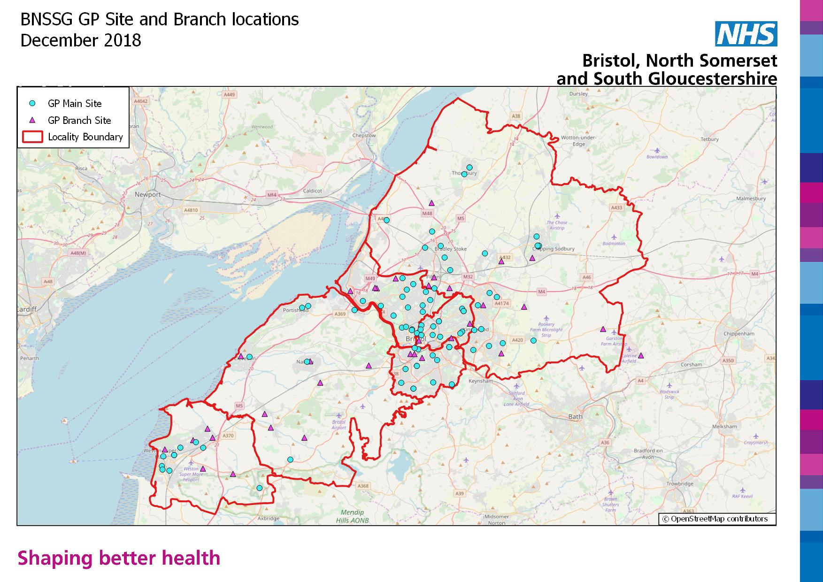

It will be the Provider’s responsibility to acquire suitable premises registered with the CQC and have suitable equipment. The premises will need to be agreed with the CCG and the provider should aim to utilise existing clinical space.

The properties must meet all criteria set out in national and local guidance including:
- To be fully accessible and compliant with the Disability Discrimination Act, 2005
- To have reasonable provision for patient parking on site
- To be accessible by public transport with journey times of no more than 45 mins for all patients covered by the service
- To have access to interpretation and translation services
- All premises and equipment to be used must be subject to proper maintenance, calibration and decontamination as appropriate
- Reception and waiting area with sufficient capacity to accommodate patients and any accompanying carers, as might reasonably be expected in line with provider appointment system
- Consultation room, suitable for the provision of minor surgical procedures and compliant with all national and local guidelines relating to infection control and patient privacy/dignity
- Adequate staff and patient toilet facilities

The Provider must have the following IT infrastructure:
- The provider must have web based access and provide their own IT equipment
- The provider must have access to secondary and primary care IT systems to enable integrated working

Version | Date | Reviewer | Comment
0.1 | 13th February 2019 | Elizabeth Williams | Initial draft
0.2 | 26th February 2019 | Elizabeth Williams | Amendments from David Bowen, Dan Maloney and Paulette Nuttall
0.3 | 1st March 2019 | Elizabeth Williams | Amendments from David Peel
0.4 | 27th March 2019 | Elizabeth Williams | Amendments to section 4.5 from Caroline Dominey-Strange
0.5 | 29th April 2019 | Elizabeth Williams | Amendments to KPI section and addition of Erectile dysfunction to Inclusion criteria
0.6 | 1st May 2019 | Elizabeth Williams | Inclusion of the need for compliance with the Accessible Information Standard from Neima Burns
0.7 | 10th May 2019 | Elizabeth Williams | Amendments to KPI section from Annie Kelly
0.8 | 13th May 2019 | Elizabeth Williams | Amendment from Lisa Collard to Inclusion criteria section
0.9 | 14th May 2019 | Elizabeth Williams | Amendments from Raj Persad to the inclusion criteria section
0.10 | 17th June 2019 | Elizabeth Williams | Amendments from Cecily Cook and feedback from CCG Commissioning Executive
0.11 | 15th August 2019 | Elizabeth Williams | Additions from the Value Based Healthcare Programme
0.12 | 1st November 2019 | Elizabeth Williams | Additions from Jen Tomkinson and Annie Kelly
0.13 | 12th November 2019 | Elizabeth Williams | Additions from Terri Agnew
0.14 | 13th November 2019 | Elizabeth Williams | Amendments from Jonathan Hayes and Julie Thallon
0.15 | 2nd March 2020 | Elizabeth Williams | Amendment to service description section post the Plan, Do, Study, Act session
0.16 | 29th October 2020 | Sue Firks | Updated for procurement paperwork

An evaluation of remote monitoring platforms has been conducted on behalf of the Somerset, Wiltshire, Avon and Gloucester Cancer Alliance and the preferred platform is ‘My Medical Record’.
www.dh.gov.uk/en/Publicationsandstatistics The NHS Constitution (Jan 2009)

