Royal Borough of Kensington and Chelsea

Net Carbon Zero Design, Specification and Technical Works Consultancy Services

Whitchurch and Blechynden House PHASE 1 and PHASE 2 future proofing and enabling works.

Client Specification

Appendix 1

Background information:
RBKC require a Net carbon zero feasibility study & recommendation, Developed design & Specification’s, Contract management & consultancy services for the communal or individual Electrical, Heating, and hot water systems on the below schemes with a view to propose feasible Net carbon zero options, design, develop the specifications and provide recommendations on the upgrade or replacement works including alternative means of delivery and the holistic approach to fabric upgrades alongside this. The specification and design will be utilized to procure installation contractors for the works.

Whitchurch and Blechynden House PHASE 1 and PHASE 2 Future proofing and Enabling works

- Feasibility & Recommendation
- Design & Specification’s
- Contract Management & Consultancy services

Overview

Building Description
The site comprises of two detached properties identified as:
- Whitchurch House
- Blechynden House
Both of which are located on Kingsdown Close, Kensington, London. W10.

Whitchurch House
Whitchurch House is an existing 3 story property providing sheltered accommodation, in the form of 42No self-contained apartments, with associated communal and support areas.

Blechynden House
Blechynden House is an existing 3 story property providing a combination of sheltered (3 ground floor apartments) and general accommodation (other floors), with a total of 11No self-contained apartments. (Blechynden has one leaseholder).

Heating and hot water services are served to both blocks via a shared heating and hot water central plantroom within Whitchurch House.

An assessment of the number of repairs and breakdowns initially determined that this site should be prioritised for upgrade. The existing plant and equipment are idle, whilst the buildings’ heating and hot water services are currently being provided via temporary plant gas boiler located outside Blechynden house. The plantroom has been flagged for full refurbishment/upgrade by the consultant (TBRE), please refer to feasibility study.

Brief

RBKC were ready to proceed with a design that had already been carried out, but due to our net carbon zero initiative and further investigation we had the option that Whitchurch and Blechynden could be connected onto the Lancaster West heating network, at some point in the future, under its phase 2 expansion(estimated 2025-2028).

Working with the Lancaster West team and TBRE, we have decided to move this site forward as a standalone system, but future proofed to allow future connection, to Heat Network when Phase 2 works are completed.

It is our plan to install a Bivalent system, incorporating gas boilers, ASHP’s and Solar technology with manufacturers confirmation that the boilers can be adapted and not fully replaced if the Hydrogen initiative was developed as such and were to go forward.

It is our assumption based on best intentions whilst surveying the buildings, that the pipework and radiators internally can be re-used with industry recognised vigorous flushing and cleaning and are sized as such that it can be re-used with the proposed high temperature bivalent boiler and ASHP system, with only minor alterations and installation of metering, control valves, TRVS, and timeclock controls to allow independent dwelling heat control, billing, and separation of communal areas. The specialist consultant is expected to survey the property and produce a design to show these alterations at strategic locations and produce and developed design in line with RBKC requirements.

Because of the nature of the property and the vulnerably residents within it, all design will need to be based around the reduction inconvenience, noise, and dust to the residents, with as minimal amount of disruption as possible, hence why we will try to keep the existing pipework and radiators.

The consultant will need investigate in depth the heating pipework and sizes, to include within their design what areas need to be modified to suit the new technologies and this should be demonstrated on drawings throughout the building on how this will be done, the specialist consultant will need to also highlight any radiators that are undersized and are to be replaced.

We plan to operate the system by using the ASHP’s as the main source of heating and only being topped up by the boilers, reducing carbon even further in warmer months, until such time the heat network is available.

A structural survey will be required up front to determine if the roof structure is indeed suitable for solar technology with calculations to support this and recommendations on structural works needed to allow this, along with budget costs.

Because of the phase 2 connection the specialist consultant shall ensure that all future proofing is allowed for within the design and shall RFI any information that is required upfront prior to their design initiation, so that all main plant, infrastructure, electrical equipment, and controls, have the capability of adopting connection to the Lancaster west heat network at the later date of installation. This shall include highlighting an area for the plate heat exchanger and allowing to execute all planning, architectural, structural, engineering and enabling works etc under phase 1, so that a design for phase 2 can be initiated upon completion of phase one.

Once connected the existing system shall operate as ASHP’s first, using the heat network as its secondary source and lastly the boilers, although the boilers may become redundant as we assume the ASHP’s and heat network would be sufficient for the duty required, they shall remain in place, given the nature of the property and its vulnerable residents on standby, as a backup in the event that either of the other heat sources fail, they shall be capable of automatic re-instatement by smart control. The design shall allow for this control, the engineering involved and a periodic cycle to satisfy water quality requirements.

Following the structural assessment and if it is deemed solar technology is actually feasible, the consultant shall present a site tailored study on the most suitable solar technology, although the current feasibility recommends Solar thermal, we are still unsure if an alternative solar technology would be more suitable and as such will require the awarded designer to present a more in depth study highlighting the pros and cons on each to assist in making an informed decision, on what shall be included within the design.

The study shall be in two parts, as mentioned above and include an in-depth site-specific risk examination, showing how Fire risks not only to the property but to fire fighters and the public will be reduced, this shall include site photos, risk assessments on each risk item and drawings to show how the risk will be reduced, whether that be wiring diagrams or evacuation procedure drawing etc. This is a key element for RBKC and future solar technology installation across the borough.

We have highlighted some of the key general risks from BRE investigations but expect the specialist consultant to cover all other tailored site-specific risks and anything not mentioned below.

- PV uses direct current and at elevated voltages and although certain parts can be isolated there will always be certain parts of the system live.
- Certain parts of the equipment don’t operate traditional by way of fuse blowing; therefore, faults are harder to detect and there is increased risk due to this of electrocution and fire
- AC isolator switch being used in place of DC isolators and being mistaken
- The use of faulty invertors and switches
- If the building supply failed the DC current would remain live to any part of the system that couldn’t be isolated, with the potential to cause electrocution
- If a fire burns of the DC cable insulation, there is increased risk of electrocution to fire fighters
- DC voltage arcs are difficult to extinguish
- Poorly installed panels may obstruct or restrict use of roof windows as means of escape.
- There may be presence of heavy metals or toxins within some specific types of PV cells, the risk is low so while such risks are low, caution is needed, as with any fire involving electronic elements, in dealing with fire damaged components.
- Increased surge into electricity grid with feedback systems, potentially overloading grid and triggering appliance fires
- Fire-fighters may not recognize a PV system, and few know what to expect
- Fire-fighters are not used to dealing with DC in buildings,
- Parts of the system are always live while light falls on the panels
- If the structure is metal, or steel frame, then an accidental short may result in parts of the building being “live”.
- Should the roof of the building be affected by fire, then the additional mechanical loading due to the weight of PV panels, or additional wind-loading caused by the panels, may cause early collapse of the roof.
- It is also possible that arrays which are stood off from the roof may cause a channeling effect, thus exacerbating a fire affecting the roof.
- There is the risk that panels, or glass from the panels, may break and fall onto personnel below.
- The panels can get hot (from the sun) with a (minor) risk of burns.

Pending the outcome of the structural, solar technology risk assessment study and programming of roof replacement, it may be that we cannot install this and that it does not need to be included within the design or that it does, and we may have to delay the solar technology installation and install under phase 2 or such time the roof is renewed.

If it is deemed feasible and low risk, then the consultant shall include this within their design and as such as an add on, so that any main plant, electrical, controls or infrastructure has the capabilities of adopting this technology later if required.

Please refer to RBKC update on fire policy regarding solar technology’s, the awarded designer will need to demonstrate in depth, whilst referring to the risks to fire fighters and fire safety in general and any study’s that have been carried out on this , how the risk will be reduced or mitigated- the tailored site study will need to be presented to RBKC’s head of fire for approval prior to any design being finalised and include risk assessments to demonstrate all risks involved and how they are to reduced.

The current scope of works as listed below is envisaged, but maybe subject to amendments identified from the design, planning process and fire regulations approval provided by the principal designer, design consultant or principal contractor.

- Full strip out.
- Asbestos removal
- Gas upgrades if applicable also removal of temporary gas pipework serving temporary boiler
- New hydrogen ready boilers.
- New Air source heat pumps.
- Roof renewal if required.
- New solar technology. (TBC on roof survey renewal/ fire department)
- Structural alterations.
- New tanking and plant room flooring.
- New mezzanine floor (within plant room) and external plant deck if there are spatial constraints.
- New water tanks, calorifiers, pumps, pipework, controls, and all other associated equipment.
- New plantroom electrical distribution.
- Distribution services alterations, metering, control valves, radiators and point of use controls upgrades so that all heating is separated communally and apartment by apartment.
- Mechanical ventilation to dwelling for overheating and air quality.
- UKPN power upgrades (if applicable)
- Upgrades to Plantroom lighting, including emergency lighting
- Modifications to fire alarm.
- Installation of fire doors and louvres.
- Full Decoration and making good.
- Phase 2 future enabling works.

The consultant’s scope of services will be as follows.

- Fire strategy Production for both building’s
- Structural assessments and developed design.
- Full developed Stage 3 Design, including planning and building regulations approval. (Note planning fee paid by RBKC)
- Power upgrade applications, design, and management.
- CDM management
- MEP stage 4, 5, 6 contractor design review
- Full Contract Administration
- Close out and handover
- 12 months defects

Description of works: (please note feasibility study already complete)
RBKC intend to utilize the consultant to carry out a Net carbon zero feasibility study and provide subsequent recommendation on upgrade works required.
The Consultant is encouraged to; “think outside the box”, be creative and innovative, whilst keeping in mind the commercial aspect that will be passed to leaseholders, whilst also taking bearing on RBKC’s sustainability Action plan.
Following review of the feasibility study report and the Consultant’s recommendation, RBKC will commission the Consultant to provide services to carry out further studies, a developed design, specification and full contract management and administration for the agreed scope of works.
The developed design and specification will be utilized to procure an installation contractor, with the design consultant assuming the function of main consultant, employer’s agent project manager and Principal Designer.

Description of the works for which the consultant is to be responsible:
- The consultant will be the Sole consultant and key contact, responsible for all aspects of the works
- The consultant will be required to act on behalf of the Client to prepare the design and specification and act as principal designer for CDM 2015.
- The consultant will be responsible for the MEP design, arranging any structural or architectural input required, throughout the course of the project, this will include and all calculations, planning/funding applications as such, as required.
- The consultant will provide overall project, financial and contract management for the project until completion and handover offering a “turnkey solution”.
- The consultant will be responsible for drafting letters to residents to allow adequate notice for design access.
- The consultant will be expected to attend all resident consultation meetings and production of presentations for this.
Part 1 – Feasibility Study and Recommendation (please note feasibility has already been carried out but the awarded consultant should allow to validate and include for anything that hasn’t been included within)
- Attend site and carry out full survey of the whole estate to determine stock condition and investigate the existing spatial surrounding’s throughout.
- Produce detailed report of all plant room areas, roof areas, basement areas communal areas, store areas, outside areas, apartments, or other areas where space could be utilized for the options put forward, Report to include surveys of each Architype apartment and measured if required to establish if recommended outcome is definitely feasible i.e., ceiling heights, riser locations, internal cupboards etc.
- Coupled with the above the Feasibility report shall also include recommendations on how to improve air quality, ventilation and prevent over heating at the property.
- It will make recommendation for upgrade of the MEP and Fabric to enable greater performance and cost/ energy efficiency and the to comply with the council’s net carbon zero initiative.
- It will also make recommendations on ways to offset any carbon at the property.
- Employ an electrical specialist to carry out load monitoring at the property to establish exactly what power is being consumed at the property(S), this will be 7 days for a small to medium property and 14 days for a medium to large property and include a brief on current supply, current rating of intake and equipment, to generate a section of the feasibility report to greater understand if a power upgrade will be required
- Employ an architectural condition specialist to identify age, condition of fabric and advise current u-values and improvements that can be made and u-values.
This shall include but is not limited to.
- Roof and loft space
- Windows
- Doors
- Walls internal and external
- Slabs and floors
- Attend resident’s consultation meeting to table feasibility to gain residents valued input to the proposed works.
- Discuss and agree scope of works with Client.
- Produce an overview on timescales.
- Consultation
- Design
- Section 20 process
- Tender
- Planning
- Install
- Commissioning
Although we encourage the awarded to submit their own Study and use their own forward thinking, The feasibility study layout and scope shall at least be as below scope but should also include any of the additional items that have been added into this tender or overlooked.
Title Page
Contents
Introduction
Description and photographic condition survey of Existing Installation.

Apartments

- How are they powered and what meters are present?
- How are they heated and how do they get their hot water?
- How is the heating and hot water controlled?
- What is the condition?
- What windows and doors do they have?
- What walls do they have?
- What insulation do they have?
- How are they ventilated?

Communal and Back of House areas
- As above
- Lofts
- Store cupboards
- Bin stores
- Garages
- Sheds
- What is situated where?
- What space is available?
- Any other areas not mentioned above?

Plantroom Areas

- As above
- Main energy center
- Pump rooms
- Tank rooms
- Electrical rooms and risers
- Electrical intake rooms
- All other plant areas not mentioned above

Existing Building Construction

- As above
- Roofs
- Walls
- Lofts
- Windows
- Doors
- Slabs/floors
- Surrounding land
- All other areas not mentioned above

External areas and areas for offsetting Carbon footprint

- Surrounding land; is the space to plant trees
- How does the building currently recycle its waste?
- Is there any scope for improvements or implementation of other ways to offset carbon?

Additional Surveys

- The property(s) shall be Electronically load monitored for a period of 7 days for small to medium sized property’s and 14 days for medium to large property’s, this is established if power upgrades will be required and if there possible before deciding on the design for the project.

What other surveys are required?

- Drilling for ground source heat pump
- Structural
- Roofs, windows, doors, walls etc.
- Thermal imaging
- GPR
- Any other survey not mentioned above

Alternative Technologies/Low Carbon Solutions – This shall include advantages and disadvantages

- Estate wide Heat Network’s
- Air Source Heat Pumps (Air to Water) (Individual)
- Community Systems ASHP Only
- Community Systems with Hybrid System ASHP and Gas Boilers
- Ambient Loop Community Heating Systems - ASHP & Water Source Heat Pump
- Ground Source Heat Pumps (Ground to Water) (Individual)
- Community Systems GSHP Only
- Community Systems with Hybrid System GSHP and Gas Boilers
- Hydrogen
- Apartment ventilation to improve better air quality and prevent overheating.
- Electric storage heaters and panel heaters.

Supporting Technologies

- Solar Photovoltaic
- Solar Thermal Hot Water
- Apartment ventilation to improve better air quality and prevent overheating.

Any other carbon saving technologies not mentioned above.

Funding

A brief write up on the Eligibility for funding on all aspects of this scheme, this would also include small items such as controls or loft insulation.

What funding is currently available, what are the deadlines?

Outline Scope and Recommendation

- Carry out initial SAP calcs for the property, if they are not already available within the “parity information” for each architype apartment, to establish the current billing estimate?
- What fabric improvements are required?
- What is the forecast SAP calc with the recommended best suited technology and fabric improvements for each architype apartment, to establish the billing forecast with improvements?

These shall be presented like the below graph with a brief write up for ease of understanding.

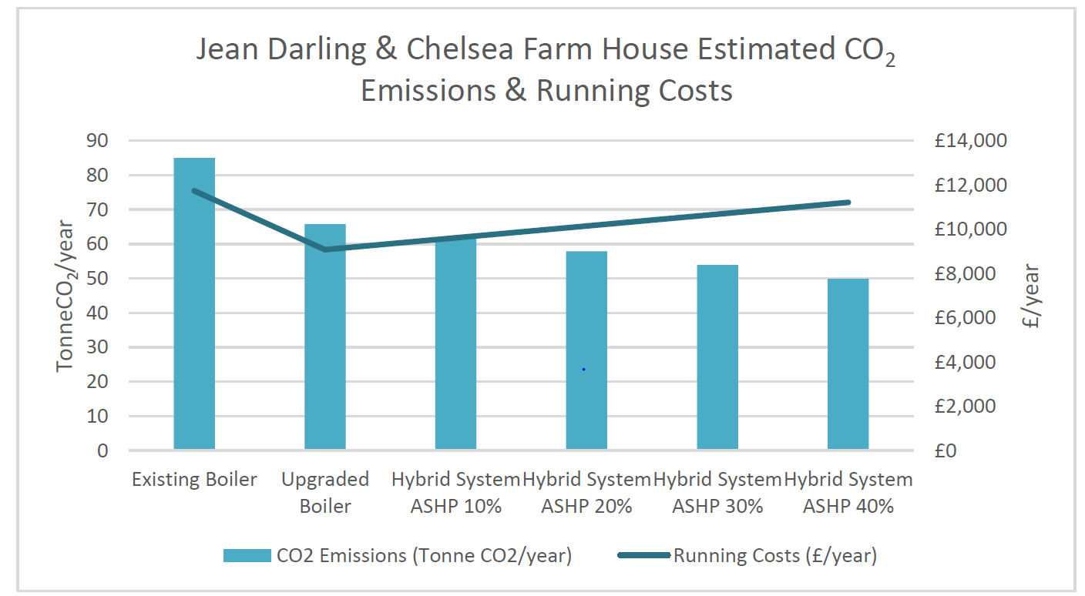

- Demonstrate Carbon output as existing and across all recommendations.

These shall be presented like the below graph with a brief write up for ease of understanding.
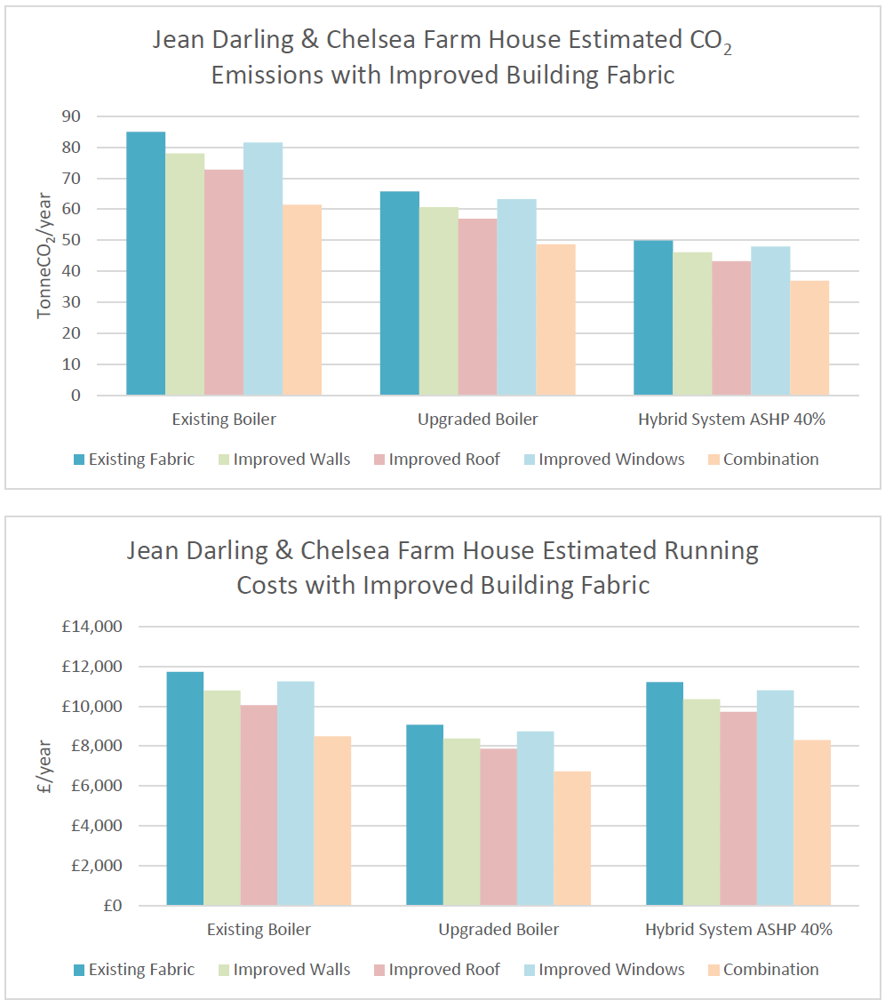

Part 2 – Design and Specification
- Attend pre-consultation and consultation resident meetings to notify what the councils’ intentions are and assist with responses to Section 20 observations.
- Appointment as Principal Designer, Sustainability champion, Architectural, Structural engineer, lead MEP and Fire consultant.
- Liaise with Manufacturer’s and specialists (as specified at time by Client) arrange onsite visit to discuss project requirements.
- Provide detailed developed specification and design; to include calculations, plant selection schedules, drawings including alteration, including schematics for full plant room and distribution renewal, enabling, planning or alterations required as mentioned above.
- Provide detailed design including schematic drawings for control and distribution or alterations of heat in Communal areas and dwellings beyond the plant room, such as air temp sensors, whether compensators, point of use thermo-static control, metering, control valves, point of use control and BMS.
- Provide review of heat control within a typical archetype dwelling’s, upgrades, or replacements to allow individual control of heat in each dwelling.
- Carrying over your own to “As built”, or the existing “Parity projects” energy and sap modelling and adjust to “As built”, for inputting back into the “parity projects” model or RBKC’S selected system.
- Review of the contractors final “as built” data and inputting back into the Parity projects model or RBKC’s selected system.
- Preparation of tender material and provide a pricing schedule to allow for tender evaluation.
- Assist in the tender evaluation to select a suitable contractor

Part 3 – Contract Management and consultancy services

Deliver project management and contract administration for full turnkey solution

- Pre-contract liaison and feasibility interrogation.
- Further survey management. Structural, architectural, asbestos etc.
- Production of a tailored Practical completion schedule.
- Resident liaison.
- Monthly project reports.
- Co-ordination of specialists, building control and professional team.
- Sustainability management.
- CDM co-ordination.
- Tender evaluation and recommendation report.
- Contractor management & Technical design review.
- On site WIP’s reports.
- Snagging and observation reports.
- Post work inspections and report.
- Sustainability handover.
- Practical completion signs off and report.
- O&M review.
- Final account evaluation and report.
- Handover to Client on completion.

“Teething issues” throughout 12-month defects and 12-month defects handover.

Its important to understand that some projects will need to be looked at holistically with other departments and therefore an Employers agent and Contract administrator may be appointed to oversee some of these elements and the consultant will be required to work as part of a team to deliver the initiative, therefore the scope of this section may be reduced, hence why it is broken down within the pricing schedule.

Part 4 – Schedule of appendixes

- Appendix A client specification.
- TBRE Net Carbon Zero Feasibility Study.
- Asbestos Surveys.
- FRA Strategy’s or any other fire information.
Existing information on schemes – please use this link for existing plans for buildings RBKC Planning Portal
- RBKC Sustainability action plan (for information)
- Parity projects SAP information
- RBKC pricing Schedule

