Specification

of requirements

GLA 82614 - Provision of the
Process Evaluation of Virtual Mentoring Academy Programme

Specification for Process Evaluation for Virtual Mentoring Academy Programme
Executive summary
Through the Mayor’s New Deal for Young People (NDYP) mission, we want to help transform the lives of young Londoners through mentoring. Our bold ambition is that 100,000 disadvantaged young people have access to a mentor by the end of 2024 and we believe that access to high quality, long term trusted relationships are vital to improve life chances.
Through NDYP we are committed to building the quantity, quality and sustainability of the mentoring and youth sector. We have already invested significantly in the sector and developed, in partnership with Action for Race Equality and Bloomberg, a Mentoring Quality Framework to give organisations a toolkit for development and to help ensure that practice is as effective as it can be.
Through NDYP we have funded over 100 mentoring organisations, each adopting different delivery modes and approaches, including a range of outcomes being measured and individual approaches to evaluation.
Building on this success, we are now looking towards the sustainability of the sector and in particular ensuring that the infrastructure that mentoring organisations need to thrive is in place at a local level. This will be tested through our Virtual Mentoring Academy Pilot (VMAP)
We are now seeking an organisation to support evaluation of VMAP, namely to:
- Evaluate effectiveness across the three VMAP delivery priorities,
  - Mentoring academy platform and training
  - System change at borough level and Increasing confidence and capacity of local mentoring sector
  - Attracting and retaining new volunteer mentors
- Consider potential scalability
- Review the process and implementation of the pilot and highlight key learnings and recommendations for sustainability

Background

NDYP ambition

The focus of the New Deal for Young People (NDYP) Mission is supporting young Londoners who are most disadvantaged. Young people, professionals, and a growing evidence base, all emphasise how important and influential a good quality mentor can be, and the difference they can make to a young person's life.

But approaches to mentoring can vary significantly across London and not all delivery is as high quality as it should be. Within NDYP, mentoring is defined as any high-quality youth activity that builds a trusted and positive relationship with a young person over time.

A good mentor uses that trust to motivate and equip a young person to change their lives, supporting the development of skills, coping strategies and confidence and the creation of social networks and opportunity. By focusing on mentoring for those most disadvantaged young Londoners, NDYP aims to grow and develop this important area of the youth and community sector and ensure that as many young people as possible can benefit from high quality mentoring support.

NDYP Delivery

The £34m NDYP mission commits to ensuring that 100,000 disadvantaged young people have access to a mentor and that all young Londoners have access to quality local youth activities. The mission aims to improve the life chances and opportunities by:

• enabling more disadvantaged young people to benefit from quality mentoring and youth activities
• improving the quality of mentoring by building capacity of the youth sector
• increasing strategic investment in London’s youth and mentoring activities
• empowering system change and sustainability within the youth sector.

To ensure capacity building of the youth sector, system change and sustainability consistent, we have developed the Mentoring Quality Framework, a self-assessment toolkit designed to support and improve mentoring practices. The use of this framework is a requirement for all organisations funded by NDYP, there is also a support package delivered by London youth and Lifeline that is aimed at enhancing the confidence and quality of mentoring programmes.

We are now looking towards the sustainability of the sector and in particular ensuring that the infrastructure that mentoring organisations need to thrive is in place at a local level. This will be tested through our Virtual Mentoring Academy Pilot (VMAP)
Rationale

Evidence gathered from sector consultation and academic research (including with young people) highlighted the following challenges that mentoring organisations are facing:
- Challenges identifying, attracting, and retaining high quality and diverse volunteer mentors
- Challenges deploying mentors where they can be most effective
- A need to increase awareness of mentoring opportunities and ensure local pathways to support for young people are clear and accessible

We know there is lots of brilliant mentoring practice being delivered across London and this infrastructure response aims to support this further, by addressing the challenges faced by mentoring organisations. The three key delivery priorities of the Virtual Mentoring Academy Pilot are shown below:

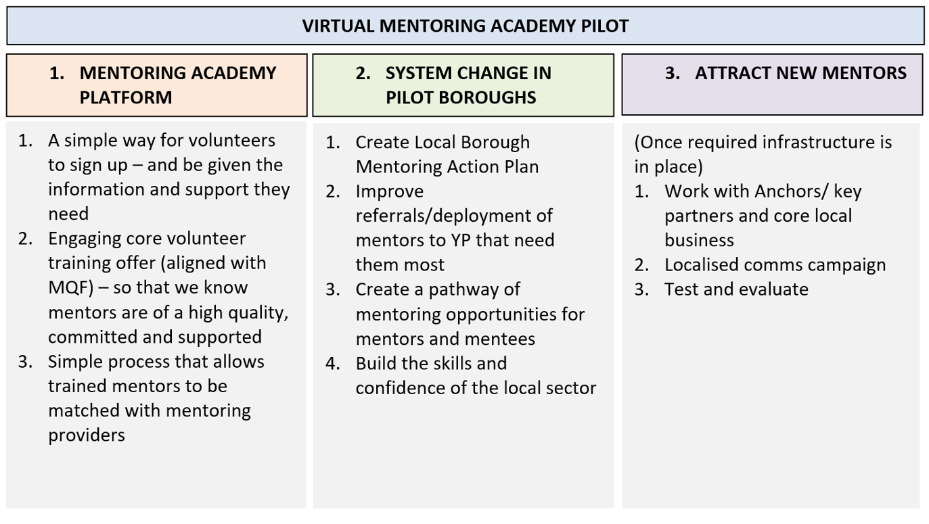
The Virtual Mentoring Academy will initially be targeted at 5 pilot London Boroughs. Through the three delivery priorities we expect to:
- Increase the quantity of volunteer mentors (delivery priority 1 and 3)
- Increase the quality, confidence and effectiveness of trained mentors (delivery priority 1)
- Strengthen local mentoring partnerships and increasing adoption of Mentoring Quality Framework (delivery priority 2)
- Improve referral routes into mentoring and access to young people (delivery priority 2)
- Increase perceptions of value of mentoring amongst young people and professionals (delivery priority 1,2,3)
- Improve pathways between mentoring offers for mentors and mentees (Delivery priority 1 and 2)

Outcomes

We expect to learn a lot through this pilot and hope that the Virtual Mentoring Academy Pilot will serve as a robust model and approach that demonstrates the value of high-quality mentoring at a local and regional level.
Evaluation objectives

Aim
The purpose of this evaluation is to:

1.Evaluate effectiveness across the three VMAP delivery priorities,
  - Mentoring academy platform and training
  - Improving referrals/deployment and pathways at borough level and Increasing confidence and capacity of local mentoring sector
  - Attracting and retaining new volunteer mentors
2.Consider potential scalability and value
3. Review the process and implementation of the pilot and highlight key learnings and recommendations for sustainability

Key Information
- A budget (across 2 years) of up to £75,000 is available for delivery of this evaluation
- A high degree of flexibility and agility will be required to respond and adapt to the local needs identified through the wider pilot.
- We are particularly interested in the voice of young people who have been supported through VMAP
- Contract is expected to be awarded by March/April 2024 and the contract will run from award for two years

Approach

The successful organisation will be required to evaluate the pilot programme over two years (from January 2024) and:
- Provide regular feedback on impact of the delivery priorities across the delivery period
- Help shape and engage with key partner workshops
- Produce interim and final evaluations to an agreed schedule

The evaluator will need to gain a good understanding of the various elements of the New Deal for Young People mission and the Virtual Mentoring Academy Pilot and the boroughs it is being delivered in.

The evaluation will require desk-based research and field work. The evaluators will need to engage with relevant partners such as GLA officers, local authorities, mentors, volunteers, charity partners, digital partners, training providers and young people through various methods.

You will be required to review available programme data across the three delivery priorities and will consider how it is progressing against its aims. A level of flexibility will be required due to elements of the programme still being developed and the successful organisation should be prepared to make recommendations to enhance the programme’s impact.

Monitoring and reporting data
To meet the objectives stated the data available will include:

- Research with mentoring providers & London councils
- Number of mentors trained
- Demographics of mentors trained
- Numbers of mentors placed with a delivery partner
- Budget spent against all delivery priorities
- Mentoring provision mapping
- Action plan and workshop insights from pilot boroughs
- Interviews/engagement with GLA’s NDYP team
- Interviews/engagement with NDYP funded organisations and staff
- Interviews/engagement with pilot boroughs
- Interviews/engagement with young people mentored
- Outcomes data for young people supported by NDYP mentors
- Outcomes data for quality of provision
- Recruitment metrics and campaign data

The VMAP digital platform and training programme will be in place from March 2024. It is essential that the evaluator works closely with the providers of these services over the life of this contract.

Outputs
The anticipated outputs for this evaluation are:

- Interim report x 2
- Final report (up to 20 pages) and summary
- Evaluation of mentor training content, mentoring platform and borough approaches and recommendations for improvement
- Evaluation of Mentoring Quality Framework and recommendations for improvement
- Recommendations on scalability of mentoring academy pilot including economic benefit
- Lessons learned about process and implementation of pilot
- Sharable presentation of topline findings
- Sharable evidence to influence further funding and evaluation
- Case studies from interviews with key stakeholders and young people

Timescales for outputs
Mentor quality framework review by September 24
Interim reports due in September 24, March 25
Final report March 26
All other outputs due by December 25

