

Resource Management System Requirements
Covering:
Rostering
Time and Attendance

September 2017

Contents – TO BE UPDATED
Introduction 4
Background 4
Glossary of Terms 5
Statement of Works 6
Timeline for implementation and go live of new system 8
1.0 Technical Requirements 9
2.0 Server Environments 10
3.0 Security 11
4.0 Integration 13
5.0 Integration from other systems TO Resource Management System 14
6.0 Integration from Resource Management System TO other systems 17
7.0 Application Requirements 19
8.0 Roles/Skills and Grades 21
9.0 Shift Patterns 22
10.0 Employee Access to View/ Request 24
11.0 Manager Access to View/ Authorise 26
12.0 Optimum Crewing Levels 27
13.0 Absences 29
14.0 On Call Attendance 31
15.0 Allocating Own Shifts 32
16.0 Additional Shifts 35
17.0 Overtime, Payments and Allowances 37
Non Uniformed Employees 39
18.0 Flexitime 39
19.0 Restricted Duties – All Employees 42
20.0 Working Time Directive 43
21.0 Reporting and Auditing Requirements 44
22.0 Exceptions/Notifications 46
23.0 System Administration 47
24.0 Training 49
25.0 Users of the System 50
26.0 Customer Service/After Sales 51
KPI’s 52
27.0 Application Performance 52
28.0 Service Performance 53
29.0 Performance Management Targets 54
Appendices 56
Appendix 1 - Types of Shifts 56
Operational Shifts 56
Appendix 2 - Types of Non Uniformed Shifts 57
Examples of Flexitime shift patterns: 57
Appendix 3 - Allocating own Shifts and OCL 58
Non uniformed employee attendance screen 60
Appendix 4 – Absence Booking Examples (Full Days) 61
Appendix 5 – Absence Bookings Examples (Part Day/Shift) 61
Appendix 6 – Groups Examples (currently in use) 61
Appendix 7 – Roles (currently in use) 61
Appendix 8 – Skills (examples) 62
Appendix 9 – Overtime and Allowances 62
Non Uniformed Employee Overtime, Allowances and Payments (Examples): 62
Uniformed Employee Overtime, Allowances and Payments (Examples): 62
Appendix 10 – Balances (examples) 63
Appendix 11 – Security Groups (examples) 63
Appendix 12- Unpaid Absence Bookings (examples) 63

Introduction

Background
Buckinghamshire & Milton Keynes Fire Authority (BMKFA) use a rostering system for operational employees. As part of the ongoing government austerity plan it is necessary for the fire service to deliver efficiencies through the use of more flexible staffing models.
The current rostering system has limitations that prevent us moving forward as flexibly as we require so Buckinghamshire Fire and Rescue Service is now looking to replace this system.
A significant change to the way in which we are delivering our service is that we never plan to have more employees rostered on duty than are needed to crew all of our fire appliances. This is known as our Optimum Crewing Level (OCL). Other fire and rescue services (FRS) may term this as minimum crewing.
Our managers are expected to plan leave, training and other absences to achieve their OCL at all times. When unplanned sickness or other absences occur we will communicate the opportunity for off duty employees to undertake additional shifts. These additional shifts will be used to provide resilience to our operational delivery. The ability to communicate OCL shortfalls and additional shift opportunities, to our workforce, will form a key component in the IT solution we are seeking.
In addition to working the traditional 2-2-4 shift pattern, the Resource Management system should allow employees the flexibility to ‘self-manage’ their roster commitments, by allowing them to ‘advertise’ or exchange rostered shifts, with other employees.
More details can be provided to understand OCL, however, features that specifically help to streamline this area are of paramount importance to BMKFA.
The purpose of this document is to provide the necessary detail so a Resource Management system can be procured. Any new system will need to demonstrate that all existing shifts can be managed, and also show flexibility. It will be accessed via mobile devices, and have design flexibility around any future requirements inc. Technology proofing
It should be noted that BMKFA use the information held in the Resource Management system to make decisions about the provision of emergency services and as such this information needs to be securely accessible to other downstream systems.
More details on the specific details in each area will be provided in this document.

Glossary of Terms

Acting Up | Uniformed employee Acts Up to a higher role
Additional Shifts | These shifts are used to cover shortfalls in OCL
Allocating Own Shifts | Employees are responsible for working a number of shifts a year and have either no fixed pattern or a basic base shift pattern. Allocating own Shifts will allow employees to see the number of shifts they have worked and the shifts they owe, where the shifts are required and allow them to add days they are available to work.
Business Support Vehicle (BSV) | BSV is a response vehicle which located at a fire station and staffed by a non – operational uniformed employee
Callout | Employees (both uniformed and non uniformed) are available to be  called out outside of their normal working hours and receive a payment
Detachments | When employees are moved temporarily to another location.
FDS | Flexible Duty System - Officers who follow and provide a flexible duty rota system
Fire Control | Employees that take emergency calls and mobilise fire appliances and other resources to an incident
Flexible Firefighter | Full time operational staff that do not have a fixed working pattern or location
Non Uniformed | Office based non uniformed employees that provide support services such as ICT, HR, Finance
On Call | Operational employees that carry and pager and respond to incidents when needed. (Also known as Retained Duty system)
Operational Staff | Emergency operational employees that ride fire appliances and other operational resources
Optimum Crewing Level (OCL) | The required number of employees riding each fire appliance across the Service, this is also called the Global Figure
Restricted Duties | When an employee is unable to perform their full range of duties.
Shift Colours | Wholetime operational employees that are attached to a Wholetime station are currently on one of 4 watches which follow a days and nights pattern
Standby | When a uniformed employee is sent to another location to work to cover a staffing deficiency (see appendix 9)
USAR | Urban Search and Rescue - operational employees who are station based and provide specialist operational responses
Vision | Command and Control system in Fire Control to mobilise appliances/officers. The resource management system feeds Vision

Statement of Works
Provide a tender proposal to complete the following:
- Provision of a flexible Resource Management System
- Assist/complete migration of relevant data into new Resource Management system
- Create / provide incoming and outgoing interfaces as listed
- Configuration of current shift patterns/other functionality required to use the product
- Any training required
- Any ongoing costs
Where anything in this document requires customisations in your application this should be identified so a cost benefit analysis can be completed.

Tender Weightings
Contained within the ITT document.
Evaluation Questions
Contained within the ITT document.

Timeline for implementation and go live of new system
Please note the below dates could be subject to change.
Date | Activity
4th September 2017 | Tender Advertised
4th October 2017 | Receipt of Final Bids Deadline
5th & 6th October 2017 | Evaluations of Bids
11th & 13th October 2017 | Supplier Presentations
By end of October 2017 | Provisional Contract Award
Estimated December 2017 – May 2018 | Implementation/Configuration
Estimated June 2018 | User Testing
Estimated June 2018– July 2018 | Training for super user/system administration
Estimated June/July 2018 | User Testing
Estimated July-Sept 2018 | Training
Estimated Oct 2018 | Go Live Date

Technical Requirements
Item No. | General System Technical Requirements | Grade | Available Now | Available in 12 months | Available in 24 months | Not available | Details on how the system meets this requirement
1.1 | BMKFA are currently reviewing cloud-based offerings – and are keen to move to this whenever possible.  In general, products offering modern APIs and with cloud technology would be more aligned to our current direction. | I
1.2 | The system will be delivered via an Internet Explorer and mobile friendly | Major
1.3 | The system should not use Window specific technologies such as desktop .exe/DLL and Internet Explorer only technology (ActiveX and similar) | Major
1.4 | The system should integrate with standard Microsoft Office products (e.g. Exchange, excel) | Minor
1.5 | Authentication via Microsoft Active Directory | Major
1.6 | Authentication possible via OAUTH- Microsoft Active Directory Federation Services | Minor
1.7 | The system should work on a range of resolutions and screen sizes and all functionality should remain available (responsive) | Major
1.8 | Any mobile device specific applications will be freely available from associated app stores and will be regularly and automatically updated as required | Major
1.9 | Where mobile applications exist this should sit on both Apple and Android platforms | Major
1.10 | All information in the system needs to be available and up to date in real time | Major
1.11 | Any calculations required by the system will run automatically or on demand as required | Major
1.12 | The application should maintain the data integrity of the data entered | Major

2.0 Server Environments
Item No. | Server Environments Requirements | Grade | Available Now | Available in 12 months | Available in 24 months | Not available | Details on how the system meets this requirement
2.1 | BMKFA require 2 environments  - Live (Production)  - Training | Major
2.2 | The training environment would be expected to be periodically refreshed from the live environment | Major
2.3 | The training environment would be expected to be refreshed periodically and anonymised every quarter or whenever a significant change is planned or made. | Minor
2.4 | Live Server uptime will be 99.9% and access to services will be required 24/7 | Major
2.5 | Downtime for upgrades would need to be communicated in advance and would be short | Major

Security
Item No. | Security Requirements | Grade | Available Now | Available in 12 months | Available in 24 months | Not available | Details on how the system meets this requirement
3.1 | All data should be secure (definition of secure according to CESG recommendations which can be located at the following link: https://www.cesg.gov.uk/guidance/end-user-devices-security-principles) and the application should only show information to people that are granted access to see it | Major
3.2 | User accounts should be able to be automatically locked out/disabled after a set amount of tries, and can only be reset by the system administrator | Major
3.3 | Users should be able to reset passwords themselves | Major
3.4 | All communication between the client and server will be secure | Major
3.5 | The system will enforce a password policy | Major
3.6 | If possible, Single Sign On is desired by BMKFA | Major
3.7 | If the solution is cloud based then adequate steps need to be taken to ensure that data is secure while on any server but also in transit across the internet | Major
3.8 | Application account creation and maintenance is expected to be a systems administration function that can be completed by BMKFA | Major
3.9 | Multiple attempts to access an account should result in the account becoming locked | Minor
3.10 | System to have the ability for security profiles and responsibilities to be created, assigned, updated and ended.  - Employee Access  - Manager Access  - System Administrator Access  Specific Access – View only, Payroll access | Major

4.0 Integration
Item No. | Integration Requirements | Grade | Available Now | Available in 12 months | Available in 24 months | Not available | Details on how the system meets this requirement
4.1 | Access to information and a reduced administration are key elements of the current time and attendance system. This would need to continue in any system selected. | I
4.2 | Currently integration is by a mix of access to database views, publically callable APIs and CSV files. BMKFA are open to using the most appropriate technology as long as the integration goals are met. | I
4.3 | Any available interfaces that allow integration with command and control system (Vision), payroll and HR (MHR - iTrent) systems should be identified and the functionality explained | Major
4.4 | Where possible the system will allow for ‘REST’ based API’s | Minor

5.0 Integration from other systems TO Resource Management System
Item No. | Requirements BMKFA that are required to be interfaced with the Resource Management System | Grade | Available Now | Available in 12 months | Available in 24 months | Not available | Details on how the system meets this requirement
5.1 | Employee Information  New and updated employee details will need to be fed from HR system into the time and attendance/rostering system and the updates should occur automatically.  Covering at least the following:  - Name (First/Last/Middle/Preferred)  - Employee Number  - Title  - Home/Duty address  - Contact No’s  Employee access must automatically be defaulted to the most appropriate level and user accounts should be auto created keeping administration in this area very low this would be created by the type of employee i.e. operational/non-operational. New user accounts should adhere to the password policy set on the system. | Major
5.2 | When an employee is terminated on HR system, again the systems should interface and terminate the employee on the time and attendance/rostering system | Major
5.3 | When an employee changes a role or leaves one role is entered into HR system, the system should interface with the time and attendance/rostering system and the new employee details should populate onto the time and attendance/rostering system | Major
5.4 | Employees can have more than one role  Current max is 5 roles with different Terms and Conditions | I
5.5 | Role Information  New and updated employee job details will need to be fed from HR system into the time and attendance/rostering system and the updates should occur automatically.  Covering at least the following:  - Name (First/Last/Middle/Preferred)  - Employee Number  - Position Number  - Position title  - Effective start/End Date  - Grade  - Job Type  - Working hours/frequency/Shift pattern  - Reporting to (parent position)  - Probation Details (Dates/Stages)  - Holiday Entitlement  - Other Role Flags | Major
5.6 | Employee Skills  New and updated skills should be automatically added and updated from a HR management system including key roster skills such as Firefighter, BA, TTL etc. | Major
5.7 | Actual Clocking  A number of employees clock in and out of work. Currently these are captured manually. These values are then read and sent to the time and attendance system periodically, this will need to continue with the new system. If an employee fails to clock they will then be required to enter missing clockings via an employee self-service access | Major
5.8 | Absence Bookings  Absence will need to be feed from the HR/Payroll system to the time and attendance/rostering system and the updates should occur automatically  Covering at least the following:  - Position Number  - Position title  - Start date  - End date  - No of days sick  - Type of absence  - Reason for absence | Major

6.0 Integration from Resource Management System TO other systems
Item No. | Requirements from the Resource Management System that are required to be interfaced with any BMKFA systems | Grade | Available Now | Available in 12 months | Available in 24 months | Not available | Details on how the system meets this requirement
6.1 | Vision  A real-time link to the mobilising system Capita Vision detailing what appliances are available  This is a fundamental link that will allow are control staff to be able to allocate appliances to incidents | Major
6.2 | Payroll file  - All enhancements to pay: acting up, overtime, standby etc. should be able to be extracted into a CSV export that lists the employee, cost centre, number of hours and a pay code.  - File should be regenerated as required  - If elements are output and subsequently removed or changed then negative/corrective values are output to correct the payroll system  - The payroll file also includes deductions for unpaid absences such as unpaid leave | Major
6.3 | Absence Bookings  Absence will need to be fed from and to the HR/Payroll system and the time and attendance/rostering system and the updates should occur automatically  Covering at least the following:  - Position Number  - Position title  - Start date  - End date  - No of days sick  - Type of absence  - Reason for absence  Should be able to be extracted into a CSV export that lists the employee, cost centre, number of hours and a pay code.  File should be regenerated as required | Major

7.0 Application Requirements
Item No. | General Application Requirements | Grade | Available Now | Available in 12 months | Available in 24 months | Not available | Details on how the system meets this requirement
7.1 | Every employee either has a normal predicted roster or allocates own shift system. There are approximately 600 employees. Of these 450 are Uniformed (both operational and non-operational), and 150 non uniformed employees | I
7.2 | System must allow for all employees, uniformed and non uniformed to have a shift pattern assigned to each role they have, or have the ability to allocate own shifts. Be able to manage their time, leave, balances, flexitime and overtime | Major
7.3 | System must be flexible to allow for potential changes to business needs.  - This may involve creation of new pattern of work, new rules that will allow managers to make decisions to a greater or lesser extent, even more flexibility with working patterns, For example, people can work for a specific incident only, more flexible communication methods or channels | Major
7.4 | System should have the ability to be locked (either weekly/monthly); this locking process will not permit any changes to any historical data by the users (except sys admin/super user). Pay periods will be locked weekly. | Major
7.5 | Security profiles to be set, to enable different views/access | Major
7.6 | Ability to create recurring rules and actions that happen when conditions are met:  - Rolling year  - Every 4 weeks  - Daily / Weekly  - 1st April  - After 5 years’ service | Major
7.7 | Allow the application of break rules when people work over a certain number of hours or don’t clock required breaks | Major

8.0 Roles/Skills and Grades
Item No. | Roles/Skills and Grades requirements | Grade | Available Now | Available in 12 months | Available in 24 months | Not available | Details on how the system meets this requirement
8.1 | To be able to view/edit/delete (end) roles/ grade/skills on the system. | Major
8.2 | When updating role/grade/ skill this will then ensure correct payments are processed if they are attached to a specific role/grade/skill (for example overtime rules) | Major
8.3 | Should be able to view employees by role/ grade/skill | Major
8.4 | OCL numbers of roles/grades should be able to be set for a location to quickly identify shortfalls of roles/ grades/skills | Major

9.0 Shift Patterns
Item No. | Shift Patterns requirements | Grade | Available Now | Available in 12 months | Available in 24 months | Not available | Details on how the system meets this requirement
9.1 | Each shift should be identifiable/code /colour/title  (see appendix 1) | Major
9.2 | Each shift would have an attached cost centre code that feeds into the payroll system | Major
9.3 | Assumed clockings (automatic)  - Assumed clockings are used currently for uniformed and non uniformed employees. | Major
9.4 | All shifts and rosters will require the correct rules (i.e. 11 hour break between shifts) | Major
9.5 | All shifts and rosters will be able to record absences, authorisations, overtime and allowances | Major
9.6 | Shift Pattern Assignment  - The ability to attach employees to shift patterns  - The ability to attach employees to multiple shift patterns  The ability to swap/change employees between shift patterns (including allocating own shifts) | Major
9.7 | Group Assignments  The ability to attach employees to 1 or more groups for a given or open ended timescale for e.g. location/station/section, grade and type of employee | Major
9.8 | Ability to create different shift patterns | Major
9.9 | Ability to have role that is zero hours for casual roles Eg Firesetters | Major
9.10 | Ability to flag the different types of officers for each shift eg NILO officer/Duty Group | Major

10.0 Employee Access to View/ Request
Item No. | Employee Access requirements | Grade | Available Now | Available in 12 months | Available in 24 months | Not available | Details on how the system meets this requirement
10.1 | All employees will require employee self-service access. Views and requests will depend of the role of the employee i.e. Non uniformed/Uniformed (operational and non-operational) employees | Major
10.2 | All employees need to be able to view basic employee details such as name, employee number, location, shift and skills | Major
10.3 | All employees need to be able to view/request and cancel absences | Major
10.4 | Employees need to be able to allocate/cancel own shifts | Major
10.5 | Employees need to be able to view how many people are rostered to work (real time) on a simple to view dashboard | Major
10.6 | All employees need to be able to view absence approvals and reasons for deferring/rejecting | Major
10.7 | View balances and entitlements (Annual leave, Public leave, Time off in lieu, overtime and flex balances for Non uniformed employees) future and past (balances as at date and balance that includes future bookings) | Major
10.8 | View shifts rostered to work (past, present and future) | Major
10.9 | View number of shifts worked (uniformed) | Major
10.10 | View hours worked | Major
10.11 | View skills/roles | Major
10.12 | View dependant on type of employee, for example:  - Operational  - Support | Major
10.13 | System admin to be able to create/edit/delete (end) the access to the screens | Major
10.14 | Access set up for employee to be defined depending on role | Major
10.15 | Ability to clock in and out multiple times during the day using the application | Major
10.16 | Allow employees to update and correct their own clocking information while retaining full auditing information (in the form of a timesheet facility) | Major
10.17 | Only show bookings that the group of employees can request. Non uniformed and uniformed employees have a slight variation on the absence bookings they can request. | Major
10.18 | Outlook integration for booking events | Minor
10.19 | System to clearly identify how clocking events were created, for example swipe, web, application, ‘timesheet’. . | Major
10.20 | System have the ability to enable geo-tagging | Minor
10.21 | Ability for staff to be able to enter rest periods or system to calculate them when system logic can be applied | Major

11.0 Manager Access to View/ Authorise
Item No. | Manager Access requirements | Grade | Available Now | Available in 12 months | Available in 24 months | Not available | Details on how the system meets this requirement
11.1 | Dashboard view that shows all stations OCL, (both projected and actual rostered shifts including skills (e.g. driver), to enable officers to see which locations are above below the Optimum Crewing Levels (OCL) to enable them to determine where an appropriate replacement can be obtained from (e.g. Standby’s) – Containing real-time info | Major
11.2 | Managers will need to be able to see employees time and attendance/rostering details i.e. absences, shifts, number of shifts worked, rest breaks and payments (overtime and allowances) and balances etc. | Major
11.3 | Managers will need to have the ability to book/edit absences directly into the system | Major
11.4 | Managers will need to be able to override/change any rostered shift | Major
11.5 | Managers will need to be able to approve/authorise overtime as payments/toil and allowances | Major
11.6 | The ability to view team wide absence to assist leave applications (managers can access a team wide calendar view) | Major

12.0 Optimum Crewing Levels
Item No. | Optimum Crewing Levels requirements | Grade | Available Now | Available in 12 months | Available in 24 months | Not available | Details on how the system meets this requirement
12.1 | Manager responsible for monitoring OCL, the system to provide a display which will easily show what the staffing levels are, if they are above/ below staffing requirement (OCL) over a variety of timescales (see appendix 3) | Major
12.2 | Staffing figures need to be displayed broken down to role/grade/skill eg number of junior officers/Emergency Fire appliance drivers | Major
12.3 | Require alerts/notifications when changes to levels | Major
12.4 | Report on OCL – to identify dates when OCL is below, system to identify suitable cover either manually or automatically and send request notifications to the RMT | Major
12.5 | BMKFA can easily check availability, once shift selected immediate updating of the OCL figures | Major
12.6 | BMKFA be able to set/change the min and max staffing level rules | Major
12.7 | Have the ability to view information for a specific location or overview of all locations (see appendix 3) | Major
12.8 | Currently BMKFA are using staffing spreadsheets to allocate shifts and manage OCL (see appendix 3) | I
12.9 | System to suggest/calculate the best roster option based on available shifts and the skill sets of the people available | Major

13.0 Absences
Item No. | Absence requirements | Grade | Available Now | Available in 12 months | Available in 24 months | Not available | Details on how system meets this requirement
13.1 | Absences need to be able to be requested by employee and approved, rejected or referred by the relevant manager | Major
13.2 | Need to be able to have full and part shift absences which will require authorisation by either manager or super user (for example sick during shift / medical screening) (see appendix 4 & 5) | Major
13.3 | Absences need to be able to be booked, deleted or edited directly into the system by manager or super user, by-passing the requests process | Major
13.4 | Full list of absences will be supplied at implementations (see appendix 4 ) | I
13.5 | System needs to be able to make a distinction between duty and rota days (used for sickness absence calculations and reporting) | Major
13.6 | Some absences will require authorisation others will not | Major
13.7 | Some absences will need to feed through to the payroll as a deduction of pay (see appendix 12) | Major
13.8 | Manager should receive a notification when absence is requested | Major
13.9 | Absence requests need to be date and timed stamped, this should be visible to managers | Major
13.10 | Every employee has a designated allowance of annual leave, (annual leave balances)BMKFA need to be able to allocate/change leave entitlements depending on role /grade and length of service | Major
13.11 | The system will maintain the annual leave entitlements and will calculate pro rata/ outstanding balances. The system will not permit anyone to take more annual leave than their entitlement | Major
13.12 | We currently have 2 leave year periods  - leave year runs April to March  - Runs January to December | I
13.13 | High level absences such as sickness, on/off duty injury will need to feed into downstream systems for absence management processes. | Major
13.14 | System should enforce rules and prevent requests outside of the rules, for example requesting leave if this takes balances below the number the individual has, or taking more than the allowed number of flexi days in a set period or takes number below agreed OCL | Major

14.0 On Call Attendance
Item No. | On Call Attendance requirements | Grade | Available Now | Available in 12 months | Available in 24 months | Not available | Details on how system meets this requirement
14.1 | Ability to capture the hours worked by on call staff Eg incident, staff that attended, number of hours | Major
14.2 | Be able to create a file for passing to the Payroll with relevant details | Major

15.0 Allocating Own Shifts
Item No. | Allocating Own Shifts requirements | Grade | Available Now | Available in 12 months | Available in 24 months | Not available | Details on how system meets this requirement
15.1 | The system must have the ability for operational employees (including FDS Officers) to Allocate their own shifts.  Selecting shifts from types of shifts available (see appendix 1) | Major
15.2 | Currently BMKFA are using staffing spreadsheets to allocate shifts(inc additional) and manage OCL (appendix 3) | I
15.3 | Stations need to be staffed with operational employees working a duty pattern without a pre-determined/or only have a basic base shift pattern. | Major
15.4 | Employees must have the ability to swap and exchange shifts taking into account skill set | Major
15.5 | The system must be accessible and have the ability for employees to choose when they are going to work by allocating their own shifts. | Major
15.6 | Employee to have some form of availability planner/ calendar to view available days and to select days they are choosing to work. | Major
15.7 | Employee can see OCL for each shift, levels will be identifiable if they are below, above or at OCL on a rolling calendar view | Major
15.8 | Employee can view total number of shifts and or hours worked (BMKFA) has rules on what counts towards shifts worked. | Major
15.9 | Station is independent and is responsible for and managing staffing to ensure they achieve their OCL.  - Employees who allocate their own shifts have a set number of contractual shifts which must be worked in a 12 month period ensuring that all dates, shifts and skills meet the required OCL | I
15.10 | System automatically updates when employees make themselves available to work  - When employees select their shifts the OCL figure should be updated as soon as the shift is allocated this is to ensure that others booking allocated shifts see the correct OCL requirements for their station. | Major
15.11 | Employees to be able to make themselves available/view shifts and staffing levels via an App or text message etc.  - When allocating own shifts the employee will be able to select their allocated shift from an operational shift (see appendix 1) | Major
15.12 | System will alert employee/manager etc. if working too many shifts (i.e. not having the required rota/rest days) (if possible the system will not let them select the day to work). | Major
15.13 | System will alert the employee if they don’t have correct skill set for the shift | Major

16.0 Additional Shifts
Item No. | Additional Shifts Requirements – These shifts are used to cover shortfalls in OCL | Grade | Available Now | Available in 12 months | Available in 24 months | Not available | Details on how system meets this requirement
16.1 | Manager to be able to see when OCL figures are below the required levels and either receive a report/list of those individuals who have made themselves available for additional shifts | Major
16.2 | Individuals must be able to submit their availability for when they are available to work an additional shift, by selecting the date and the shift they are available to work. | Major
16.3 | If the individual tries to make themselves available on a shift that breaks BMKFA rules(inc Working time directive) or they don’t meet the required criteria i.e. driver required then they receive an unable to select additional shift message | Major
16.4 | Where additional shifts are available then there should be the means to notify people via text/ email/push notifications | Major
16.5 | Additional Shift rules, fair process to ensure same people don’t keep doing Additional Shifts (report/screen with BMKFA rules, showing how many additional shifts/hours undertaken) | Major
16.6 | Depending on how many shifts are available at a location a shift will remain available until the OCL is met. When the shift is accepted by an employee the number of shifts available at the selected location will reduce. | Major
16.7 | Once available additional shifts have been filled then there should be the means to confirm the additional shift with the employee via text/ email/push notifications | Major

17.0 Overtime, Payments and Allowances
Item No. | Overtime, Payments and Allowances requirements | Grade | Available Now | Available in 12 months | Available in 24 months | Not available | Details on how system meets this requirement
17.1 | Employees will need the ability to book additional hours as paid overtime or as time off in lieu | Major
17.2 | BMKFA have various overtime payments which will be detailed on implementation  - Some examples include OT / TOIL accrued @ Plain time, Time and half and Double time.  - Bank rate – different rates depending on time of day  - Ensure payment rules for shifts done on Bank holidays can be captured and fed to payroll eg Double time or double hours  (see appendix 9) | Major
17.3 | The correct payment depends on role/grade/skill, type of shift or type of employee (for example Non uniformed, Operational, Casual)  Payment Calculations relating to rate of pay will be made in the existing payroll system | I
17.4 | There are currently varying rules that allow end of shift overtime to be rounded to 15 minutes, full shift, part shift | Major
17.5 | All overtime and payments need to be mapped to a payroll code and cost centre code | Major
17.6 | All overtime needs to be authorised by either manager or super user | Major
17.7 | Easy entry of overtime and be able to update the system on an individual or group basis. | Major
17.8 | There should also be the ability to output payments for allowance payments for Acting Up, Standbys and Callouts | Major

Non Uniformed Employees

18.0 Flexitime
BMKFA have in place a flexible working policy, which allows employees to apply to work different hours/shifts and days. The shift allows an employee to start working as early as 0600 hours and the latest end time is 2200 hours. Employees can clock in and out multiple times within this period of time. There is no limit on the minimum number of hours an employee can work during a normal day.
Item No. | Flexitime requirements | Grade | Available Now | Available in 12 months | Available in 24 months | Not available | Details on how system meets this requirement
18.1 | Majority of non uniformed employees’ work a Monday to Friday shift pattern consisting of their contracted hours which vary from 2 hrs to 9 hrs per day. | I
18.2 | A number of employees participate in Standby schemes where they work an additional roster to provide ‘out of hours’ cover for nights and weekends. e.g. ICT staff, these should be available as part of a shift pattern and attract relevant allowances/payments (OT/TOIL) | Major
18.3 | Non uniformed employees on the flexi shift pattern have some of the same balance requirements as uniformed employees with additional balances for flex time and the number of flex days taken in a settlement period. | I
18.4 | Some non uniformed employees work a flexible shift but work the shift Monday to Sunday  - When working a Saturday, system accrues positive hours, which are taken on an allocated day within a 5 week shift pattern | I
18.5 | The flex balance accrues time after an employee has worked more than their contracted daily hours the additional time worked will be added to their daily flex balance. | Major
18.6 | If the employee works less than their contracted daily hours then the deficit is taken off their daily flex balance (see appendix 2) | Major
18.7 | Any new system would need to be enforce the BMKFA flexi time rules. Eg. Can only carry over 10 hours, can only take 0.5 days flexi a month | Major
18.8 | If an employee has worked more than 6.15 hrs without a 30 minute break the system will automatically deduct 30 minutes from the employees daily flex balance | Major
18.9 | System will need to work with the BMKFA clocking in and out system (Paxton Net2). | Major
18.10 | A system will need to have an employee self-service facility (i.e. timesheet) for employees to enter clockings when at locations with no swipe points. | Major
18.11 | Must be able to enter multiple clockings during the day | Major
18.12 | Would need to be able to accrue overtime either as payment or time off in lieu and allowance payments, in line with BMKFA flexitime plus rules | Major
18.13 | Need to be able to be able to swap shifts, to enable change of working day | Major
18.14 | Any system will need to record all absences and authorisations | Major
18.15 | System will be able to identify with the 4 week settlement period rule | Major

19.0 Restricted Duties – All Employees
If an employee is unable to perform their full range of duties, the employee may be placed on restricted duties these duties will be an alternative to their normal working shift pattern
Item No. | Restricted Duties requirements – All Employees | Grade | Available Now | Available in 12 months | Available in 24 months | Not available | Details on how system meets this requirement
19.1 | There are various combinations of restricted duty shifts for Uniformed, Non Uniformed. | Major
19.2 | Certain restricted duty shifts would need to be able to accrue overtime and allowance payments, in line with BMKFA rules | Major
19.3 | When an operational (station based) employee is on restricted duties they must not be shown as available to work on any available to work screens/reports or count in any on duty OCL figures | Major

20.0 Working Time Directive
Item No. | Working Time Directive requirements | Grade | Available Now | Available in 12 months | Available in 24 months | Not available | Details on how system meets this requirement
20.1 | Flag when someone is getting close to working time directive rules | Major
20.2 | Stop staff being offered shifts if it breaks working time directive | Major
20.3 | Stop staff being able to do shifts that break working time directive | Major
20.4 | Be able to capture all roles, the total hours worked by role and the rest taken | Major
20.5 | Manager able to see what hours are worked and what rest has been taken for all shifts/roles they perform with a RAG status flag | Major
20.6 | Flag up to the individual and line manager using a RAG status when not enough rest has been taken in accordance with working time regulations (over a rolling 26 weeks for operational staff and 17 weeks for support staff) | Major

21.0 Reporting and Auditing Requirements
Item No. | Reporting and Auditing requirements | Grade | Available Now | Available in 12 months | Available in 24 months | Not available | Details on how system meets this requirement
21.1 | Reports should be available to super users and managers | Major
21.2 | Reports should respect the security settings of the person running them | Major
21.3 | BMKFA must have the ability to create own reports | Major
21.4 | Reports can be added or removed from users | Major
21.5 | Must be able to run reports in regards to overtime, absences and balances | Major
21.6 | Be able to run reports clockings and daily/weekly hours worked and rest taken | Major
21.7 | Be able to run the reports for present day, past and future information | Major
21.8 | Must be able to audit/interrogate the system for all entries for example absence booked by who/when | Major
21.9 | For FDS would require a report/summary screen or dashboard for Fire Control to see daily/weekly which FDS Officers are on duty – feed into vision | Major
21.10 | Where possible the system would be able to feed into BMKFA Business Intelligent Tools i.e. In-Phase | Minor
21.11 | Be able run reports in regards to people available inc skills and locations | Major
21.12 | For all operational stations a summary screen/dashboard for fire control to see daily/weekly which station have what levels of staff available | Major

22.0 Exceptions/Notifications
Item No. | Exceptions/ Notifications Requirements | Grade | Available Now | Available in 12 months | Available in 24 months | Not available | Details on how system meets this requirement
22.1 | The system will be required to produce on screen alerts or notifications - Must flag up errors to managers and employees where exceptions occur relating to their staff or OCL: | Major
22.2 | When balances (e.g. flex balances) are too high/low depending on BMKFA rules | Major
22.3 | OCL is above or below required figure | Major
22.4 | When employee allocating own shift breaks BMKFA rules | Major
22.5 | Missing clockings (non uniformed employees) | Major
22.6 | Sick on day where absence previously requested | Major
22.7 | Clockings where an employee is booked as absent | Major
22.8 | Absent without leave | Major
22.9 | Unauthorised overtime | Major
22.10 | Incorrect values entered i.e. Acting Up | Major
22.11 | BMKFA to be able to create/edit notifications | Major
22.12 | Insufficient rest breaks v’s hours worked | Major

23.0 System Administration
Item No. | System Administration requirements | Grade | Available Now | Available in 12 months | Available in 24 months | Not available | Details on how system meets this requirement
23.1 | BMKFA expect to have administration access to configure and maintain the system | Major
23.2 | Must be able to override and create absences (both paid and unpaid), balances | Major
23.3 | Must be able to override and create shifts/roster patterns | Major
23.4 | Ability to override, create and assign and amend OCL figures | Major
23.5 | Must be able to override clockings, overtime and allowances | Major
23.6 | Have the ability to add bank holidays/none working days | Major
23.7 | Must be able to respond efficiently to the regular movement of employees (detachments, light duties, roster changes). The system should be updated instantly | Major
23.8 | Must be able to assign employees to groups, i.e. department /location, skill/role. | Major
23.9 | Must be able to assign an employee to multiple groups as required | Major
23.10 | Must be able to create and update groups on the system (i.e. locations/sections etc.) | Major
23.11 | Must be able to create/ edit/delete (end) the access to the manager and employee screens | Major
23.12 | BMKFA need to be able to create full/part time shifts and annualised roster patterns for all employees. Shift code/colour/title/ cost centre code should be able to be set | Major
23.13 | Must be able to allocate a roster pattern to employees as either a group or individual updates, either a day at a time or for a longer period | Major
23.14 | System administration must be able to create/amend and assign security profiles | Major
23.15 | Must be able to book an absence as either an individual or group booking | Major
23.16 | Must have the ability to remove employees from the system | Major
23.17 | Where manual calculations become necessary, these should be able to be run by systems administration or the manager | Major
23.18 | Be able to create/override/delete skills | Major

24.0 Training
Item No. | Training Requirements | Grade | Available Now | Available in 12 months | Available in 24 months | Not available | Details on how system meets this requirement
24.1 | Easy to use and require minimal training for users to perform basic tasks. | Major
24.2 | Training for system admin/super users | Major
24.3 | Types of training  - Group Training  - Webinars  - Online videos  - Train the trainer | Major

25.0 Users of the System
Item No. | Users of the System requirements | Grade | Available Now | Available in 12 months | Available in 24 months | Not available | Details on how system meets this requirement
25.1 | Authority reserves the right to add or remove users throughout the contract period | I
25.2 | The system should allow BMKFA to deactivate employees that leave the organisation; access for an existing employee should be removed within 24 hours of them leaving the organisation | Major
25.3 | When employees (users of the system) are removed the organisation would require a reduction in licence fee the following year or a rebate based on the e reduction in users | Major

26.0 Customer Service/After Sales
Item No. | Customer Service/After Sales Support requirements | Grade | Available Now | Available in 12 months | Available in 24 months | Not available | Details on how system meets this requirement
26.1 | Provision of a helpdesk to take and log fault calls between the hours of 07:00 – 19:00. When a fault is logged it should be prioritised and dealt with accordingly as per the KPI Problem Management Categorisation within this document | Major
26.2 | Ensure there is a level of out of hours support | Major
26.3 | The Authority should be designated an account manager from the supplier; whom would attend quarterly review meeting which would consist of a performance review of the system and the customer service provided. | Major
26.4 | The supplier should have an escalation procedure for complaints | Major

KPI’s
The below KPI’s are mandatory requirements and must be met if any of the areas cannot be met or an acceptable alternative solution cannot be submitted this may result in a fail and your bid being rejected.

27.0 Application Performance
Item No. | Application Performance – Target | Grade | Available Now | Available in 12 months | Available in 24 months | Not available | Details on how supplier meets this requirement
27.1 | Response Times  Sub 2 second local response for all transactions | Major
27.2 | Batch Turnaround  All scheduled and normally requested out of hours batch jobs including backups to complete between:  - 0600 – 2000 hours  - 0900 – 2300 hours | Major
27.3 | Application availability  Application uptime will be 99.9% and access to services will be required 24/7 | Major
27.4 | Network Response Times  < 1 second end to end for 95% of all transactions  < 2.5 seconds end to end for the remaining 5% | Major

28.0 Service Performance
Item No. | Service Performance – Target | Grade | Available Now | Available in 12 months | Available in 24 months | Not available | Details on how supplier meets this requirement
28.1 | Helpdesk  - Within 30 seconds of call being placed it is answered  - 0700 – 1900 hours weekdays | Major
28.2 | Training  Standards agreed between BMKFA and supplier are met | Major
28.3 | Problem Management  Call back within 10 minutes to 1 hour depending on severity of problem (See Performance Management Targets for diagnosis and resolution times) | Major

29.0 Performance Management Targets
Each problem will be individually assessed and assigned a Priority Category. The category value will relate to the impact of the problem on BMKFA users. The target requirements for response, resolution and escalation will compromise:-
Priority Category 1
The whole time and attendance/rostering or a module comprising part of the time and attendance/rostering application is unusable, or a critical task is not working or the work of BMKFA locations is seriously affected
Action Required | Within
Call back for more information | 10 minutes
Initial diagnosis | 45 minutes
Definitive plan of action for resolution identified and agreed with the helpdesk | 2 hours
Overall problem resolution timeframe from initial call to corrective solution | 24 hours

Priority Category 2
Part of the time and attendance/rostering application is not functioning or not functioning correctly, but BMKFA users are not seriously affected.
Action Required | Within
Call back for more information | 20 minutes
Initial diagnosis | 2 hours
Definitive plan of action for resolution identified and agreed with the helpdesk | 7 hours
Overall problem resolution timeframe from initial call to corrective solution | 72 hours

Priority Category 3
The time and attendance/rostering problem is causing inconvenience but can be overcome locally by some other means, or there will be a considerable period of time before it affects the work of BMKFA users
Action Required | Within
Call back for more information | 45 minutes
Initial diagnosis | 4 hours
Definitive plan of action for resolution identified and agreed with the helpdesk | 12 hours
Overall problem resolution timeframe from initial call to corrective solution | 96 hours

Priority Category 4
The reason for the contact is for information not to report a problem. Nevertheless it is expected that a reasonable effort will be put into a response.
Action Required | Within
Call back for more information | 60 minutes
Definitive plan of action for resolution identified and agreed with the helpdesk | 48 hours
Overall problem resolution timeframe from initial call to corrective solution | 120 hours

Priority Category | Initial Call Back | Initial Diagnosis | Definitive Plan or Resolve | Problem Completion | % Achieved each Day | Details on how supplier meets this requirement
1 | 10 Minutes | 45 Minutes | 2 Hours | 24 hours | 99%  (100% within 2 days)
2 | 20 Minutes | 2 Hours | 7 Hours | 72 Hours | 95%  (100% within 2 days)
3 | 45 Minutes | 4 Hours | 12 Hours | 96 Hours | 95%  (100% within 2 days)
4 | 60 Minutes | 24 Hours | 48 Hours | 120 Hours | 90%  (100% within 2 days)

The supplier, as part of the helpdesk support responsibility, will maintain the number of problems logged and their resolution. At the regular service reviews the response to problems will be assessed and the average performance determined by agreement based on documentary evidence from both parties maintained for the purpose. Each month the average performance for completed calls will be assessed and credits agreed accordingly.

Appendices

Appendix 1 - Types of Shifts

Operational Shifts
The shifts below are currently worked as a set shift pattern but in the future will be used on an Allocating of Own Shifts system so they will also need to be created as shift patterns on any new system
- Wholetime Day Shift - 9 hours (0900 – 1800 hrs)
- Wholetime Night Shift - 15 hours (1800 – 0900 hrs)
- Day Crew Day Shift – 10 hours (0800-1800hrs)
- Day Crew Night Shift – 14 hours (1800-0800) – On Call

Examples of an Operational watch based shift pattern:

Core Shift
Type of Pattern | Week No | Day 1 | Day 2 | Day 3 | Day 4 | Day 5 | Day 6 | Day 7 | Day 8
Aylesbury – Blue Watch | 1 | Aylesbury Day 0900 -1800 | Aylesbury Day 0900 -1800 | Aylesbury Night 1800 -0900 | Aylesbury Night 1800 – 0900 | Off | Off | Off | Off
 | 2 | Off | Aylesbury Day 0900 -1800 | Aylesbury Day 0900 -1800 | Aylesbury Night 1800 -0900 | Aylesbury Night 1800 – 0900 | Off | Off | Off

FDS and Uniformed Director Shifts:

- Flex Duty Cover – 24 hours (0800 – 0900), 9 positive and 15 standby hours (Mon – Fri), 6 positive and 18 hours standby (Sat, Sun and Bank Holidays)
- Flex Duty Day – 8 hours (0900 – 1700)
- Rota Day – Non working day (various versions for part shift cover)

Example of an FDS shift pattern:

Type of Pattern | Week No | Day 1 | Day 2 | Day 3 | Day 4 | Day 5 | Day 6 | Day 7
FDS | 1 | Rota | Rota | Day 0900 – 1800 | Day 0900 – 1800 | Cover 0900 – 0858 | Cover 0900 - 0858 | Cover 0900 - 0858
 | 2 | Rota | Rota | Cover 0900 - 0858 | Cover 0900 - 0858 | Day 0900 – 1800 | Rota | Rota
 | 3 | Cover 0900 - 0858 | Cover 0900 - 0858 | Day 0900 – 1800 | Day 0900 – 1800 | Day 0900 – 1800 | Rota | Rota
 | 4 | Rota | Day 0900 – 1800 | Day 0900 – 1800 | Day 0900 – 1800 | Day 0900 – 1800 | Rota | Rota
 | 5 | Day 0900 – 1800 | Day 0900 – 1800 | Cover 0900 - 0858 | Cover 0900 - 0858 | Day 0900 – 1800 | Rota | Rota
 | 6 | Cover 0900 - 0858 | Cover 0900 - 0858 | Day 0900 – 1800 | Day 0900 – 1800 | Day 0900 – 1800 | Rota | Rota

Appendix 2 - Types of Non Uniformed Shifts

Monday – Sunday 0600 – 2200 hrs
- All shift patterns are built for clocking in and out between 0600 hrs and 2200hrs
- Daily working hours could be anything from 1hr-12hrs (BMKFA currently have approximately 20 different daily shifts created).
- BMKFA have in place a flexible working policy, which allows employees to apply to work different hours/shifts and days,
- Employees can clock in and out multiple times within this period of time. There is no limit on the minimum number of hours an employee can work during a normal day.
- If an employee has worked more than 6.15 hrs without a 30 minute break the system will automatically deduct 30 minutes from the employees daily flex balance

Examples of Flexitime shift patterns:
Fulltime Flexitime Plus Shift:
Type of Pattern | Week No | Day 1 | Day 2 | Day 3 | Day 4 | Day 5 | Day 6 | Day 7
Flexi | 1 | Flex 0600 -2200 | Flex 0600 -2200 | Flex 0600 -2200 | Flex 0600 -2200 | Flex 0600 -2200 | Off | Off

Part-time Flexitime Plus Shift:
Type of Pattern | Week No | Day 1 | Day 2 | Day 3 | Day 4 | Day 5 | Day 6 | Day 7
Flexi | 1 | Off | Flex 0600 -2200 | Off | Flex 0600 -2200 | Flex 0600 -2200 | Off | Off

Flexitime Plus Shift Job Share:
Type of Pattern | Week No | Day 1 | Day 2 | Day 3 | Day 4 | Day 5 | Day 6 | Day 7
Flex | 1 | Off | Flex 0600 -2200 | Off | Flex 0600 -2200 | Flex 0600 -2200 | Off | Off
 | 2 | Flex 0600 -2200 | Off | Flex 0600 -2200 | Off | Off | Off | Off
Appendix 3 - Allocating own Shifts and OCL
Examples of spreadsheets currently being used to support BMKFA OCL
Shifts Screen
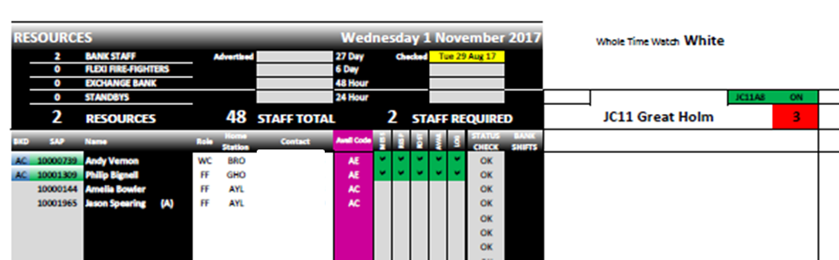

Exchange Shift Screen
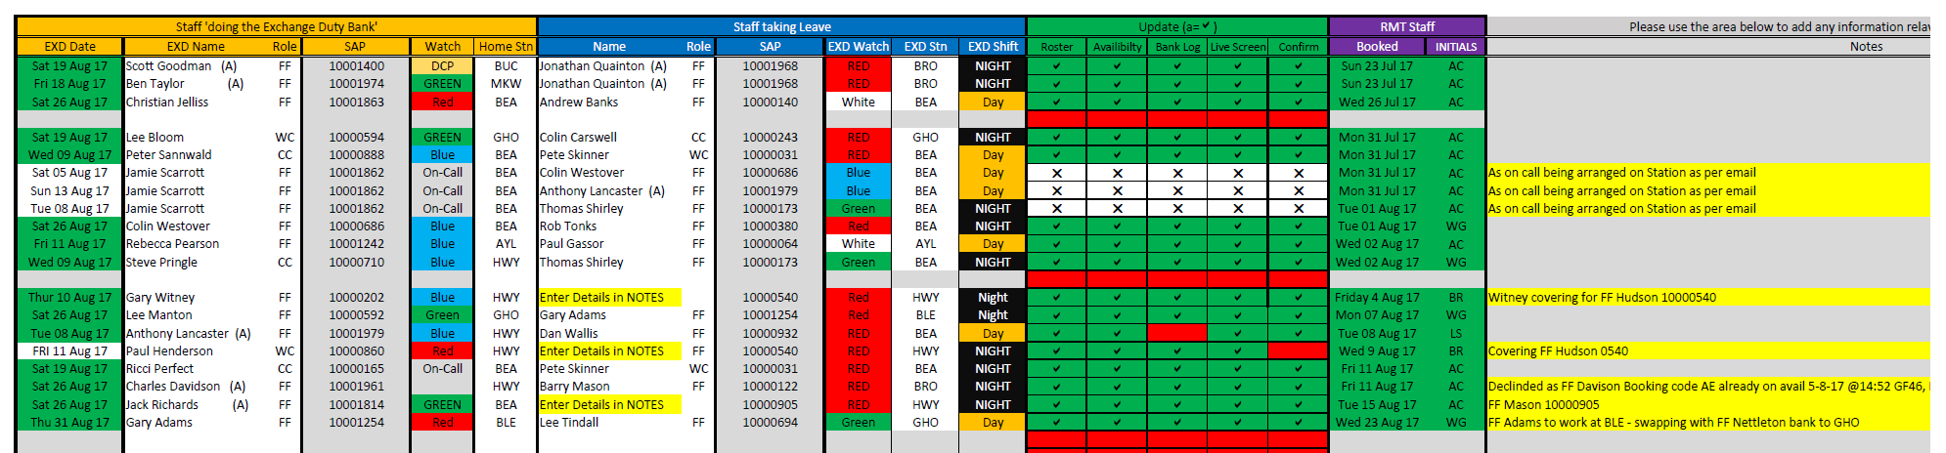

Monthly Summary
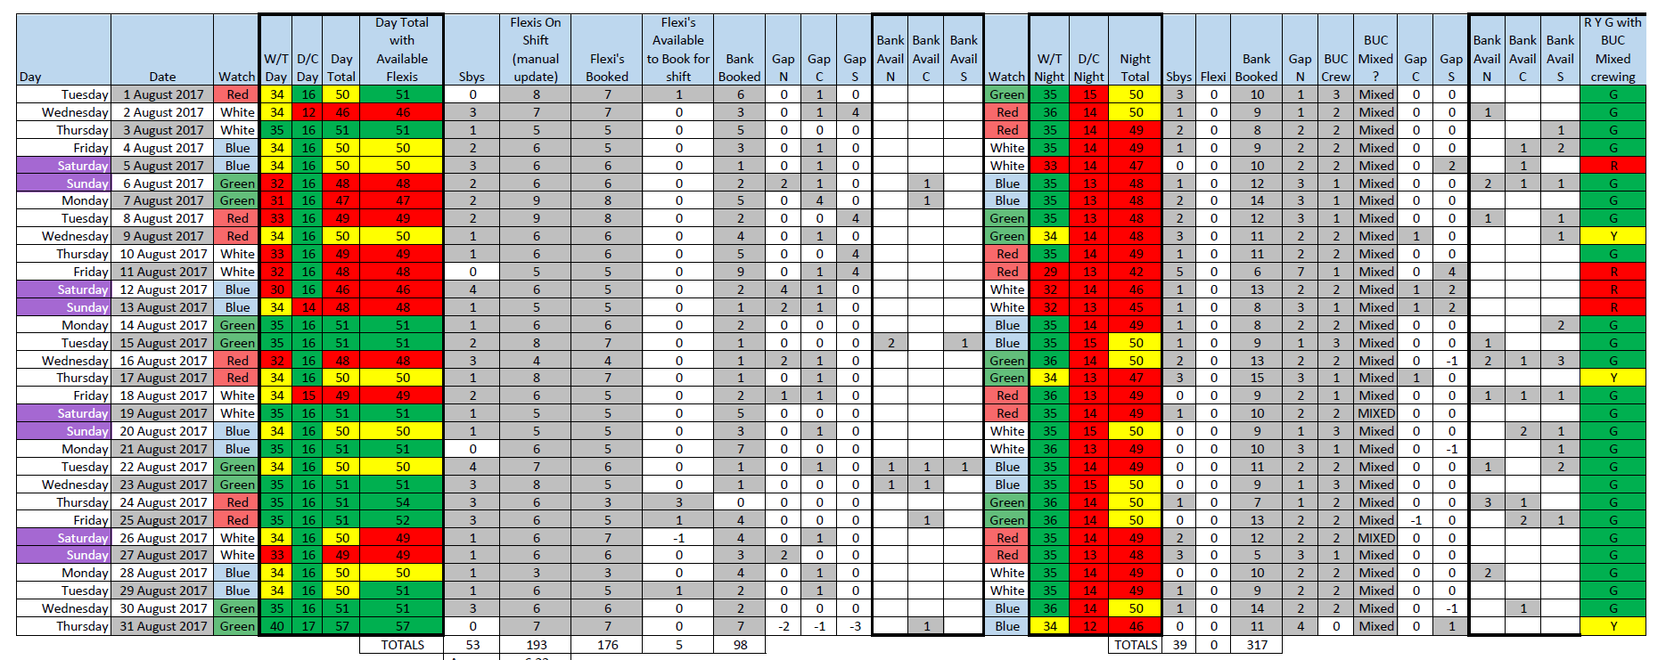

Resource Management Team Dashboard
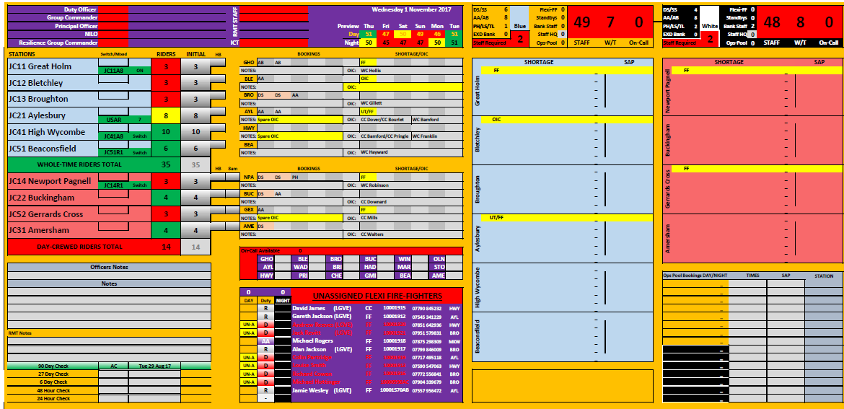

Ridership Details
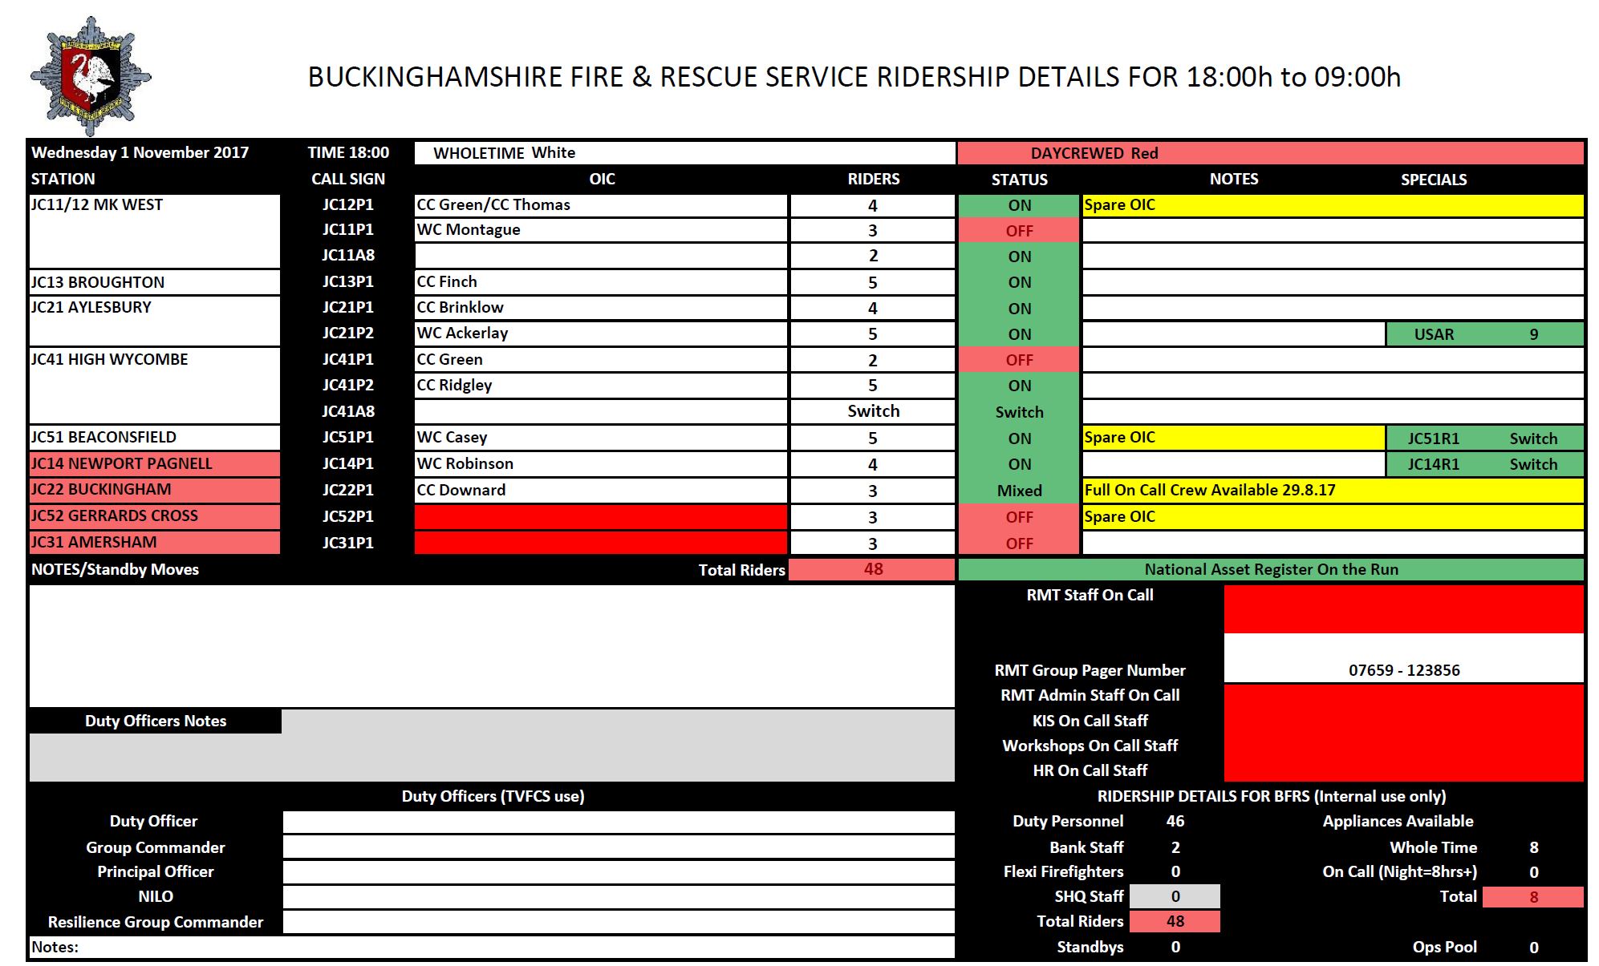

Service Map View
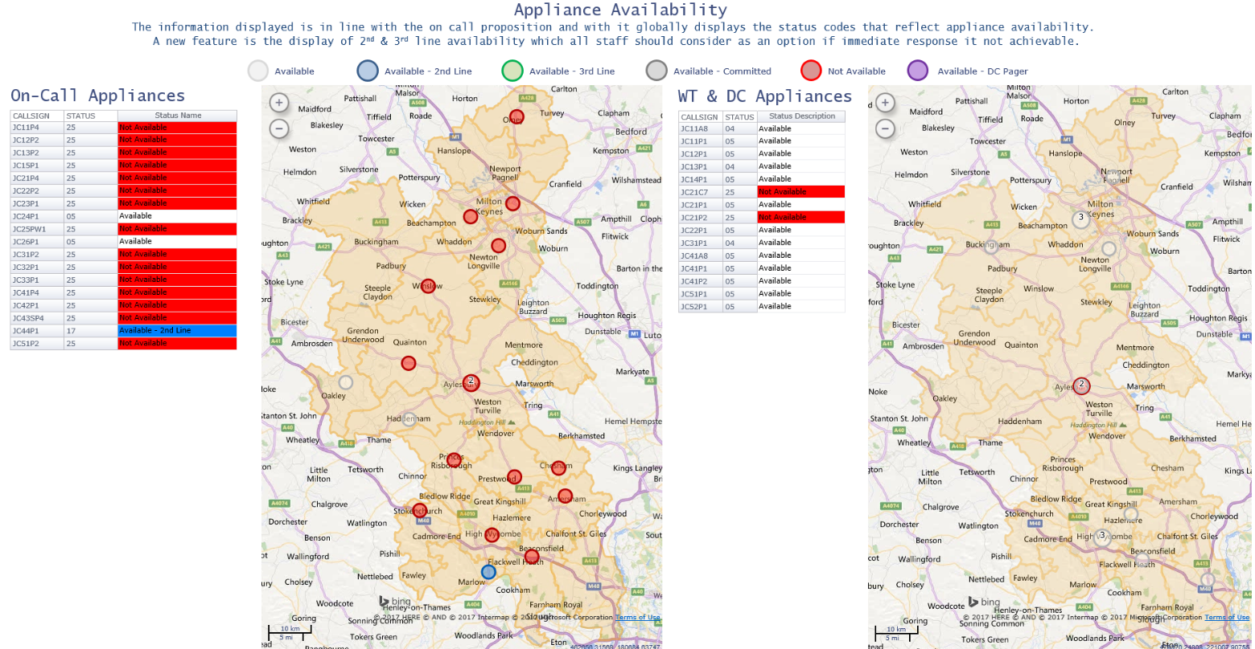

Non uniformed employee attendance screen

The below screen shows a non uniformed employees attendance screen with clockings and flexitime balances.
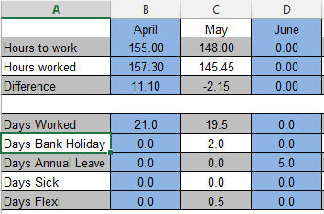
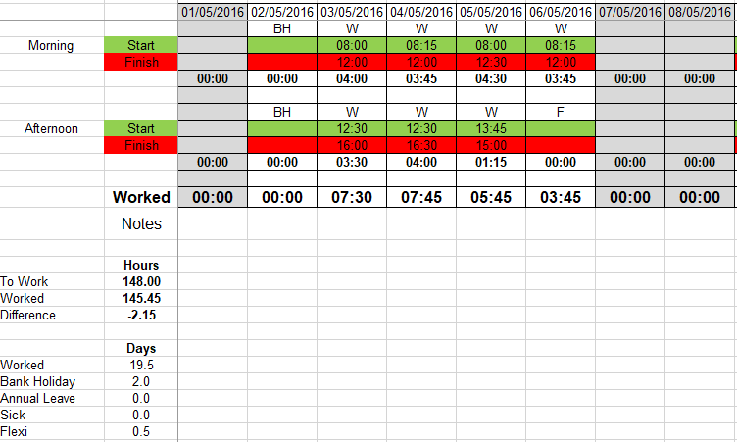

Appendix 4 – Absence Booking Examples (Full Days)
- Sickness
- Injury On Duty
- Injury Off Duty
- Annual Leave – A Leave/B Leave/Long Service Leave/Bank holiday Leave
- Annual Leave Support
- Flex Leave
- Public Leave
- Toil
- Training (Internal, External and FSC)
- Adoption
- Maternity
- Awards
- Course
- Court Attendance
- Critical Illness
- Day Release
- Funeral
- Family Death
- Exam Leave
- Trade Union – (Training, Activity Paid, Activity Unpaid and Duties)
- Unpaid Leave
- Parental Leave
- Industrial Action
- Unauthorised Absence

Appendix 5 – Absence Bookings Examples (Part Day/Shift)
- Annual Leave ½ day Support
- Sick During Shift
- Study Leave
- Time off in Lieu
- Medical Screening
- Lateness
- Early Leaving
- Training

Appendix 6 – Groups Examples (currently in use)
- All Stations – sub categories to watches and non watches
- All Stations - sub categories to all stations
- Fire Control – sub categories to watches
- Departments/Sections – sub categories to teams
- Brigade Roles – sub categories to uniformed roles
- Support Grades - sub categories to support grades/scale points
- Employee Type - sub categories to Uniformed/Support/Fire Control

Appendix 7 – Roles (currently in use)
- Brigade Manager
- Area Commander
- Group Commander
- Station Commander
- Watch Commander
- Crew Commander
- Firefighter

Appendix 8 – Skills (examples)
- Breathing Apparatus (BA)
- Positive Pressure Ventilation (PPV)
- Emergency Fire Appliance Driver (EFAD)
- Fork Lift Truck (FLT)
- Arial Ladder Platform (TL)
- Incident Command Unit (ICU)
- Working at Heights (WAH)

Appendix 9 – Overtime and Allowances

Non Uniformed Employee Overtime, Allowances and Payments (Examples):
- Overtime is paid to the minute
- Part time or job share employees will be paid at plain time until they have worked full time hours (37 hours) before they will receive enhanced payment. (Except for Overtime undertaken on Saturday, Sunday, or Bank Holidays which is not subject to this rule.)
- Some employees receive allowance payments for standbys and callouts
- Some employees receive an overtime payment that is paid at a monetary rate per hour.

Uniformed Employee Overtime, Allowances and Payments (Examples):

- Standby Payments:
- When a uniformed employee is sent to another location to work to cover a deficiency, depending on the location there are 3 types of payments.

- End of shift Overtime/Time off in lieu:
  - Payment is at the rate of time and half. If this overtime is on a public holiday the rate is at double time
  - Each occurrence is treated separately for pay purposes or time off in lieu.
  - No payment is made for any period less than 15 minutes.
  - A period of 15 minutes or more, but less than one hour, is treated as one hour
  - When a period exceeds one hour, payment is made for complete periods of 15 minutes.

- Pre-Arranged Overtime:
- Full Shift Overtime, currently paid at time and half.

- Pre-Planned Overtime/Time off in lieu:
  - This type of overtime can be done by all employees. This overtime is voluntary and used to address non-operational events, activities or tasks that need the attendance of an individual at a specific time.
  - Some employees receive an overtime payment that is paid at a monetary rate per hour.

- Flexi Duty Officers Overtime/Time off in Lieu:
- Accrued at plain time

- Recall to Duty
- All staff who are voluntarily recalled to duty, receive a minimum payment of three hours. Overtime will be paid at double time and thereafter for complete periods of fifteen minutes

Appendix 10 – Balances (examples)
- Annual Leave – A Leave/B Leave/Long Service Leave/Bank holiday Leave
- Public Leave
- Flexi Balance
- Toil – Accrued/taken - broken down to category and rate
- Overtime - broken down to category and rate
- Callout
- Standbys

Appendix 11 – Security Groups (examples)
- System Administrator
- Super User
- Resource Management Team
- Operational (Crew Commanders and above have access to the system for stations)
- Line Manager – department/section or team
- Firefighter/End user
- Payroll

Appendix 12- Unpaid Absence Bookings (examples)
- Parental Leave
- TU Activity Unpaid
- Unauthorised Absence
- Unpaid Leave

