**Call-Off Schedule 13 (Implementation Plan and Testing)**

**Part A - Implementation**

1. **definitions**
   1. In this Schedule, the following words shall have the following meanings and they shall supplement Joint Schedule 1 (Definitions):

|  |  |
| --- | --- |
| **"Delay"** | 1. a delay in the Achievement of a Milestone by its Milestone Date; or 2. a delay in the design, development, testing or implementation of a Deliverable by the relevant date set out in the Implementation Plan; |
| **"Deliverable Item"** | an item or feature in the supply of the Deliverables delivered or to be delivered by the Supplier at or before a Milestone Date listed in the Implementation Plan; |
| **"Milestone Payment"** | a payment identified in the Implementation Plan to be made following the issue of a Satisfaction Certificate in respect of Achievement of the relevant Milestone; |
| **Implementation Period"** | has the meaning given to it in Paragraph 7.1; |

1. **Agreeing and following the Implementation Plan**
   1. A draft of the Implementation Plan is set out in the Annex to this Schedule. The Supplier shall provide a further draft Implementation Plan twenty (20) Working Days days after the Call-Off Contract Start Date.
   2. The draft Implementation Plan:
      1. must contain information at the level of detail necessary to manage the implementation stage effectively and as the Buyer may otherwise require; and
      2. it shall take account of all dependencies known to, or which should reasonably be known to, the Supplier.
   3. Following receipt of the draft Implementation Plan from the Supplier, the Parties shall use reasonable endeavours to agree the contents of the Implementation Plan. If the Parties are unable to agree the contents of the Implementation Plan within twenty (20) Working Days of its submission, then such Dispute shall be resolved in accordance with the Dispute Resolution Procedure.
   4. The Supplier shall provide each of the Deliverable Items identified in the Implementation Plan by the date assigned to that Deliverable Item in the Implementation Plan so as to ensure that each Milestone identified in the Implementation Plan is Achieved on or before its Milestone Date.
   5. The Supplier shall monitor its performance against the Implementation Plan and Milestones (if any) and report to the Buyer on such performance.
2. **Reviewing and changing the Implementation Plan**
   1. Subject to Paragraph 4.3, the Supplier shall keep the Implementation Plan under review in accordance with the Buyer’s instructions and ensure that it is updated on a regular basis.
   2. The Buyer shall have the right to require the Supplier to include any reasonable changes or provisions in each version of the Implementation Plan.
   3. Changes to any Milestones, Milestone Payments and Delay Payments shall only be made in accordance with the Variation Procedure.
   4. Time in relation to compliance with the Implementation Plan shall be of the essence and failure of the Supplier to comply with the Implementation Plan shall be a material Default.
3. **Security requirements before the Start Date**
   1. The Supplier shall note that it is incumbent upon them to understand the lead-in period for security clearances and ensure that all Supplier Staff have the necessary security clearance in place before the Call-Off Start Date. The Supplier shall ensure that this is reflected in their Implementation Plans.
   2. The Supplier shall ensure that all Supplier Staff and Subcontractors do not access the Buyer's IT systems, or any IT systems linked to the Buyer, unless they have satisfied the Buyer's security requirements.
   3. The Supplier shall be responsible for providing all necessary information to the Buyer to facilitate security clearances for Supplier Staff and Subcontractors in accordance with the Buyer's requirements.
   4. The Supplier shall provide the names of all Supplier Staff and Subcontractors and inform the Buyer of any alterations and additions as they take place throughout the Call-Off Contract.
   5. The Supplier shall ensure that all Supplier Staff and Subcontractors requiring access to the Buyer Premises have the appropriate security clearance. It is the Supplier's responsibility to establish whether or not the level of clearance will be sufficient for access. Unless prior approval has been received from the Buyer, the Supplier shall be responsible for meeting the costs associated with the provision of security cleared escort services.
   6. If a property requires Supplier Staff or Subcontractors to be accompanied by the Buyer’s Authorised Representative, the Buyer must be given reasonable notice of such a requirement, except in the case of emergency access.
4. **What to do if there is a Delay**
   1. If the Supplier becomes aware that there is, or there is reasonably likely to be, a Delay under this Contract it shall:
      1. notify the Buyer as soon as practically possible and no later than within two (2) Working Days from becoming aware of the Delay or anticipated Delay;
      2. include in its notification an explanation of the actual or anticipated impact of the Delay;
      3. comply with the Buyer’s instructions in order to address the impact of the Delay or anticipated Delay; and
      4. use all reasonable endeavours to eliminate or mitigate the consequences of any Delay or anticipated Delay.
5. **Compensation for a Delay**
   1. If Delay Payments have been included in the Implementation Plan and a Milestone has not been achieved by the relevant Milestone Date, the Supplier shall pay to the Buyer such Delay Payments (calculated as set out by the Buyer in the Implementation Plan) and the following provisions shall apply:
      1. the Supplier acknowledges and agrees that any Delay Payment is a price adjustment and not an estimate of the Loss that may be suffered by the Buyer as a result of the Supplier’s failure to Achieve the corresponding Milestone;
      2. Delay Payments shall be the Buyer's exclusive financial remedy for the Supplier’s failure to Achieve a Milestone by its Milestone Date except where:
         1. the Buyer is otherwise entitled to or does terminate this Contract pursuant to Clause 10.4 (When CCS or the Buyer can end this contract); or
         2. the delay exceeds the number of days (the "**Delay Period Limit**") specified in the Implementation Plan commencing on the relevant Milestone Date;
      3. the Delay Payments will accrue on a daily basis from the relevant Milestone Date until the date when the Milestone is Achieved;
      4. no payment or other act or omission of the Buyer shall in any way affect the rights of the Buyer to recover the Delay Payments or be deemed to be a waiver of the right of the Buyer to recover any such damages; and
      5. Delay Payments shall not be subject to or count towards any limitation on liability set out in Clause 11 (How much you can be held responsible for).
6. **Implementation Plan**
   1. The Implementation Period will be a six (6) Month period.
   2. During the Implementation Period, the incumbent supplier shall retain full responsibility for all existing services until the Call-Off Start Date or as otherwise formally agreed with the Buyer. The Supplier's full service obligations shall formally be assumed on the Call-Off Start Date as set out in Order Form.
   3. In accordance with the Implementation Plan, the Supplier shall:
      1. work cooperatively and in partnership with the Buyer, incumbent supplier, and other Framework Supplier(s), where applicable, to understand the scope of Services to ensure a mutually beneficial handover of the Services;
      2. work with the incumbent supplier and Buyer to assess the scope of the Services and prepare a plan which demonstrates how they will mobilise the Services;
      3. liaise with the incumbent Supplier to enable the full completion of the Implementation Period activities; and
      4. produce a Implementation Plan, to be agreed by the Buyer, for carrying out the requirements within the Implementation Period including, key Milestones and dependencies.
   4. The Implementation Plan will include detail stating:
      1. how the Supplier will work with the incumbent Supplier and the Buyer Authorised Representative to capture and load up information such as asset data ; and
      2. a communications plan, to be produced and implemented by the Supplier, but to be agreed with the Buyer, including the frequency, responsibility for and nature of communication with the Buyer and end users of the Services.
   5. In addition, the Supplier shall:
      1. appoint a Supplier Authorised Representative who shall be responsible for the management of the Implementation Period, to ensure that the Implementation Period is planned and resourced adequately, and who will act as a point of contact for the Buyer;
      2. mobilise all the Services specified in the Specification within the Call-Off Contract;
      3. produce a Implementation Plan report for each Buyer Premises to encompass programmes that will fulfil all the Buyer's obligations to landlords and other tenants:
         1. the format of reports and programmes shall be in accordance with the Buyer's requirements and particular attention shall be paid to establishing the operating requirements of the occupiers when preparing these programmes which are subject to the Buyer's approval; and
         2. the Parties shall use reasonable endeavours to agree the contents of the report but if the Parties are unable to agree the contents within twenty (20) Working Days of its submission by the Supplier to the Buyer, then such Dispute shall be resolved in accordance with the Dispute Resolution Procedure.
      4. manage and report progress against the Implementation Plan;
      5. construct and maintain a Implementation risk and issue register in conjunction with the Buyer detailing how risks and issues will be effectively communicated to the Buyer in order to mitigate them;
      6. attend progress meetings (frequency of such meetings shall be as set out in the Order Form) in accordance with the Buyer's requirements during the Implementation Period. Implementation meetings shall be chaired by the Buyer and all meeting minutes shall be kept and published by the Supplier; and
      7. ensure that all risks associated with the Implementation Period are minimised to ensure a seamless change of control between incumbent provider and the Supplier.

**Annex 1: Implementation Plan**

The Implementation Plan is set out below and the Milestones to be Achieved are identified below:

The Supplier ensure constructive engagement with the management team transferring to via TUPE and who will continue to provide many of the BAU services.

The Supplier will implement three key phases of mobilisation:

* Phase 1 Mobilisation; Focus on ongoing service delivery and maintaining continuity.
* Phase 2 Engagement; Identify and refine initiatives in conjunction with the Management Team and LLDC.
* Phase 3 Integration & Innovation: Enact changes to enhance performance.

The Supplier will appoint a transition manager who will work with the Authority and the current incumbent.

Key tasks include:

• The Supplier will appoint a Mobilisation Manager to be responsible for ensuring the formative stages of the project are correctly shaped to ensure effective management of transition, providing a single point of contact for communication. Focus on mobilisation as opposed to Business as Usual (BAU).

• Embed Communication Plan: Clear consistent communication throughout so the full stakeholder environment is mapped and roles and responsibilities are identified and set.

• Establish Risk Register: Identify potential risks / dependencies and record via a transition risk register

• Financial Data: act as Data Manager, responsible for managing the transfer of data from the incumbent to our systems completing the transfer after mapping, verification and checking.

• Supplier Review: undertake a full review of supplier contracts to be novated, appropriate notice periods and mechanisms. He will then undertake a period of engagement and take responsibility for managing the full transition.

• Right person, Right role: The supplier will ensure specialist workstream experts will be involved during the transition to ensure a consistent approach. Work-stream leads will be appointed for: Senior Management, Property Data, Technology, Property Management, Facilities Management, Sales & marketing and Compliance & Quality Assurance. Each lead will be responsible for deliverables outlined in the transition plan.

DATA: The Supplier’s Data Manager is responsible for the data transfer and testing, using their extensive mobilisation experience to ensure efficient and compliant results for 3 Mills Studios with a clear plan as to format, location, reporting and how will we source any missing records.

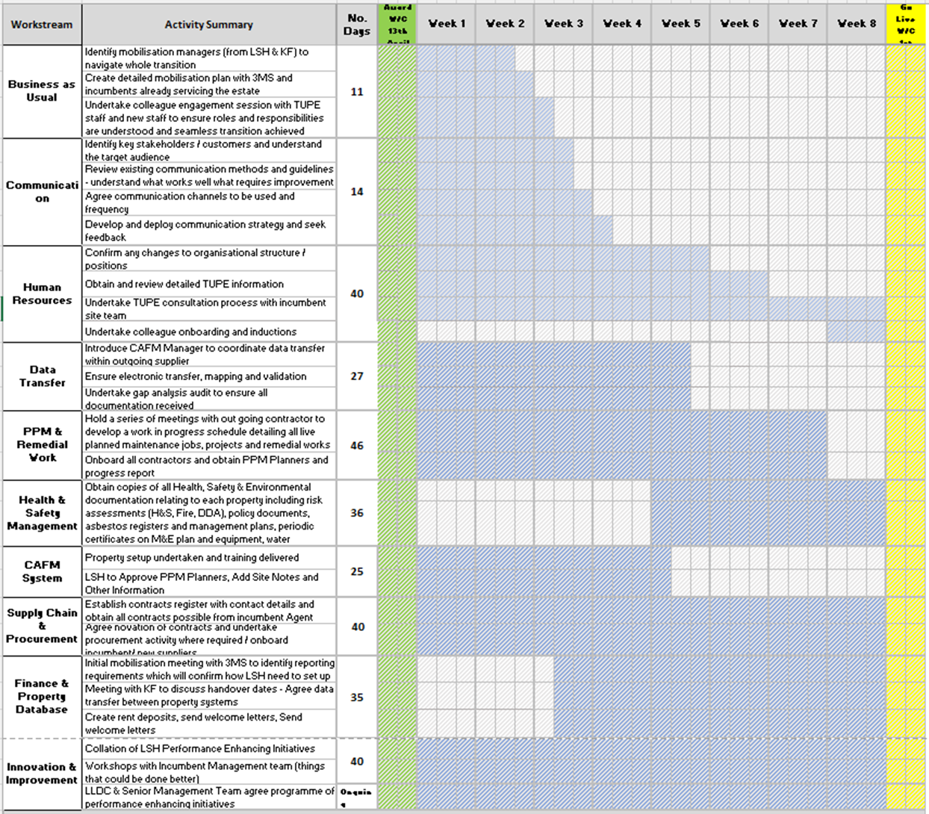

All mobilisations tasks will be completed by 30th June 2025 to enable Contract Commencement to begin on 1st July 2025 and maintain continuity and business as usual.