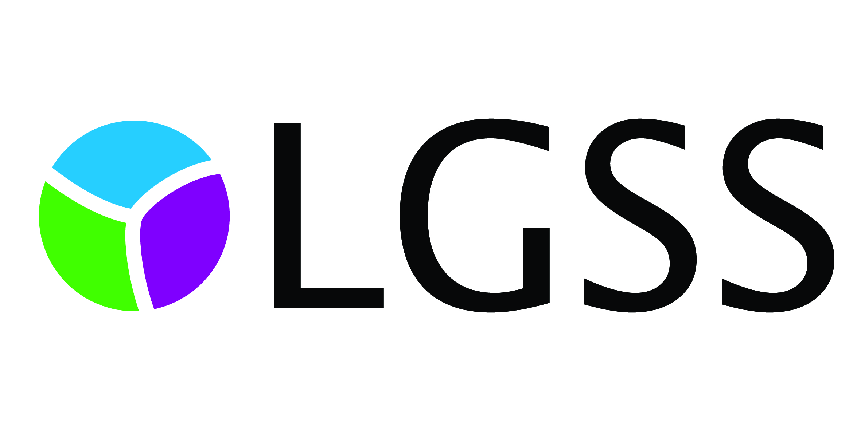

Soft Market Test
For
Unified Service Desk Software Replacement
For LGSS
Ref: HDSM090118

Section 1: Introduction

General Requirements
  - The purpose of this document is to briefly explain to suppliers the business and technical requirements and the expected scope of the Unified Service Desk Software in order that suppliers can explain the relevance of products, services and their experience to the requirements.

  - Please note: this market testing exercise is not an invitation to tender or a request for formal expressions of interest. This document does not form any part of an invitation to tender. LGSS is issuing this request for information only. Any supplier invited to present to LGSS is doing so to support market research only and to help make any potential procurement process more focused and efficient. No supplier selection or supplier preference is implied.

Confidentiality and Freedom of Information (FOI)
  - Please note: all information included in this Soft Market Testing is confidential and only for the recipients’ knowledge. No information included in this document or in discussions connected to it may be disclosed to any other party without prior written authorisation.

  - All responses will be treated confidentially. However, please be aware that we are subject to the disclosure requirements of the FOI Act and that potentially any information we hold is liable to disclosure under that Act. For this reason, we strongly advise that any information you consider to be confidential is labelled as such. In the event that a request is subsequently made for disclosure under FOI the request will be dealt with in accordance with the legislation.

Background
LGSS is the shared services venture set up by founding partners Cambridgeshire County Council (CCC) and Northamptonshire County Council (NCC), with Milton Keynes Council (MKC) becoming a third partner in April 2016. LGSS offers a fully integrated support service. The partnership was formed in response to the challenges faced by local authorities, namely, the public sector funding crisis, impact of the recession, rising expectations and growing demand, and seeks to reduce the cost of support services through the consolidation of resources, process redesign and exploitation of technology.

LGSS is governed by a joint committee and began operating legally as a shared service in October 2010. Within LGSS there are four directorates: Finance, Human Resources & Organisational Development, Operations and Legal Services. These directorates provide professional and transactional business services to the two founding councils and a range of other public sector customers.

CCC, MKC and NCC work together in partnership under the name of LGSS.

Soft Market Test Timetable
  - Please read this document and if you feel that your organisation is able to contribute to this exercise please complete the questionnaire at the end of this document and return, via email to kevin.halls@cambridgeshire.gov.uk by Wednesday 31st January 2018.

  - Following receipt of the questionnaires, a maximum of 5 respondents may be invited to attend separate workshop sessions to present and discuss their responses. A decision will then be made internally on the best procurement approach. The timetable is provided below:
Stage | Date
Deadline for receipt of responses to Soft Market Test. | 31/01/2018
Workshop Week. | TBA
Decision on way forward. | TBA

  - Potential responders will not be prejudiced in any future procurement processes by either responding or not responding to this soft market test exercise.

Section 2: Identification of Requirement

Current Situation
LGSS IT currently run multiple IT Helpdesks providing support to some 20,000 end users across multiple local government and Healthcare sites using a mix of Helpdesk call recording software.

This soft market test is to explore what market options are available to implement a standardised system across all of the Helpdesks.

Our Requirements
  - For Mandatory, Essential and Desirable requirements, please see the LGSS Unified Service Desk Software Requirements document.
All staff supported by LGSS IT should be able to access the self-service function for logging and updating calls.

Approximately 50 users need full access to the system in front and second line support roles who would need administration and reporting access.

350 further IT staff would need access to update and administer calls to their own teams and workload.

Section 3: Supporting information
Please note: you do not need to resize the table; it will automatically adjust to fit your response.

Section A: Organisation and Contact Details
Question | Response
Name of your organisation
Registered office (if applicable)
Trading address (if different from office)
What if any local connections do you have with the authority?
Name of person whom an queries relating to this questionnaire should be addressed
Telephone Number(s)
Email
Address if different to above

Section B: Questions
Please note: you do not need to resize the table; it will automatically adjust to fit your response.
Question | Response
What is the name of the solution you propose?
How will your proposal meet the stated requirements? Please include information for both cloud based and on premise options, if applicable.
How long would your proposal take to implement?
If your proposal is already in use elsewhere: please give an example of your proposed solution in use and state how it has met the requirements of the customer.
Please provide details of the licensing model for your proposal.
Please provide indicative pricing for your proposal based on the information provided.

