# **Personal Dosimetry** **Service**

## SPECIFICATION for CUTTING & ENCODING OF PADC DETECTOR ELEMENTS

## Change Control

| Version | Effective Date | Significant Changes |
| --- | --- | --- |
| 01A | 2020 | First issue |
| 2022A | 7th September 2022 | Amended to UKHSA; updated for new contract |

### Introduction

UK Health Security Agency (UKHSA) provides personal dosimetry services which measure the amount of radiation exposure received by workers. Amongst these services are dosemeters which record neutron or radon exposure, employing PADC (Poly Allyl Diglycol Carbonate, also known as CR-39).

PADC is produced in sheets, which will be supplied directly from UKHSA's contracted manufacturer in equal deliveries every calendar month.

### Cutting and Encoding Specification

1. PADC to be cut and encoded as specified below and despatched to UKHSA by carrier within 10 working days of receipt of the sheets from the manufacturer.
2. Sheets should be handled with care, to avoid scratching; e.g. using cotton gloves. The sheets will be supplied in open polythene bags, to which they should be returned for delivery to UKHSA.
3. Sheet dimensions are: Minimum 490 mm x 330 mm

Maximum 510 mm x 350 mm

Mean thickness: 0.51 mm

1. PADC sheets to be kept in a low-radon environment at all times. (Exposure to radon gas and its decay products can cause unwanted levels of “background” on unexposed dosemeters. See, for example, <http://www.ukradon.org/>.)
2. Laser to be used for cutting and encoding: suitably powered and set up CO2 laser.
3. From each sheet ninety (**90)** detectors are to be cut, in an array centrally located. The short sides of the detector elements are parallel with the short sides of the sheet, and the dimensions of the array should be 9 elements parallel to the short side of the sheet, by 10 elements parallel to the long side. See fig. 1.

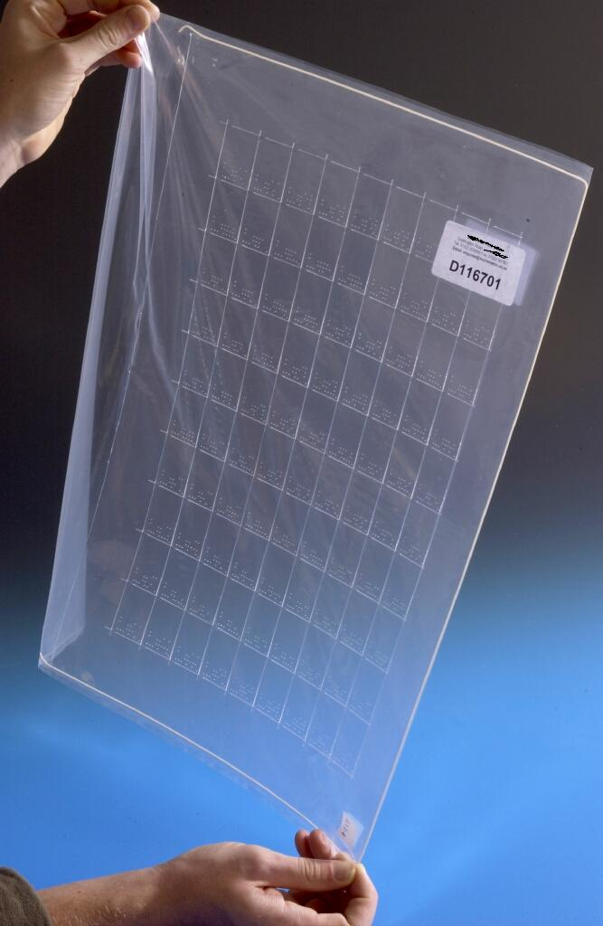

Fig. 1. Cut and encoded PADC sheet in polythene bag

1. Two small bridges of approximate width 0.25 mm should be left between

neighbouring elements, on the short sides only.

1. Element dimensions are 39 x 27 mm, with tolerances 0.3 mm, and a single 4 mm chamfered corner at top left. (See figs. 2 & 3.)

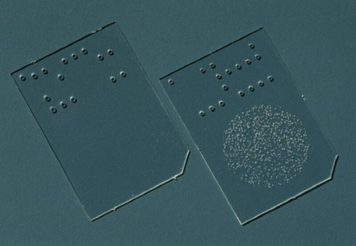

Fig. 2. Example detector elements

1. Cuts between rows and columns of elements to be approximately 0.25 mm to 0.75 mm in width.
2. The encoding consists of laser drilled holes of dimensions 0.6 ± 0.1 mm in an 8 x 4 location matrix (see drawing) plus an additional location hole, to bottom right of array.
3. The location holes should **taper** from 0.60 ± 0.10 mm on front[1] face down to 0.15-0.30 mm on back face[2].
4. The 8 columns *a-h* are of 2.54 mm spacing and are centrally located. The 4 rows are spaced at 3 mm, the bottom row being 3 mm from the edge of the detector. (All relative locations are from hole centre to hole centre.
5. The encoding is of binary form. Col. ***a*** encodes detector type, a hexadecimal number from 1 to F, using the convention that zero is represented by A(10). Cols. ***b-g*** each encode a 4 bit binary coded decimal number 0-9.. Col. ***h*** is an odd parity check: this should ensure that the number of holes in each row is odd. The bottom row is the least significant and represents 1, the second row represents 2, the third row 4 and the top row 8.
6. Example code: A208975

|  |  |  |  |  |  |  |  |
| --- | --- | --- | --- | --- | --- | --- | --- |
| ***a*** | ***b*** | ***c*** | ***d*** | ***e*** | ***f*** | ***g*** | ***h*** |
| O |  | O | O | O |  |  | O |
|  |  |  |  |  | O | O | O |
| O | O | O |  |  | O |  | O |
|  |  |  |  | O | O | O |  |
| A | 2 | 0 | 8 | 9 | 7 | 5 | parity check |

1. Cols. ***b-e*** give sheet number; cols ***f-g*** give position on sheet, 1-90. The example shows a detector from position 75 on sheet 2089 assigned as detector type A. This also could be a number e.g. 2 or 3
2. For each batch, UKHSA will supply type code plus range of sheet numbers; sheet numbers will run sequentially. E.g. a batch of 15 sheets might produce detector numbers A208001-A208090; A208101-A208190; A208201-A208290, through to A209401-A209490.

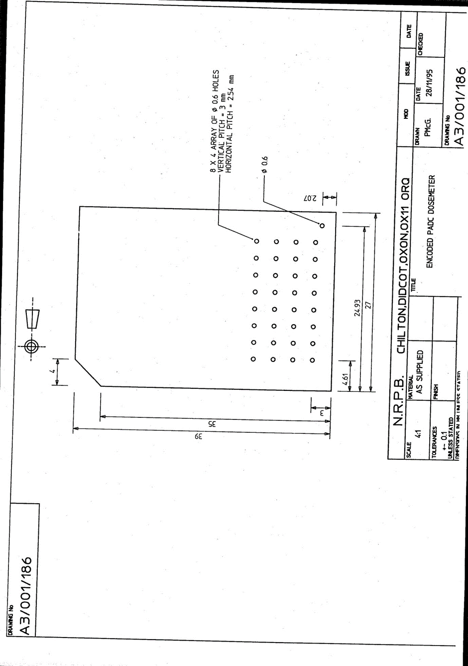

1. Front: as viewed with code array at bottom and chamfered edge at top left.
2. Back: as viewed with code array at bottom and chamfered edge at top right.