Specification

Refurbishment and redesign of toilets and showers at The Wharf


Contract Reference: RAIB18002

Date: 15/03/18
Version: 5

Contents

Contents 2
1. Introduction 3
2. Background to the Requirement 3
3. Procurement Timetable 3
4. Scope 4
5. Pricing this tender 4
6. Specifying Goods 5
7. Management and Contract Administration 6
8. Security 6
9. Documentation 6
10. Arrangement for End of Contract 6
11. Evaluation Criteria 7
12. Points of Contact 88
Annex 1 – Evaluation criteria quality factors 8
Annex 2 – Layouts and approximate measurements 9
Annex 3 – DfT Short-Form Conditions of Contract 12
Annex 4 – Tender evaluation criteria 14

1. Introduction

The Rail Accident Investigation Branch (RAIB) was established to independently investigate accidents on the UK’s railway to improve safety and inform the industry and the public.

The RAIB invites proposals for the works described in Section 4 of this document. This contract will be subject to the DfT Short-Form Conditions of Contract (Annex 3).

2. Background to the Requirement
The RAIB requires the toilets and shower/changing rooms at The Wharf in Derby to be refurbished and redesigned to accommodate the current staffing level. The project is for a phased refurbishment, to ensure some facilities remain available to staff during the work, with minimal disruption to the organisation. All works are to be undertaken during normal office hours and to the agreed timescale.

3. Procurement Timetable

Description | Date
Start of tender | 15/03/18
Close of tender | 06/04/18 at 16:00
Tender evaluation | 10/04/18
Contract award | 13/04/18
Completion | 31/08/18

4. Scope
The overall scope of the works is described below:

- Strip out and removal from site of all the existing WC’s, cubicles and shower rooms
- Strip out and removal from site of all ceiling tiles, wall panelling and doors
- Removal of 2 breezeblock walls in 1st floor toilets
- Supply and install all new sanitary ware
- Supply and install a water efficient toilet system with concealed cistern, where suitable
- Supply and install all new cubicles, wall and floor covering, partitions and doors colour tbc
- Supply and install accessible toilet compliant with the specification set out in BS8300. Some variations may be necessary but these must be agreed with RAIB in advance.
- Supply and install new ironmongery to all doorsets to match, including, but not exclusively, kickplates, pushplates, pull handles, door closers.
- Supply and install female/male/accessible WC signage, Euro profile lock and thumb-turn and Escutcheons
- Supply and install easy care non slip floor covering appropriate for each area
- Supply and install new lighting and hand dryers
- Supply and install new showers fed from mains water supply if suitable
- Every sanitary appliance is to have its own ‘ball ‘o’ fix’ isolation valve directly before it on both hot and cold feeds as applicable
- All hot and cold pipe work is to run in copper tubing with soldered and compression fitting connections where applicable. Stainless steel braded flexible tap connectors may be used to make the final connection between appliance and pipe system. Push fit, plastic pipes, crimped connections and alike will not be permitted.

The required layout and measurements are shown in Annex 2. Measurements are approximate, but can be considered accurate to +/-50mm. To confirm absolute accuracy a site visit may be required.

5. Pricing this tender
The pricing structure should be as follows;

- Listing cost and specification of main components including ceiling system, lighting system, toilets, cubicles, partitions, urinals, basin, taps, radiators and hand dryers.
- Total cost for all other materials ,e.g. cables and pipework
- Applicants should submit a base bid, using mid-range sanitary ware/equipment (unless otherwise specified in section 6). Applicants are welcome to offer priced alternatives as options and RAIB may choose to exercise one or more of those options.
- A cost allowance for contingency and provision must be specified separately
- Labour costs.
- Milestone payments to be included within the pricing structure
- Works are to be run simultaneously, or consecutively, whilst still leaving sufficient facilities available for use.
- All prices are to be exclusive of VAT

6. Specifying Goods

The RAIB require plumbing and sanitary works for the refurbishment of the male, female and accessible toilets over the 3 floors at The Wharf, Derby.
Toilet refurbishment to include:
- Supply and fit a suitable demountable suspended ceiling design compliant with BS/EN-13501-2 2016 including new support system if required
- Supply and fit low energy lighting with presence control compliant with current legislation
- Supply and fit suitable wall coverings to match or complement the colours and design in matching or complementary colours and design
- Supply and fit suitable non slip easy care floor covering
- Supply and install Stream Hygiene - Streamless urinal system to all gents toilets
- Supply and fit new radiators suitable for the environment
- Supply and install porcelain sinks with eco flow mixer tap and vanity units to complement the colour and design of the facilities
- Supply and install a low energy Airblade style hand dryer
- Advise the RAIB contact of any items not listed but considered to be required

The RAIB also require plumbing and sanitary works for the refurbishment of the male and female changing / shower rooms on the ground floor at The Wharf, Derby.
Changing/shower room’s refurbishment to include:

- Convert current showers from electric to mains fed with suitable mixer head
- Convert current shower cubicles into wet room with appropriate drainage system and door
- Supply appropriate drainage for 3 showers
- Supply and fit new radiators suitable for the environment
- Repair and recover walls in durable easy to maintain materials
- Supply and fit a suitable demountable suspended ceiling design compliant with BS/EN-13501-2 2016 including new support system if required
- Supply and fit low energy lighting with presence control compliant with current legislation
- One of the shower rooms should be available for use during the works
- Advise the RAIB contact of any items not listed but considered to be required

Management and Contract Administration
The tender should include details of any milestone payment to be made, such as a provisional sum for the removal of current fixtures and fittings, a sum for the cost of the new fixtures and fittings. On completion of works a retention of 2.5% of total value shall be withheld until all snagging works are completed and any issues resolved.

DfT is committed to removing barriers to SME participation in its contracts, and would like to also actively encourage its larger suppliers to make their sub-contacts accessible to smaller companies and implement SME-friendly policies in their supply-chains (see our website for further information).

8. Safety and security
The Stores Road site is shared between the RAIB and a tenant who occupies the second floor. The appointed contractor is expected to show consideration for all occupants of The Wharf while undertaking the works and minimise disruption in the car park and building at all times.

A full risk assessment and method statement is to be provided to RAIB prior to the commencement of each lot.

Safe and secure storage of all items is the responsibility of the contractor and all contractors and their employee will observe RAIB security policies and procedures.
The chosen contractor shall nominate a single point of contact who will be available to speak to the RAIB contact regarding any matters relating to the works, including safety and security.

9. Documentation
Annex 1 provides details of the evaluation criteria.
Annex 2 provide outline designs and approximate measurements (possible +/-50mm variance)
Annex 3 DfT Short-from conditions of contract

10. Arrangements for End of Contract

On completion of the project compete details of future maintenance and after care is to be supplied to RAIB contact and contractors. All areas are to be left clean and fully functional on completion of the works. All guarantees must be for a minimum of 12 months and are to be left for RAIB to register on completion of each lot.

11. Evaluation Criteria

Selection will be based on the evaluation criteria encompassing the most economically advantageous tender, which demonstrates a high degree of overall value for money, competence, credibility and ability to deliver. The initial assessment will be on quality and any tender scoring zero in any one of the sub categories or a total below 70% will be discounted and no financial assessment will take place.

This tender will be evaluated using the weightings set out at Annex 1 to obtain the optimal balance of quality and cost.

Quality Factors Scoring Methodology

The Quality Factors will be assessed against the criteria specified in Annex 1.

Tender Score Criteria

Score | Definition of Score
5 | The Tenderer demonstrates fully that they can meet the requirement as detailed in the Specification
4 | Meets all requirements but with minor issues
3 | Meets some requirements but with a few major gaps or issues
2 | Meets some requirements; major concerns
1 | Meets few requirements; serious concerns
0 | The method of fulfilling the stated requirement is inadequate / not addressed

Financial / Price Factors Scoring Methodology:

Tendered / Lowest Price Methodology
A lowest Price Scoring Methodology will be used to evaluate all cost proposals for this requirement. This methodology is based on the following principles:

RAIB will establish the Lowest Price from the tender’s received. The mark of 100 will be allocated to the tenderer with the lowest price. All other bids that arrive will be scored using the following formula:

(Lowest Price÷ Price Tendered) x 100

This quality of the submission will be assessed separately and cost and quality factors combined as described shown in Annex 1 to allow an overall score to be assigned.

12. Points of Contact

Procurement Contact
 | Name | Ian Stuart
 | Tel | 01332 253323
 | e-mail | Ian.stuart@dft.gsi.gov.uk
 | Address
Project Lead

Project Lead | Name | Damian Dutton

All queries/ questions should be sent to the procurement contact

Annex 1 – Evaluation Criteria: Quality Factors

Primary Criteria | Primary Criteria Weighting (%) | Sub-criteria weighting and description | Individual Sub -Criteria Weighting (%)
Company’s appropriate capabilities and quality of fixtures and fitting | 70 | Company’s experience in similar projects | 30
 | 70 | Proposed methodology | 15
 | 70 | Customer testimonials | 20
 | 70 | Energy rating and economy of products | 15
 | 70 | Quality and suitability of proposed products | 20
Cost | 30 | Includes all material and  labour costs | NA
 | Total = 100%

.

Annex 2 – Layouts and approximate measurements

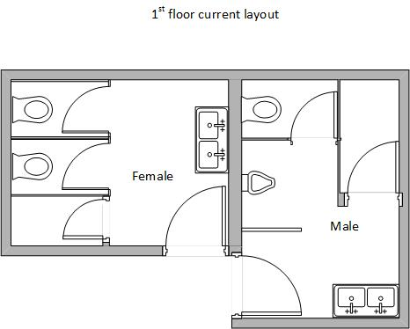

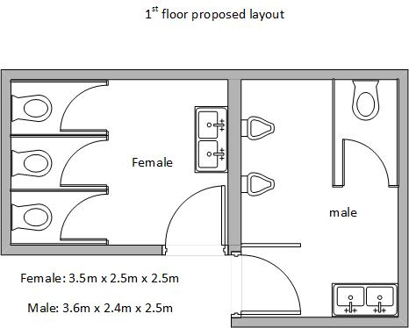

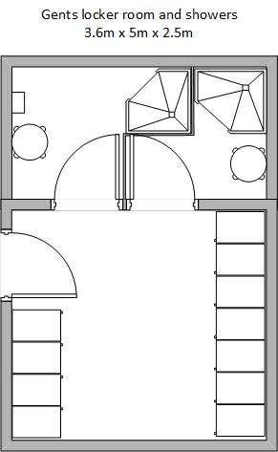
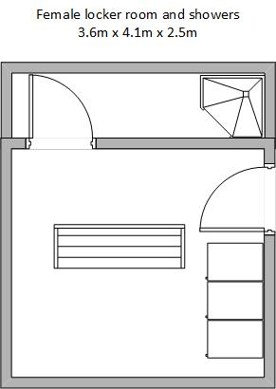
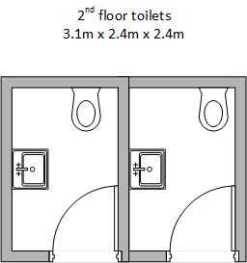

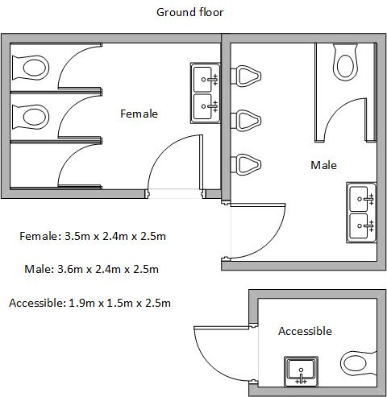

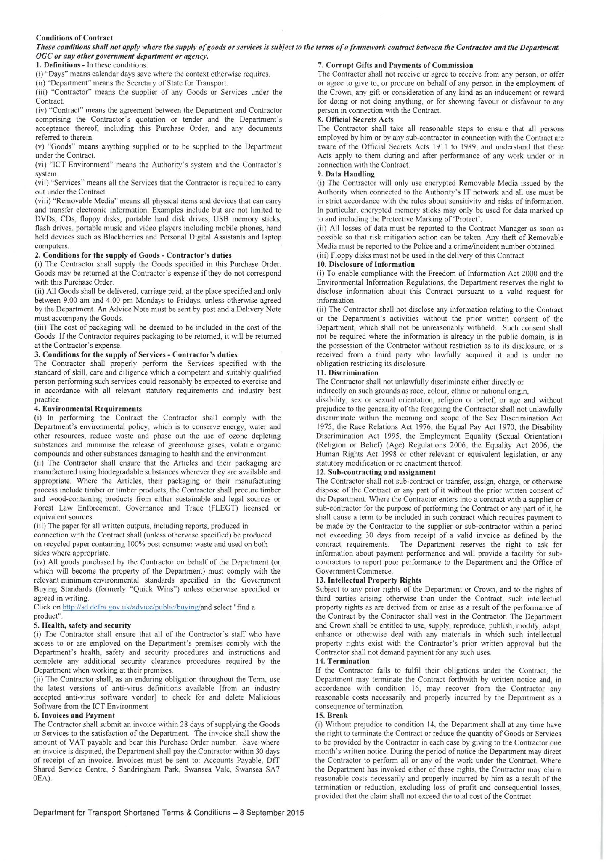
Annex 3 – DfT Short-Form Conditions of Contract
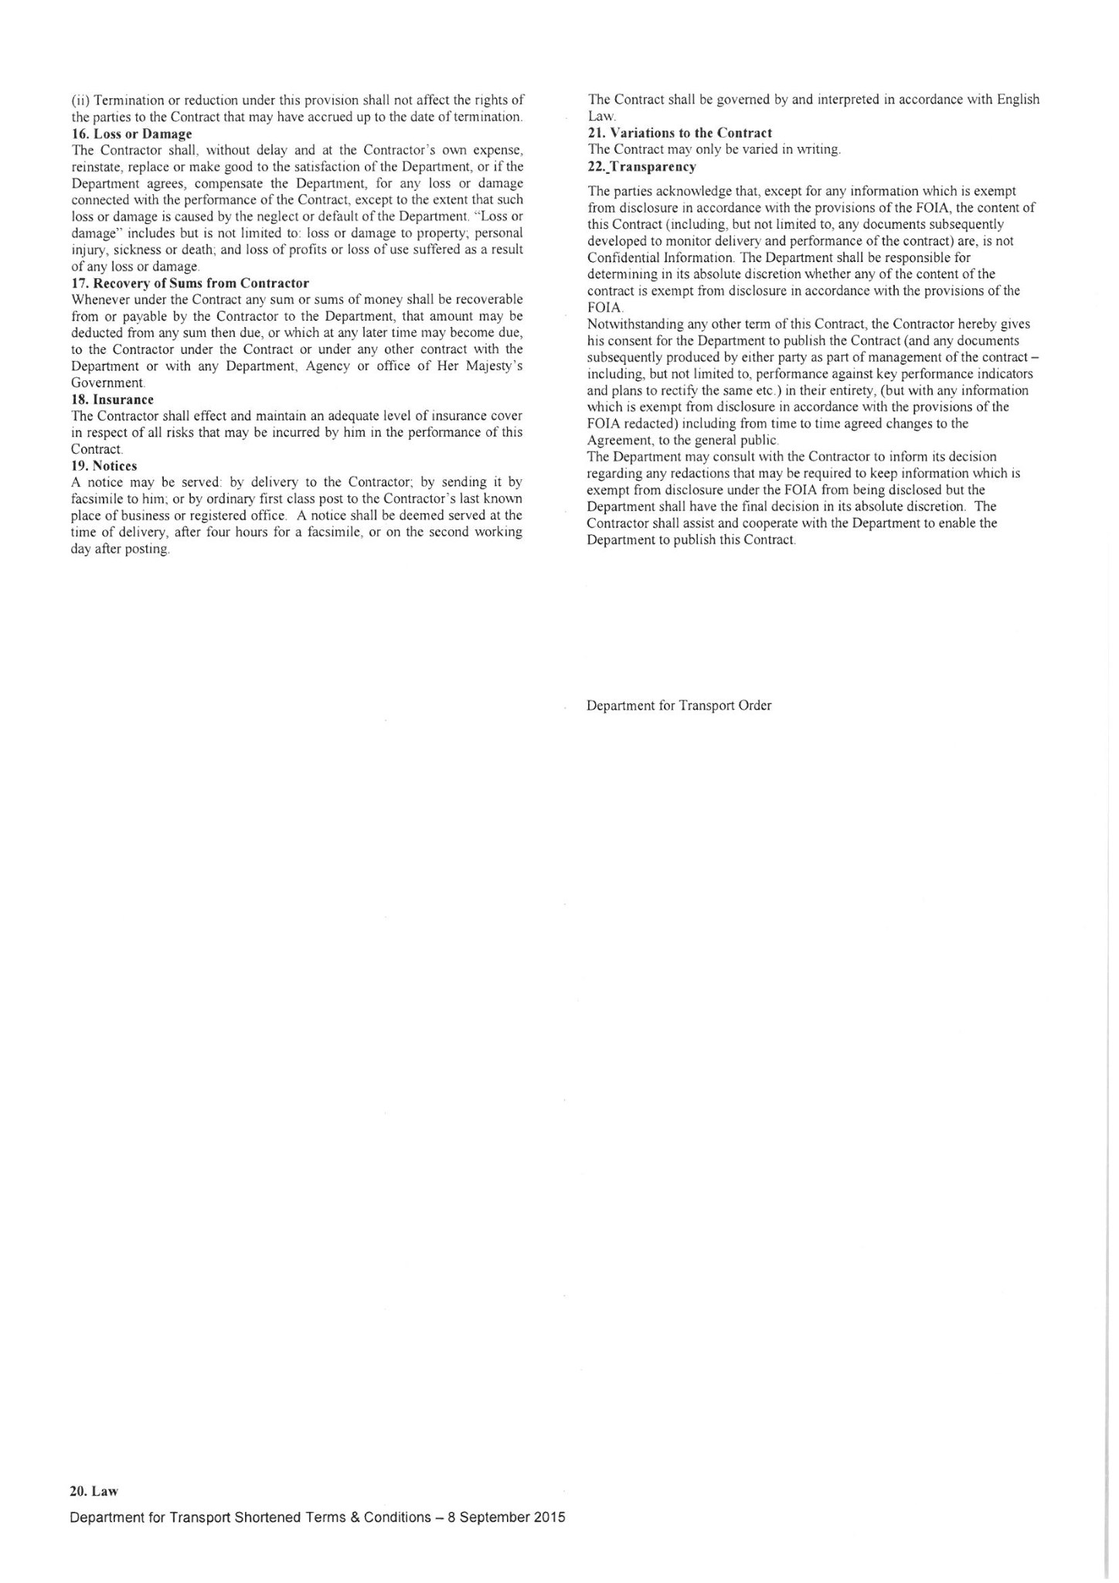

Annex 4 – Tender evaluation criteria
Tender Assessment Stage 1 – Quality Element

Tenderer:
Quality Criteria (Example only)  Company’s experience of similar tasks  Proposed methodology  Customer testimonials  Energy rating and economy of products  Quality and suitability of proposed products | ASPECT  WEIGHTING  (A)  30  15  20  15  20 | MARKS  AWARDED  (B) | WEIGHTED  MARKS (C)  (AxB=C)
 | ASPECT  WEIGHTING  (A)  30  15  20  15  20 | MARKS  AWARDED  (B) | Total score  (possible 500)

The total of the ‘Weighted Marks’ is then divided by five to give the Total Score (or Quality Assessment Mark).

Tender Score Criteria

A  B  C  D  E  F | CRITERIA  Very high standard with no reservations at all about acceptability.  High standard but falls just short of A.  Good standard.  Generally of a good standard but with some reservations.  Basic compliance only.  Fails to meet the minimum requirements (bid rejected) | MARKS  5  4  3  2  1  0

Quality Evaluation Criteria and sub-criteria

- Company’s experience of similar projects
  - Has the provider completed similar projects in commercial environments?
  - Has the company undertaken similar works for government agencies?

- Proposed methodology
  - Proposed programme of works
  - Proposed safe system of works
  - Commitment to completion of task on time

- Qualification and experience of team undertaking the work
  - Involvement in similar work
  - Blend of experience of fitters
  - Evidence of qualifications of those assessing the works on completion

- Efficiency of products
  - Energy rating of proposed items
  - Efficiency rating for running costs of proposed products

- Quality and sustainability of products
  - Design quality of products
  - Ongoing maintenance and energy consumption where applicable.

Tender Assessment Stage 2 – Financial Element

Worked Example

Tender A Tender Total £12,000
Tender B Tender Total £10,000
Tender C Tender Total £13,000
Tender D Tender Total £15,000

Tenderer B is awarded 100

$$\frac{Lowest tender price}{Tender price}x 100=Financial Mark$$

Tender A

$$\frac{£10,000}{£12,000}x 100=83$$

Tender B

$$\frac{£10,000}{£10,000}x 100=100$$

Tender C

$$\frac{£10,000}{£13,000}x 100=77$$

Tender D

$$\frac{£10,000}{£15,000}x 100=67$$

Tender Assessment Stage 3 – Overall Tender Assessment

Worked example

In the example below 70% weighting has been given to quality and 30% to financial.

1 | 2 | 3 | 4 | 5 | 6
Tender | Quality Mark | 70% of (2) | Financial Mark | 30% of (4) | Aggregate (3) + (5)
A  B  C  D | 90  80  100  90 | 63  56  70  63 | 83  100  77  67 | 25  30  23  20 | 88  86  93  83

C is successful

