**REQUEST FOR INFORMATION**

**SUBMARINE DELIVERY AGENCY**

**Supply of Spares, Repairs and Technical Support Relating to Ametek Pressure Hull Penetrators (PPENS), Cables & Connectors**

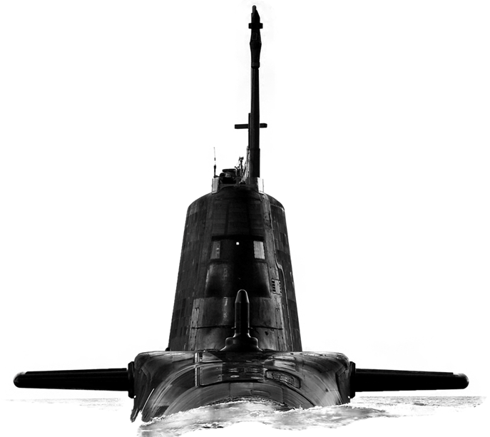

Version 1.0

07 November 2023

**CONTENTS**

Confidentiality..............................................................................................................3

Introduction..................................................................................................................3

Background…………...................................................................................................3

Purpose of the Request for Information (RFI).............................................................3

RFI Procedure............................................................................................................ 4

How to Delivery Responses to this RFI………............................................................4

Contacts......................................................................................................................4

Timeframe...................................................................................................................5

Annex A - Request for Information Questionnaire……….........................................A-1

**Confidentiality**

1. All information included in this Request for Information (RFI) is confidential and only for the named addressee. No information included in your response, or in discussions connected to it, will be disclosed to any other party.

**Introduction**

1. The Submarine Delivery Agency (SDA) has an enduring requirement to provide spares, repairs and support for the PPEN’s and associated cabling.
2. The effective provision of support and spares is crucial to achieving platform availability. The SDA is seeking opportunities to reduce lead times and friction in the delivery of spares and repairs, and we would like to invite your company to answer a few questions to explore ways in which this can be achieved.
3. This RFI is not a bidding opportunity but a means by which industry can provide information. Any resulting procurement activity will be conducted competitively.

**Background**

1. The Submarine Delivery Agency has a requirement to supply of consumables and permanent stock items to support the equipment described below, including survey and repair of supporting equipment, plus technical support relating to all in scope equipment.
2. The Astute Class submarine has a significant number of sensors external to the pressure hull, ranging from sonar arrays, cathodic protection, signal and power paths and platform management systems essential to the operation, capability, and safety of the submarine. The external sensors are connected to corresponding equipment and systems within the pressure hull, via specialist waterproof cabling and connectors and through the pressure hull via penetrators (PPENs), which are considered first level items attracting specific safety and quality procedures and documentation.
3. The SDA wishes to reduce timescales and build a good working relationship with the potential supplier(s) for any failures, investigations, and support with subsequent repair if needed. SDA are looking at supporting a 48hr turnaround once a repair has been reported by The Authority.

**Purpose of the RFI**

1. This RFI aims to achieve 4 outcomes:
2. To gather information about the current market offering for the provision of PPEN spares and repairs;
3. To explore the ways in which a future contract or contracts could be structured and priced to enable a high performing supply and repair service which offers reliability and responsiveness in order to improve frontline platform availability;
4. Develop a procurement strategy that will deliver best value for money for Defence and enable a contract to be in placed in mid 2025.

**RFI Procedure**

1. This Request for Information will be advertised on the Defence Sourcing Portal (DSP) and Contracts Finder and issued to all who request an RFI together with other companies whom the MOD believes may be able to provide useful intelligence on this requirement.
2. Responses to this RFI will be reviewed by subject matter experts from different functional areas within the Submarine Delivery Agency. Following receipt of responses to this RFI the Authority may initiate follow on engagement with either individual potential suppliers, groups of potential suppliers or all potential suppliers. This may be undertaken in writing or through virtual meetings.
3. Any details provided in response to this RFI or during subsequent engagement will be used for information purposes only and will not be used to determine the potential suppliers who will be invited to bid, should the Authority proceed to tender.
4. The results and analysis of this RFI shall not constitute any form of pre-qualification exercise. Any formal procurement process will be undertaken in accordance with EU Procurement Law.
5. Nothing in this RFI, or any other engagements with Industry prior to a formal procurement process, shall be construed as a representation as to the Authority’s ultimate decision in relation to the future requirement.

**How to deliver responses to this RFI**

1. To respond to this RFI please complete the form at Annex A and return electronically to [Harry.Partridge101@mod.gov.uk](mailto:Harry.Partridge101@mod.gov.uk) no later than 13:00 28th November 2023. Responses will be acknowledged by email although please be aware that due to annual leave over the Easter period confirmation responses may be delayed.

**Contacts**

1. Please raise questions relating to this RFI by email to [Harry.Partridge101@mod.gov.uk](mailto:Harry.Partridge101@mod.gov.uk)

**Timeframe**

1. This is the timeframe for the RFI and follow-on activity:

7th November 2023 - RFI Published on Defence Sourcing Portal.

13.00 – 28th November 2023 – Last date for submission of answers to RFI.

Supply of Spares, Repairs and Technical Support Relating to Ametek Pressure Hull Penetrators (PPENS), Cables & Connectors

**Request For Information – Supplier Response**

|  |  |
| --- | --- |
| **Question** | **Answer** |
| Company Name |  |
| Company Address |  |
|  |  |
| Name of Company representative completing the RFI |  |
| Contact details (e-mail and telephone number) |  |
| Company web site address |  |
|  |  |
| Main products/services/line of business |  |
| Main market sector/customers |  |
| Number of years in this market sector |  |
|  |  |
| Pricing |  |
| The MOD seeks FIRM prices for a duration of one year, with subsequent years priced using a pre agreed Variation of Price (VOP) formula based upon Office for National Statistics (ONS) indices. | |
| 1. Considering the current supply market, please outline any risks, assumptions and dependencies which impact your ability to provide FIRM prices for a year? |  |
| 1. Where anticipated demand can be guaranteed for the majority of items, does this support longer duration firm pricing? |  |
| 1. Where items do not have a planned demand but may be required on an ad hoc basis, what would be the anticipated lead time for the provision of a price and what factors would influence this? |  |
| 1. The Authority has set out its intention to award a contract which is firm priced for the first year and VOP for subsequent years. Please provide your comments upon the acceptability of this approach to your organisation. |  |
| 1. The Authority is required to consider the use of Reverse Auctions in procurement Activity. What, if any impact would a Reverse Auction have on your ability or decision to bid? |  |
| Contract Composition |  |
| This RFI explores the option of bringing together the supply of spares, repairs and technical support in respect of Ametek Pressure Hull Penetrators (PPENS), Cables & Connectors. | |
| 1. Does your organisation have a UK site location to hold spare provisions? |  |
| 1. Are there any risks or concerns specific to this market that the SDA should be aware of? |  |
| 1. How would you ensure SQEP resource was available when required, but also drive VFM for the life of the contract? |  |
| 1. It is the Authority’s intention to award a single Contract for supply of spares, repairs and technical support. Does your organisation envisage being able to cover all of the requirement described above? |  |
| 1. If your organisation does not envisage covering all of the requirement detailed above would your organisation consider working with another organisation/s to be able to meet the requirement? |  |
| 1. Does your organisation have the capability to undertake specialist waterproofing to cabling and connectors? |  |
| Social Value | |
| 1. Central Government seeks to identify opportunities to increase social value across its contracts. What opportunities for added social value are relevant to the supply of PPEN spares, repairs and support and how could your company work with the SDA in pursuit of these? Further information on the Government’s approach to Social Value can be found on gov.uk |  |