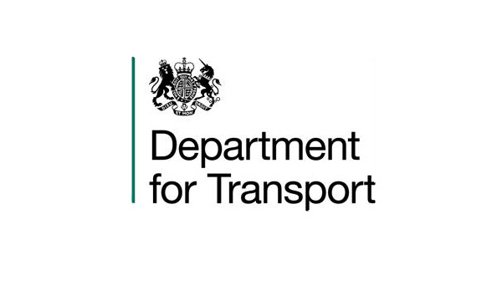

VARIATION TO CONTRACT FORM

Contract Name: The Provision of Legal Support to Assist with the Implementation of National Smart Ticketing Arrangements

CONTRACT REF: CCLL17A07-01

Current CCS ref: CCLL17A07

Variation Number: 1

Effective from: 6th December 2017

Between:

The Department for Transport (hereinafter called “the Client”) and Eversheds-Sutherland (hereinafter called “the Contractor”)

The Contract is varied as follows:

- This is a variation to the contract between the Client and the Contractor.
The Terms and Conditions of Contract as previously agreed and amended between the Client and the Contractor will still apply but with the following amendments:

The contract shall be extended for three months which is within the scope of the original contract from 6th December 2017 to 5th March 2018.

The terms and conditions of the contract will remain unchanged.

2. Words and expressions in this Variation shall have the meanings given to them in the Contract.

3. The Contract shall remain effective and unaltered except as amended by this Variation.

SIGNED

For the Client: For the Contractor:

[REDACTED] [REDACTED]

Full Name: [REDACTED] Full Name: [REDACTED]

Title: [REDACTED] Title: [REDACTED]

Date: 22/11/2017 Date: 27/11/2017

