Major Programmes and Projects Preconstruction Information

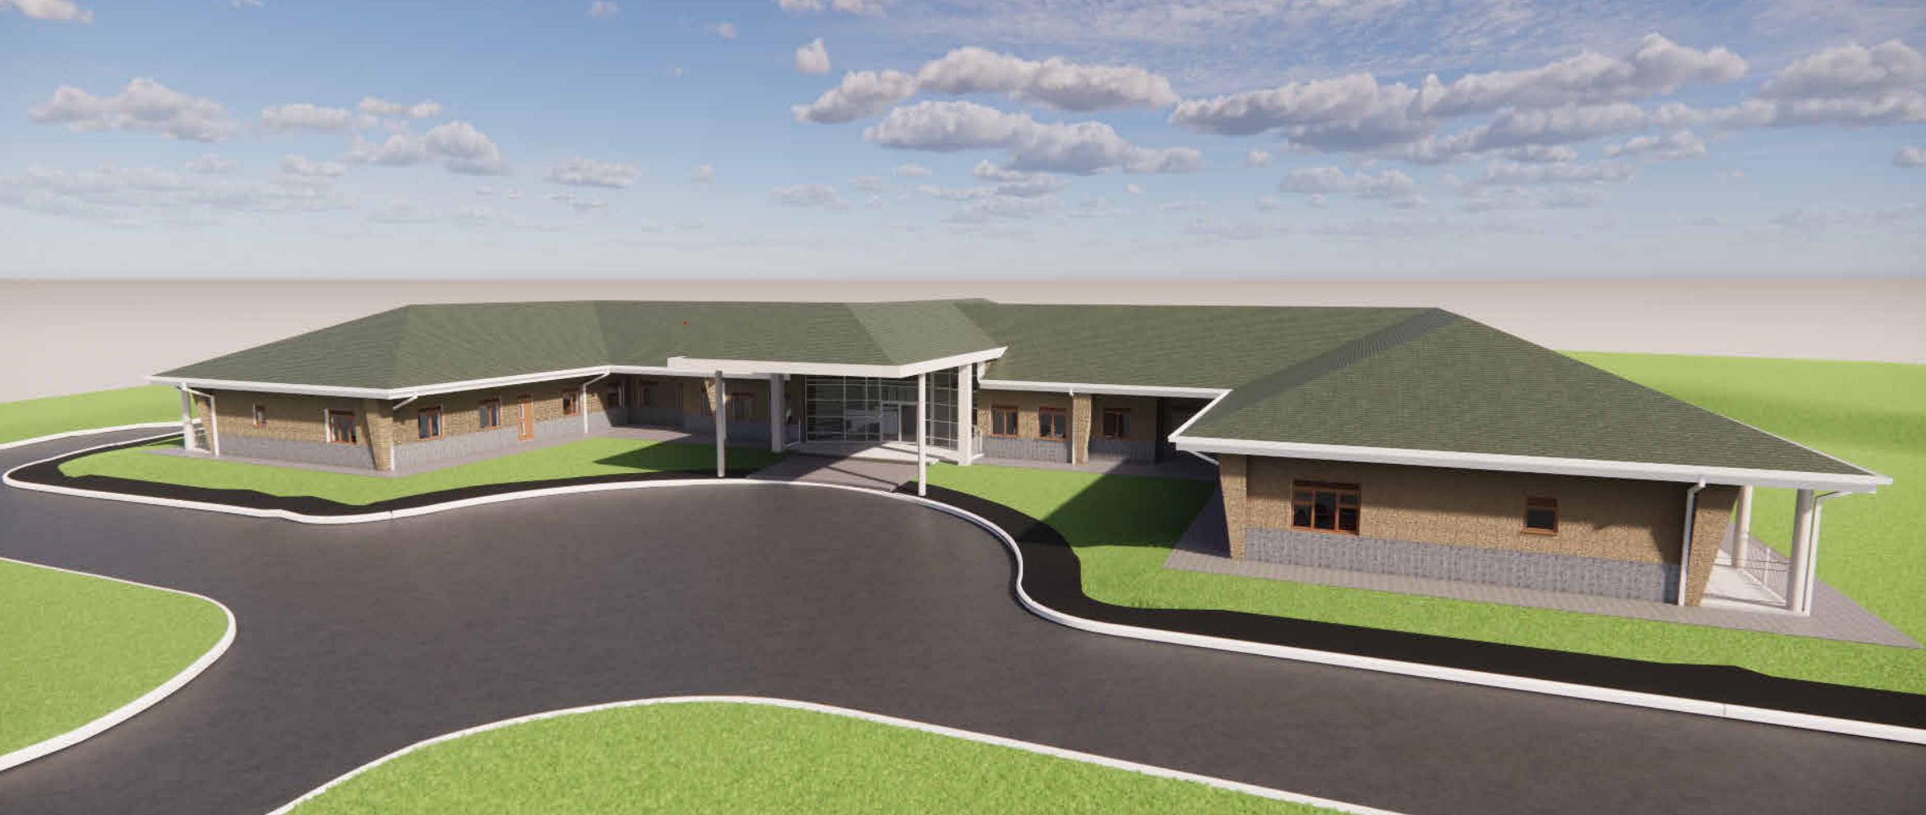

MPP Preconstruction Information Template

|  |  |
| --- | --- |
| **Project Title** | **Headquarters and Medical Centre – Enabling Works Package** |
| **Project Location** | **Counter Insurgency Terrorism & Stability Operations Training Centre - Kenya** |
| **Date Prepared** | **4th April 2024** |
| **Version (see end for details)** |  |

Table of Contents

Introduction 4

Preconstruction Information 4

Construction Phase Plan 4

Description and Overview of the Project 5

Timescales for Construction Events 5

Permitted Hours and times for Construction Activities 5

Site Details 5

Contact Details 5

Description of Project 7

Access Constraints 8

Surrounding Land Use 8

Existing Records and Plans 10

Project Constraints 11

Client’s and Head of Establishment Requirements 11

Health and Safety Goals 13

Health and Safety Aspirations 14

Communication and liaison with Client and Other Stakeholders 14

Welfare Provision 14

Smoking on Site 15

Site Transport and Deliveries 15

Permits to Work 15

Fire Precautions 15

Emergency Procedures and Means of Escape 15

No-go areas or other authorisation requirements for those involved in the project 15

Confined Spaces 15

Environmental Restrictions 16

Significant Design and Construction Hazards 16

Construction Phase Plan 16

Health and Safety File 16

# Introduction

## Preconstruction Information

1. This pre-construction information document forms part of the tender documentation for the appointment of the Principal Contractor (PC). It describes the project, construction work, timing, hazards, risks, standards of health, safety and welfare and identifies interfacing activities.
2. Designers and Contractors may use this information in conjunction with other contract documentation to plan their work. It is a responsibility of the Client (MPP) to ensure its preparation. MPP project managers must provide this document to the Principal Designer (PD) and PC as soon as practicable being considered for appointment.
3. The purpose of this MPP pre-construction information template is to simplify and standardise the process for MPP project managers and Technical Service Providers (TSPs). It also identifies the main health and safety issues in connection with the construction work and forms a basis for tenderers to explain their proposals for managing the risk inherent in the project.

## Construction Phase Plan

1. Once appointed, the Principal Contractor will further develop/update the pre-construction information as part of their duties (under Regulation 12) to produce their Construction Phase Plan. They will pay particular attention with taking reasonable steps to ensure co-operation between all Contractors to achieve compliance with the Regulations together with any specific rules and recommendations set down within the Construction Phase Plan.
2. No construction work will be allowed to commence until the Client (MPP Project Manager) is satisfied that a Construction Phase Plan has been prepared in accordance with Regulation 12 and this document is to be stored in the Project’s Z Folder.

# Description and Overview of the Project

## Timescales for Construction Events

1. The **MPP PM** is to denote the dates of when the key events will take place and number of weeks to complete:

|  |  |  |
| --- | --- | --- |
| Key Events | Date | Weeks |
| Start of Design | 15/05/2023 | 52 |
| Contract Award | 17/07/2024 Provisional |  |
| Minimum mobilisation period for preparation and planning for Construction Phase | 01/08/2024 | 2 weeks |
| Anticipated/provisional start date for the Construction Phase | 15/08/2024 |  |
| Anticipated/provisional duration of the Construction Phase |  | 17 weeks |
| Anticipated/provisional completion date | 12.12.2024 |  |

## Permitted Hours and times for Construction Activities

1. The **MPP PM** is to enter the permitted hours and days and any restrictions for noise for construction activities by contacting the Head of Establishment:
2. Hours: 08:00 until 18:00 Monday – Friday. 08:00 – 13:00 Saturday

1. Days: Monday to Saturday
2. Restrictions: N/A

## Site Details

8. The **MPP PM** is to enter the location of the project is: Counter Insurgency Terrorism & Stability Operations Training Centre – Kenya.

9. The **MPP PM** has determined that the structure will not be used as a workplace under the requirements of the Workplace Health, Safety and Welfare Regulations 1992.

## Contact Details

10. The **MPP PM** is to populate each point of contact for the following appointments listed within the table below using the left column to enter the organisation’s name and right column to enter specific contact details for that organisation:

|  |  |
| --- | --- |
| Client (enter MPP PM details) | |
| Defence Infrastructure Organisation | Name: Russell Ellwood  Mobile: +44 (0) 7773 220539  Email: [russell.ellwood.103@mod.gov.uk](mailto:russell.ellwood.103@mod.gov.uk) |
| Technical Service Provider or PSP | |
| AECOM | Name: George Rossi  Mobile: +44 (0) 7872 912114  Email: [george.rossi@aecom.com](mailto:george.rossi@aecom.com) |
| Head of Establishment | |
| Kenyan Defence Force | Name: Brigadier R B Wario  Telephone:  Mobile:  Email: |
| Head of Establishment Appointed Persons (Site Contractors) | |
| Kenyan Defence Force | Role: Head of Infrastructure – Kenyan Defence Force  Name: Col. Joshua Ndungu  Telephone: N/A  Mobile:  Email: [onenderi@gmail.com](mailto:onenderi@gmail.com)  Role: Clerk of Works  Name: Koros  Telephone: N/A  Mobile: +254 (0) 7245 18301  Email: |
| Principal Designer | |
| AECOM | Name: Anth Warren  Mobile: +44 (0) 7553 196353  Email: [anth.warren@aecom.com](mailto:anth.warren@aecom.com) |
| Principal Contractor | |
| To be confirmed | Name:  Mobile:  Email: |
| Contractors | |
| To be confirmed | Name:  Mobile:  Email: |
| Architect | |
| AECOM | Name: David Kelly  Mobile: +44 (0) 7388 948188  Email: [david.kelly2@aecom.com](mailto:david.kelly2@aecom.com) |
| Structural Engineer | |
| AECOM | Name: Matthew Penellum  Mobile: +44 (0) 7799 099517  Email: [matthew.penellum@aecom.com](mailto:matthew.penellum@aecom.com) |
| Civil Engineer | |
| AECOM | Name: Tommy Shinton Mobile: +44 (0) 7990 073538 Email: [tommy.shinton@aecom.com](mailto:tommy.shinton@aecom.com) |
| Mechanical & Electrical | |
| AECOM | Name: Guy Farline - Mechanical  Mobile: +44 (0) 7775 027495  Email: [guy.farline@aecom.com](mailto:guy.farline@aecom.com)  Name: Anthony Jameson - Electrical  Mobile: +44 (0)7384 819385  Email: [anthony.jameson@aecom.com](mailto:anthony.jameson@aecom.com) |
| Quantity surveyor | |
| AECOM | Name: Ben Snowling  Mobile: +44 (0) 7799 099842  Email: [ben.snowling@aecom.com](mailto:ben.snowling@aecom.com) |
| Health and Safety | |
| Ministry of Labour, Social Security and Services | Website: [www.laboursp.go.ke](http://www.laboursp.go.ke) |

## Description of Project

The Kenya CITSO Project is to deliver 2 Nr new facilities on the existing Nanyuki training base, via a tri-lateral arrangement between the UK, US, and Kenya. These new facilities are being constructed as part of the Conflict, Stability and Security Programme, and will consist of a new Headquarters and Medical Centre.

The buildings are single storey of masonry and concrete construction with a pitched roof covered with a jungle green clay tile. The headquarters building includes the provision of a reception facility, office space, conference facilities and associated building support (such as parking areas, footpaths, and landscaping). The medical centre includes the provision of a reception facility, examination rooms, laboratory, male & female observation rooms and a triage/procedures room and associated building support (such as parking areas, footpaths, and landscaping).

## Access Constraints

1. The MPP PM is to enter the Head of Establishment’s site constraints regarding access or articulate that there are no access constraints given by the Head of Establishment:
2. The PC is only authorised to access the headquarters and medical centre sites.

No contractor access will be given to access any KDF buildings on site.

## Surrounding Land Use

1. The MPP PM is to provide a description of the site, hazards, and area around the construction area. They are to consider the following:
2. Existing land.

The site is located on the south-eastern outskirts of Nanyuki, a town located at the foothills of Mt. Kenya which is approximately 150 km (90 miles) north of Nairobi. The proposed headquarters and medical facility sites currently comprise a conifer plantation managed by the Kenyan Forestry Service divided by several tracks at the northern end of the site. It should be noted that the conifer plantation is to be cleared for the proposed development.

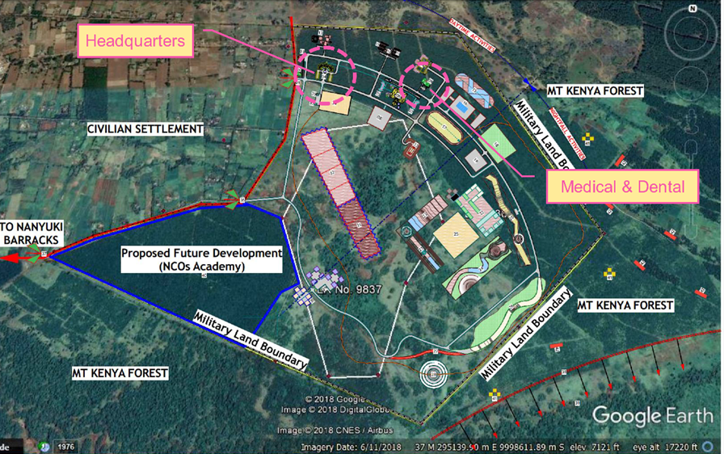

CITSO Training Centre Masterplan

The main access point for the site is a dirt road located southeast of the proposed headquarters. Construction work on some CITSO buildings has been completed. The central portion of the site extending from the western boundary to southeast is partially vegetated grassland with isolated clumps of trees, showing some signs of erosion such as wash outs, rills, and gullies. Significant portions of the site in the north, eastern and southwestern extents comprise of conifer plantations. Land located east of the site is a settlement comprised of numerous small agricultural holdings with residences. North and northwest of the site is recorded as Mt. Kenya Forest Land comprising of a mixture of woodlands with what appears to be scattered agricultural fields. Land bordering the site to the south and southwest also comprises of Mt. Kenya Forest although there are no signs of agriculture here and the land is more heavily vegetated.

1. Asbestos (include results of surveys and site asbestos management plan)

No asbestos management plan available for the site as it is currently a woodland site managed by the Kenyan Forestry Services.

Asbestos testing to be carried out as part of the ground investigation, and the results will be provided as part of the tender documentation.

1. Existing storage of hazardous materials. (This may have been included above, but please ensure chemical names are included)

No known storage of hazardous materials on site.

1. Contaminated ground (include results of surveys)

Ground investigation has been carried out and the results of ground contamination testing will be provided as part of the tender documentation.

1. Existing structures containing hazardous materials (Are there any zones that require special protection/ PPE due to materials being stored there?)

There are currently no existing structures on site containing hazardous materials.

1. Health risks arising from Head of Establishment (Ammo Compound, CS Gas etc.)

No storage of ammunition & CS gas on the 2no proposed development sites, although the Kenyan Defence Force may store ammunition, CS gas on the wider CITSO site – this is to be confirmed.

The Principal Contractor is to be aware that live ammunition/spent ammunition cases may be discovered within the development sites from previous military exercises.

## Existing Records and Plans

1. The **MPP PM** is to provide electronic links to locations the following documentation. These documents can be obtained via the Head of Establishment and Asset Information Model Common Data Environment (AIM CDE). Copies of these documents should be stored within the Project’s Z Folder, which was set up by your Project/Portfolio Management Office (PMO).
2. Existing asbestos surveys: Not applicable.
3. Existing ground surveys: Ground investigation to be provided as part of the tender documentation.
4. Any other existing surveys: A topographic survey of the site is available and will be provided as part of the tender documentation.
5. Existing drawings: Not applicable.
6. Project drawings: Drawings to be provided as part of the tender documentation.
7. Existing H&S File for the building: Not applicable.
8. Existing services: Existing services are present on site, and include:

* Overhead electric cables located on the southern boundary of the medical centre site, with an existing power pole located adjacent to the medical centre site entrance.
* Existing watermain located at the southern boundary of the medical centre site. Assumed to be temporary and will be removed prior to the start of construction.
* A water tank located adjacent to the headquarters site.
* Water mains located on the headquarters site – diversion required as part of the enabling works. A survey has been requested to confirm the water main route, size of main and tie-in points of the diversion.
* Water mains located on the headquarters site – existing 90mm pipe to be reinstalled to provide a minimum of 900mm cover below the proposed access road level.

1. Consider services below ground serving or crossing the site may be affected by this project insofar as new connections to utilities and subsurface drainage may be required.
2. Head of Establishment’s asbestos information/register: Not applicable
3. The accuracy and sufficiency of any asbestos information that may be available, is not guaranteed by the Client or the Head of Establishment. The Contractor must ascertain if any additional information is required to ensure the safety of all persons and the works, they must draw to the attention of all personnel working on the site the nature of any possible contamination and the need to take appropriate precautionary measures.
4. Existing fire safety management plans and risk assessments: Not available as advised by the KDF .
5. Existing structures: Not applicable
6. It is likely that nature and condition of the sites/buildings cannot be fully ascertained before construction has started. However, please include any structural information, ground conditions, lead paint and anthrax surveys.
7. Ground conditions: Ground investigation report to be provided as part of the tender documentation.
8. Provide information on ground conditions survey if undertaken or if no information is available on ground conditions and the contractor will need to ascertain ground conditions for the works and ensure that the site of the works is surveyed where necessary to establish and define conditions, particularly in respect of excavations for and the placing/construction of foundations, etc.

Previous structural modifications (including weakening or strengthening of the structure, If there have been previous projects that you think may have an effect on this one, please indicate where to find further information on that project).

## Project Constraints

1. The MPP PM is to enter the following details, if MOD staff retain some occupancy during construction works:
2. Are there other projects concurrently taking place that will affect delivery of this project:

KDF are undertaking separate projects on the wider CITSO site but these are outside of the headquarters and medical centre site areas, although both the headquarters building and medical centre are to be constructed concurrently by the same Principal Contractor.

1. Are department/building occupiers using or their work will be affected by biological, chemical, radioactive, noise or vibration issues?

No.

1. If any other relevant additional information which becomes available **MPP PMs** will forward to the Designers and Principal Contractor.

# Client’s and Head of Establishment Requirements

1. An outline of the arrangements for planning and managing Health and Safety during the construction phase of the project is listed below:
2. The **Head of Establishment** is responsible for the health and safety of all their employees at work and other people not in their employment, who are affected by the works, except within the demarcation lines of the construction site.
3. The **Principal Contractor** is responsible for health and safety within the demarcation lines construction site and those that might be affected by construction operations, including fire prevention and environmental protection.
4. **MPP** or the **Head of Establishment** shall have the right to suspend the construction work if they believe that a person’s safety is at risk.
5. **MPP** require that all work is undertaken in accordance with all statutory requirements with respect to health and safety. In addition, all relevant approved codes of practice and guidance notes shall be adhered to.
6. The **Principal Designer** shall review drawings and design changes throughout the project and raise any associated issues with respect to health and safety considerations with the design team.
7. The **Principal Contractor** is responsible for developing the Construction Phase Plan and maintaining it on site throughout the duration of the project. MPP requires that the Construction Phase Plan has been created before work commences on site. The **MPP PM** will be required to assess the plan to ensure it is suitable and sufficient.
8. **All personnel** on site must have received adequate training to undertake their work in a safe and competent manner. Information on the training of personnel, refresher training and statutory training certification should be held by the **Principal Contractor** and must be available for inspection at the site.
9. The **Principal Contractor** is required to take Head of Establishment site specific requirements like the site’s emergency procedures, management requirements and incorporate these requirements within their induction programme. The **Principal Contractor** is required to provide assurance to the MPP PM.
10. All Reporting of Injuries, Diseases and Dangerous Occurrences Regulations (RIDDORs) or overseas equivalents to RIDDORs and high-potential near misses, asbestos and legionella incidents or near-misses within the support chain shall be reported to DIO within 24hrs using the DIO Staff Reporting Application.
11. All other Accidents, Incidents and Near misses within the supply chain are to be reported onto Project Monthly Report (PMR), Project Progress Report (PPR) or Offline Incident Reporting Spreadsheet.
12. Accident, Incident and Near Miss Investigations are to be carried out by the **Principal Contractor** with an initial investigation report submitted to the MPP PM within one week and a full investigation is to be executed within four weeks.
13. Any training needs identified as being required during the course of the project shall be undertaken. These may be in the form of toolbox talks or other suitable methods.
14. The **Principal Contractor** shall be responsible for the management and behaviour of staff in accordance with Head of Establishment’s requirements and policies.
15. Health and safety shall be included on the agenda of all site meetings and significant items recorded and distributed to all relevant parties.
16. A system of monitoring the construction works to ensure the effective management of safety throughout the project duration shall be implemented by the Principal Contractor.
17. Such monitoring shall include:
18. Workplace inspections:
19. All **MPP PMs** are to execute DIO Tier 1 inspections to the construction site in accordance with the MPP Health, Safety and Environmental Protection (HS&EP) Arrangements.
20. **Technical Service Provider (TSPs)** are to execute DIO Tier 2 inspections to the construction site in accordance with the MPP Health, Safety and Environmental Protection (HS&EP) Arrangements
21. **Principal Contractor** and/or **TSP** agreed inspections.
22. Statutory inspections – scaffold, plant, equipment, excavations etc.
23. Sub-contractors – the monitoring of sub-contractors.
24. The **Principal Contractor** is responsible for the production of all required method statements and risk assessments with respect to his undertakings. In addition, the **Principal Contractor** shall review the method statements and risk assessments of all subcontractors on site and ensure that their content is suitable and sufficient before permitting any relevant activities to commence.
25. Details of all accidents, incidents on site and the findings of such investigations shall be forwarded promptly to the Client and Head of Establishment in accordance with MPP Health, Safety and Environmental Protection (HS&EP) Arrangements and the PD and PC appointment letters.

## Health and Safety Goals

1. The **MPP PM** and **TSP** are to list safety ‘Goals’ for the project. Safety goals are the result you want to specifically achieve. For example no RIDDOR accidents, net zero etc.

|  |  |
| --- | --- |
| List your goals | Explain how you will achieve this |
| Contractors are to follow the DIO Safety Strategy 2021 . | * Contractors’ senior HS&EP staff will request and read copy of the strategy. * Contractors’ senior HS&EP staff will implement and monitor relevant requirements within their HS&EP action plans. |
| For the site operatives, supervisory staff and general CITSO staff the safety goal of this project is zero accidents or incidents, injuries’, and illnesses. | By managing the risks to health and safety on site through design where applicable and by appointing competent contractors on site. |
| Contractors are to have no PPE non-conformances. | By appointing a competent Principal Contractor and competent contractors. Engaging with the workforce regarding health and safety. |
| Reporting of all near misses and incidents on site. | Encouraging the Principal Contractor to report incidents including near misses. |
|  |  |
|  |  |
|  |  |

## 

## Health and Safety Aspirations

1. The **MPP PM** and **TSP** is to list the safety ‘aspirations’ for the project. Safety aspirations are what you would like to achieve. For example zero accidents, carbon negative etc.

|  |  |
| --- | --- |
| List your aspirations | Explain how you will achieve this |
| Communicate safety matters in a suitable and timely manner & identify good and poor practices and share information | We will put people to work safely by ensuring they are capable, supported and risk aware.  We will influence decisions.  through compelling information, expert  advice and active advocacy |
| Prevent accidents and cases of work-related ill health | By managing the risks to health and safety on site through design where applicable and by appointing competent contractors on site. |
| Engage and consult with employees on day-to-day health and safety conditions | Principal Contractor to hold regular toolbox talks, safety briefings, open door policy |
| Provide and maintain plant, equipment’ and machinery | Principal Contractor to carry out regular recorded plant and equipment checks. |
| Positively reward health and safety performance/initiatives | Reward employees for positive health and safety performance/initiatives, e.g. prepaid SIM cards for mobile phones. |
| Provide and maintain welfare facilities to a high standard. | Provide the Principal Contractor with the guidance for the welfare facilities and confirm the DIO standards to be maintained. Monitor during site inspections and/or during video calls. |
|  |  |

## 

## Communication and liaison with Client and Other Stakeholders

1. The **MPP PM** is to list All formal communications, instructions, technical queries, etc. are executed in accordance with:
2. Project Progress Meetings.
3. Project Assurance Group Meetings.
4. Gateway Reviews.
5. Principles Meetings.

1. Designers, including those working for the Principal Contractor, have a duty to ensure design detailing is co-ordinated for health and safety.
2. A formal Design Change Approval process is required. Design development details, changes, instructions, etc. are to be copied to the Principal Designer for review and where necessary, comment. To facilitate this, the Principal Contractor shall identify appointed designers, provide designers with all necessary information and issue in good time design information, such as drawings to the Principal Designer.

## Welfare Provision

1. Unless agreed with the Head of Establishment, the Principal Contractor shall be required to provide his own facilities in this regard that shall comply with the requirements of Schedule 2 of the Construction (Design and Management) Regulations 2015. These are to be established before any construction activity commences on site and maintained in a hygienic manner for the duration of the project. Connection or alteration of water and wastewater services will require liaison with KDF via the MPP project manager.
2. The **MPP PM** is to include here details of any welfare considerations for the contractor to be aware of.

The Principal Contractor is to ensure the welfare facilities are provided for the full duration of the construction works and include the following as a minimum:

* Suitable and sufficient sanitary conveniences, these must be well lit and ventilated, kept in a clean & tidy condition, and have an adequate supply of toilet paper at all times. Separate facilities must be provided for men and women.
* Suitable and sufficient washing facilities, these must be in the immediate vicinity of the sanitary conveniences, these must be well lit and ventilated, and kept in a clean and tidy condition. Provision of an adequate supply of hot/warm and cold running water, have an adequate supply of soap and hand towels for drying.
* An adequate supply of potable drinking water, that is marked by appropriate signage and a sufficient number of suitable cups must be provided.
* Rest rooms to be provided complete with an adequate number of tables and seating, facilities to be provided for preparing/cooking food and boiling water. The facilities to be kept in a clean and tidy condition at all times.
* Changing rooms to be provided with separate facilities for men and women, adequate seating, and facilities for drying clothing.

## Smoking on Site

1. In accordance with MOD policy there is no smoking or vaping within the construction site or establishment.

## Site Transport and Deliveries

1. The **Principal Contractor** is to create a written Traffic Management Plan and agree in writing with Head of Establishment before work commences.

## Permits to Work

1. The **Principal Contractor** shall, implement a permit to work system (including Safe System of Work and Permits to Work, which includes interfacing with Head of Establishment contractor appointed persons for higher risk works activities, or where Head of Establishment requires it as part of their safety arrangements.

## Fire Precautions

1. The **Principal Contractor** shall carry out and keep an up-to-date Fire Risk Assessment consulting with the Head of Establishment.
2. The **Principal Contractor** shall act as the ‘Responsible Person’ for the construction area/site.

## Emergency Procedures and Means of Escape

1. The **Principal Contractor** shall create their emergency procedures and means of escape in accordance with the Head of Establishment’s emergency arrangements. They will participate in training and drills, if necessary.
2. The **Principal Contractor** is to ensure that their activities do not compromise any fixed or temporary alarms or the means of escape or any fire smoke detection equipment.
3. The **Principal Contractor** shall ensure that emergency procedures and means of escape are maintained throughout the Construction Phase and any additional measures as a result of the works or erection of scaffolding/hoarding, etc. on site are put in place and maintained as required. This includes the physical protection of routes, floors and other types of surfaces, access/egress points, locks and door furniture and emergency and safety lighting and signage for escape routes, etc.
4. The **Principal Contractor** shall have particular regard to the safety of the adjoining neighbours and shall ensure that all exit and escape routes from the adjoining premises are not obstructed and are maintained in a clean and clear condition at all times.

## No-go areas or other authorisation requirements for those involved in the project

1. The **Principal Designer** and **Principal Contractor** will consult with the Head of Establishment and list the areas that are ‘no go or have authorisation requirements:
2. **MPP PM** to list no go areas/other authorisation requirements or write N/A. Examples are operational restrictions, photography, airfield driving, tar boilers Radio Controlled equipment, electric substations etc.

All KDF building on the wider CITSO site are no-go areas for the Principal Contractor and contractors.

## Confined Spaces

1. All works involving work on or entry into confined spaces either listed on the Head of Establishment’s risk assessments or identified by the contractor shall be carried out in accordance with the requirements of the regulations and shall be subject to a safe system of work and the issue of a confined spaces permit to work, as appropriate.
2. N/A.

## Environmental Restrictions

1. All environmental protection zones like Special Site of Scientific Interests (SSSI), Ramsar sites and protected species are to be listed from the Head of Establishment’s documents by speaking to their HS&EP Advisor.
2. **MPP PM** to list all environmental protect and protected species near to camp that may be affected by construction or pollution or write N/A.

The Principal Contractor is to comply with the National Environment Management Authority (NEMA) License – NEMA/EIA/PSL/9356

1. The **Principal Contractor** is to engage and execute spill response training and practice, foreign object debris, dust, and noise control with the support of the Head of Establishment.

# Significant Design and Construction Hazards

1. Identify significant risks for Construction Phase (Designers risk register):
2. **Principal Designer** to list all risks identified during the design process.

* Water main diversion and water main reinstallation to the headquarters site.
* Temporary water main located on the medical centre site – it has been assumed this will be removed prior to the start of the construction works.
* Overhead cables and power poles located on the medical centre site.
* Excavations.
* Cut slope gradients 1:3.
* Site segregation – site to be segregated/fenced off from the surrounding training area and wildlife.
* Traffic movements around the CITSO site.
* Tree removal.

# Construction Phase Plan

1. The **Principal Contractor** is to produce at RIBA Stage 4 and develop thereon and ensure the Client agrees to the construction phase plan.

# Health and Safety File

1. The **Principal Contractor** shall comply with their duties under the CDM Regulations 2015 and obligations set out in the contract documents. The Principal Contractor is to complete the Health and Safety File within four weeks of issue of the Certificate of Practical Completion. Operation and Maintenance Manuals must be available before the building is handed over to the Client in electronic format.