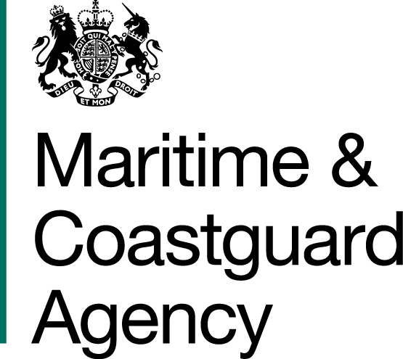 |  |  | Bay 3/21  Spring Place  105 Commercial Road  Southampton  SO15 1EG
 | To whom it may  Concern, |  | Tel:  E-mail: | +44 (0)20 381 72173  contracts@mcga.gov.uk
 |  |  | Your ref:  Our ref: |  | TCA 3/7/1000
 |  |  | 29 August 2017

INVITATION TO TENDER FOR INTRINSICALLY SAFE HYDRAULIC POWER PACKS

You are invited by the Secretary of State for Transport (from now on referred to as "the Authority") to submit a tender for the above contract.

One original and one copy (so marked) of your tender and proposals, including any covering letter, will be required. Your Tender Price should be entered onto the Price Schedule included within the documentation.

Tenders must be delivered by 11.00 hours on 3rd October 2017.

Late tenders will not be accepted and it is your responsibility to ensure that your tender is received on time.

As part of your tender you should supply the documents and information set out in sections 5, 6, 7 and 11-17 inclusive of the specification.

SHOULD YOU BE SUCCESSFUL, THESE DOCUMENTS AND ANY SUBSEQUENT CORRESPONDENCE BETWEEN YOU AND THE DEPARTMENT WILL FORM A BINDING CONTRACT BETWEEN YOU AND THE AUTHORITY.

Please read all the documents listed in the Form of Tender. To ensure that all tenderers have access to the same information you can only obtain further information about contractual issues and Technical Information from me (The Contract Officer). All requests must be submitted in writing to me at the above e-mail address, and must arrive no later than 5pm on Tuesday, 19th September 2017. The Department will respond to all queries not later than 5pm on Tuesday, 26th September 2017, and in the interest of fairness responses will be copied in anonymised form to all tenderers for the contract.

Yours sincerely,

Cheryl Whittle
MCA Procurement Team

