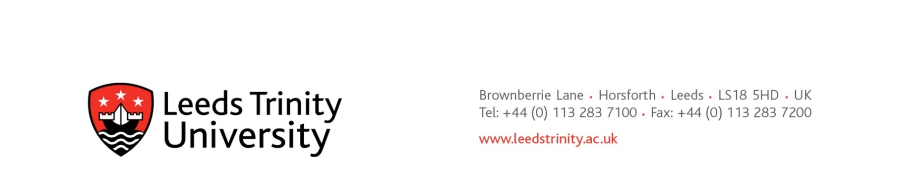

**15 December 2023**

**Preliminary Market Consultation**

Dear prospective supplier,

**University Shuttle Bus 2024 – Procurement Reference: TRA007 LTU**

**Background:**

The university currently operates a Shuttle Bus service, inclusive of vehicle and driver, for the transportation of passengers via predetermined routes connecting the university’s Horsforth Campus to Horsforth Rail Station and the local community. This is a non-fare service for the benefit of the university’s students, staff, and visitors.

The current contract expires at the end of this academic year, and tenders will soon be invited for the next contract period, which may endure until 31st July 2031.

In respect of the above, and as part of its early market engagement strategy for this procurement, Leeds Trinity University seeks advice from prospective suppliers with a view to developing the scope and specifications needed to plan and conduct its procurement procedures.

All relevant information exchanged or resulting from this preliminary market consultation will be documented and may be communicated to other candidates and tenderers participating in any resultant procurement procedure.

For the avoidance of doubt, no call for competition has yet been made. The university does not intend to use this early engagement notice as a means to shorten any tender period.

**The consultation:**

The university offers prospective suppliers the opportunity to review and critique its draft tender documents, thereby giving early insight to procurement intention. The documents are very much open to change, and the university will take on board relevant information exchanged in the consultation period and will amend drafted tender documents as appropriate.

Prospective suppliers are asked to consider the criteria, questions, and weightings, and to suggest any new or improved basis to ensure tenders it receives will demonstrate best value for money to the university.

Attention is also drawn to the tender timetable. The university wishes to allow prospective suppliers plenty of time in which to prepare their most compelling tenders. The university is also mindful to allow sufficient time for service mobilisation between contract award and start of the timetabled service.

The university wishes to receive guidance from prospective suppliers about any industry related mandatory standards, qualifications, or other legislative requirements that are applicable.

**Expressions of interest and responding**

Requests to participate in this preliminary market consultation will be received until 1000h on Friday 19th January 2024.

In the first instance, please indicate your interest and address queries by e-mail to [Mark Hayter](mailto:m.hayter@leedstrinity.ac.uk), Head of Procurement ([m.hayter@leedstrinity.ac.uk](mailto:m.hayter@leedstrinity.ac.uk)).

We intend to host an in-person pre-tender engagement meeting at the university on Thursday 25th January 2024, starting at 1000h. Attendees will need to be pre-registered.

We envisage being in a position to publish our invitation to tender on Monday 29th January 2024.

**Schedule of documents:**

TRA007 1.Preliminary Market Consultation (this document).

TRA007 2.Invitation to tender PMC DRAFT

TRA007 3.Specification and Service Level PMC DRAFT

TRA007 4.Response Guidance PMC DRAFT

TRA007 5.Response Document PMC DRAFT