Overview
Cornwall Council are exploring the option of working with a strategic partner with experience and a track record of successfully leading the delivery of support service transformation in a local authority environment. The intention is that the Strategic Partner would provide one senior individual to act in the role of programme director and perform a leadership role on the Support Services Transformation Portfolio Board. Furthermore we need a partner who can draw on a pool of Subject Matter Experts (SME) and business analysts to provide the capacity and capabilities across the various workstreams required to ensure the success of the programme.
Customer & Support Services directorate and the Support Services Review
In a recent restructure, Cornwall Council have brought all support services together into one directorate in order to offer the other Council directorates operating in resident facing roles the support of centralised back office and business critical services including HR, Finance, Legal, Audit, Property, Capital Projects delivery, Change & Project Management and IT/Digital Transformation.
Recognising that the performance of these areas was in need of review and understanding that internal & external customers had mixed opinions on the cost and quality of Support Services functions, a ‘discovery’ phase of work was undertaken as part of a Support Services Review, looking into issues and opportunities across the entire directorate. The review has gathered extensive insight into the Services provided by the Customers & Support Services (CSS) directorate to understand how it is currently performing and the biggest opportunities for improvement.
Target Operating Model (TOM)
The analysis showed that there are several key priorities and cross cutting themes that need to be addressed to improve the current level of service provided to our customers. As a result, the service has established a transformation programme to move to a new Target Operating Model (TOM see figure 1) with the associated investment in supporting tools, systems and ways of working alongside a sizeable cultural change.

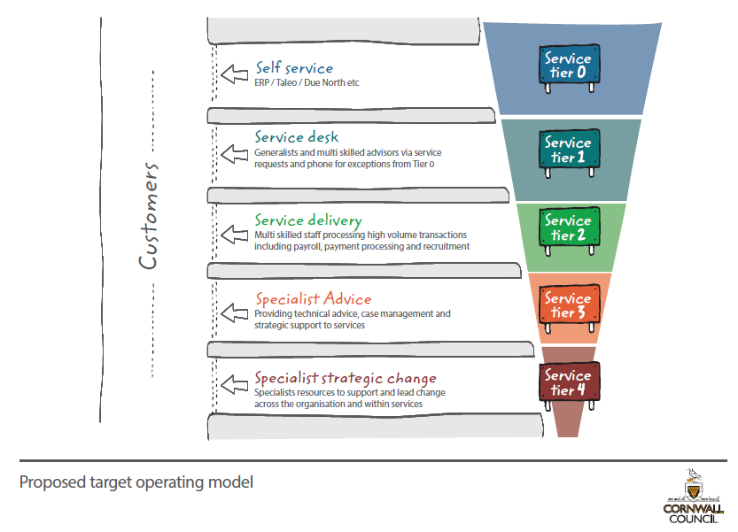
Figure 1 Target Operating Model
The TOM responds to issues that have been raised and provides a more visible and streamlined way of accessing Support Services for Customers. It also provides a better framework for internally aligning our Support Services with a push on improving Self Service and responding to frequent requests via a multi skilled service desk. This change in accessing and responding to information requests will release higher skilled resources capacity to support strategic and critical change across the organisation.
Moving to this Operating Model will require every team within C&SS to define which of its services will fit within each tier (i.e. which services will be self-service in future, how other services will be reached via service desks, which will be qualified as specialist advice etc.) and to establish what needs to be set up to enable this future functional model to work (i.e. which systems, which processes, which data etc.). The intentions of each team will also need to be brought together to ensure a future model which makes sense across the whole of C&SS, not just within single teams.
To enable delivery of the TOM and improve the effectiveness of the delivery of support services, there is also a need to improve and transform the key policies, processes, data, systems and the way that we access Support Services. This will respond to customer feedback and enable a more streamlined, efficient and leaner way of working which is aligned to the TOM. We also need to carry out some requirements gathering to enable us to put the right technology, processes, training & skills in place to move to the TOM. This work will form part of an Improve & Transform Programme.
Wider than simply dealing with issues within our own Council, the future of Support Services will also include closer partnership working with other public sector entities in the South West. This would mean working as a joint committee to share risk and reward, use common platforms, follow best practice, sharing pools of expertise and limit peaks and troughs by pooling resources to smooth skills & knowledge gaps. This approach will also ensure Cornwall Council has the flexibility to adapt to changing environments whilst preparing for a more Commercial outlook and becoming more future proof.
Transformation programme
In order to deliver the above, the Support Services Transformation Portfolio is being established with the following outlined objectives:
- Delivery of the new Target Operating Model for CSS
- Delivery of identified quick wins within each Support Service
- To deliver the savings targets for the Council
- To improve customer service
- To improve employee engagement
- To clarify our service offering and improve the way that customers access our services
- To provide more services online (digital by default)
- To provide the correct tools and training to empower our employees and Managers to work responsibly and effectively (in support of self service)
- To implement transparent and efficient processes with clear guidance and training
- To provide quality, timely servicing for strategic and critical requirements (including change management)
- To establish clear methods of costing and charging
- To generate more income via income generation
- To establish and implement a framework for working in partnership with other public sector entities
- To ensure effective governance arrangements to share dependencies and manage transition between this programme and Digital Cornwall
- To deliver all of the above through co-design with customers
A clear driving principle of the programme is that we will design our future solution in collaboration with the customers/service users of support services and with those who deliver the services themselves. The Programme governance structure has been designed to ensure customers are involved across the levels of decision-making and that co-design is included across all phases of the programme.
Figure 2: SST Governance Structure
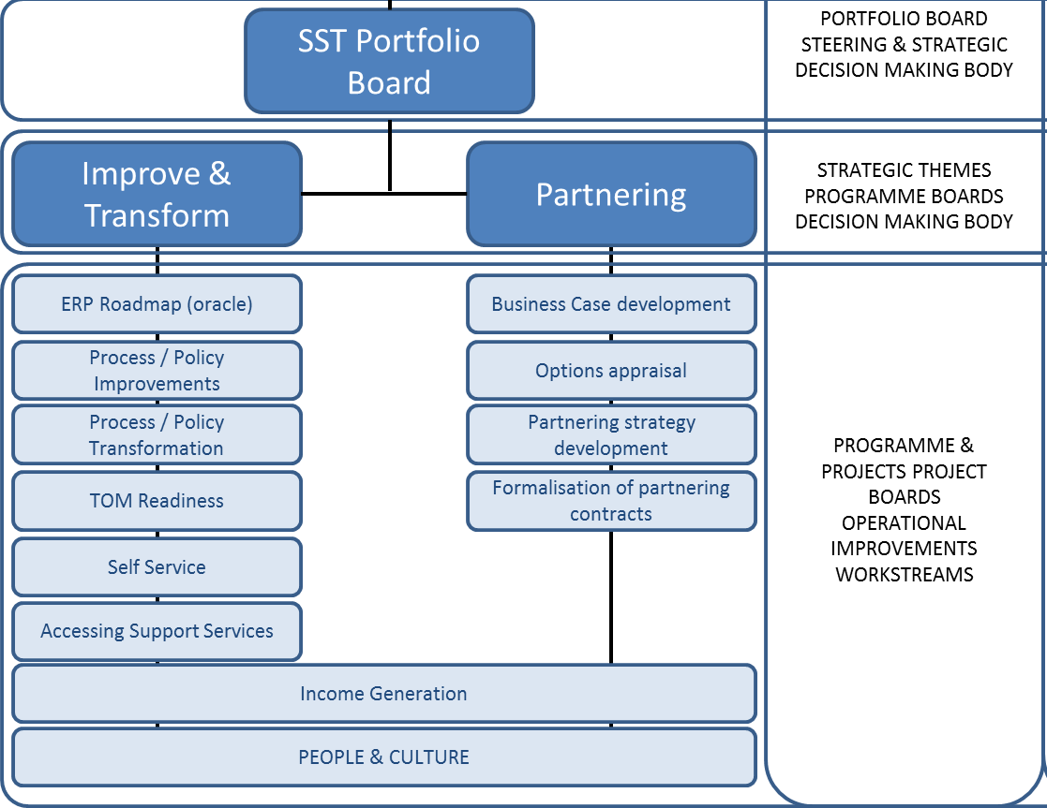
The Programme Director will act as a delegated SRO and will be responsible for driving the Portfolio to achieve the objectives and deliver the benefits targets.

