www.gov.uk/naturalengland

Request for Quotation:
River Derwent SSSI/SAC: A River Restoration Optioneering Project
You are invited to submit a quotation for the requirement described in the specification, Section 2.

Please confirm, by email, receipt of these documents and whether you intend to submit a quote or not.

Your response should be returned to the following email addresses by:

Email: Jennifer.Rowntree@Naturalengland.org.uk, Chris. Mcgregor@Naturalengland.org.uk
Date: 17th May 2024
Time: 12:00

Ensure you include the name of the quotation and ‘Final Submission’ in the subject field to make it clear that it is your response.

Contact Details and Timeline
Jenny Rowntree will be your contact for any questions linked to the content of the quote or the process. Please submit any clarification questions via email and note that, unless commercially sensitive, both the question and the response will be circulated to all tenderers.
Action | Date
Date of issue of RFQ | 23rd April 2024
Deadline for clarifications questions | 10th May 2024
Deadline for receipt of Quotation | 17th May 2024
Intended date of Contract Award | 3rd June 2024
Intended Contract Start Date | 10th June 2024
Intended Delivery Date / Contract Duration | 13th December 2024

Section 1: General Information

Glossary
Unless the context otherwise requires, the following words and expressions used within this Request for Quotation shall have the following meanings (to be interpreted in the singular or plural as the context requires):
“Authority” | Means Natural England who is the contracting authority.
“Contract” | Means the contract to be entered into by the Authority and the successful supplier.
“Response” | Means the information submitted by a supplier in response to the RFQ.
“RFQ” | Means this Request for Quotation and all related documents published by the Authority and made available to suppliers.

Conditions applying to the RFQ
You should examine your response and related documents ensuring it is complete and in accordance with the stated instructions prior to submission.

Your response must contain sufficient information to enable the Authority to evaluate it fairly and effectively. You should ensure that you have prepared your Response fully and accurately and that prices quoted are arithmetically correct for all the units stated.

By submitting a Response, you, the supplier, are deemed to accept the terms and conditions provided in the RFQ. Confirmation of this is required in Annex 2.
Failure to comply with the instructions set out in the RFQ may result in the supplier’s exclusion from this quotation process.

Acceptance of Quotations
By issuing this RFQ the Authority does not bind itself to accept any quotation and reserves the right not to award a contract to any supplier who submits a quotation.

Costs
The Authority will not reimburse you for any costs and expenses which you incur preparing and submitting your quotation, even if the Authority amends or terminates the procurement process.

Self-Declaration and Mandatory Requirements
The RFQ includes a self-declaration response (Annex 1) which covers basic information about the supplier, as well as any grounds for exclusion. If you do not comply with them, your quotation will not be evaluated.
Any mandatory requirements will be set out in Section 2, Specification of Requirements and, if you do not comply with them, your quotation will not be evaluated.

Clarifications
Any request for clarification regarding the RFQ and supporting documentation must be submitted via email no later than the deadline for clarifications set out in the Timetable. The Authority shall be under no obligation to respond to queries raised after the clarification deadline.
The Authority will respond to all reasonable clarifications as soon as possible but cannot guarantee a minimum response time. The Authority will publish all clarifications and its responses to all suppliers via email unless deemed commercially sensitive.
If a supplier believes that a request for clarification is commercially sensitive, it should clearly state this when submitting the clarification request. However, if the Authority considers either that:
- the clarification and response are not commercially sensitive; and
- all suppliers may benefit from its disclosure,
then the Authority will notify the supplier (via email), and the supplier will have an opportunity to withdraw the request for clarification by sending a further message requesting the withdrawal of the clarification request. If not withdrawn by the supplier within 2 working days of the Authority’s notification, the Authority may publish the clarification request and its response to all suppliers and the Authority shall not be liable to the supplier for any consequences of such publication.
The Authority reserves the right to seek clarification of any aspect of a quotation and/or provide additional information during the evaluation phase to carry out a fair evaluation. Where the Authority seeks clarification on any aspect of the quotation, the supplier must respond within the timeframe requested by the Authority.

Amendments
The Authority may amend the RFQ at any time prior to the deadline for receipt. If it amends the RFQ the Authority will notify you via email.
Suppliers may modify their quotation prior to the deadline for Responses. No Responses may be modified after the deadline for Responses.
Suppliers may withdraw their quotations at any time by submitting a notice via the email to the named contact.

Conditions of Contract
The Authority’s Standard Good and Services Terms & Conditions (used for purchases under £50k) can be located on the Natural England Website and will be applicable to any contract awarded as a result of this quotation process. The Authority will not accept any changes to these terms and conditions proposed by a supplier.
Suppliers should note that the quotation provided by the successful bidder will form part of the Contract.

Prices
Prices must be submitted in £ sterling, exclusive of VAT.

Disclosure
All Central Government Departments, their Executive Agencies and Non Departmental Public Bodies are subject to control and reporting within Government. In particular, they report to the Cabinet Office and HM Treasury for all expenditure. Further the Cabinet Office has a cross-Government role delivering overall Government policy on public procurement, including ensuring value for money and related aspects of good procurement practice. For these purposes, the Authority may disclose within Government any details contained in your quotation. The information will not be disclosed outside Government during the procurement.
In addition, the Authority is subject to the Freedom of Information Act 2000 and the Environmental Information Regulations 2004, which provide a public right of access to information held by public bodies. In accordance with these two statutes, the Authority may be required to disclose information contained in your quotation to any person who submits a request for information pursuant to those statutes.
Further to the Government’s transparency agenda, all UK Government organisations must advertise on Contract Finder in accordance with the following publication thresholds:
- Central Contracting Authority’s: £12,000
- Sub Central Contracting Authority’s and NHS Trusts: £30,000
For the purpose of this RFQ the Authority is classified as a Central Contracting Authority with a publication threshold of '£12,000' inclusive of VAT.
If this opportunity is advertised via Contracts Finder, we are obliged to publish details of the awarded contract including who has won the contract, the contract value, and indicate whether the winning supplier is a small and medium-sized enterprise (“SMEs”) or voluntary organisation or charity. A copy of the contract must also be published with confidential information redacted.
By submitting a quotation you consent to these terms as part of the procurement.

Disclaimers
Whilst the information in this RFQ and any supporting information referred to herein or provided to you by the Authority have been prepared in good faith the Authority does not warrant that this information is comprehensive or that it has been independently verified.
The Authority does not:
- make any representation or warranty (express or implied) as to the accuracy, reasonableness or completeness of the RFQ;
- accept any liability for the information contained in the RFQ or for the fairness, accuracy or completeness of that information; or
- accept any liability for any loss or damage (other than in respect of fraudulent misrepresentation or any other liability which cannot lawfully be excluded) arising as a result of reliance on such information or any subsequent communication.
Any supplier considering entering into contractual relationships with the Authority following receipt of the RFQ should make its own investigations and independent assessment of the Authority and its requirements for the goods and/or services and should seek its own professional financial and legal advice.

Protection of Personal Data
In order to comply with the General Data Protection Regulations 2018 the contractor must agree to the following:
- You must only process any personal data in strict accordance with instructions from the Authority.
- You must ensure that all the personal data that we disclose to you or you collect on our behalf under this agreement are kept confidential.
- You must take reasonable steps to ensure the reliability of employees who have access to personal data.
- Only employees who may be required to assist in meeting the obligations under this agreement may have access to the personal data.
- Any disclosure of personal data must be made in confidence and extend only so far as that which is specifically necessary for the purposes of this agreement.
- You must ensure that there are appropriate security measures in place to safeguard against any unauthorised access or unlawful processing or accidental loss, destruction or damage or disclosure of the personal data.
- On termination of this agreement, for whatever reason, the personal data must be returned to us promptly and safely, together with all copies in your possession or control.

General Data Protection Regulations 2018
For the purposes of the Regulations the Authority is the data processor.
The personal information that we have asked you provide on individuals (data subjects) that will be working for you on this contract will be used in compiling the tender list and in assessing your offer. If you are unsuccessful the information will be held and destroyed within two years of the award of contracts. If you are awarded a contract it will be retained for the duration of the contract and destroyed within seven years of the contract’s expiry.
We may monitor the performance of the individuals during the execution of the contract, and the results of our monitoring, together with the information that you have provided, will be used in determining what work is allocated under the contract, and in any renewal of the contract or in the award of future contracts of a similar nature. The information will not be disclosed to anyone outside the Authority without the consent of the data subject unless the Authority is required by law to make such disclosures.

Equality, Diversity & Inclusion (EDI)
The Client is striving to create a diverse and inclusive working environment where every individual has equality of opportunity to progress and to apply their unique insights to making the UK a great place for living. The Service Provider is expected to respect this commitment in all dealings with Natural England staff and service users.
Suppliers are expected to:
- support Defra group to achieve its Public Sector Equality Duty as defined by the Equality Act 2010, and to support delivery of Defra group’s Equality & Diversity Strategy.
- meet the standards set out in the Government’s Supplier Code of Conduct
- work with Defra group to ensure equality, diversity and inclusion impacts are addressed (positive and negative) in the goods, services and works we procure, barriers are removed and opportunities realised.

Sustainable Procurement
Addressing global sustainability impacts and realising additional community benefits within commercial activity is core to Defra group’s approach, working with its supply chain is key to achieving sustainable outcomes. In addition to supporting Defra group to meet its outcomes we look to understand and reduce negative sustainability impacts associated with our commercial activity and realise benefits.
The Client encourages its suppliers to share these values, work to address negative impacts and realise opportunities, measure performance and success.
Suppliers are expected to have an understanding of the Sustainable Development Goals, the interconnections between them and the relevance to the Goods, Services and works procured on the Client’s behalf.

Conflicts of Interest
The concept of a conflict of interest includes but is not limited to any situation where an Involved Person or Relevant Body has directly or indirectly, a financial, economic or other personal interest which might be perceived to compromise their impartiality and independence in the context of the procurement procedure and/or affect the integrity of the contract award.
We expect suppliers to mitigate appropriately against any real or perceived conflict of interest through their work with government. A supplier with a position of influence gained through a contract should not use that position to unfairly disadvantage any other supplier or reduce the potential for future competition
Where the supplier is aware of any circumstances giving rise to a conflict of interest or has any indication that a conflict of interest exists or may arise you should inform the Authority of this as soon as possible (whether before or after they have submitted a quotation). Tenderers should remain alert to the possibility of conflicts of interest arising at all stages of the procurement and should update the Authority if any new circumstances or information arises, or there are any changes to information already provided to the Authority. Failure to do so, and/or to properly manage any conflicts of interest may result in a quotation being rejected.
Provided that it has been carried out in an open, fair and transparent manner, routine pre-market engagement carried out by the Authority should not represent a conflict of interest for the supplier.

Section 2: Specification of Requirements
River Derwent SSSI/SAC: A River Restoration Optioneering Project
1. Background
1.1 Background to Natural England
The Authority is Natural England. The Authority’s priorities are to secure a healthy natural environment; a sustainable, low-carbon economy; a thriving farming sector and a sustainable, healthy and secure food supply. Further information about the Authority can be found at: https://www.gov.uk/government/organisations/natural-england
Our remit is to ensure sustainable stewardship of the land and sea so that people and nature can thrive. It is our responsibility to see that England’s rich natural environment can adapt and survive intact for future generations to enjoy.

1.2 Background to the Project

A River Restoration Optioneering Project is required to demonstrate the potential for working with natural processes to improve the geomorphological function of the River Derwent SSSI/ Special Area of Conservation (SAC), in North & East Yorkshire.
To date, there has been limited progress with improving the naturalness of the geomorphology of the River Derwent SSSI/SAC. Several key challenges have contributed to this such as the presence of several weirs and a tidal barrage, two significant drinking water abstractions and balancing the restoration of the river with the management of the adjacent internationally important floodplain meadows in the Lower Derwent Valley. The primary aim of this optioneering project is therefore to develop a set of possible restoration actions that could take place in the short-term within current constraints, whist investigations continue into wider aspects of restoration.
A River Restoration Plan and associated Technical Report was written in 2010 and outlines Natural England and the Environment Agency’s restoration ambitions on the River Derwent SSSI/SAC. The recommendations from this plan should be used to inform this optioneering project. The River Restoration Plan and associated Technical Report can be found on the River Restoration Centre website.

1.3 Background to the Study area
The Yorkshire River Derwent is a major tributary of the River Ouse, located to the north and east of York. The river rises on Fylingdales Moor in the North York Moors National Park and flows south until it meets the River Hertford. It then flows west through the Vale of Pickering, resumes its southerly direction through the Vale of York, and joins the River Ouse at Barmby-on-the-Marsh. The river has been designated as a Site of Special Scientific Interest (SSSI) from its confluence with the River Rye to its downstream confluence with the River Ouse (with the exception a short sections through Malton), the SSSI having a total length of c.70km.
The River Derwent SSSI is divided into 21 SSSI units, which Natural England uses to manage and monitor the condition of the site. Four of these units relate to the river itself, whilst the remainder relate to land-based supporting habitats along the river corridor. The four river-based units are shown in Figure 1. This constitutes the area for investigation of this optioneering project. For the purposes of the River Restoration Plan, the river units of the SSSI have been further broken down into 22 reaches, shown in Figure 2. This optioneering project should report findings on a both a reach and SSSI unit level.
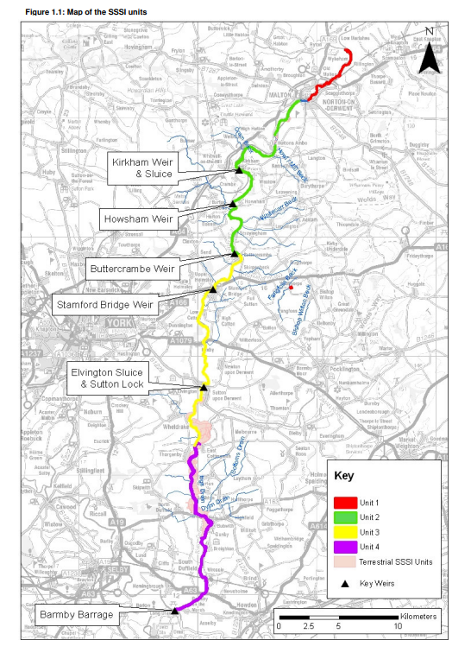
Figure 1: Study area and River Derwent SSSI Units. River Derwent Restoration Plan, 2010

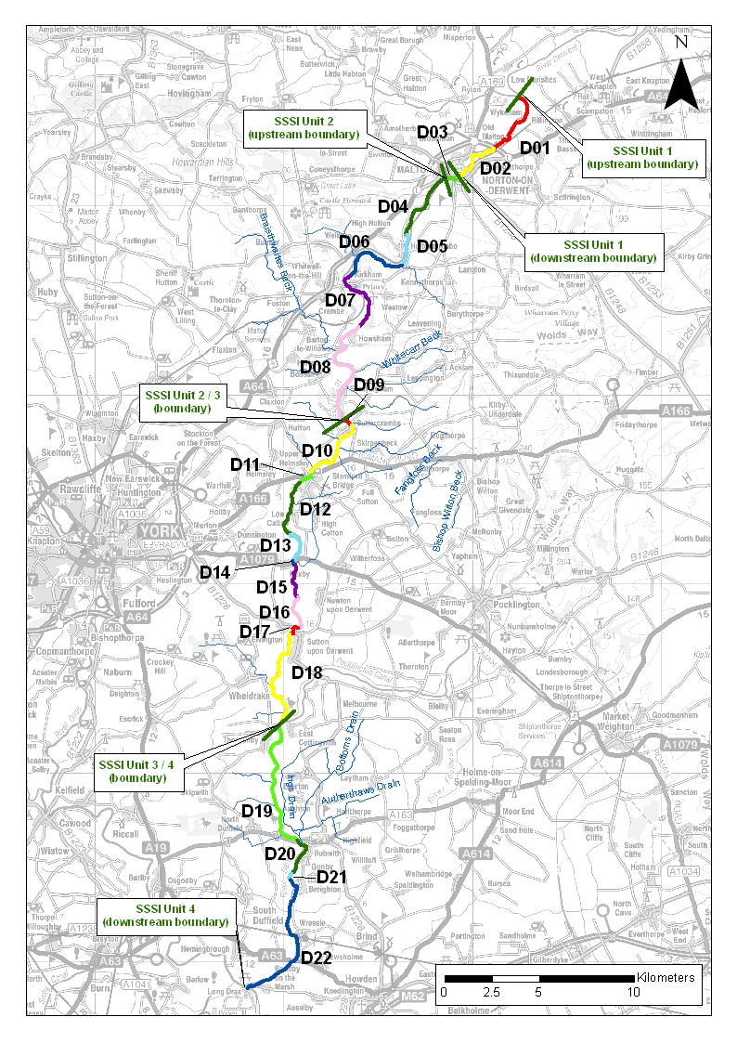

Figure 2: Location of River Restoration Plan reaches D01 to D22 (and SSSI units) along the River Derwent SSSI. River Derwent Restoration Plan, 2010
Designated Features
The River Derwent SSSI has been designated for its natural lowland character as well as the particular characteristics:
- Classic lowland river profile with diverse flora and fauna.
- Aquatic plant community characteristic of lowland rivers (including un-branched bur-reed (Sparganium emersum), yellow water-lily (Nuphar lutea), flowering rush (Butomus umbellatus), shining pondweed (Potamogeton lucens), arrowhead (Sagittaria sagittifolia) and narrow-leaved water-parsnip (Berula erecta)).
- Otter (Lutra lutra.
- Diverse fish communities including bleak (Alburnus alburnus) and ruffe (Gymnocephalus cernuus).
- Rich assemblage of invertebrates including mayflies (Baetis buceratus, Heptagenia fuscogrisea and Brachycerus harisella) as well as the banded agrion dragonfly (Agrion splendens).
- The breeding bird community including common sandpiper (Actitis hypoleucos), dipper (Cinclus cinclus), kingfisher (Alcedo atthis), yellow wagtail (Motacilla flava) and grey wagtail (Motacilla cinerea).

In addition to being designated as a SSSI, the River Derwent is also internationally designated as a Special Area of Conservation (SAC), and some areas of the river are part of the Lower Derwent Valley Special Protection Area (SPA). The additional SAC/SPA designation is recognition that some or all of the wildlife and habitats are particularly valued in a European context.
The River Derwent SAC designation is based on the following interest features:
- Natural lowland river character
- Assemblage of floating and submerged plants, including Ranunculion fluitantis and Callitricho-Batrichion communities
- River lamprey (Lampetra fluviatilis)
- Sea lamprey (Petromyzon marinus)
- Bullhead (Cottus gobio)
- Otter (Lutra lutra)

The River Derwent flows through the Lower Derwent Valley in it lower reaches, which is made up of a number of SSSI floodplains together making up the Lower Derwent Valley Special Area of Conservation (SAC), Special Protection Area (SPA) and Ramsar, parts of which are managed as a National Nature Reserve (NNR).
These floodplain meadows are of importance for their grassland and fen communities, of particular importance is the large extent of MG4 Alopecurus pratense – Sanguisorba officinalis grassland, which forms part of the SAC and SSSI designations. The floodplain in this area also supports internationally and nationally important bird features throughout the year which include wintering, breeding and migratory waterfowl. The birds are dependent upon suitable habitat conditions provided by the broad range of floodplain habitats.
The Conservation Objectives and Supplementary Advice for the River Derwent SAC and Lower Derwent Valley SAC and SPA can be found via the Designated Sites View website here:
- River Derwent SAC
- Lower Derwent Valley SAC
- Lower Derwent Valley SPA

1.4 Project Aims
The River Derwent Restoration Plan and Technical Report contain background information on the geomorphology and ecology of the river and its floodplains, key constraints, and broad restoration recommendations, broken down into reach-by-reach summaries and maps. The aim of this project is to use these broad recommendations (and any other opportunities identified outside of the Restoration Plan) to identify and present potential restoration projects in a visually engaging way at the river reach and SSSI unit scale.
This project is not intended to be a full feasibility project, but rather aims to identify possible restoration actions and present them in engaging maps/graphics to use with landowners and partners, prior to being worked up in future to full project-level detail. Presenting restoration actions in a visually engaging and accessible way is therefore a key aim of this project. It may be appropriate to work with a different specialist organisation to ensure this aim can be met.
In particular, this optioneering project should outline possible restoration projects that focus on naturalising the geomorphology of the river and improving natural function.
The following work or investigations, highlighted in the River Derwent Restoration Plan, is already underway through different workstreams and is therefore outside of the scope of this project:
- Investigating the removal or amendment of the weirs and tidal barrage to restore more natural river geomorphology and associated processes.
- Reduction of sediment pollution/sediment inputs.
- Management of Invasive Non-Native Species (INNS)

In addition, this project will only look at the removal or amendment of flood banks where they are not connected with the management of the Lower Derwent Valley SAC/SPA/Ramsar floodplain meadows, and where the flood banks are not providing significant flood protection to people and property. This is in line with the project aim to focus on restoration options that can take place in the short-term to improve the geomorphology of the river, whilst strategic work is ongoing to investigate wider restoration.
This optioneering project should therefore focus on restoration options that can take place within the following scenario:
- The weirs and Barmby Tidal Barrage being in place in their current form.
- The flood banks that deliver a significant flood risk benefit to people and property and those associated with the management of the Lower Derwent Valley SPA/SAC/Ramsar not being altered.
It should however, be stressed that restoration options should not compromise, possible longer-term actions to restore more natural river geomorphology and a natural tidal regime. Options should be suggested within the context that the natural tidal regime and associated river processes in the lower part of the river could be reinstated in the future.
- Project Requirements
2.1 Areas of Investigation
This project will form an options appraisal and will:
- Undertake a desk-based audit to inform the project, using existing available data, including the River Derwent Restoration Plan and Technical Report. This should include: Existing geomorphological features and hydrology, wildlife and biodiversity, landscape and historic features. Seek additional/updated information where necessary.
- Produce a restored river Width: Depth profile along the length of the SSSI/SAC, informed by the characteristics of the river (e.g. flow, sediment regime).
- Undertake a targeted field survey informed by the desk-based audit, to collect updated or any additional information required to make project recommendations. This should involve up to 10 site visits. Sites will be selected in consultation with Natural England. Access permission will be organised by Natural England, as detailed in section 2.3. One Natural England staff member should have the option to join site visits.
- Identify restoration opportunities for re-naturalising the river, in particular; channel reprofiling (e.g., addressing the historic deepening and widening of the channel), improving marginal and riparian vegetation, re-meandering, improving flow variation, increasing woody debris and removing or altering selected flood banks (see below). The restoration options identified should contribute towards moving the SSSI towards favourable condition in terms of the monitoring targets related to the river’s geomorphology, as measured through River Habitat Survey (RHS), and the key issues identified in the River Derwent Restoration Plan. Several restoration options may be proposed per reach, where relevant.
- Flood bank investigation:
- Identify flood banks that could be removed or amended to improve connectivity between the river and the floodplain. To note, flood banks identified must not be associated with the hydrology of the Lower Derwent Valley SAC/SPA/Ramsar floodplain meadows or be providing significant flood risk benefit to people and property.
- In the areas identified, actions required to restore the hydrological function of the floodplain and create suitable floodplain habitats should also be outlined.
- Any key changes and risks from restoring geomorphological processes should be outlined (including the likelihood of avulsion and the extent of any likely lateral channel migration).
- Outline the key impacts (positive and negative) of implementing the proposed restoration works both on and off the holdings, particularly considering the impact on other SSSI/SAC/SPA interest features which may be present on functionally connected land as well as within the SSSI/SAC/SPA itself.
- Outline, at a high-level, the likely impacts on flood regime and flood risk to people and property (full feasibility study detail is not expected).
- Identify further work needed to inform statutory permissions for project implementation and consider likely constraints, consents and approvals. Historic features within the project area that could be impacted by works should be included.
- Provide approximate estimated cost scenarios associated with restoration options.

  - Summary of Deliverables

- Produce standalone, visually engaging maps/graphics illustrating the proposed restoration options and specific points of interest. As appropriate, these may be supported by target notes, photographs, or example cross sections, to clearly show options in an engaging manner. The maps/graphics should be produced at a scale that shows the proposed works clearly. The mapping output must be produced in a format that Natural England can easily share with partner organisations and land managers.
- Summarise project findings in a comprehensive project report. The supplier must comply with Natural England publishing standards for commissioned reports (NECR000) and use the report template provided on the page, following the guidance within it. The supplier must include a clear section on any third-party data replicated or used to derive the output from, and how, within the report. An electronic copy of the draft report, in Word format, should be submitted to Natural England for consideration and comments. The report should include:
- Executive Summary.
- Introduction to the project.
- Summary of the desk audit and site visit findings, including any additional data collected and photos.
- Methods.
- Presentation and discussion of the restored river Width: Depth profile.
- Summary of the recommended restoration options, including key considerations, constraints, permissions and future work required as detailed in section 2.1.
- A discussion of the findings, outlining any caveats and/or limitations of project findings.
- References and details of data lineage and licensing.
- Deliver a presentation of the key project findings and recommendations to the Natural England project group.
- Produce a presentation that can be used by Natural England to engage with partner organisations on the project outputs, using the Natural England presentation template.
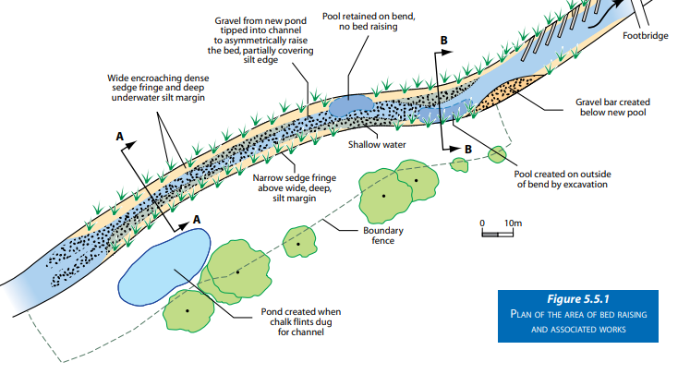
Figure 3: Example Restoration Map – Extract from River Restoration Centre Manual of River Restoration techniques

  - Access to Land and Health and Safety

Natural England will obtain landowner/manager permission in advance of the site visits. As may be necessary, we will supply contact details of local personnel with whom the contractor will liaise. We can also supply site access notes and other details as may be helpful based upon our knowledge of the area. Any personal or other confidential details must be treated in strict confidence according to GDPR requirements. Where required, permissions must be obtained at least 48 hours prior to each visit. Should permission be refused at short notice or upon arrival, the Natural England project officer should be notified as soon as possible with the view to rapid resolution.
The contractor is responsible for the health, safety and welfare of the contract workforce. You should enclose your own risk assessment for the work to be done with your quotation submission, as detailed in the evaluation criteria.

  - Data ownership, intellectual property rights and copyright

All data captured and produced shall be fully owned by and copyrighted to Natural England. This shall include any intellectual property rights that might otherwise impede on Natural England’s usage and data sharing of the outputs.
See standard Terms and Conditions for further details.
The supplier can request to use data held by Natural England and complete some of our contractor licences at https://www.gov.uk/guidance/how-to-access-natural-englands-maps-and-data#request-data.
Additional Data Sources
Additional data and information is available on the River Derwent SSSI to support this project on request. This includes but is not limited to SSSI monitoring data such as River Habitat Survey (RHS), macrophyte and bird surveys. We may also be able to facilitate obtaining selected Environment Agency data.

- Sustainability

Natural England protects and improves the environment and is committed to reducing the sustainability impacts of its activities directly and through its supply chains. We expect the Contractor to share this commitment and adopt a sound, proactive sustainable approach in keeping with the 25-year environment plan/ our commitments compliant with all applicable legislation. This includes understanding and reducing direct and indirect sustainability impacts and realising opportunities, including but not restricted to; resilience to climate change, reducing greenhouse gas emissions, water use and quality, biosecurity, resource efficiency and waste, reducing the risk of pollution, biodiversity, modern slavery and equality, diversity & inclusion, negative community impacts.
As a delivery partner, the successful contractor is expected to pursue sustainability in their operations, thereby ensuring the Contracting Authority is not contracting with a supplier whose operational outputs run contrary to the Contracting Authority’s objectives. The successful contractor will need to approach the project with a focus on the entire life cycle of the project.

4. Outputs and Contract Management

This contract shall be managed on behalf of the Authority by:
Project officer: Jenny Rowntree
Support officer: Chris McGregor
The project officer will serve as the principle point of contact from Natural England. They will be responsible for the day-to-day management of this contract and will coordinate Natural England’s attendance at regular meetings to review the work and ensure it meets the project’s aims and objectives. As outlined below, meetings will be incorporated into the programme of works to discuss progress and facilitate feedback provision. Meetings will be organised by the contractor.
The contractor will be expected to appoint a Project Manager who will act as the principle point of contact and will be responsible for the day-to-day management of the project. The contractor will be required to regularly update the Natural England Project Officer on project progress via meetings (MS Teams preferred) arranged by the contractor, and email/ phone updates, where necessary. Any unforeseen issues arising in the course of the contract must be raised with the Project Officer as early as possible to facilitate prompt resolution. The contractor is responsible for assessing the risks associated with the project as planned and for putting in place mitigation measures to respond to them.

Reference | Deliverable | Responsible Party | Date of completion
 | Monthly progress reports will be provided to the project officer | Contractor | Monthly
Task 1 | Project start and inception meeting:  Key project milestones for fieldwork and submission of draft and final reports and mapping outputs will be confirmed at a project inception meeting between the supplier and the Project Officer | Contractor and Natural England | W/c  10th June 2024  (estimated)
Task 2 | Methodology finalised and confirmed via email. | Contractor | W/c  24th June 2024  (estimated)
Task 3 | Progress meeting via video conference | Contractor and Natural England | W/c  12th August 2024  (estimated)
Task 4 | Submission of draft maps and draft report | Contractor | W/c  28th October 2024  (estimated)
Task 5 | Progress meeting via video conference-discussion of draft maps and draft report | Contractor and Natural England | W/c  11th November 2024  (estimated)
Task 6 | Maps, report and presentation finalised and submitted | Contractor | W/c  25th November 2024  (estimated)
Task 7 | Present findings to the Natural England project steering group. | Contractor | W/c  2nd December 2024  (estimated)

5. Payment
The Authority will raise purchase orders to cover the cost of the services and will issue to the awarded supplier following contract award.
The Authority’s preference is for all invoices to be sent electronically, quoting a valid Purchase Order number. Natural England should be invoiced once the final report, maps and presentation have been supplied to and signed off by Natural England at the end of the project.
It is anticipated that this contract will be awarded for a period of approximately 6 months and 1 week to end no later than 13th December 2024. Prices will remain fixed for the duration of the contract award period. We may at our sole discretion extend this contract to include related or further work. Any extension shall be agreed in writing in advance of any work commencing and may be subject to further competition.

6. Evaluation Methodology
We will award this contract in line with the most economically advantageous tender (MEAT) as set out in the following award criteria:
Technical (quality) – 70%
Commercial (price) – 30%
6.1. Evaluation criteria
Evaluation weightings are 70% technical and 30% commercial, the winning tenderer will be the highest scoring combined score.
Award Criteria | Weighting (%) | Evaluation Topic & Weighting | Sub-Criteria | Weighted Question
Technical | 70% | Service / Product Proposal | Methodology | 1 question  Q1 (40% of technical score available) Provide details of the methodology and approaches proposed to deliver the requirements set out in the Specification.
 |  |  | Key personnel and technical expertise | 1 question  Q2 (30% of technical score available) Provide details of the key personnel proposed to deliver the requirements of this project.
 |  |  | Project and Risk Management | 3 questions  Q3.1 (10% of technical score available) Provide details of how you intend to manage the project to identify risks to delivery and ensure that project tasks are achieved within the timescales.  Q3.2 (10% of technical score available) Provide details of how you intend to quality assure work undertaken as part of this project.  Q3.3 (10% of technical score available) Provide details of how you intend to manage health and safety risks associated with this project
Commercial | 30% | Whole life cost of the proposed Contract | Commercial Model | 1 Question  Q6 (100% of commercial score available) Provide a breakdown of the costs to provide the deliverables stated in the Specification of Requirements.

6.2 Scoring responses

6.2.1. Technical (70%)
Technical evaluations will be based on responses to specific questions covering key criteria which are outlined below. Scores for questions will be based on the following:
Description | Score | Definition
Very good | 100 | Addresses all the Authority’s requirements with all the relevant supporting information set out in the RFQ. There are no weaknesses and therefore the tender response gives the Authority complete confidence that all the requirements will be met to a high standard.
Good | 70 | Addresses all the Authority’s requirements with all the relevant supporting information set out in the RFQ. The response contains minor weaknesses and therefore the tender response gives the Authority confidence that all the requirements will be met to a good standard.
Moderate | 50 | Addresses most of the requirements with most of the relevant supporting information set out in the RFQ. The response contains moderate weaknesses and therefore the tender response gives the Authority confidence that most of the requirements will be met to a suitable standard.
Weak | 20 | Substantially addresses the requirements but not all and provides supporting information that is of limited or no relevance or a methodology containing significant weaknesses and therefore raises concerns for the Authority that the requirements may not all be met.
Unacceptable | 0 | No response or provides a response that gives the Authority no confidence that the requirement will be met.

Technical evaluation is assessed using the evaluation topics and sub-criteria stated in the Evaluation Criteria section above.
Separate submissions for each technical question should be provided and will be evaluated in isolation. Tenderers should provide answers that meet the criteria of each technical question.
Methodology | Detailed Evaluation Criteria
Q1 Provide details of the methodology and approaches proposed to deliver the requirements set out in the Specification. | Your response should:  1) Demonstrate a clear understanding of the nature of the requirements, as set out in the Specification.  2) Be a clear, practical and achievable methodology to deliver these requirements.  3) Include a proposed outline schedule/timetable of works, and details of the proposed approach.  4) Have sufficient detail to allow a full appraisal of the suitability of the approach to deliver for the project.  A minimum score of 50 averaged across evaluators is required to be met for this question. Any average score below this may result in a fail.

Key personnel and technical expertise | Detailed Evaluation Criteria
Q2 Provide details of the key personnel proposed to deliver the requirements of this project. | Your response should:  - Provide relevant qualifications, technical knowledge and experience of the project team personnel that would be engaged on the contract.  - Provide examples of similar projects that the team have worked on. This should outline the experience of staff members of obtaining and using similar data, using appropriate mapping software, and providing evidence-based river restoration advice.  - Demonstrate experience of producing visually engaging river restoration graphics/maps/concept designs. Examples of these should be included in your response.  - Demonstrate that the project team will have appropriate balance of inputs by senior and more junior staff. The information provided should include, for each member of the project team: Information on the amount of time input to this specific project, their roles, responsibilities, levels of seniority, the value added that they will bring to the project, their lines of reporting and their availability to do the work.  We suggest a project specific organogram is provided.  A minimum score of 50 averaged across evaluators is required to be met for this question. Any average score below this may result in a fail.

Project and Risk Management | Detailed Evaluation Criteria
Q3.1 Provide details of how you intend to manage the project to identify risks to delivery and ensure that project tasks are achieved within the timescales. | Your response should:  - Provide an assessment of the potential risks to project delivery and mitigation (including contingency in the event of delays). This includes how you intend to manage any risks to project delivery associated with any sub-contracting arrangements, if applicable.  - Provide a proposed timetable of data collation, field work and work delivery, referring to the deliverables in the Specification.  A minimum score of 50 averaged across evaluators is required to be met for this question. Any average score below this may result in a fail.
Q3.2 Provide details of how you intend to quality assure work undertaken as part of this project. | Your response should:  - Demonstrate quality assurance measures that will be implemented to ensure deliverables are provided to a high standard, efficiently and on time.  - Outline what experience you have in relation to quality assurance for similar projects.  A minimum score of 50 averaged across evaluators is required to be met for this question. Any average score below this may result in a fail.
Q3.3 Provide details of how you intend to manage health and safety risks associated with this project | Your response should:  - Identify and describe how you will manage any health and safety issues associated with this project, in particular the field visits.  Please provide examples of the following documents as evidence of your risk management, health and safety and environmental policies and procedures:  • A field survey risk assessment  • Lone working practices  • Any Health and Safety policies and certificates  A minimum score of 50 averaged across evaluators is required to be met for this question. Any average score below this may result in a fail.

6.3 Commercial (30%)
The Contract is to be awarded as a fixed price, which will be paid according to the completion of the deliverables stated in the Specification of Requirements.
Suppliers are required to submit a total cost to provide the deliverables stated in the Specification of Requirements. In addition to this the Commercial Response template must be completed to provide a breakdown of the whole life costs against each deliverable used in the delivery of this requirement

6.4 Calculation Method
The method for calculating the weighted scores is as follows:
- Commercial Score = (Lowest Quotation Price / Supplier’s Quotation Price ) x 30% (Maximum available marks)

- Technical Score = (Bidder’s Total Technical Score / Highest Technical Score) x 70% (Maximum available marks)
The total score (weighted) (TWS) is then calculated by adding the total weighted commercial score (WC) to the total weighted technical score (WT): WC + WT = TWS.

7. Information to be returned
Please note, the following information requested must be provided. Incomplete tender submissions may be discounted.
Please complete and return the following information:
- Completed Commercial Response template
- Separate response submission for each technical question (in accordance with the response instructions)
- Completed Mandatory Requirements (Annex 1)
- Completed Acceptance of Terms and Conditions (Annex 2)

8. Award
Once the evaluation of the Response(s) is complete all suppliers will be notified of the outcome via email.
The successful supplier will be issued the contract, incorporating their Response, for signature. The Authority will then counter sign.

Annex 1 Mandatory Requirements

Part 1 Potential Supplier Information
Please answer the following self-declaration questions in full and include this Annex in your quotation response.

Part 1.1 Potential Supplier Information:
Question no. | Question | Response
1.1(a) | Full name of the potential supplier submitting the information
1.1(b) | Registered office address (if applicable)
1.1(c) | Company registration number (if applicable)
1.1(d) | Charity registration number (if applicable)
1.1(e) | Head office DUNS number (if applicable)
1.1(f) | Registered VAT number
1.1(g) | Are you a Small, Medium or Micro Enterprise (SME)? | (Yes / No)
Note: See EU definition of SME https://ec.europa.eu/growth/smes/business-friendly-environment/sme-definition_en

Part 1.2 Contact details and declaration
By submitting a quotation to this RFQ I declare that to the best of my knowledge the answers submitted and information contained in this document are correct and accurate.
I declare that, upon request and without delay you will provide the certificates or documentary evidence referred to in this document.
I understand that the information will be used in the selection process to assess my organisation’s suitability to be invited to participate further in this procurement.
I understand that the authority may reject this submission in its entirety if there is a failure to answer all the relevant questions fully, or if false/misleading information or content is provided in any section.
I am aware of the consequences of serious misrepresentation.

Question no. | Question | Response
1.2(a) | Contact name
1.2(b) | Name of organisation
1.2(c) | Role in organisation
1.2(d) | Phone number
1.2(e) | E-mail address
1.2(f) | Postal address
1.2(g) | Signature (electronic is acceptable)
1.2(h) | Date

Part 2 Exclusion Grounds

Part 2.1 Grounds for mandatory exclusion
Question no. | Question | Response
2.1(a) | Please indicate if, within the past five years you, your organisation or any other person who has powers of representation, decision or control in the organisation been convicted anywhere in the world of any of the offences within the summary below.
 | Participation in a criminal organisation. | (Yes / No)  If yes please provide details at 2.1 (b)
 | Corruption. | ((Yes / No)  If yes please provide details at 2.1 (b)
 | Fraud. | (Yes / No)  If yes please provide details at 2.1 (b)
 | Terrorist offences or offences linked to terrorist activities | (Yes / No)  If yes please provide details at 2.1 (b)
 | Money laundering or terrorist financing | (Yes / No)  If yes please provide details at 2.1 (b)
 | Child labour and other forms of trafficking in human beings | (Yes / No)  If yes please provide details at 2.1 (b)
2.1(b) | If you have answered yes to question 2.1(a), please provide further details.  Date of conviction, specify which of the grounds listed the conviction was for, and the reasons for conviction.  Identity of who has been convicted  If the relevant documentation is available electronically please provide the web address, issuing authority, precise reference of the documents.
2.1 (c) | If you have answered Yes to any of the points above have measures been taken to demonstrate the reliability of the organisation despite the existence of a relevant ground for exclusion? (i.e. Self-Cleaning) | (Yes / No)
2.1(d) | Has it been established, for your organisation by a judicial or administrative decision having final and binding effect in accordance with the legal provisions of any part of the United Kingdom or the legal provisions of the country in which the organisation is established (if outside the UK), that the organisation is in breach of obligations related to the payment of tax or social security contributions? | (Yes / No)
2.1(e) | If you have answered yes to question 2.3(a), please provide further details. Please also confirm you have paid or have entered into a binding arrangement with a view to paying, the outstanding sum including where applicable any accrued interest and/or fines.

Part 2.2 Grounds for discretionary exclusion
Question no. | Question | Response
2.2(a) | The detailed grounds for discretionary exclusion of an organisation are set out on this webpage, which should be referred to before completing these questions.  Please indicate if, within the past three years, anywhere in the world any of the following situations have applied to you, your organisation or any other person who has powers of representation, decision or control in the organisation
2.2(b) | Breach of environmental obligations? | (Yes / No)  If yes please provide details at 2.2 (f)
2.2(c) | Breach of social obligations? | (Yes / No)  If yes please provide details at 2.2 (f)
2.2(d) | Breach of labour law obligations? | (Yes / No)  If yes please provide details at 2.2 (f)
2.2(e) | Shown significant or persistent deficiencies in the performance of a substantive requirement under a prior public contract, a prior contract with a contracting entity, or a prior concession contract, which led to early termination of that prior contract, damages or other comparable sanctions? | (Yes / No)  If yes please provide details at 2.2 (f)
2.2 (f) | If you have answered Yes to any of the above, explain what measures been taken to demonstrate the reliability of the organisation despite the existence of a relevant ground for exclusion? (Self Cleaning)

Annex 2 Acceptance of Terms and Conditions
I/We accept in full the terms and conditions appended to this Request for Quote document.
Company ________________________________________________
Signature ________________________________________________
Print Name _______________________________________________
Position __________________________________________________
Date ____________________________________________________

