Attachment 3a - Price Matrix and Price Evaluation Guidance

Estate Management Services

Reference number RM6168

CONTENTS

1 Introduction 2
2 Overall Approach 2
3 Lots 3
4 The Price Matrix Worksheets 4
5 Instructions for completion of the Price Matrix Worksheets 1 to 8 5
6 Price Evaluation 14
7 How we will calculate your price score 18
8 Tied positions guidance 18
9 Abnormally low tenders 19

Introduction

These instructions apply to all seven (7) Lots of the Estates Management Services Framework, and are provided to assist all Bidders in the completion of the Price Matrix worksheets. Bidders shall ensure that they read these instructions in conjunction with the individual Price Matrix worksheets, and follow the instructions.

We will also set out how we will evaluate the bid you submit.

Bidders shall note that any definitions or guidance as to coverage of rates provided within these instructions shall be deemed to be incorporated into any framework agreement ultimately entered into if successful, and shall subsequently apply to rates included as framework rates

Overall Approach

Bidders are required to complete all mandatory fields within the Price Matrix worksheets, for each Lot(s) for which they intend to submit a tender.

Bidders are required to submit prices for percentage fees, fixed fees, time charges and other miscellaneous rates within the Price Matrix worksheets, as appropriate for each Lot for which they are submitting a tender. In addition, you must also ensure that the maximum day rates that you submit within the Price Matrix for the Lots you intend to bid for adhere to the requirements of the National Living Wage.

All prices and rates submitted by Bidders represent the maximum charge for the services provided by the Bidder, and shall be based on national office rates for property and exclude VAT at the prevailing rate, unless reduced by further competition or as a result of a negotiated reduction in a single source procurement or other process.

The Price Matrix allows price adjustments per Lot for the type of Property referenced (Industrial, Retail, Residential and Land), and Bidders have the ability to include zero, positive or negative percentages for these property types to provide adjustment against their inputted office rate.

Pricing within all worksheets must be:

Inclusive of all profit and overheads;

Exclusive of value added tax;

Exclusive of mobilisation costs;

Exclusive of TUPE (To be agreed at Call-Off);

Entered using British pounds sterling;

Exclusive of expenses to the Buyer’s location where the Services are principally to be delivered. The location will be confirmed by the Buyer in the Contract Call Off process; and consistent with the Buyer’s travel & subsistence policies; and

Inclusive of the Management Charge of 1% which shall be paid by the Supplier to CCS.

Disbursements will be agreed at contract call-off. Disbursement means any sum spent or to be spent by the Bidder on behalf of the Buyer (including any VAT element), excluding expense claims. For example, a payment made to a third party and then claimed back from the Buyer.

Lots

The table below sets out the Lots and Price Matrix to be completed:

Lot | Description | Worksheet
1 | Total Estate Management | 1
2 | Estate (Property) Management | 2
3 | Agency and Lease Management | 3
4 | Surveying and Strategic Advice | 4
5 | Valuation and Compulsory Purchase Orders | 5
6 | Business Rating Services | 6
7 | Integrated Workplace Management | 7
8 | Evaluation summary sheet | 8

The Price Matrix Worksheets

A single Price Matrix (in Microsoft Excel format) is provided for the Framework Agreement and relates to the Attachment 9 - Framework Schedule 1 - Specification.

The worksheets within the Price Matrix have been protected to ensure that only the required information is provided.

Worksheets must not be unprotected, copied or amended in any way. Any Bidder who unprotects, copies, amends or otherwise modifies the Price Matrix worksheets in any way may be excluded from further participation in this procurement. Detailed instructions related to each Lot are provided below.

The Price Matrix provides a separate worksheet for each Lot.

The Bidder shall refer to the table at paragraph 3.1 above to determine the relevant Price Matrix worksheet(s) applicable to the Lot(s) for which they are submitting a tender.

Bidders who are submitting a tender for more than one Lot must complete the appropriate Price Matrix worksheets for each Lot for which they are submitting a tender.

Bidders must complete all blank, yellow or blue cells were instructed for the Lot(s) for which they are submitting a tender.

The Price Matrix includes a number of coloured cells; within the individual worksheets the following guidance applies:

Colour | Description | Bidder input required
Blank | Blank text | Yes
Green | Information only (for example service, resource or fee type) | No
Yellow | £ or % fee | Yes
Blue | Minimum or maximum fee £. These limits will be applied to fee structures where a minimum fee has not been achieved or a fee has exceeded the maximum cap. | Yes
Grey | Auto calculation to take into account any property type variance | No
Orange | Evaluation calculation based on scenario or median of Bidder input | No
Red | Figure carried forward for evaluation | No

Each table within the worksheet will provide an overview of the resource or service type and a basis for the pricing methodology or unit of measure.

If a fully completed Price Matrix worksheet is not submitted by the Bidder for any of the Lot(s) for which the Bidder has submitted a tender, this may be deemed to be a non-compliant bid for the Lot(s) in question. This may result in the Bidder being excluded from further participation in this procurement for that Lot.

Bidders must upload the fully completed Price Matrix into question PQ1 within the commercial envelope in the eSourcing Suite.

Instructions for completion of the Price Matrix Worksheets 1 to 8
Please note all the figures in the example tables are for illustrative purposes only.

Lot 1 - Total Estate Management (Worksheet 1)
Section | Instruction
Is your organisation bidding for this Lot? | The Bidder shall indicate from the drop down box Yes or No
Company Name (Please complete) | The Bidder shall input the trading name
Matrix populated by (Please complete name and role) | The Bidder shall input the point of contact for any pricing queries. All pricing queries identified during compliance will be issued through the eSourcing suite.
Please select Yes/No to confirm you have read and understood Attachment 3a - Price Matrix and Price Evaluation Guidance | The Bidder shall indicate from the drop-down box Yes or No that you have read and understood Attachment 3a - Price Matrix and Price Evaluation Guidance.
Property type | The Bidder shall input a price adjustment (+/-) to a maximum of two (2) decimal places, for the provision of Services as per paragraph 2.3 above. For the avoidance of doubt, the Bidder may decide to offer no adjustment, in which case the Bidder should insert zero (0).
Table 1 | The Bidder shall complete the cells highlighted in yellow with their £ fee for each resource based on an 8 hour day.
Table 2 – 10, 12, 13 | The Bidder shall complete the cells highlighted in blue with their minimum and maximum £ fee for delivering the Services identified and as detailed in Attachment 9 - Framework Schedule 1 - Specification.  The Bidder shall complete the cells highlighted in yellow with their percentage fee for delivering the Services identified and as detailed in Attachment 9 - Framework Schedule 1 - Specification.  Zero bids are not permitted. If you submit a zero bid, this will result in your tender being deemed to be non-compliant, and will be excluded from further participation in this procurement.  The Bidder shall note that tranche fees apply to these tables. An example of this methodology is included below this table.
Table 11, 14, 20, 21 | The Bidder shall complete the cells highlighted in yellow with their £ fee for delivering the Services identified and as detailed in Attachment 9 - Framework Schedule 1 - Specification for each individual stage.  Zero bids are not permitted. If you submit a zero bid, this will result in your tender being deemed to be non-compliant, and will be excluded from further participation in this procurement.
Table 15 -19, 22 | The Bidder shall complete the cells highlighted in blue with their minimum and maximum £ fee for delivering the Services identified and as detailed in Attachment 9 - Framework Schedule 1 - Specification.  The Bidder shall complete the cells highlighted in yellow with their percentage fee for delivering the Services identified and as detailed in Attachment 9 - Framework Schedule 1 - Specification for each individual stage.  Zero bids are not permitted. If you submit a zero bid, this will result in your tender being deemed to be non-compliant, and will be excluded from further participation in this procurement.

Tranche fees example

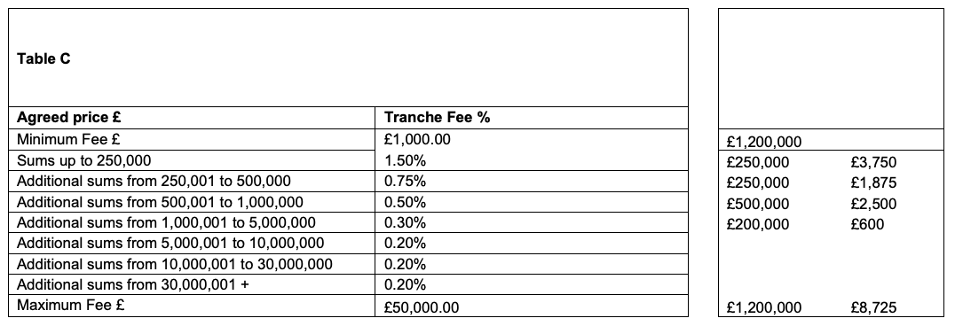
The example above shows a breakdown for a fee of £1,200,000

The fee is therefore broken down by the different values as shown in the table:
£250,000 x 1.50%
£250,000 x 0.75%
£500,000 x 0.50%
£200,000 x 0.30%
Workings for the sum are shown as an example on the right-hand side of the table.

Apportion/split the value into the bands until we have covered the full £1,200,000. For example, as above, apportion £250,000 of this £1,200,000 to the top band. Apportion another £250,000 to the second band. Apportion £500,000 to third band. Finally apportion the remaining £200,000 to the final band. Check the sum apportioned (as above £1,200,000 has now been apportioned into the allocated bands which is correct)

Then apply the ‘tranche fees’ to values apportioned within each band. For example, for the £250,000 in the first band: 250,000*1.50%= £3750 fees. Add all the calculations together to get an overall fee (£3750+£1875+£2500+£600= £8725)

Lot 2 - Estate (Property) Management (Worksheet 2)
Section | Instruction
Is your organisation bidding for this Lot | The Bidder shall indicate from the drop-down box Yes or No
Company Name (Please complete) | The Bidder shall input the trading name
Matrix populated by (Please complete name and role) | The Bidder shall input the point of contact for any pricing queries. All pricing queries identified during compliance will be issued through the eSourcing suite.
Please select Yes/No to confirm you have read and understood Attachment 3a - Price Matrix and Price Evaluation Guidance | The Bidder shall indicate from the drop-down box Yes or No that you have read and understood Attachment 3a - Price Matrix and Price Evaluation Guidance.
Property type | The Bidder shall Input a price adjustment (+/-) to the maximum of 2 decimal places for the provision of Services as per paragraph 2.3. For the avoidance of doubt the Bidder may decide to offer no adjustment, in which case the Bidder should insert zero (0).
Table 1 | The Bidder shall complete the cells highlighted in yellow with their £ fee for each resource based on an 8 hour day.  Zero bids are not permitted. If you submit a zero bid, this will result in your tender being deemed to be non-compliant, and will be excluded from further participation in this procurement.

Lot 3 - Agency & Lease Management (Worksheet 3)
Section | Instruction
Is your organisation bidding for this Lot | The Bidder shall indicate from the drop-down box Yes or No
Company Name (Please complete) | The Bidder shall input the trading name
Matrix populated by (Please complete name and role) | The Bidder shall input the point of contact for any pricing queries. All pricing queries identified during compliance will be issued through the eSourcing suite.
Please select Yes/No to confirm you have read and understood Attachment 3a - Price Matrix and Price Evaluation Guidance | The Bidder shall indicate from the drop-down box Yes or No that you have read and understood Attachment 3a - Price Matrix and Price Evaluation Guidance.
Property type | The Bidder shall Input a price adjustment (+/-) to the maximum of 2 decimal places for the provision of Services as per paragraph 2.3. For the avoidance of doubt the Bidder may decide to offer no adjustment, in which case the Bidder should insert zero (0).
Table 1 | The Bidder shall complete the cells highlighted in yellow with their £ fee for each resource based on an 8 hour day.  Zero bids are not permitted. If you submit a zero bid, this will result in your tender being deemed to be non-compliant, and will be excluded from further participation in this procurement.
Table 2-10, 12, 13 | The Bidder shall complete the cells highlighted in blue with their minimum and maximum £ fee for delivering the Services identified and as detailed in Attachment 9 - Framework Schedule 1 - Specification.  The Bidder shall complete the cells highlighted in yellow with their percentage fee for delivering the Services identified and as detailed in Attachment 9 - Framework Schedule 1 - Specification for each individual stage.  Zero bids are not permitted. If you submit a zero bid, this will result in your tender being deemed to be non-compliant, and will be excluded from further participation in this procurement.  The Bidder shall note that tranche fees apply to these tables, an example of this methodology is included below this table.
Table 11 | The Bidder shall complete the cells highlighted in yellow with their £ fee for delivering the Services identified and as detailed in Attachment 9 - Framework Schedule 1 - Specification for each individual stage.  Zero bids are not permitted. If you submit a zero bid, this will result in your tender being deemed to be non-compliant, and will be excluded from further participation in this procurement.

Tranche fees example

The example above shows a breakdown for a fee of £1,200,000

The fee is therefore broken down by the different values as shown in the table:
£250,000 x 1.50%
£250,000 x 0.75%
£500,000 x 0.50%
£200,000 x 0.30%
Workings for the sum are shown as an example on the right-hand side of the table.

We apportion/split the value into the bands until we have covered the full £1,200,000. For example, as above, apportion £250,000 of this £1,200,000 to the top band. Apportion another £250,000 to the second band. Apportion £500,000 to third band. Finally apportion the remaining £200,000 to the final band. Check the sum apportioned (as above £1,200,000 has now been apportioned into the allocated bands which is correct)

Then apply the ‘tranche fees’ to value apportioned within each band. For example, for the £250,000 in the first band: 250,000*1.50%= £3750 fees. Add all the calculations together to get an overall fee (£3750+£1875+£2500+£600= £8725)

Lot 4 - Surveying and Strategic Advice (Worksheet 4)
Section | Instruction
Is your organisation bidding for this Lot | The Bidder shall indicate from the drop-down box Yes or No
Company Name (Please complete) | The Bidder shall input the trading name
Matrix populated by (Please complete name and role) | The Bidder shall input the point of contact for any pricing queries. All pricing queries identified during compliance will be issued through the eSourcing suite.
Please select Yes/No to confirm you have read and understood Attachment 3a - Price Matrix and Price Evaluation Guidance | The Bidder shall indicate from the drop-down box Yes or No that you have read and understood Attachment 3a - Price Matrix and Price Evaluation Guidance.
Property type | The Bidder shall Input a price adjustment (+/-) to the maximum of 2 decimal places for the provision of Services as per paragraph 2.3. For the avoidance of doubt the Bidder may decide to offer no adjustment, in which case the Bidder should insert zero (0).
Table 1 | The Bidder shall complete the cells highlighted in yellow with their £ fee for each resource based on an 8 hour day.  Zero bids are not permitted. If you submit a zero bid, this will result in your tender being deemed to be non-compliant, and will be excluded from further participation in this procurement.

Lot 5 - Valuation and Compulsory Purchase Orders (Worksheet 5)
Section | Instruction
Is your organisation bidding for this Lot | The Bidder shall indicate from the drop-down box yes or no
Company Name (Please complete) | The Bidder shall input the trading name
Matrix populated by (Please complete name and role) | The Bidder shall input the point of contact for any pricing queries. All pricing queries identified during compliance will be issued through the eSourcing suite.
Please select Yes/No to confirm you have read and understood Attachment 3a - Price Matrix and Price Evaluation Guidance | The Bidder shall indicate from the drop-down box Yes or No that you have read and understood Attachment 3a - Price Matrix and Price Evaluation Guidance.
Property type | The Bidder shall Input a price adjustment (+/-) to the maximum of 2 decimal places for the provision of Services as per paragraph 2.3. For the avoidance of doubt the Bidder may decide to offer no adjustment, in which case the Bidder should insert zero (0).
Table 1 | The Bidder shall complete the cells highlighted in yellow with their £ fee for each resource based on a 8 hour day.  Zero bids are not permitted. If you submit a zero bid, this will result in your tender being deemed to be non-compliant, and will be excluded from further participation in this procurement.
Table 2 | The Bidder shall complete the cells highlighted in yellow with their £ fee for delivering the Services identified and as detailed in Attachment 9 - Framework Schedule 1 - Specification for each individual stage.  Zero bids are not permitted. If you submit a zero bid, this will result in your tender being deemed to be non-compliant, and will be excluded from further participation in this procurement.

Lot 6 - Business Rating Services (Worksheet 6)
Section | Instruction
Is your organisation bidding for this Lot | The Bidder shall indicate from the drop-down box yes or no
Company Name (Please complete) | The Bidder shall input the trading name
Matrix populated by (Please complete name and role) | The Bidder shall input the point of contact for any pricing queries. All pricing queries identified during compliance will be issued through the eSourcing suite.
Please select Yes/No to confirm you have read and understood Attachment 3a - Price Matrix and Price Evaluation Guidance | The Bidder shall indicate from the drop-down box Yes or No that you have read and understood Attachment 3a - Price Matrix and Price Evaluation Guidance.
Property type | The Bidder shall Input a price adjustment (+/-) to the maximum of 2 decimal places for the provision of Services as per paragraph 2.3. For the avoidance of doubt the Bidder may decide to offer no adjustment, in which case the Bidder should insert zero (0).
Table 1 | The Bidder shall complete the cells highlighted in yellow with their £ fee for each resource based on an 8 hour day.  Zero bids are not permitted. If you submit a zero bid, this will result in your tender being deemed to be non-compliant, and will be excluded from further participation in this procurement.
Table 2 to 5, 8 & 9 | The Bidder shall complete the cells highlighted in blue with their minimum and maximum £ fee for delivering the Services identified and as detailed in Attachment 9 - Framework Schedule 1 - Specification.  The Bidder shall complete the cells highlighted in yellow with their percentage fee for delivering the Services identified and as detailed in Attachment 9 - Framework Schedule 1 - Specification for each individual stage.  Zero bids are not permitted. If you submit a zero bid, this will result in your tender being deemed to be non-compliant, and will be excluded from further participation in this procurement.
Table 6 & 7 | The Bidder shall complete the cells highlighted in yellow with their £ fee for delivering the Services identified and as detailed in Attachment 9-Framework Schedule 1 - Specification for each individual stage.  Zero bids are not permitted. If you submit a zero bid, this will result in your tender being deemed to be non-compliant, and will be excluded from further participation in this procurement.

Lot 7 - Integrated Workplace Management (Worksheet 7)
Section | Instruction
Is your organisation bidding for this Lot | The Bidder shall indicate from the drop-down box yes or no
Company Name (Please complete) | The Bidder shall input the trading name
Matrix populated by (Please complete name and role) | The Bidder shall input the point of contact for any pricing queries. All pricing queries identified during compliance will be issued through the eSourcing suite.
Please select Yes/No to confirm you have read and understood Attachment 3a - Price Matrix and Price Evaluation Guidance | The Bidder shall indicate from the drop-down box Yes or No that you have read and understood Attachment 3a - Price Matrix and Price Evaluation Guidance.
Property type | The Bidder shall Input a price adjustment (+/-) to the maximum of 2 decimal places for the provision of Services as per paragraph 2.3. For the avoidance of doubt the Bidder may decide to offer no adjustment, in which case the Bidder should insert zero (0).
Table 1 | The Bidder shall complete the cells highlighted in yellow with their £ fee for each resource based on an 8 hour day.  Zero bids are not permitted. If you submit a zero bid, this will result in your tender being deemed to be non-compliant, and will be excluded from further participation in this procurement.
Table 2 | The Bidder shall complete the cells highlighted in yellow with their £ fee for delivering the Services identified utilising the scenario included in grey.  Zero bids are not permitted. If you submit a zero bid, this will result in your tender being deemed to be non-compliant, and will be excluded from further participation in this procurement.

CCS Price Evaluation (Worksheet 8)
The Price Matrix contains one worksheet which provides a summary of the data inserted by the Bidder into the ‘fee for evaluation’ (highlighted red cell) within each Lot-specific worksheet. This summarised data will be exported by CCS to the tender evaluation template.

Price Evaluation

This section describes how Bidders’ Price submissions will be evaluated.

The award of this framework will be on the basis of the ‘Most Economically Advantageous Tender’ (MEAT).

The weighting for the quality evaluation is 70%, and the weighting for the price evaluation is 30%. This applies to all Lots.

Each Lot follows the same evaluation principle for the Services tendered and this is set out below.

Each of the worksheets contains an automatically populated ‘fee for evaluation’ (highlighted red cell) for each service table which populates the tables in the Bidder summary tab. The sum for evaluation is extracted into the CCS worksheet from the tables in the CCS Summary tab and will be used to evaluate the Bidder’s tender.

The fee for evaluation is calculated as follows for the different fee types/tables:

Day Rate
The ‘fee for evaluation’ in table 1 throughout the worksheets is calculated by taking a median of the yellow cells (Bidder’s inputted data) and grey highlighted cells (automated data taking into account any property adjustments) for the following tables, as per the example below:

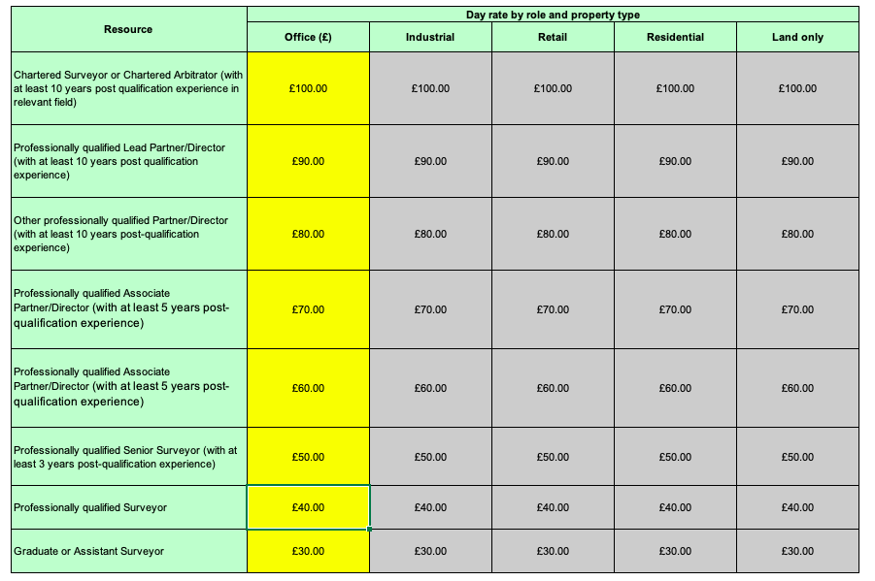

The median for each resource is then added together to provide the sum for evaluation, as per the example below:

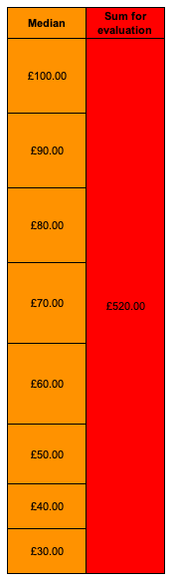

Minimum, maximum and % fee
The ‘fee for evaluation’ in tables with minimum, maximum and % fees per band throughout the worksheets is calculated by taking the median of each stage of the yellow cells (Bidder’s inputted data) and grey highlighted cells (automated data taking into account any property adjustments). The following table provides a staged example:
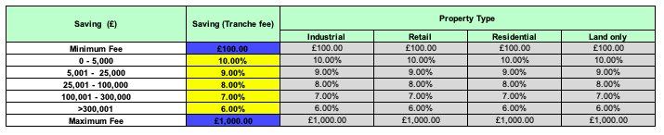
The median percentages are automatically populated to the next table, example below and applied to a scenario within the worksheets:

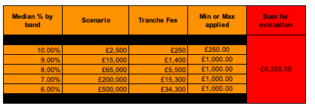

The median % is applied to a scenario fee (£), which is the midpoint of each stage value. The median % and the scenario fee are multiplied to calculate the scenario band fee. The scenario band fee is applied to the adjusted band fee and this takes into account the Bidders minimum and maximum fee values, applying the blue cell maximum or minimum if the fee charge is below or above this figure. The sum for evaluation is calculated as the total of final scenario band fees.

Fixed fee
The ‘fee for evaluation’ in tables with a fixed fee per band throughout the worksheets is calculated by taking the median of each stage of the yellow (Bidders inputted data) and grey highlighted (automated data taking into account any property adjustments). The following table provides a staged example:
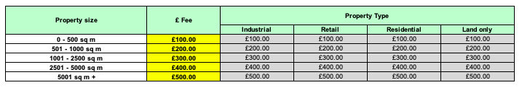
The median for each resource is then added together to provide the sum for evaluation, as per the example below:
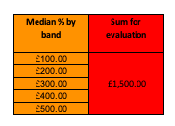

Initial consultation, percentage (%) and maximum fee:
The ‘fee for evaluation’ in tables with initial consultation, percentage (%) and maximum fee: per band throughout the worksheets is calculated by taking the median of each stage of the yellow (Bidders inputted data) and grey highlighted (automated data taking into account any property adjustments). The following table provides a staged example:
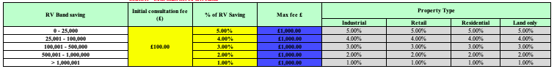
The median percentages are automatically populated to the next table, example below and applied to a scenario within the worksheets:
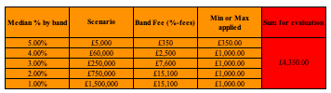
The median % is applied to a scenario fee (£), which is the midpoint of each stage value. The median % and the scenario fee are multiplied to calculate the scenario band fee plus the initial consultation fee. The scenario band fee is applied to the adjusted band fee and this takes into account the Bidders minimum and maximum fee values, applying the blue cell maximum or minimum if the fee charge is below or above this figure. For the avoidance doubt it should be noted that the maximum fee is exclusive of the initial consultation fee

How we will calculate your price score

A Bidders price mark is calculated by adding all the evaluated tables to provide a single value that will be used for evaluation and ranking this against the other Bidders price mark.

The evaluation template will review the Bidder’s price marks and rank them from all Bidders submission median per Lot.

All Bidders will then be allocated a Price Score based on their ranking as in the following table:

Ranking Group | Price Score
1 - 5 | 30
6 - 10 | 25
11 - 15 | 20
16 - 20 | 15
21 - 25 | 10
26+ | 5

Tied positions guidance

If two or more Bidders are ranked in an equal, or tied position, the Bidder that is in the next position will be ranked in accordance with their overall position in the ranked list. For example, if two Bidders are ranked in equal 1st place, the next Bidder is ranked in 3rd place, not 2nd place. This is illustrated in the table below:

Bidder | Rank
Bidder A | 1
Bidder B | 1
Bidder C | 3
Bidder D | 4
Bidder E | 4
Bidder F | 6

Please refer to Attachment 2 - How to Bid for further information on the final decision to award.

Abnormally low tenders

Where we consider any of the prices you have submitted to be potentially abnormally low we will ask you to explain the prices you have submitted (in accordance with regulation 69 of the Regulations).

If your explanation is not acceptable, we will reject your bid and exclude you from this competition. We will inform you if your bid has been excluded and why.

