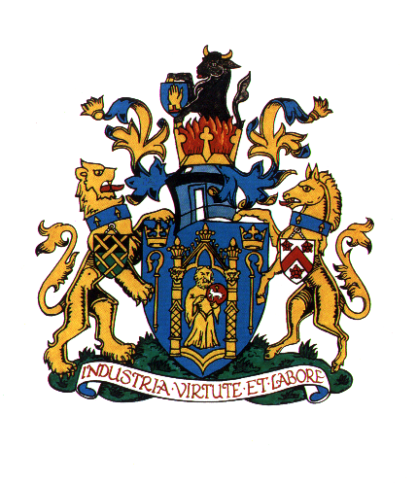
Yeovil Town Council
Town House
19 Union Street
Yeovil
Somerset
BA20 1PQ

Telephone : (01935) 382424 Fax : (01935) 382429
Website : www.yeovil.gov.uk
Amanda Card Town Clerk

Date: November 2020
Ask for: Sally Freemantle
E-mail: sally.freemantle@yeovil.gov.uk

NEW WEBSITE SPECIFICATION

OVERVIEW
Yeovil Town Council is a tier of local government which covers an administration area of Yeovil serving 45,000 residents.
The services provided include events, allotments, community halls, public toilets, local planning representation and other shared amenities. The Council is made up of 24 elected Councillors and a team of 11 staff.
The website will provide an opportunity for some aspects of the work and information to be accessed, relevant forms downloaded and payments to be made by members of the public.
There will also be an area specifically for Councillors to log into to gain access to minutes, agendas, meeting notices and confidential papers.

PROJECT TEAM
Sally Freemantle is heading up the project with input from team members and Councillors.
CONTENT STRUCTURE
Standard CMS Page
- Picture, text and contact details
- Can link up to other websites
Bespoke Email form (detail to be provided by Yeovil Town Council)
- Allotment enquiry/application form
- Halls for hire enquiry form
- Online contact form
- Mayor enquiry form
Gateway to payment
- Use payments for allotment rent and hall rent (simple method for user to type in a reference and pay) TC need to agree what method of payment to use i.e. PayPal, strike etc.
Allotments
- locations – to include an electronic map
Halls for hire
- location – to include an electronic map
Halls for hire
- availability – to include a user-friendly calendar system that can be used on mobile and desktop (please advise what system you use)
Public Toilets
- location – to include an electronic map

SEARCH – to search for words on the website and pick up relevant information
COUNCILLOR LOG IN – secure area for each councillor to log in and access confidential papers
FACEBOOK – button to link with the Yeovil Town Council Facebook page

SEARCH / COUNCILLOR LOG IN / FACEBOOK

SERVICES
(HEADING)
DESIGN
Design must be agreed before first payment. No design work has been completed so must be included. Town Crest must be included on home page. Typical colours for Yeovil Town Council are green and blue, with some gold (see colours in crest at start head of this document).
Responsive design – compatible with desktop, tablet and mobile.

ACCESSIBILITY
https
GDPR and DDA compliant in accordance with Web Content Accessibility Guidelines.

BROWSER AND DEVICE SUPPORT
Chrome, Safari, Internet Explorer/Edge, Firefox and any other browsers as advised by designer.

HOSTING
The website requires hosting and back-up. Please specify annual cost for this separately.
The domain name is www.yeovil.gov.uk
(information on existing host will be provided to successful tenderer).

TRAINING, MAINTENANCE AND SUPPORT

The CMS pages will be updated by Yeovil Town Council staff, therefore training will be required. Any other upgrades to remain compliant will be requested to be carried out by successful tenderer. Please specify costs for these aspects separately.

