**Attachment 1**

Site plan of Thorne Moors (Part of Humberhead Peatlands NNR)

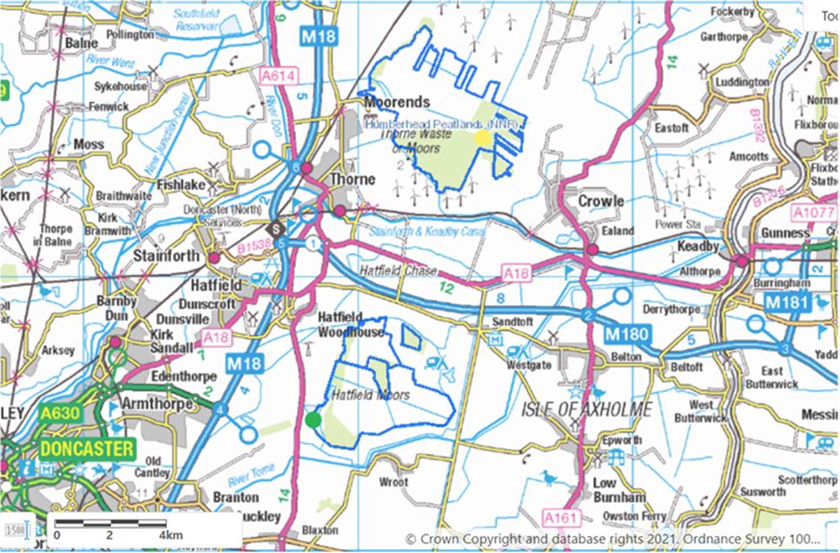

**Attachment 2**

Site plan showing the location of the building requiring a new supply, and the position of the nearest existing supply. (Key – The yellow dot represents the location of the workshop; the green dot represents the location of the current generator; the blue dot represents Top Moors farm, which is the location of the nearest domestic electricity supply)

