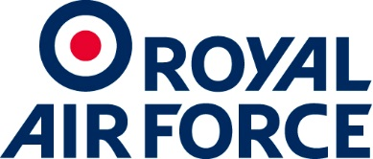 | Headquarters Air Command  From: Joanna Paish MA
 | Air Commercial Contract Management 2B
Royal Air Force High Wycombe
Buckinghamshire 4UE
Centerprise International Ltd
Hampshire International Business Park
Lime Tree Way
Basingstoke
Hampshire
RG24 8GQ

Date: 24th March 2020
Dear Sir,
Offer of Call Off Contract 700424385 for the Provision of Adesoft Project File for Defence School of Electro Mechanical Engineering (DSEME).
Further to your recent submission of Annex 1: Service Offer Template carried out under the Crown Commercial Service Technology Services 2 (RM3804) framework, I am pleased to inform you that we would like to award the above named contract to your company.
A copy of the completed Technology Services 2 Agreement RM3804 Framework
Schedule 4 - Annex 1 Order Form and the Department's Confirmation of Acceptance DEFFORM 10. will be forwarded to you shortly for your signature and return.
No contract will come into existence until you have accepted the Department's offer. Accordingly, prior to your unconditional acceptance of this offer, the Department shall not be responsible in any way whatsoever for any:
- work undertaken by you; or
- costs incurred by you.
When you have accepted the Department's offer you must proceed with the performance of the Contract in accordance with the Technology Services 2 Agreement RM3804 Framework Schedule 4 - Annex 1 Order Form.
We trust that this is acceptable to you and we look forward to receiving your acceptance as soon as is convenient.
Yours faithfully

Joanna Paish
Air Commercial Contract Manager 2B

