Project Name: | Southern Windermere Trails | 
 | Route Visualisation Section 4 and 5

Section 4 – Great Knott Wood to Stott Park Bobbin Mill via Finsthwaite

Section 4a 000 – View N
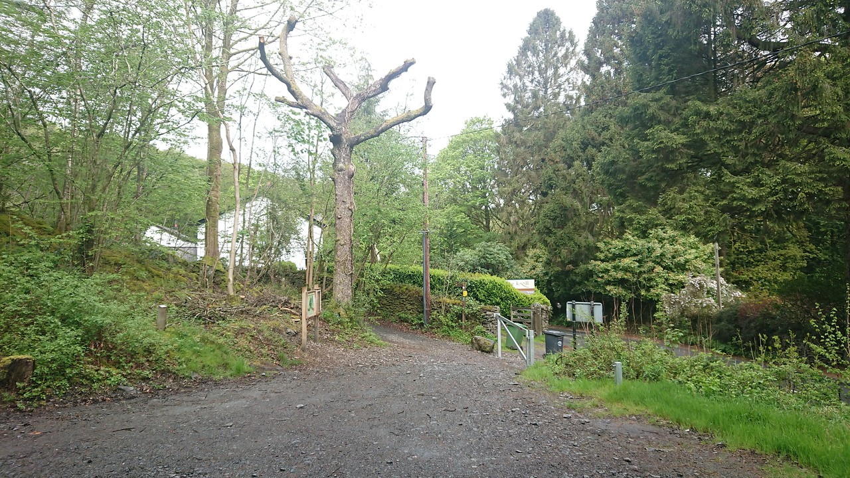
000

Section 4a 100 – View W
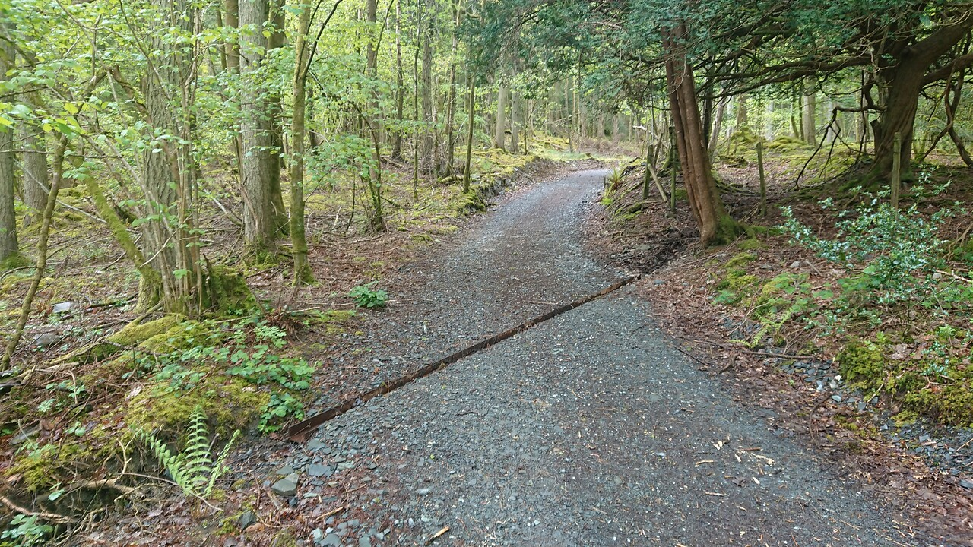
4 a

Section 4b 400 – View W
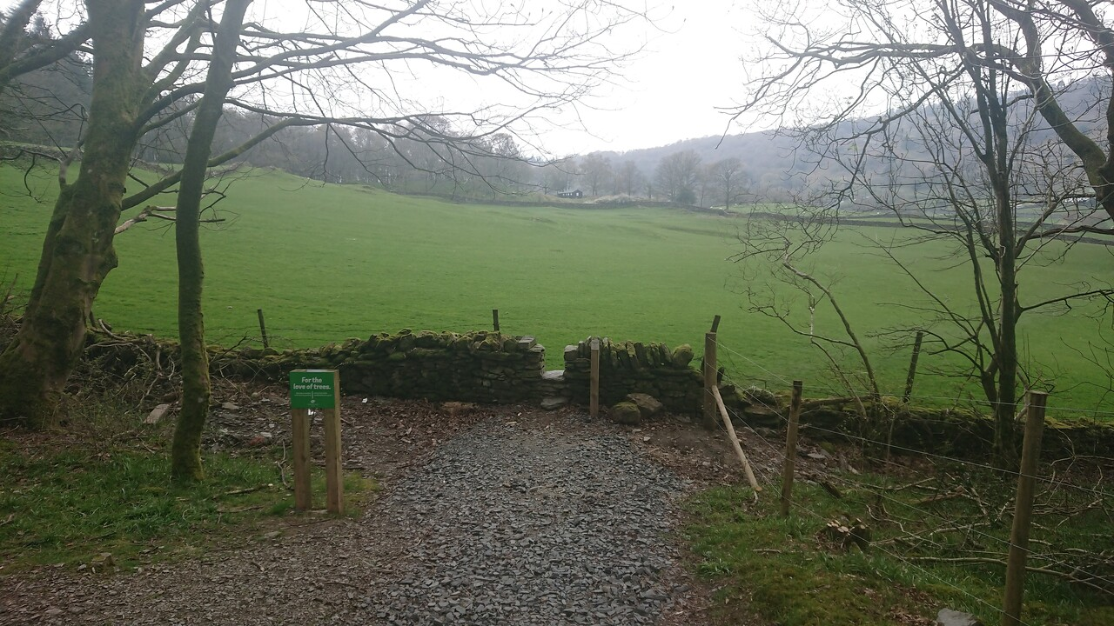
4 b
4 a
400

Section 4b 400 – View E
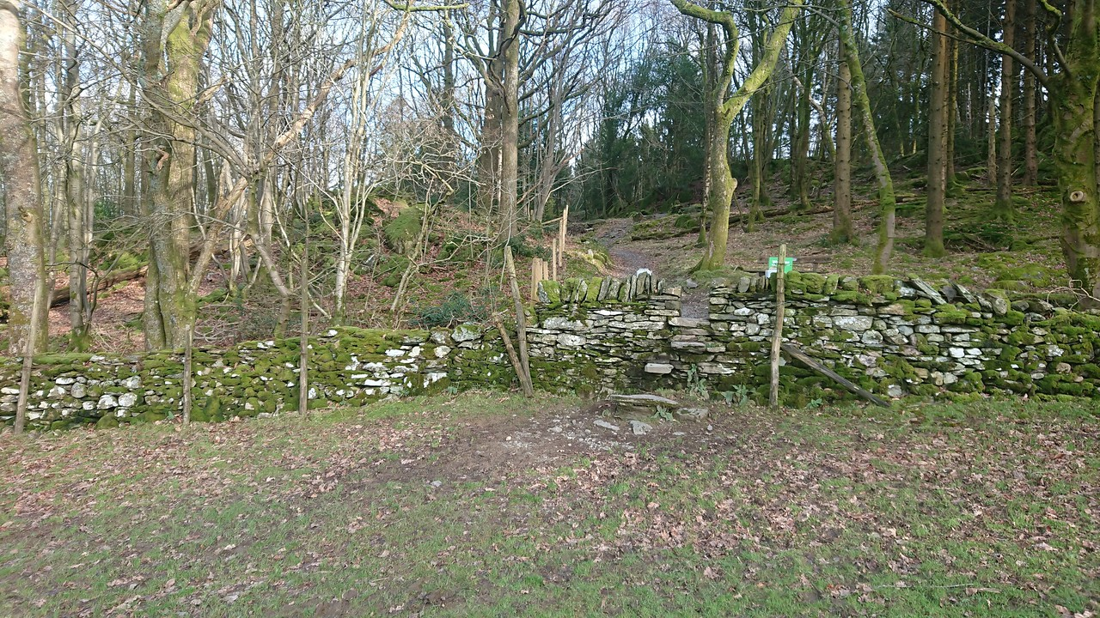
4 b
400

Section 4b 420 – View W
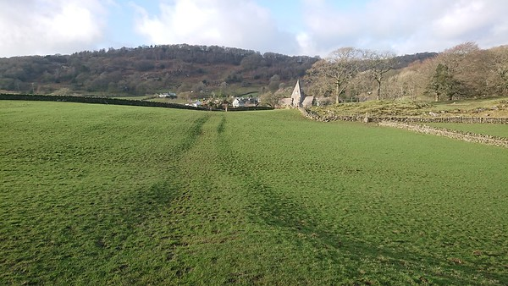
4 b
582

Section 4b 582 – View W
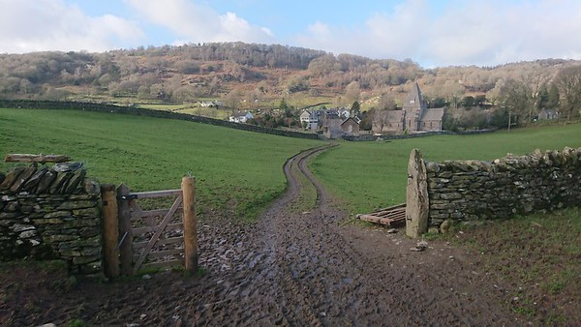
4 b
702
582

No images of 4c – Existing Highway

Section 5 – High Dam to High Stott Park

Section 5a 030 – View NW
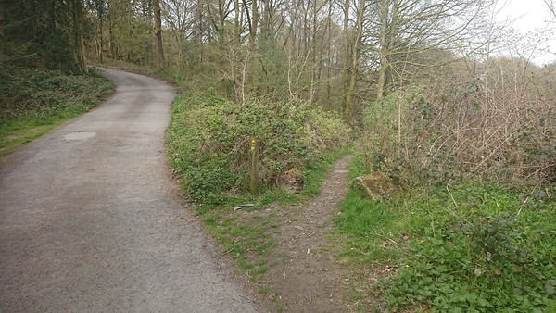
036
5 a

Section 5a 050 – View N
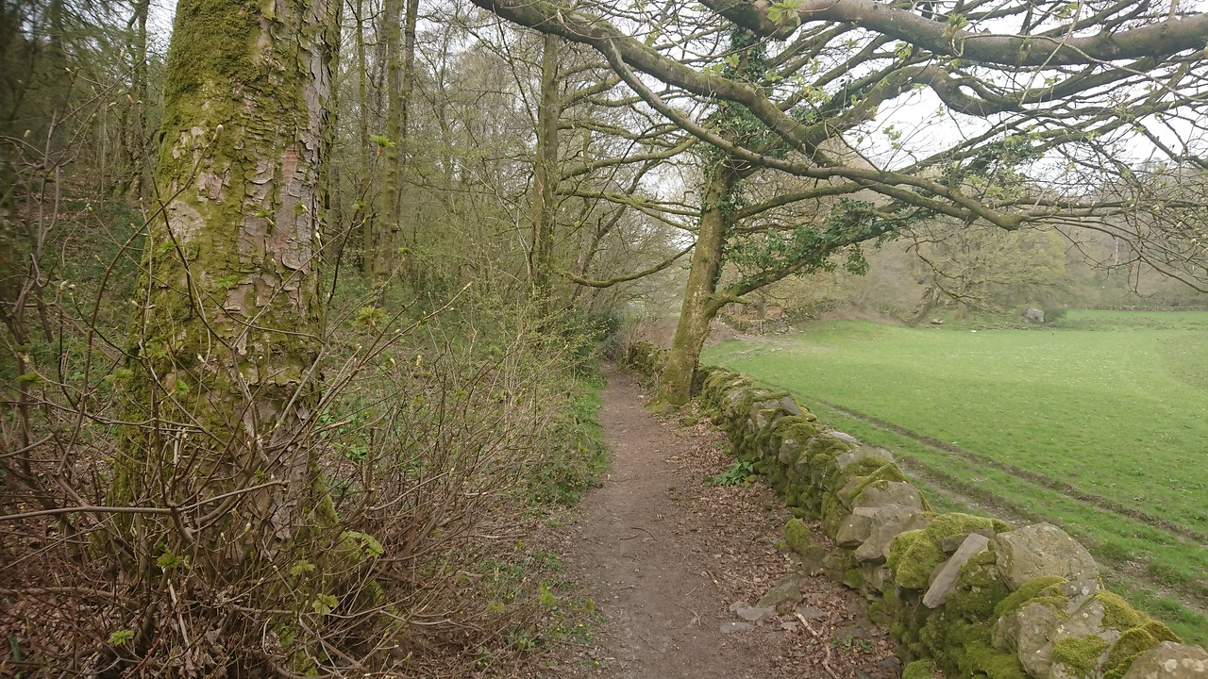
5 a

Section 5a 128 – View N
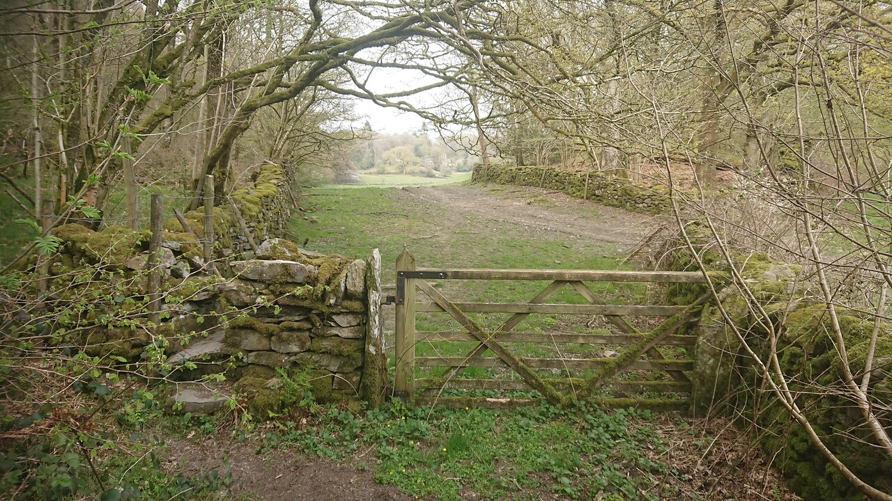
126
5 b
5 a

Section 5b 250 – View S
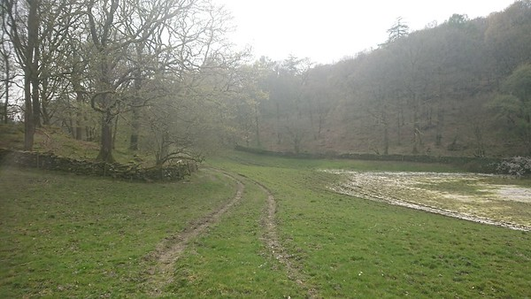
377
5 b

Section 5b 250 – View N
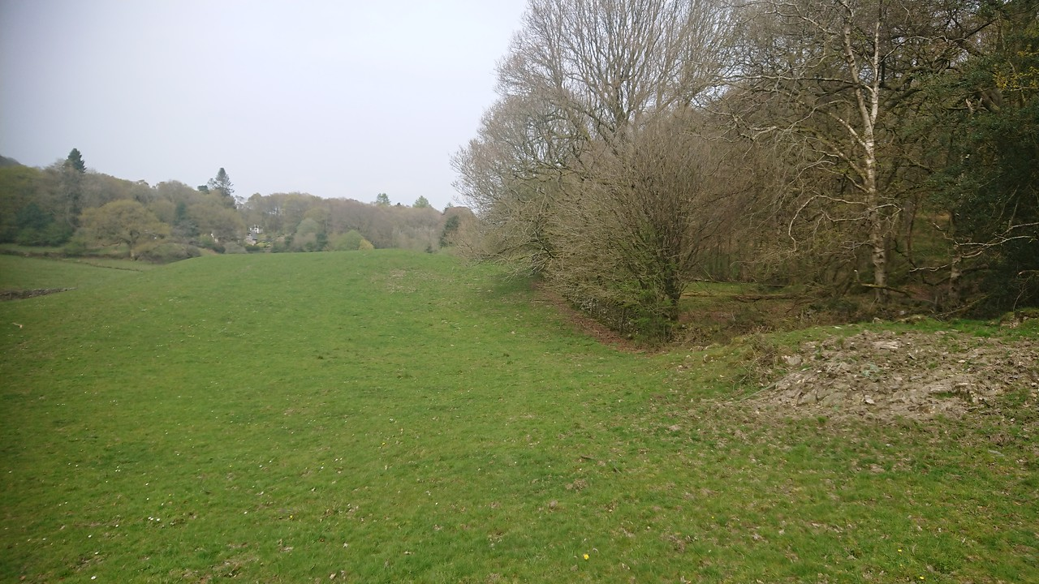
5 b

Section 5c 500 – View S
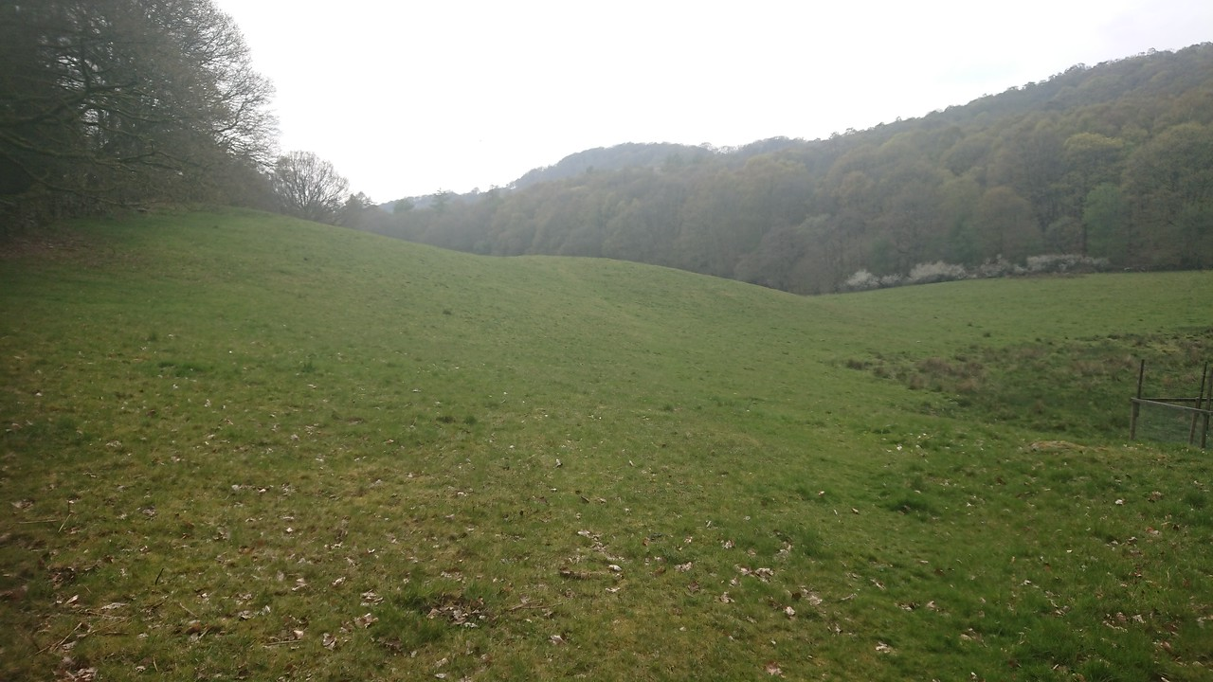
5 c

Section 5c 500 – View N
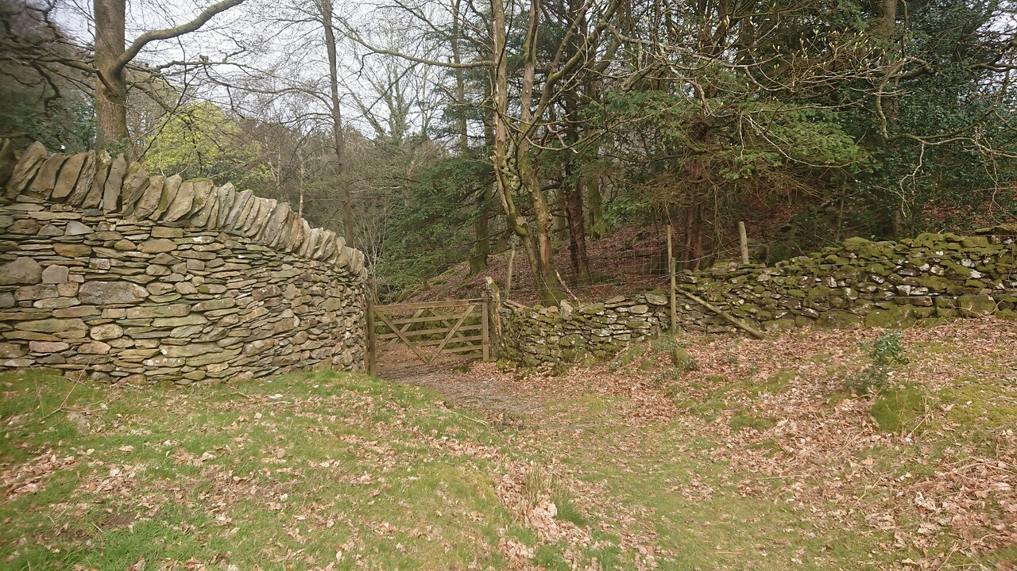
5 c
502

Section 5d 550 – View N from 500m mark in section 5c
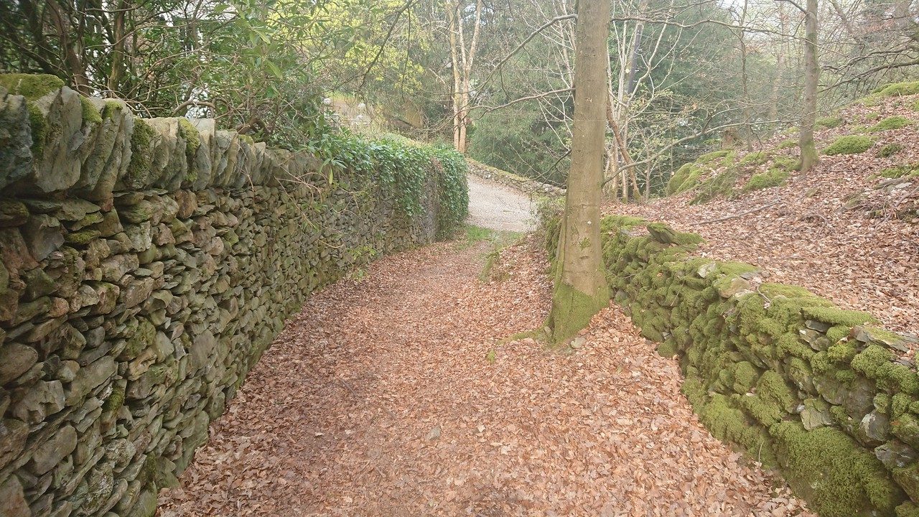
526
5 d

No images of 5e – Existing Highway C5026

