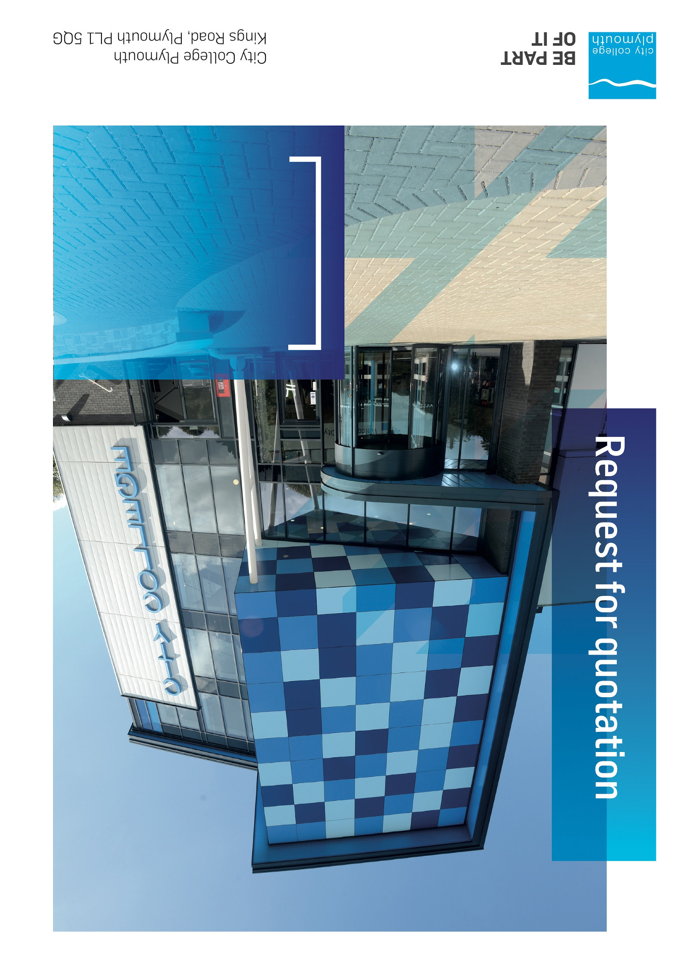



# Table of Contents

Table of Contents 2

Confidentiality Statement 3

Open Procedure 4

Submission Details 4

Submission Deadlines 4

Submission Questions and Clarifications 4

Electronic Submissions 5

Introduction and Executive Summary 5

Business Overview & Background 6

Our Vision … is where our future lies 6

Our Mission … is what we focus on each and every day 6

Background 6

Detailed Requirement 7

SAFEGUARDING 8

SECURITY 8

ENVIRONMENTAL 8

CONDUCT OF WORK 8

Timescales 9

Written Submission 9

Pricing 10

Terms and Conditions 10

Validity 10

Selection Criteria 10

Award Price 11

Written submission 11

Assessment of Quotations 12

Freedom of Information Act 2000 12

General Data Protection Regulation (GDPR) 2018 12

Agreement Conditions Acceptance and Declaration 12

Supporting Documentation 13

# Confidentiality Statement

This document, and any attachments thereto, regardless of form or medium, is intended only for use by the addressee(s) and may contain legally privileged and/or confidential, copyrighted, trademarked, patented or otherwise restricted information viewable by the intended recipient only. If you are not the intended recipient of this document (or the person responsible for delivering this document to the intended recipient), you are hereby notified that any dissemination, distribution, printing or copying of this document, and any attachment thereto, is strictly prohibited and violation of this condition may infringe upon copyright, trademark, patent, or other laws protecting proprietary and, or, intellectual property. In no event shall this document be delivered to anyone other than the intended recipient or original sender and violation may be considered a breach of law fully punishable by various domestic and international courts. If you have received this document in error, please respond to the originator of this message or email him/her at the address below and permanently delete and/or shred the original and any copies and any electronic form this document, and any attachments thereto and do not disseminate further.

Thank you for your consideration, City College Plymouth.

Where no notice is given, all information contained herein is Copyright 2020 City College Plymouth.

# Open Procedure

The College fully adheres to the requirements of the Public Contracts Regulations 2015, including for opportunities which are under threshold amounts.

Any Contractor who directly or indirectly canvasses any Member or Officer of the Institution, or advisor concerning the award of the contract for the provision of the services, or who directly or indirectly obtains or attempts to obtain information from any such member or Officer concerning any Tender or proposed Tender for the service will be disqualified from having his/her Tender considered.

# Submission Details

## Submission Deadlines

All submissions for responding to this Request for Quote must be submitted via email as stated below, no later than:

**Friday 9th June 2023**

**12:00 Noon**

Any submissions received after this date will not be considered.

## Submission Questions and Clarifications

You may contact the following person if you have any questions or require clarification on any topics covered in this Request for Quotation by Friday 5th June 2023.

**Adam Baker**

Procurement Officer

Phone: 01752 305313

Email: tenders@cityplym.ac.uk

All correspondence during the Tender should be channelled via the Procurement Officer using the above details only. Bidders found to have gained an unfair advantage shall be disqualified from the current opportunity and future opportunities with the College for a minimum of four (4) years.

## Electronic Submissions

Electronic submissions in response to this Request for Quotation will be accepted as long as they meet the following criteria:

Sent via email to: [tenders@cityplym.ac.uk](mailto:tenders@cityplym.ac.uk)

Document standards:

* Text must be in Microsoft Word format;
* Price tables must be in Microsoft Excel format (using pricing schedule in Appendix A);
* Supportive evidence may additionally be submitted in PDF format;
* Images, Designs, and other supporting evidence may be in either JPEG or PDF format
* Completed Appendix C Suitability Assessment & Selection Questionnaire (Including Mandatory & Discretionary Exclusions) Parts 1, 2 and 3. - *Please note this suitability assessment will not be viewed unless you are the winning tenderer. Failure at this stage may prevent the contract from being awarded.*
* Signed Agreement Acceptance and Declaration.

*Please note that the College is able to accept submissions sent in a compressed or “.zip” file format, so long as the files contained meet the standards described above.*

**WARRANTY**:

By submitting your tender bid, you are warrantying to the College that you have not breached our canvassing or soliciting clause.

If any successful tenderer awarded a contract is found to have provided an inaccurate warranty, then the College reserves the right to terminate the awarded contract with immediate effect and re-tender the contract from which the successful tenderer will be excluded from re-bidding and shall be disqualified from any future opportunities for a period of four years.

# Introduction and Executive Summary

City College Plymouth is seeking to contract with a single supplier for the provision of Grounds maintenance and landscaping works across its Kings Road, Picquet Barracks and Oceansgate sites.

The successful tenderer will benefit from an exclusive contract for a period of 3 years, subject to satisfactory performance from 1st August 2023 until 31st July 2026 with an option to extend for an additional 2 years (1+1)

# Business Overview & Background

City College Plymouth is one of the largest providers of innovative, technical and professional, education in the South West with a national reputation for promoting enterprise, employability and science, technology, engineering and mathematics (STEM). The College plays a central role in the educational, cultural and economic life of the region and works with strategic partners to facilitate growth, raise aspirations and foster wealth creation.

The College was awarded the Teaching Excellence Framework (TEF) Gold award for its university-level provision and its most recent Ofsted inspection confirmed that the College continues to be ‘Good’ with many outstanding features.

City College Plymouth is also one of the first Institutes of technology in the UK Working in collaboration with education providers and employers across the South West to improve the training in science, technology, engineering and maths in order to address skills gaps within these industries and support regional growth.

City College supports the region’s employers with their award-winning Apprenticeship provision, as well as providing a range of courses and bespoke training programmes which enable employees to upskill or retrain to better support their business’ requirements.

The College operates on two main sites within the city, serving 12,500 students and employing over 600 staff. The College operates year round, with opening times from 0800-2100 on some days.

## **Our Guiding principle**

City College Plymouth has a learning environment and organisational culture that impacts positively on the health, wellbeing and sustainability of our community and enables all of our students and staff to achieve their full potential.

## **Our Vision**

To be the learning destination of choice

## **Our CORE VALUES**

Respect, ownership, integrity.

## **Our CULTURE**

Nurturing a passion for teaching and learning

Enriching our community through knowledge, experience and skills

Enabling every student to be the best that they can be

## **The Way Forward - our Priorities**

• Staff - our most important investment

• Students - our purpose

• Community - making a difference

• Achievement - reputation for success

• Wellbeing - infusing health into every day

# Detailed Requirement

The anticipated cost is £7500 per annum.

City College Plymouth is booking to procure a Garden maintenance company to ensure its two main sites Kings Road and Picquet Barracks are kept Tidy, Weed free and presentable for all staff, students and visitors.

Below is the minimum scope for the activities that we would expect the prospective company to carry out at the sites;

**Kings Road**

* Maintain all grass areas to site using rotary mower with collector including litter pick (excluding large items). All grass cuttings are to be removed from site. Strimming to banks at Kings Road Site.
* Kings Road public services to be kept clean, cut back overhanging plants and remove all moss and build up of debris to nursery playground and paths. College woodland paths to be maintained, cleared and weeded.
* Wild flower Meadow area to be cut with removal of arisings.
* Maintain the soft landscaping around the front extension of the college and the fruit trees to the College embankment path.
* Maintain a weed free site, treating any stubborn areas that arise at both Kings Road and Picquet Barracks. Maintain existing shrubbery and external plants to Kings Road site. To include tree and bush trimming to staff and student car park.
* We would like you to include a provision for seasonal planting and the continued upkeep of this.

**To undertake a BS 5837 tree survey of the site – report to be provided to the estates department in addition to any arising’s from it.**

**Picquet Barracks**

* Maintain a weed free site, treating any stubborn areas that arise.

**Pinpoint**

* To treat small banked area

We would welcome your own suggestions as to how you would achieve the above, please provide a proposed schedule of visits/works alongside costings that you believe would achieve our goals.

## Site Visit

Bidders should make themselves aware of the nature of each site prior to submitting their cost to ensure that the full extent of the work is understood and priced accordingly. June 1st has been set aside by the Premises Manager Dom Jennings to view the sites, please can you confirm attendance by emailing: djennings@cityplym.ac.uk.

## SAFEGUARDING

In order to meet the College safeguarding requirements, all contractors on site during the main College term should hold a full English DBS disclosure. This requirement may be suspended where it can be demonstrated that, as a minimum, the contractor’s supervisor on site holds this disclosure and the Premises Manager is satisfied that contractor’s supervision arrangements of their staff is adequate.

## SECURITY

All staff on site will be required to comply with health and safety requirements at all times and to wear appropriate identification.

All staff will be required to sign in and sign out when on College premises.

## ENVIRONMENTAL

All work must be carried out with a responsible attitude to environmental concerns. All waste arising from the work is the responsibility of the contractor, and must be handled and disposed of in accordance with the current waste and all relevant environmental legislation.

## CONDUCT OF WORK

The Contractor is to arrange their work as to avoid interference with routine use of occupied premises and must co-operate with persons occupying or using the premises whilst he is working.

The Contractor shall protect and keep free from damage the buildings, fences, walls, roads, paths kerbs and all other parts of the work location.

## Timescales

|  |  |
| --- | --- |
| **Action** | **Date** |
| Tender Issued | 19/05/2023 |
| Site visit | 1st June 2023 |
| Deadline for Queries | 05/06/2023 |
| Tender Response Date | 09/06/2023 |
| Award Date | 23/06/2023 |
| Commencement Date | 01/08/2023 |

## Written Submission

We also require a written document which details your company offer with particular interest to the following areas. This submitted document will be scored as per the table on page 11.

* Contact Management, including details of primary contacts and responsiveness to additional requests.
* How you would achieve our expectations from the contract ie tidy, weed free site and your proposals for site attendance.
* Experience of carrying out tree surveys to the required standard.
* How you will meet the college safeguarding requirements, including your supervision arrangements of staff when on site during term times.
* Your contribution to Sustainability, the Environment and Social Responsibility.
* Any student opportunities you would be willing to provide eg work experience, student talks, or any other value added items.

You should also confirm your understanding of our DBS requirements and that you will be able to comply.

# Pricing

Bidders should provide their pricing for each of the opportunities in Appendix A. Prices should be firm and valid for the contract period (36 months) and not subject to increase or escalation of any kind throughout the contract.

There should be no additional costs incurred, save for any purchase order for ad hoc works.

# Terms and Conditions

The College’s normal business terms are 1-2 months from the date of invoice. Payment will become due subject to the above upon the College’s full acceptance of the goods/services. This Request for Quotation and any resulting purchase order will be subject to the College’s General Terms and Conditions of Purchase of Goods/Services – see Appendix B.

The College reserves the right to request a formal contract for all contracts over 1 year duration in supplement to the terms and conditions and contract acceptance documents.

# Validity

Bidder’s offers should be open and valid for acceptance for a period of no less than ninety [90] days from the date of submission.

# Selection Criteria

The successful supplier will have provided the Most Economically Advantageous Tender (MEAT) to the college. It should be noted that the bidder with the lowest submitted prices will not necessarily be down-selected. All bidders will be notified via email of the results of the outcome no later than 90 days from the date of submission. The date of contract award will be provided within that email.

The marking criteria follows:

|  |  |
| --- | --- |
| Category | Weight |
| Price | 70% |
| Contract Management and service response times | 10% |
| Proposals for a grounds maintenance solution | 10% |
| Student opportunities/added value | 5% |
| Sustainability, the Environment and Social Responsibility | 5% |

Please see table below for more details on the scoring method.

## Award Price

Lowest quote price divided by quote price multiplied by 100

## Written submission

|  |  |  |
| --- | --- | --- |
| **Assessment** | **Score** | **Interpretation** |
| **Excellent** | 4 | *Comprehensive response supported by examples*  *Description fully supported by details that demonstrate the applicant’s ability to provide the required services.* |
| **Good** | 3 | *Broad response supported by relevant examples.*  *Description well supported by details that demonstrate the applicant’s ability to provide the required services.* |
| **Satisfactory** | 2 | *Reasonable response supported by some evidence.*  *Description adequately supported by details that demonstrate the applicant’s ability to provide the required services.* |
| **Poor** | 1 | *Limited response not well supported by evidence.*  *Description inadequately supported by details that demonstrate the applicant’s ability to provide the required services.* |
| **Unacceptable** | 0 | *No response or insufficient information provided.* |

# Assessment of Quotations

Bidders must ensure that their quotation fully addresses all information requested within this RFQ document. Bidders must ensure that any quotation fully meets the specification required. The College reserves the right to discount any quotation which does not fully meet the specification.

The College reserves the right to seek clarification with bidders upon receipt of quotations.

# Freedom of Information Act 2000

Under the Freedom of Information Act 2000 the College cannot guarantee that information provided by bidders during the course of this RFQ procedure or any resulting contract will be held a confidential. The College will not routinely release information to interested parties unless required to do so in order to meet our statutory obligations.

# General Data Protection Regulation (GDPR) 2018

All bidders must comply with the General Data Protection Regulation (GDPR) 2018 in respect of using and processing personal information. Bidders must have in place technical and organisational safeguards to protect personal data from unauthorised use, disclosure or loss.

The College reserves the right to request a copy of your privacy statement if you are the successful bidder.

# Agreement Conditions Acceptance and Declaration

Bidders are required to sign and return the attached Agreement Conditions Acceptance and Declaration. Appendix D

# Supporting Documentation

Appendix A: Pricing Schedule

Appendix B: City College Plymouth Standard Terms & Conditions

Appendix C: Suitability Assessment & Selection Questionnaire

Appendix D: Agreement Conditions Acceptance and Declaration