Framework Schedule 6 (Order Form Template and Call-Off Schedules)

Order Form

CALL-OFF REFERENCE: TCA 3/7/1486

THE BUYER: Maritime and Coastguard Agency

BUYER ADDRESS Spring Place, 105 Commercial Road, Southampton, SO15 1EG

THE SUPPLIER: NEC SOFTWARE SOLUTIONS UK LIMITED
SUPPLIER ADDRESS: 1st Floor, iMex Centre, 575-599 Maxted Road, Hemel Hempstead, Hertfordshire HP2 7DX
REGISTRATION NUMBER: Company Number 13052116
DUNS NUMBER: 21-750-3127SID4GOV ID: 209109
SUPPLIER REF NUMBER: CRM147750, FWA 6814 (eMarketplace reference: 2151)

APPLICABLE FRAMEWORK CONTRACT

This Order Form is for the provision of the Call-Off Deliverables and is dated the date upon which the last party signs this Order Form as set out below.

It’s issued under the Framework Contract with the reference number RM6259 for the provision of Vertical Application Solutions.

CALL-OFF LOT(S):

Lot: 5 (Blue Light Solutions)
CALL-OFF INCORPORATED TERMS

The following documents are incorporated into this Call-Off Contract. Where numbers are missing we are not using those schedules. If the documents conflict, the following order of precedence applies:
- This Order Form including the Call-Off Special Terms, Call-Off Special Schedules, and Service Definition (included in the contract pack)
- Joint Schedule 1 (Definitions and Interpretation) RM6259
- The following Schedules in equal order of precedence:

- Joint Schedules for RM6259

  - Joint Schedule 2 (Variation Form)

  - Joint Schedule 3 (Insurance Requirements)

  - Joint Schedule 4 (Commercially Sensitive Information)

  - Joint Schedule 6 (Key Subcontractors)

- Joint Schedule 7

- Joint Schedule 8

  - Joint Schedule 10 (Rectification Plan)

  - Joint Schedule 11 (Processing Data)

- Call-Off Schedules for TCA 3/7/1486

  - Call-Off Schedule 1 (Transparency Reports)

  - Call-Off Schedule 2 (Staff Transfer) – Only Part C and E apply

  - Call-Off Schedule 3 (Continuous Improvement)

- Call-Off Schedule 6 – ICT Services

- Call-Off Schedule 8 – Business Continuity and Disaster Recovery

- Call-Off Schedule 9 Security

- Call-Off Schedule 10 (Exit Management)

- Call-Off Schedule 14 (Service Levels)

- Call-Off Schedule 15 (Call-Off Contract Management)

- CCS Core Terms (version 3.0.11) which are subject to Framework Special Term 1 detailed in point 3 above.

- Joint Schedule 5 (Corporate Social Responsibility) RM6259

No other Supplier terms are part of the Call-Off Contract. That includes any terms written on the back of, added to this Order Form, or presented at the time of delivery.

CALL-OFF SPECIAL TERMS

Call-Off Special Term 1: Joint Schedule 8 (Parent Company Guarantee). Where the signed Parent Company Guarantee has not been provided to the Buyer within 3 months of the Call-Off Start Date, the Buyer shall be entitled to terminate the Call-Off Contract on written notice to the Supplier.

CALL-OFF START DATE: 01.01.2025

CALL-OFF EXPIRY DATE: 31.12.2027

CALL-OFF INITIAL PERIOD: 3 Years

CALL-OFF EXTENSION PERIOD: 2x 1 Year
CALL-OFF DELIVERABLES

- Software, Hardware and Support & Maintenance Services
Support and maintenance to be provided for the duration of the Initial Period and any Extension Period for the NEC Software and Third Party Software, Hardware and Support listed below.

[REDACTED]

- Professional Services

Product Name | Delivery Hours | Delivery Location | Number of Days
ICCS and VISION – Dedicated Support Team | Normal Business Hours | Onsite & Offsite | N/A - fixed price project

A description of each of the Deliverables listed above are set out below:

FWA 6814, eMarketplace reference: 2151

Each of the above products and services shall, regardless of any other provision in the Call-Off Contract, be provided in accordance with and subject to the provisions of the above Service Definition.

MAXIMUM LIABILITY
The limitation of liability for this Call-Off Contract is stated in Clause 11.2 of the Core Terms .

The Estimated Year 1 Charges used to calculate liability in the first Contract Year is
[REDACTED]

The Data Protection Liability Cap is £10,000,000.
CALL-OFF CHARGES (excluding VAT)

[REDACTED]

Total Annual Charge
[REDACTED]

Total Call-Off Contract Charge: £4,363,529.00

TUPE:

[REDACTED]

Support & Maintenance Services Charges

The annual increase will not exceed the annual percentage increase in the Consumer Price Index (CPI) as calculated in the preceding June or preceding December, whichever is closer to the date indexation is due to be applied.

REIMBURSABLE EXPENSES
Recoverable during extraordinary events, for example a BCDR situation, expenses will be recoverable in line with the DfT Expenses policy below:
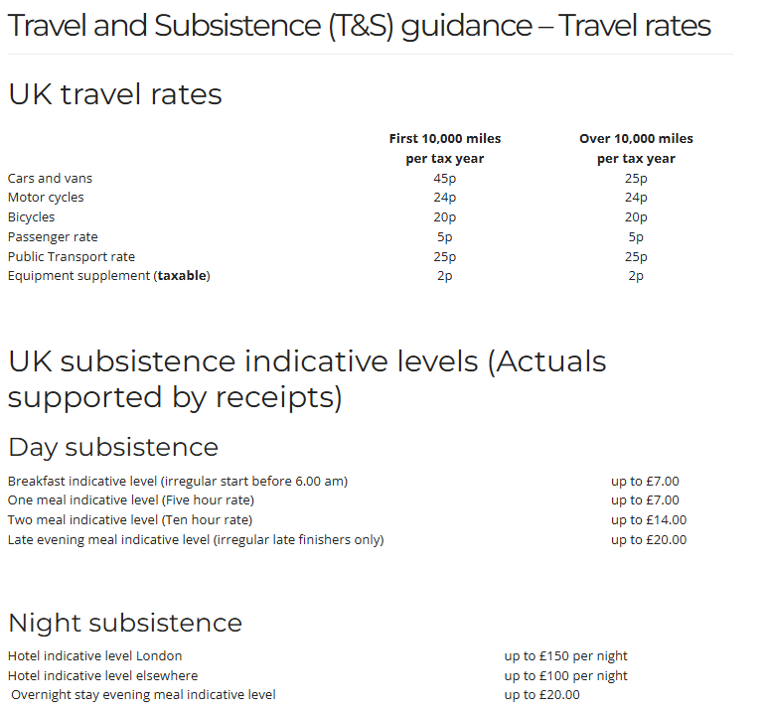

This will be subject to indexation in line with CPI from Year 3.

PAYMENT METHOD
[REDACTED]

BUYER’S INVOICE ADDRESS:
DfT Shared Service Centre
Unity Business Services
5 Sandringham Park
Swansea Vale
Swansea
SA7 0EA
SSa.invoice@Ubusinessservices.co.uk

BUYER’S AUTHORISED REPRESENTATIVE
[REDACTED]

BUYER’S ENVIRONMENTAL POLICY
DfT’s Corporate Environmental Policy (included in contract pack)

BUYER’S SECURITY POLICY
MCA Security Aspects Letter (included in contract pack)

[REDACTED]

SUPPLIER’S AUTHORISED REPRESENTATIVE
[REDACTED]

SUPPLIER’S CONTRACT MANAGER
[REDACTED]

PROGRESS REPORT FREQUENCY
Remote or onsite monthly meetings (as agreed between the Parties)

PROGRESS MEETING FREQUENCY
Remote or onsite monthly meetings (as agreed between the Parties)

KEY STAFF
[REDACTED]

KEY SUBCONTRACTOR(S)
SSS Public Safety Limited

COMMERCIALLY SENSITIVE INFORMATION
See document: NEC information exempt from disclosure, (included in contract pack)

SERVICE CREDITS
As detailed in the Service Definition

ADDITIONAL INSURANCES
The insurances listed under 1.1, 1.2 and 1.3 of the Annex of Joint Schedule 3 have been increased to £5m.

GUARANTEE
[REDACTED]

COMMERCIAL KPIS
[REDACTED]

SOCIAL VALUE COMMITMENT
[REDACTED]

For and on behalf of the Supplier: |  | For and on behalf of the Buyer:
Signature: | SEE DOCUSIGN PAGE | Signature: | SEE DOCUSIGN PAGE
Name: | SEE DOCUSIGN PAGE | Name: | SEE DOCUSIGN PAGE
Role: | SEE DOCUSIGN PAGE | Role: | SEE DOCUSIGN PAGE
Date: | SEE DOCUSIGN PAGE | Date: | SEE DOCUSIGN PAGE

