**Moss Side Farm**

**Pond Field Works Phase 2**

**Specification**

**1.1** **Site Background information**

Pond field was formerly agricultural land and is now being re wet as part of a wetter farming project to grow bog plants and pilot food crops that can grow in wetter conditions. Eventually the land will have further works for restoration to a wetland habitat.

There are many land drainage pipes within the field resulting in the drawdown of the water table within the peat. This work will bring the hydrology into management to enable raising water levels.

**1.2** **Contractor Experience**

Contractors are invited to tender for this work, which will require not only skill and experience of this type of work but particularly on boggy, difficult to navigate peat soils. Successful Contractors must demonstrate knowledge of and have regard for the sensitive nature of wetland hydrology. It is not expected that this work will be sub-contracted out and must therefore be undertaken by the successful Contractor.

**1.3** **Nature of work**

These works will include the following:

The installation of **1313** m of deep trench bunding

The installation of **404** m of cut off trench

Installation of water control pipes x **1**

Installation ditch outlet pipes x **3** (30m long)

stop log sluices **x5** (supplied by Natural England)

Peat inversion **0.1** ha

Install cut off ditch with a total length of **152** m

Irrigation pond x**1** @400m²

Sump pond x**1** @100m²

Cell accesses ramp x**3** over bunds culverted with sufficient pipes

internal ditch 677m

**2.0** **Contact Information**

Project Manager

Chris Evans 07979 873504 [christopher.evans@naturalengland.org.uk](mailto:christopher.evans@naturalengland.org.uk)

**3.0** **Access**

The site can be reached via access point gateway at53.466944, -2.450138 Astley, Manchester M29 7LU.

This road is in a dilapidated state but is wide enough and stable enough to allow access for large machinery.

Access to the site beyond the road is only on foot and by vehicles that are specially adapted to driving on peatland i.e. low ground pressure vehicles.

The centre of the site can be found at SJ 70173 97016

A google maps pin [**https://maps.app.goo.gl/3gKuQ9VkXcyUJ4c58**](https://maps.app.goo.gl/3gKuQ9VkXcyUJ4c58)for access to Pond Field.

**4.0** **Project Management**

* Day-to-day management and supervision of all machines and operatives will be the responsibility of the Contractor.
* The Contractor will be required to liaise weekly with Natural England (NE) during the project and provide progress reports when required.

**5.0** **General Principles**

**5.1** **Prevention of enrichment/pollution of the sites**

It is vital to the management of the site that there is no nutrient enrichment or spillage of chemicals, of any kind, onto the site. The Contractor shall meet high environmental standards by providing (and using) spill kits for all equipment and using bio-fuels and bio-lubricants in all machines where possible.

**5.2** **Method of works**

Due to the difficulty of transporting any weight around on the peat surface, the work will need to be planned such that access and/or movement of material is done solely on foot or by low ground pressure plant/vehicles.

**5.3** **Peat/mineral interface**

The Contractor must be careful to avoid disturbing the peat/sand or peat/clay interface at all costs. Therefore, great care needs to be taken when excavating/scraping/moving any peat whilst creating the bunds. The client will need to be informed immediately of any occasion where the underlying mineral surface is accidentally exposed. If bunding works encounter the underlaying clay, the clay can be used to form the bunds.

**6.0** **Works to be carried out**

**6.1** **Creation of deep trench bunds**

**6.1.1** **Background**

Bunding techniques for peatland restoration have developed over time and these works reflect current best practice for lowland raised bog restoration. Deep trench bunds will benefit the site by blocking the subsurface water movement.

**6.1.2** **Bunding required.**

**1313** m of bunding pond field area to form sub-surface peat walls. A further 404m of outer cut of trench will be installed outside the main peat bund along the railway ditch and deep drain along the road, this is to provide hydrological buffering. This will be to the same spec as the deep trench bunding but without the surface / above ground bund element of the bund.

This will be achieved by digging to a depth of approx. 2m, turning over the peat and compacting this in place. This compaction is essential for sealing any pipes, cracks or voids in the peat and stopping water leaking.

The surface bunds’ main purpose is to slow the movement of surface water and provide some above ground water storage, which will further counter the effects of drier months.

The top bund must be made with wet putty peat and in line with the trench bunding underneath. It should be no more than 0.5m high and 1m wide at the base. It is then covered with loose vegetation, stripped from the surface when excavating the deep trench bund line.

To achieve the correct method of installation, this technique allows for a number of preliminary inspection digs to determine the required depth of the trench. Once determined, the installation must dig below the water loss depth and ensure good peat is compacted in the trench to seal against water loss. The bunds need to be constructed to at least 0.5m in height and 1m in width on level ground. However, ground levels within the field vary, so in higher areas the top level of the bund can be graded to ground level so that the bund is only a visible above ground in low lying areas.

The extra peat needed for building the bunds will be won by digging a series of shallow scrapes no deeper than 0.5m. Extra borrow pit locations will be discussed on site with NE staff through arrangement with the project manager.

No peat is to be won from within 2 metres of any bund feature or bund construction site. This is to ensure that the newly constructed bunds are not subjected to extra pressure from water pooling.

An outer cutoff trench of **152**m will be installed within the buffer zone along the northern edge of the field to give further protection from the deep drain along the railway. This will be achieved by digging to a depth of approx. 2m, turning over the peat and compacting this in place. This compaction is essential for sealing any pipes, cracks or voids in the peat and stopping water leaking as is done with the deep trench bunds, but in this case one surface bund will be installed so the trench will only stop water moving below ground level.

**Figure 1 Wetter farming plan - pond field phase 2**

**6.2** **Installation of Water Control Pipes**

**6.2.1** **Background**

The creation of a bunding network will result in water pooling in the ‘borrow pits’ where peat is won to build those bunds. Pooled water exerts higher hydraulic pressures on surrounding peat. Without any means of re-distributing this water and lowering that pressure, the bunds may suffer leakage, erosion caused by over-topping, wave action or a combination - compromising their structural integrity and ultimately resulting in their failure.

**6.2.2** **water level Control required**

**2** 30m long overflow pipe will be installed within the bund at the north side of the field in the lowest bog cells linking them to the ditch by the railway (see fig 1). A further Water flowing out of the celled area will be controlled by stop log sluices at the exits to the drainage network. A sump will be installed at on the main outlet to allow water to be pumped up to the irrigation ponds at the south end of the field if required during farming operations Further stop log sluice will be installed between the internal cells and the upper irrigation pond to allow fine tuning of levels within the wetter farming system. A total of **5** stop log sluices will be needed for phase 1 (see appendix 1 for further info).

The outlets from the small wetland plant propagation areas will be controlled by 90-degree control pipes installed within the peat bunds to allow water levels to be managed. Upstream end of the pipe will be keyed into the bund with the invert level set at the natural ground level at the upstream end.

an internal water control ditch will be dug to a depth of 1.2m and a width of 1m, with a total length of **677**m (see fig 1). This ditch will link to the existing infield drainpipes, intercepting them before the internal bunds cut them off. These should carry water into the existing drainage ditches, though a seeresses of stepped water level controls. At the head of the ditch network there will be irrigation pond, and the lower end will contain a sump bond to allow for internal water management. Spoil created from this can be used in the construction of nearby bunds. The ditches can have wider areas along the length, to a maximum of 1.5m to create a varied and more nature friendly edge.

The irrigation pond will be 400m2 with a maximum depth of 1.5m at the centre of the pond grading down to 0.5 at the edge and the sump pond 100m2.

A cut off ditch will be dug to a depth of 1m to 1.2 m and to a width of 1 to 1.5m, with a total length of **152**m. Spoil created from the ditches can be used in the construction of nearby bunds. The ditches can have wider areas along the length, to a maximum of 1.5m to create a varied and more nature friendly edge. The cut off ditch will be linked to the ditch network by a further 30m long overflow pipe.

Install x3 peat Access ramps with 1:10 gradient fig 1. Ramp will include 300mm pipe where it goes over a ditch to allow water to continue to flow through the ditch.

**6.3 Soil burying and surface microtopographic forming.**

**6.3.1 Background**

The presence of a soil layer on top of the peat is a significant obstacle to the restoration of lowland raised bog peat converted to farmland in the 1800s. This “night soil” and modified peat layer is restricted to the depth of historical ploughing, so tends to be between 50-60cm deep on chat moss but can be shallower in areas of pastureland (10-30cm). To restore an area of this type of farmed peatland directly back to bog, all the nutrients and lime within the night soil need to be removed to expose acidic nutrient poor peat to provide the correct conditions for sphagnum and cotton grass to grow.

**6.3.2 Soil burying and surface microtopographic forming.**

Inversion of the top 1.5 m of peat and night soil, to bury night soil below a layer of wet, nutrient poor & acid peat. The wet peat at the surface will then be compacted to form microtopographic pools across the surface in the area highlighted covering **0.1** ha in total (see areas labelled bog on fig 1). The peat invention will be done by excavator working in retreat, with the peat mass excavated, and then inverted into a trench, then the back of the bucket used to compress the peat and sculpt the pools on the surface, the process will then be repeated to fill the newly cut trench (see fig 2). This will be done over the entirety of the area highlighted in fig1. The area will then be enclosed by a deep trench bund to cut any drainage pipes flowing in or out of the area (note this is included as part of the overall bunding total). The result will be a mosaic of wet peat and bog pools ready for the establishment of bog habitat.

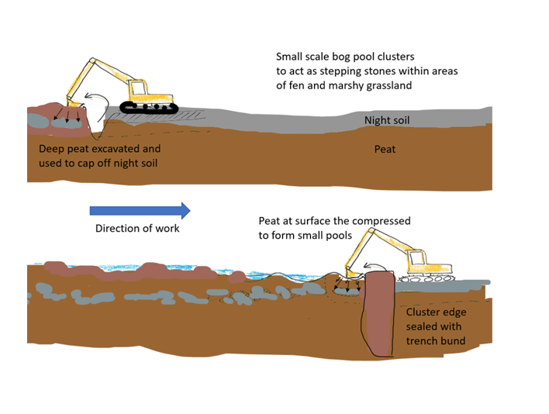

**Fig 2. Envisioned working method Night soil burying and surface microtopographic forming**

**7.0** **General work requirements**

* All operatives will hold current, relevant certification for all machinery and the contractor will have appropriate public liability insurance cover. All certification, public liability insurance documents and a Health and Safety policy statement must be presented with the tender documents.
* All operators will be experienced of working on wet peatland sites undertaking restoration work of a similar kind.
* The contractor shall provide all equipment, all fuel and maintain all equipment required for the completion of the project, including all appropriate PPE.
* The contractor will be responsible for all first-aid within the contract work force, and a practising first-aider with current certification will be present at all times. The contractor will provide appropriate first aid equipment. Lone working will not take place under any circumstances. Welfare facilities can be provided at the close by Moss Side Farm if required.

**7.1** **Health and Safety**

* A public access track runs to the east, west and south of the site and a private fishery is located in the south of the field. A mainline railway runs to the north of the site.
* The successful contractor will be expected to provide appropriate Risk Assessments and Method Statements.
* A Construction Phase Plan will be required with reference to welfare provided to operatives.
* Toilet facilities including warm water and a rest area can be made available at Moss Side Farm.
* Storage of plant can be provided at Moss Side Farm.

|  |  |  |  |
| --- | --- | --- | --- |
| **Quantities** | | | |
| **ITEM** | **DESCRIPTION** | **QTY** | **UNIT OF WORK** |
| **1.1** | **The installation of deep trench bunding** | **1313** | **metres** |
| **1.2** | **The installation of cut off trench** | **404** | **metres** |
| **1.3** | **Installation of 300mm water control pipes** | **1** | **each** |
| **1.4** | **Installation 30m long 300mm outlet pipes** | **3** | **each** |
| **1.5** | **Cell accesses ramp with pipe** | **3** | **ha** |
| **1.6** | **Cut-off ditch** | **152** | **metres** |
| **1.7** | **stop log sluices (installation only** | **5** | **each** |
| **1.8** | **Irrigation pond** | **1** | **each** |
| **1.9** | **Sump pond** | **1** | **each** |
| **1.10** | **Peat inversion** | **0.1** | **ha** |
| **1.11** | **Internal ditch** | **677** | **m** |