**Tendring District Council**

**Specification**

**Design for improvement to Roydon Way play area Heronsgate, Frinton-on-Sea CO13 0AW**

**29th June 2022**

**Version 0.1**

**Our Vision**

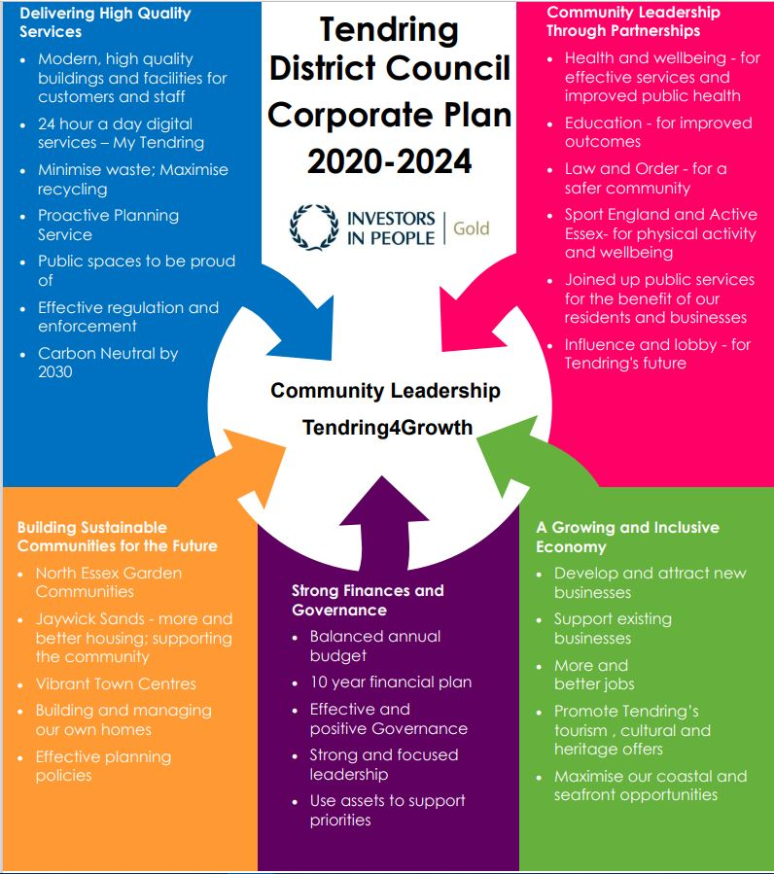***To put community leadership at the heart of everything we do through delivery of high quality, affordable services and working positively with others.***

**Our Values**

♦ Councillors and staff uphold **personal integrity, honesty,** and **respect** for others

♦ **Innovative, flexible, professional** staff **committed** to delivering excellence

♦ Recognising the diversity and equality of individuals

♦ Working **Collaboratively**

1. **Specification**

|  |
| --- |
| Tendring District council are seeking designs for the improvement of the above play area up to the value of £9000.  Designs should complement the area with consideration of use of colour, type of material used, landscaping and the addition to the play value and variety of the park.  Any new equipment is to be as inclusive as possible to allow children of all abilities to play together as well as being challenging to the age of children the site is designed for.  All quotations should include supply and fit of any new equipment including any safety surfacing requirements, planning permission requirements, removal of waste, surveying costs and any welfare facilities. A site visit is recommended especially for access requirements.  All equipment supplied and installed will be in accordance with EN1176 and EN1177  Designs can include a scale plan of the area and a breakdown of costs. A description of the equipment and why it has been included in the design is beneficial. |

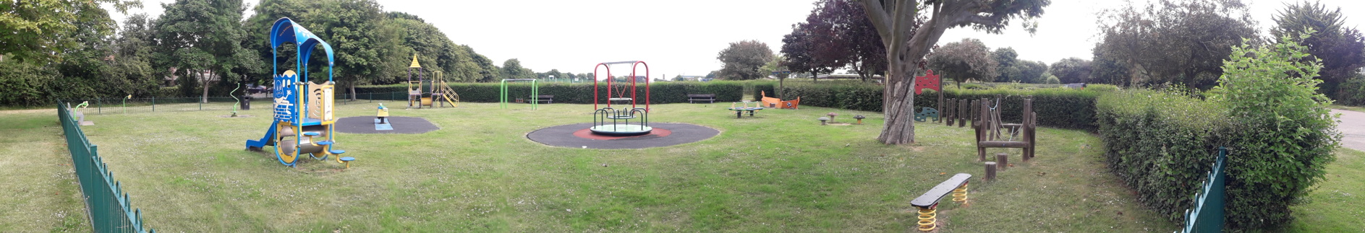

1. **Timetable**

The proposed timetable for this employment for guidance:

|  |  |
| --- | --- |
| *Publish RFQ* | 29.06.2022 |
| *Clarifications* | 29.07.2022 – midday |
| *RFQ Submission deadline* | 10.08.2022 – midday |
| *Evaluations* | 15.08.2022 – 19.08.2022 |
| *Award notification* | 22.08.2022 |
| *Contract start* | 01.09.2022 |
| *Contract end date* | TBC between TDC and the winning supplier |

1. **Payment**

Payment to contractors will be made on receipt of invoice AFTER the completion of the works and in accordance with the council’s procurement and payment policies.

1. **Evaluation Criteria**

Each design will be selected based upon the following Evaluation Criteria:

30% Quality weighting: 70% price weighting

* The originality of the design in line with our specification and how it complements the local area. Including the quality and suitability of the product for the location.

**30% Quality** (Section A: Technical questions below)

* Value for money such as how it maximises the play value and the variation of play against current equipment

**70% Price** (Section B: Pricing Matrix in separate document)

**You must pass the Mandatory** questions below to be considered for this RFQ.

|  |  |  |  |
| --- | --- | --- | --- |
| **Mandatory** | **Question** | **Evaluation Criteria** | **Weighting and Page Limit** |
|  | All equipment supplied and installed must be in accordance with EN1176 and EN1177 or equivalent. | You demonstrate the ability to comply with EN1176 and EN1177 or equivalent.  This is pass/fail | 1x A4 page maximum (plus relevant attachments). |

**Quality Technical Questions**

**Scores will be awarded on a 0-5 basis and then weighted in accordance with the table below.**

**If on any question you score below 3, this will classify as a failed score and a failed bid overall.**

**Scoring Methodology Table A:**

|  |  |
| --- | --- |
| **0** | **Wholly Unsatisfactory -** No response or the whole response is irrelevant to all of the question and evaluation criteria**.** |
| **1** | **Unsatisfactory -** The response only covers a minor element of the question and evaluation criteria and lacks relevant evidence regarding competence, capacity, and ability to successfully fulfil the requirements of the question. |
| **2** | **Partially Acceptable -** The response covers more than one element of the question and evaluation criteria but lacks relevant evidence regarding competence, capacity and ability to successfully fulfil the requirements of the question. |
| **3** | **Acceptable -** The response addresses most of the question and evaluation criteria but some areas contain limited relevant evidence regarding competence, capacity and ability to successfully fulfil the requirements of the question. |
| **4** | **Very good -** The response fully addresses the question and evaluation criteria and provides relevant evidence regarding competence, capacity, and ability to successfully fulfil the requirements of the question. |
| **5** | **Outstanding -** The response fully addresses the question and evaluation criteria and provides relevant evidence regarding competence, capacity and ability to successfully fulfil the requirements of the question and goes beyondexpectations tooffer an outstanding level of performance or an additional benefit which exceeds specified requirements. |

**The following parameters are shown as a guide to the scoring:**

The total score for each Technical Question statement scored will not exceed 5 and will carry equal weight. There are mandatory minimum assessments set out below; failure to reach these scores in anyone may result in a failure mark and the consultant will be excluded before price evaluation takes place.

**SECTION A – QUALITY – 30% Weighting**

|  |  |
| --- | --- |
| Questions 1-4 | Mandatory Minimum |
| Q1 – Technical Question 1 | Score 3 – Satisfactory Response |
| Q2 – Technical Question 2 | Score 3 – Satisfactory Response |
| Q3 – Technical Question 3 | Score 3 – Satisfactory Response |

|  |  |  |  |
| --- | --- | --- | --- |
| **Technical Evaluation**  **30%** | **Question** | **Evaluation Criteria** | **Weighting and Page Limit** |
| **1.** | How will the design add value to the current play area? | Explain how the design of the play area adds value? | **10%**  Up to 1x A4 page **per Play Area Bid**  Scoring methodology: Table A (please see pg 3) |
| **2.** | Show the value for money and durability of the equipment, explaining what maintenance schedules should be applied. | Number of items included, quality of product and minimum maintenance required 20% | **10%**  Up to 1x A4 page **per Play Area Bid**  Scoring methodology: Table A (please see pg 3) |
| **3.** | Give as accurate as possible time scales for installation and how disruption to the use of the play area will be kept to a minimum. | Show how quickly the project can be completed.  Can the area be opened while work carried out, what reinstatement of ground is needed after installation? | **10%**  Up to 1x A4 page **per Play Area Bid**  Scoring methodology: Table A (please see pg 3) |

**SECTION B – PRICING – 70% Weighting**

A pricing matrix spreadsheet has been included as part of the RFQ documentation issued

Bidders are required to complete and submit a full Pricing Matrix demonstrating their costs associated with delivering the requirement as set out in the specification.

For more information, please refer to the Bidder’s Guidance.

1. **Modern Slavery**

The bidder self-certifies that they are taking steps to ensure that there is no modern slavery or human trafficking (as defined in the Modern Slavery Act 2015) in their organisation or supply chain relating to the requested services/supplies requirements.

Here is a link to the Act: <http://www.legislation.gov.uk/ukpga/2015/30/contents/enacted>

1. **Health and Safety**

The bidder self-certifies that they adhere to the Health & Safety at work Act. Here is a link to the Act: <http://www.hse.gov.uk/legislation/hswa.htm>

1. **Environment**

The bidder confirms that they are aware of Tendring District Council’s Environmental Statement, and should they be successful, they are committed to working with the Council fulfil the vision outlined in the Statement.

<https://www.tendringdc.gov.uk/environment>

1. **E-procurement requirements**

Tendring District Council has a fully automated Purchase to Pay (P2P) system.

The successful bidder will be able to:

* View their orders online;
* Update their status;
* Notify delivery; and
* Submit and monitor the status of electronic invoices, once they have been submitted.

Orders will be sent electronically to the successful bidder’s central e-mail address from the contract start date.

The successful bidder will be expected to submit electronic invoices from the contract start date. On approval of the electronic invoice an automatic payment will be made via BACS, direct to the successful bidder’s bank account supported by an e-mailed remittance advice, in line with Tendring District Council’s contracted payment terms.

1. **Submission**

**Return of Submission**

For clarifications please contact: [tendringdc@essex.gov.uk](mailto:tendringdc@essex.gov.uk) by the 29**.07.22 midday.**

The deadline for your submission is **10.08.2022** **midday** and must be sent to our locked email address: [tenderbox1@tendringdc.gov.uk](mailto:tenderbox1@tendringdc.gov.uk)

Submissions will only be accepted by this method and before the deadline.

Additional copies **MUST NOT** be submitted in hard copy to any other recipient or member of the Council, or email copied or forwarded to additional email recipients. This is likely to disqualify your submission and could nullify the tender exercise.

There is a receipt limit of 20 megabytes per email on the Council email system. We do not accept files from download sites. For large files you may like to send zip files up to 20Mb per email. here is a large file rejection automated notice set up which will alert you if this is the case.

We also have an automated delivery receipt on these secure email accounts. If you do not receive this response from the Procurement team it is likely that your submission has failed to reach our Server so please resend and failing that contact [procurement@tendringdc.gov.uk](mailto:procurement@tendringdc.gov.uk)

You are advised to allow enough time before the deadline for any delays or errors reaching our server or rejection for oversize etc.

The onus is on you, the responder, to ensure that emails are received by us before the deadline.

The Council does not bind itself to accept the lowest or any quotation/tender.