Route Map into Lakeside from The Parks (on topo survey)
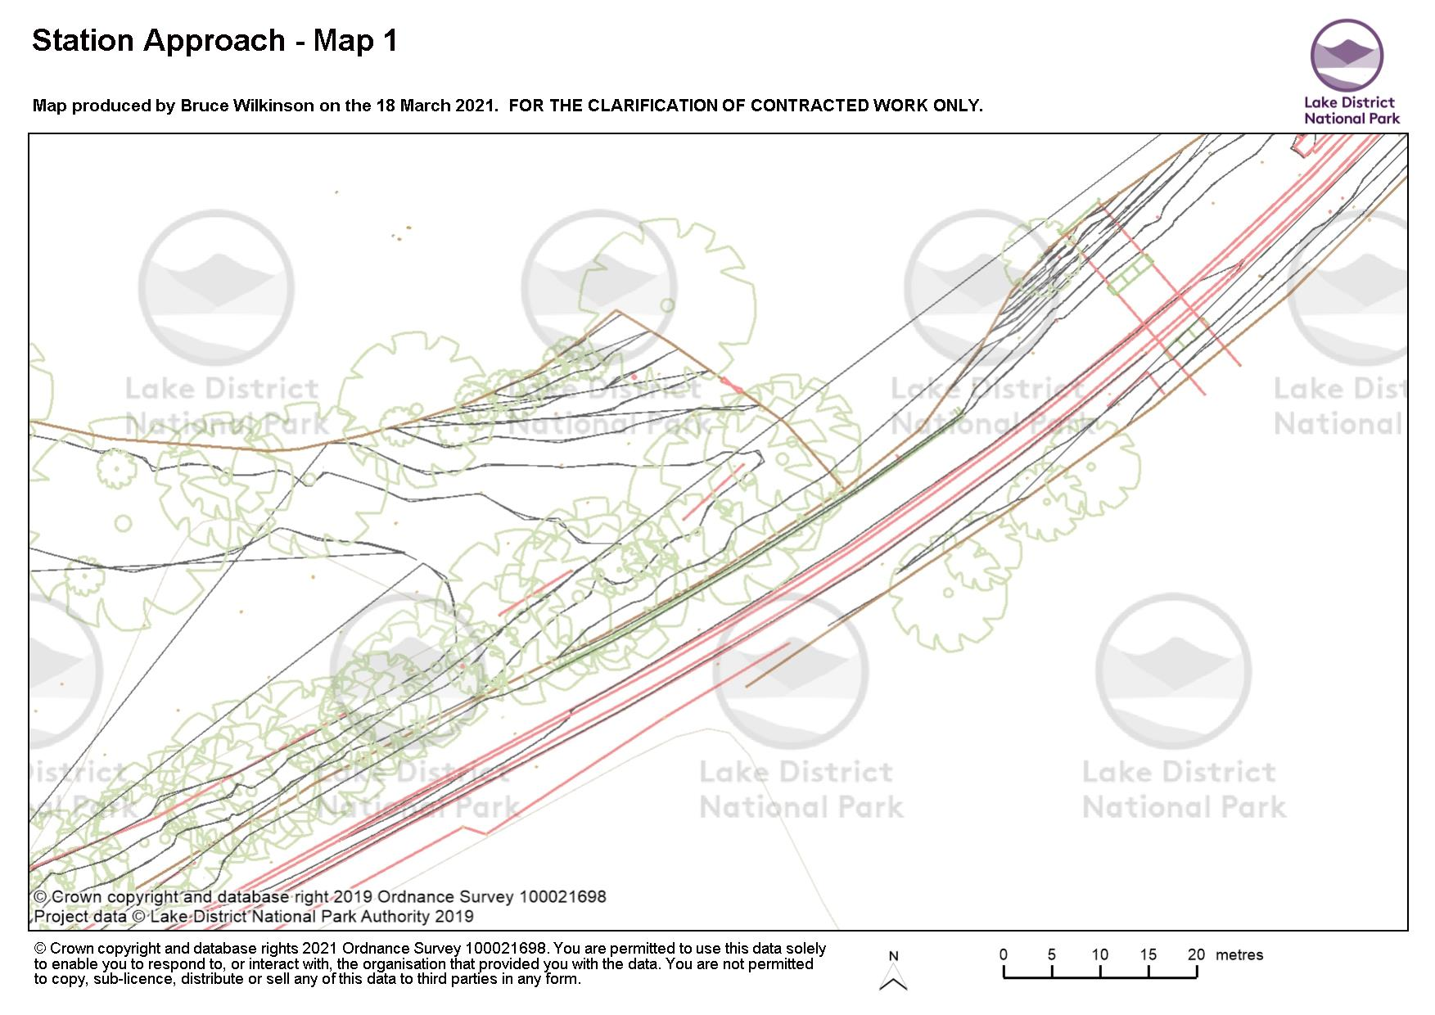
KEY
Trail
Fence / retaining wall
Note this map shows land owner / manager in relation to the trail and not the actual extent of any land holding.
The Parks
LANDING HOW
L&HR

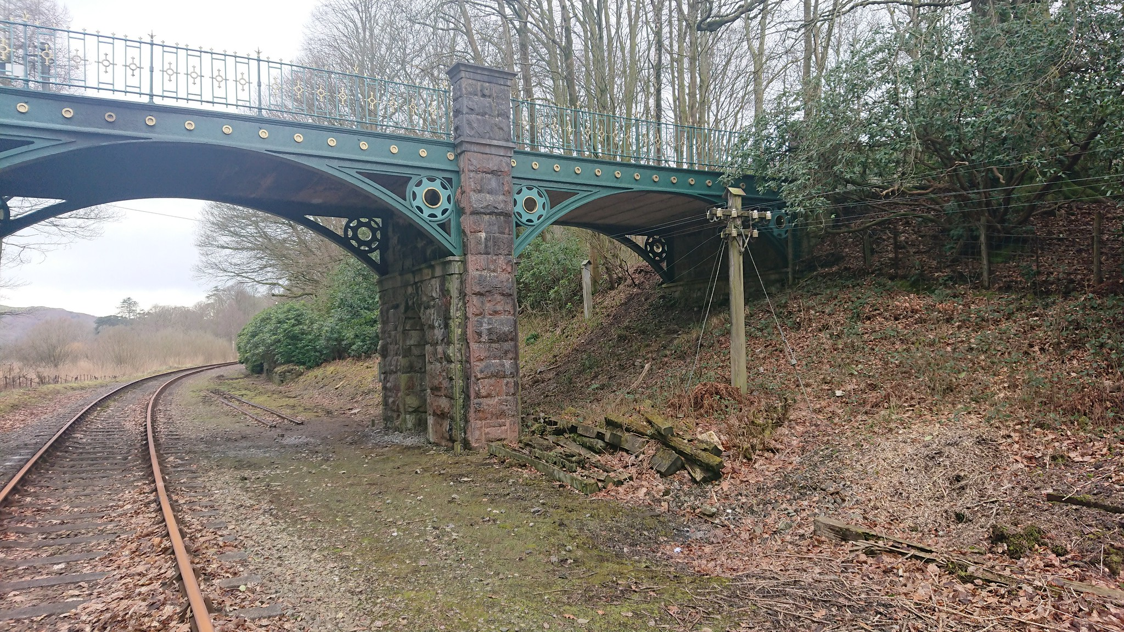
D
A – Ramp down from Landing How Section 1:10m gradient
B – Pole removed
C – Pole removed
D – trail passes through the arch @ 150mm – 300mm above track bed. Trial width @ 2.5-3.0m through arch with retaining wall against bank.
E – trail ramps up
E
B
C
A
Map Two – Station
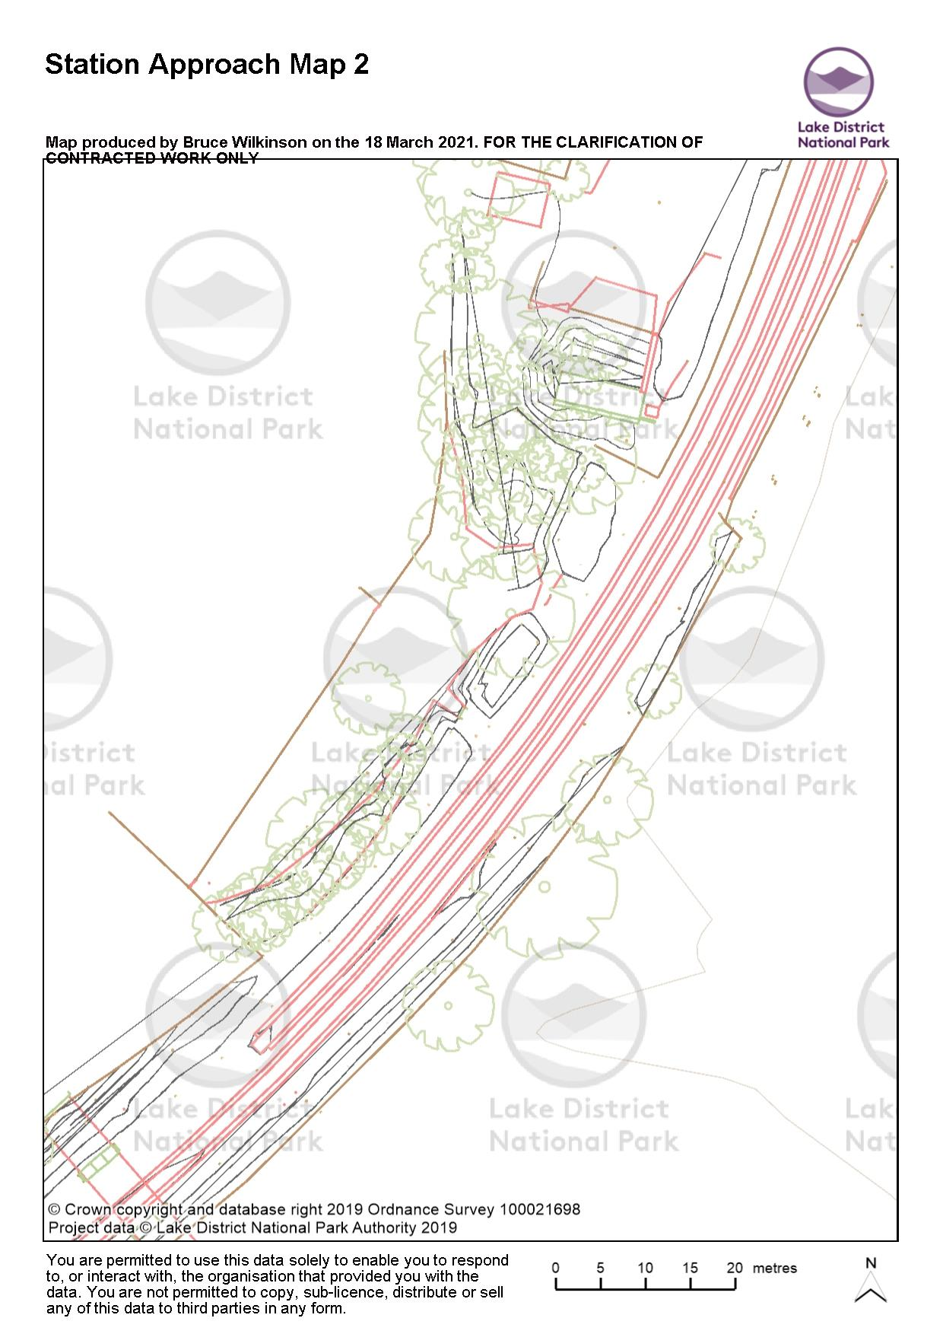
Cabinet to be screened or fenced / gated access from car park. Route passes to E (left). Trail @ 2.5mwide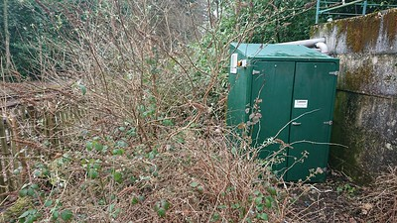
Please confirm nature of cabinate & if connected to services? It will require moving or romoval.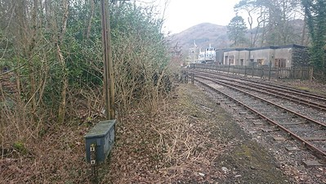
Fence / retaining wall
Trail
Box Culvert

Station Approach
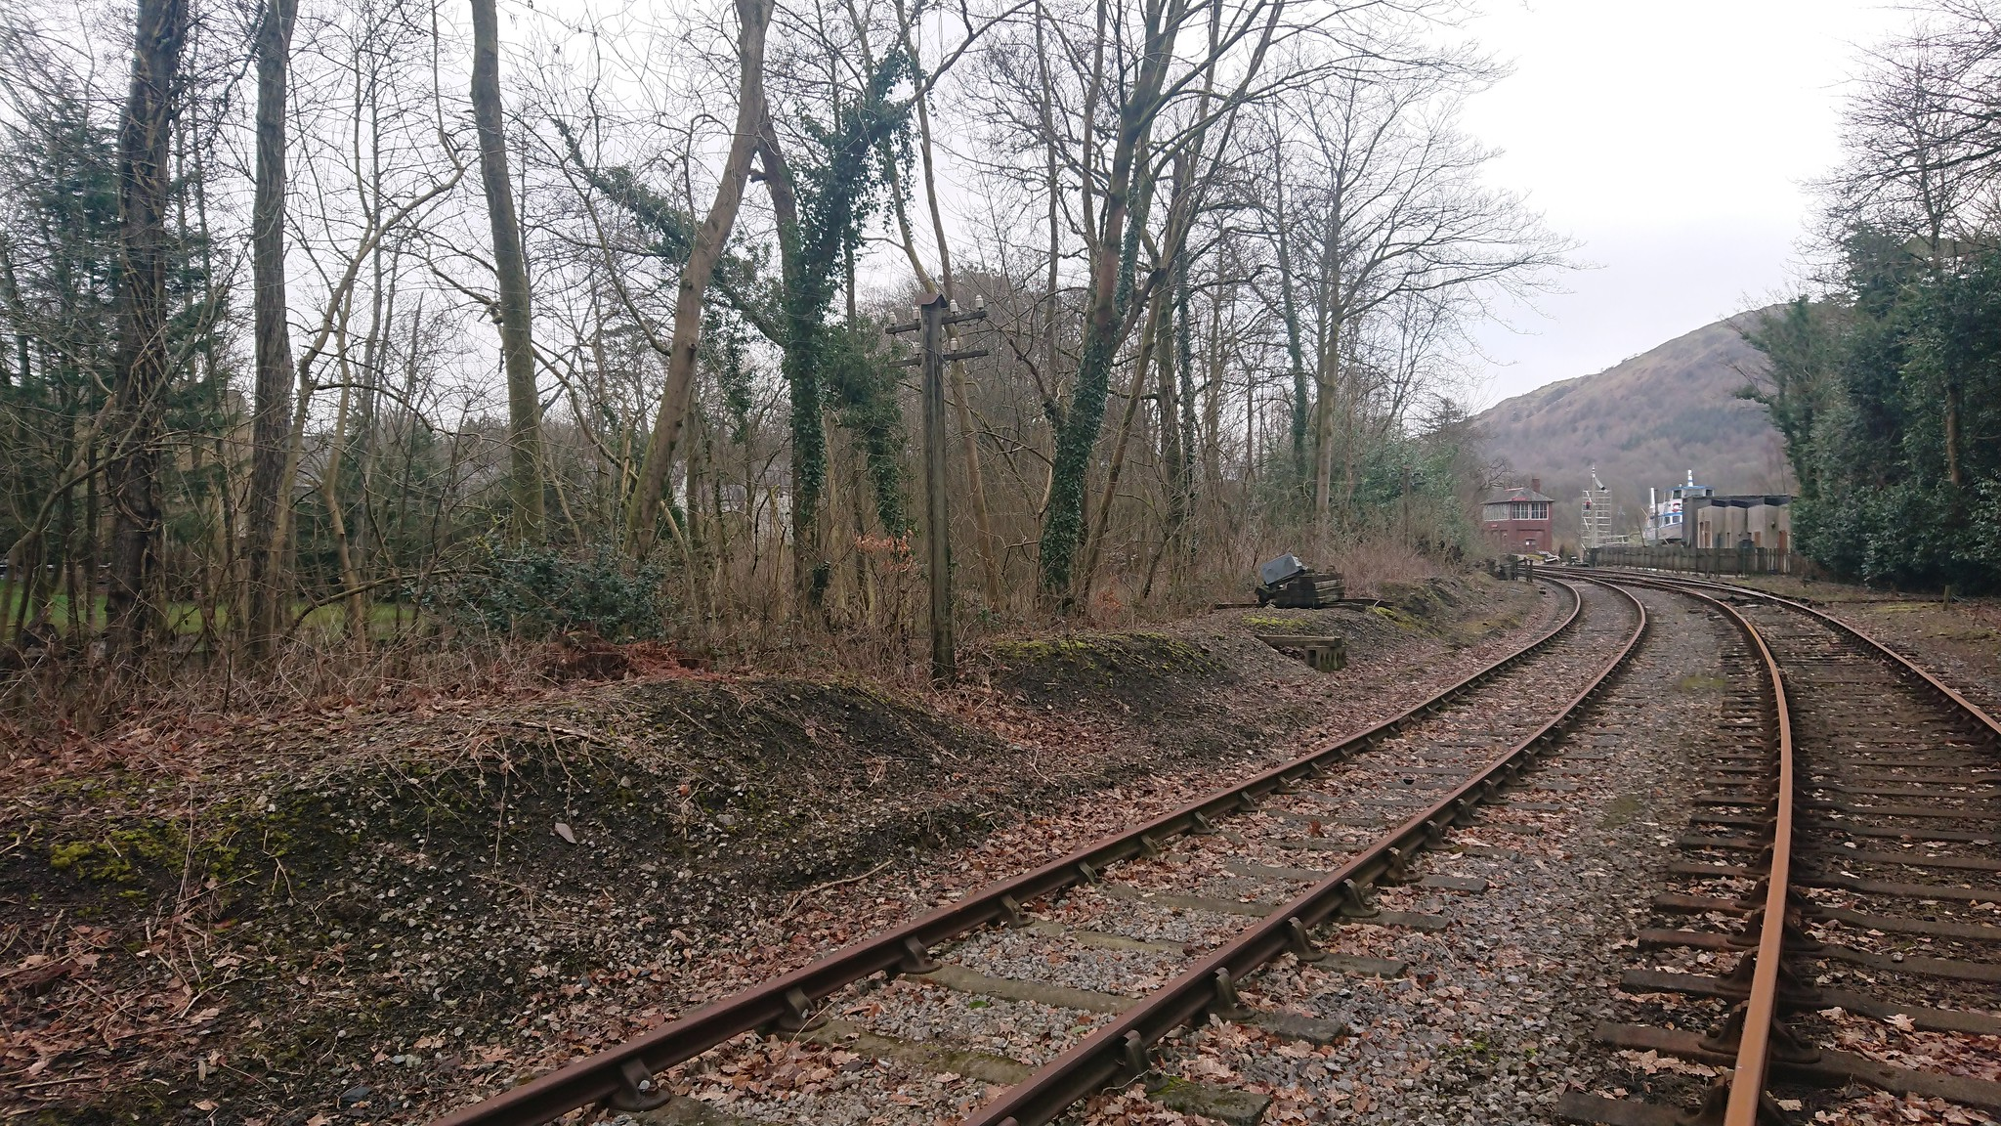
1 – fence / retaining wall edge taken as ‘step’ up from ballast / track bed. Please confirm distance from rail required?
2 – ballast used as sub base. Level reduced by 300mm.
3 – Telegraph pole removed. Can be replaced if required but location would need to be identified.
4 – Concrete box culvert to prevent impounding
5 – Concrete box culvert to prevent impounding
4
5
2
3
1

