

Hair: Untold Stories temporary touring exhibition – Transport from the Horniman Museum to Tullie House Museum & Art Gallery, Carlisle, and Weston Park Museum, Sheffield.

# Invitation to Tender

# 1. Invitation to Tender:

1.1 The purpose of this document is to invite tenders for a single contract to carry out the transport of the Horniman Museum touring exhibition ‘Hair: Untold Stories’, including set works and collections, from the Horniman Museum and Gardens to Tullie House Museum & Art Gallery, Carlisle, and then to Weston Park Museum, Sheffield, and then back to the Horniman Museum and Gardens as well as optional additional elements set out below (5.4).

1.2 This document constitutes an Invitation to Tender (ITT) for the contract. Subsequent sections describe the background to the project, the work to be done under the tender and the terms and conditions under which tendering will take place.

**2. Background:**

2.1 The Horniman Museum and Gardens is an inspiring, surprising, family-friendly, free attractions in South London's Forest Hill. The Horniman has been open since Victorian times, when Frederick John Horniman first opened his house and extraordinary collection of objects to visitors. Since then, the collection has grown tenfold and includes internationally important collections of anthropology and musical instruments, as well as an acclaimed aquarium and natural history collection.

Visitors come time and again to explore the free museum, take part in activities and enjoy the 16-acre gardens. And they discover something fascinating and mesmerising every time.

2.2 The Horniman is currently showing the temporary exhibition ‘Hair: Untold Stories’ until 21 June 2022. It will tour to Tullie House Museum & Art Gallery, Carlisle to be exhibited from 1 October 2022 – 08 January 2023. It will then tour to Weston Park Museum, Sheffield for exhibition between 10 February 2023 – 29 October 2023 following which it will return to the Horniman Museum and Gardens.

**3. Objectives:**

* Safe transportation of the Exhibition from the Horniman Museum (provisional date week beginning 19 September 2022)
* Delivery of the Exhibition to Tullie House Museum & Art Gallery
* Collection and transportation of the Exhibition from Tullie House (provisional date for collection 23 January 2023)
* Delivery of the Exhibition to Weston Park Museum, Sheffield
* Return transport of Exhibition to the Horniman Museum (provisionally week beginning 6 November 2023)

|  |  |
| --- | --- |
| **Crates** | **32 crates, approx. 23.25m3** |
| **Set works not crated (soft wrapped)** | **Approx 10.5m3** |

**4. Project Participants for the Horniman:**

Magnet Coordinator**: Laura Davidson** (contact for tender)

Exhibitions and Design Manager: **Cressida Diez-Finch**

Collections Manager: **Adrian Holloway**

Conservation Manager: **Julia Gresson**

The Magnet Coordinator will manage the tender process and monitor the progress of the project.

5. **Description and Scope of Works:**

5.1 As an itemised quote, please provide *detailed* costings for:

Collection of set works and object crates and transportation from the Horniman Museum and Gardens to Tullie House Museum & Art Gallery, Carlisle (provisional date 19th September 2022). Object crates to ideally travel single layer. Set works crated and soft wrapped can be stacked for transport.

Notes re collection from Horniman Museum and Gardens:

Address: 100 London Rd, Forest Hill, London SE23 3PQ (or SCC?)

Access ideally before museum opening (10am) or after closing (5.30pm).

We are an urban site with little parking for large vehicles close to the museum. Entry to the museum should be in suitable vehicles for the site (ideally 7.5 tonne vans).

If you are not able to provide 7.5 tonnes vehicles which can drive directly to the museum please itemise how you would propose loading larger lorries (which can be parked only at our Bandstand which is up a short steep path to the museum) and include an itemised cost for forklifts to transport the crates from the museum entrance to the lorries if required.

Please ask for our site access report for more details if required.

5.2 As an itemised quote, please provide an *estimated* cost for:

Collection of the exhibition from Tullie House Museum & Gallery, Carlisle, and transportation to Weston Park Museum, Sheffield (provisional date for collection 23 January 2023).

Access at Weston Park Museum is restricted to vehicles no larger than a Luton van for direct unloading or larger vehicles need to park in the adjoining public park (if approved by Sheffield Council) and transfer crates up a ramp to the main museum entrance.

5.3 As an itemised quote, please provide an *estimated* cost for:

Collection of the exhibition from Weston Park Museum, Sheffield, and return transport to the Horniman Museum and Gardens store, Old School Close, Greenwich, London, SE10 0PG (provisional date for collection 6 November 2023).

Access at Weston Park Museum as above.

5.4 As separate itemised quotes, optional elements if you wish to tender:

1. Refurbishment of crates – up to 10 crates (noted on Appendix 1) need cleaning, sealing and fitted with new gaskets and handles (to Horniman crate specifications) prior to end June 2022. This can be completed on site at the Horniman Museum store in North Greenwich, SE10 or taken offsite. See Appendix 4 for Crate Specifications.
2. Soft wrapping of set works at Horniman Museum and Gardens (see Appendix 2) including materials cost, ideally with reusable packing
3. Soft wrapping at Tullie House Museum & Gallery and at Weston Park Museum (with additional materials cost if necessary)
4. Assisting with loading at the Horniman Museum (2 x art handlers)
5. Packing of separate Cult Hair display (see Appendix 3)

5.5 Contractor Responsibilities

* The provision of risk assessments and method statements for all activities on the Horniman Museum premises and in line with CDM regulations.
* The provision of staff with relevant experience in packing, transit and storage of museum collections and a lead contact / foreman when on Horniman premises.
* All works to follow the Museum’s Rules for Visiting Contractors guidelines.

5.6 Essential Requirements

* The transport of museum collections must meet the minimum conditions to conform to Annex E of the Government Indemnity Scheme guidelines. Note the set works can travel using appropriate non-GIS compliant transport.
* Proven experience with references in the UK for this type of work.

**6. Tender Response:**

Formal tender submissions must be received by noon 12th May 2022. Tender submissions should be made electronically to Laura Davidson ([ldavidson@horniman.ac.uk](mailto:ldavidson@horniman.ac.uk)). We do not expect hardcopy submissions.

Documents may be sent in MS Word or PDF format. Receipt of submissions will be acknowledged by email.

6.1 Supplier Selection

Tender responses will be evaluated on the basis of

* Costs
* Meeting tender/programme requirements
* Proposed method statement and understanding of risks
* References
* Relevant experience including:
* Previous experience of exhibition transport to GIS standards
* Organisational ability

Tender responses will be evaluated by Laura Davidson, Cressida Diez-Finch and Adrian Holloway. We hope to appoint the contract during the week commencing 16th May 2022.

6.2 Structure of tender submissions, please include all these items, ideally listed as below:

A. **Your fees,** costs should be quoted ex-VAT.

|  |
| --- |
| **Essential:** |
| Fixed price fee proposal for the elements at 5.1, and estimated costs for the items in 5.2 and 5.3 above |
|  |
| **Optional:** |
| itemised fees for the items under 5.4 if you wish to bid for these |

B. **Your other details**

|  |
| --- |
|  |
| Proposed method statement and outline programme of work |
| 2-3 Examples of relevant projects worked on, with named referees with contact details |
| A statement of any risks that you foresee for this project and what mitigations you would put in place (please include your policy for disruptions caused by Covid-19 outbreaks or requirements for self-isolation by your team) |
| Details of your company history and profile, with financial information (including the last two years sets of accounts) and environmental policy. |
| A suitable single point of contact for all correspondence relating to the tender, including email address, postal address and telephone number(s). |
| Details including contact information for any sub-contractors you would plan to use. |

6.3 Contract award

Suppliers and those organisations looking to bid for public sector contracts should be aware that if they are awarded a new contract with a publicly funded body, the resulting contract will be published. In some circumstances, limited redactions will be made to some contracts before they are published in order to comply with existing law and for the protection of national security.

6.4 Approximate project timeline

* Issue invitation to tender: 06 May 2022
* Deadline for tender submissions noon: 12 May 2022
* Aim to award: week commencing 16th May 2022
* Soft wrapping and packing of set works: August / September 2022
* Collection of Exhibition from Horniman Museum and delivery to Tullie House Museum & Gallery, Carlisle: 19th September 2022
* Collection from Tullie House Museum and delivery to Weston Park Museum: 23 January 2023
* Collection from Weston Park Museum and delivery to the Horniman Museum and Gardens commencing 6 November 2023

6.5 Contract Terms and Conditions

**Horniman Museum and Gardens**

**Standard Terms & Conditions of Purchase for Goods and Services (November 2018)**

1. Definitions

In these conditions "HMG" means the Horniman Public Museum & Public Park Trust (known as the Horniman Museum and Gardens); “Contract" means the Purchase Order together with these Conditions and any other documents attached or referred to therein; " Data" means all designs, models, mock ups, drawings, prints, samples, analysis results, data and documents of all kinds, materials, photographs, negatives, diskettes, films, software or any similar items supplied by the HMG or procured from the Supplier of any third party for the purposes of the Contract; "Goods" means the goods specified in the Purchase Order (or amendment thereof) to be supplied by the Supplier in accordance with the Contract. "IPRs" means all copyright and other intellectual property rights, howsoever arising throughout the world and in whatever media or format, whether or not registered, including patents, trademarks, service marks, database rights, trade names, design rights, performance rights (incorporating, without limitation, an irrevocable license to use the name, sobriquet, autograph, likeness, photograph, portrait, caricature, silhouette or voice of any performer), publication and distribution rights and any applications for the protection or registration of these rights, for the full period for which such copyright and other rights subsist including all renewals, revivals and extensions thereof; "Purchase Order" means the HMG's official numbered order; " Services" means the services specified in the Purchase Order including the giving of advice ( or amendment thereof) to be carried out by the Supplier in accordance with the Contract; The "Supplier” means the supplier named in the order.

1. Assignment or Sub-Contracting

The Supplier shall not assign or subcontract the whole or part of the benefits or burdens under the Contract without the previous consent of the HMG. The HMG may assign or subcontract the whole or part of the benefits or burdens under the Contract to any company which is a subsidiary of the HMG.

1. Performance

Goods supplied under this Contract shall: (a) be of good and sound design, materials and workmanship; (b) be of merchantable quality and fit for the purpose(s) for which they are supplied under the Contract; (c) conform as to description, specification and quantity with the particulars stated in the Contract; (d) comply with all statutory requirements; (e) be free from any defect in title; and (f) be returnable to the Supplier within 21 days in the event the Goods are damaged or have suffered damage during manufacture or transit which could reasonably be discerned from the inspection on delivery or which are not in accordance with the Contract, in which case the Contract shall be deemed to be terminated in accordance with clause 20 (a).

Services executed under the Contract shall (a) be carried out with reasonable skill and care; (b) be carried out with due expedition and in so far as is reasonably practicable within the time if specified under this Contract; (c) comply as to the description, specification and quantity with the particulars stated in the Contract; and (d) comply with all statutory and other regulations applicable to the Services that are in force at the time and delivery of the Services.

1. Price/Payment
2. The price(s) detailed in the Contract shall remain firm and fixed for the duration of the Contract. The Supplier shall send a detailed invoice; with VAT quoted separately, quoting the Order number to the Finance Department, Horniman Museum & Gardens, 100 London Road, London, SE23 3PQ or may be emailed to [invoices@horniman.ac.uk](mailto:invoices@horniman.ac.uk).
3. Payment will be made by the HMG no later than the end of a period of 30 days from the date on which relevant invoice is regarded as valid and undisputed. HMG will consider any invoices for payments submitted by the Supplier in a timely fashion and undue delay in doing so is not to be regarded as sufficient justification for failing to treat an invoices as valid and undisputed.
4. In the case of the supply of Services: unless otherwise expressly agreed on the face of the Purchase Order the Supplier shall be fully responsible for arranging his/her travel and any accommodation (and that of any member of the Supplier’s staff or any person employed or engaged by a sub-contractor, agent or servant of the Supplier) within and/or to and from the United Kingdom in connection with Contract (including but not limited to all flights, transfers and other travel arrangements, travel insurance and visas) and shall be fully responsible for meeting all costs associated with the above.
5. Delivery/Completion of Order

The Goods shall be delivered at the times, dates and place specified in the Contract. Delivery shall be deemed to be made on receipt of the Goods by the HMG in accordance with the Contract.

The Services shall be deemed completed when completed in accordance with the Contract. Where the Supplier requires access to the HMG's premises in order to discharge its obligations under the Contract, the Supplier shall at all times comply with the security requirements and site rules and regulations of the HMG and it shall be responsible for effecting its own insurances which shall, where applicable, include employer’s liability, professional indemnity and public liability insurance.

1. Inspection, Rejection and Guarantee

Without prejudice to any of its other rights hereunder, the HMG may by notice to the Supplier reject all or any of the Goods and/or Services if the Supplier fails to comply with any of its obligations under the Contract. The HMG shall not be deemed to have accepted the Goods and/or Services until the HMG has had a reasonable time after delivery to inspect the Goods and/or Services without charge. The Supplier shall at the HMG's option replace Goods or rectify Services rejected by the HMG with Goods and/or Services which in all respects conform to the Contract or credit the HMG with the invoice price thereof. The Supplier shall guarantee the Goods for the shorter of 12 months from putting into service or 18 months from delivery.

1. Risk and Property

Risk and property in the Goods shall without prejudice to any other rights or remedies of the HMG pass to the HMG at the time of acceptance of the delivery of the Goods at the HMG.

1. Damage in Transit

The Supplier shall without charge to the HMG promptly either repair or replace (at the HMG's option) any Goods damaged in transit or which having been placed in transit fail to be delivered to the HMG, provided that the HMG gives notice, within 30 days of delivery, of damage to the goods or within 10 days of the notified date of delivery that the Goods have not been delivered.

1. Labelling and Packaging

The Goods shall be packed and marked in a proper manner and in accordance with the HMG's instructions and any statutory requirements and any requirements of the carrier. The Goods shall be marked with the Purchase Order number and name of contents on each container and all containers of hazardous Goods (and all related documents) shall bear prominent and adequate warnings. All packaging materials will be considered non-returnable and destroyed unless the Supplier's advice note states otherwise.

1. Intellectual Property Rights

Any Data supplied by the HMG for the purposes of the Contract shall remain the unencumbered intellectual property of the HMG.

The Supplier warrants that in the manufacture of the Goods/ supply of Services/ provision of know-how to the HMG under the Contract the Supplier shall not infringe the IPRs of any third party and that the Supplier shall ensure that it has the right to provide such know-how and is not disclosing the same in breach of confidence.

Unless HMG otherwise expressly agrees ion writing all IPRs in the Goods and/or Services (including without limitations IPR's comprised in any associated Data) prepared or developed (or to be prepared or developed) by the Supplier under or in connection with the Contract are hereby assigned to and shall vest in the HMG free from any encumbrance and with full title guarantee. The Supplier unconditionally, irrevocably and in perpetuity waives all moral and author's rights and rights of a similar nature under the laws of any jurisdiction which the Supplier may have in Goods and/or Services and any associated Data.

If for the delivery of the Goods/supply of the Services the Supplier requires the supply by HMG of Data comprising the registered and/or unregistered trademarks of the Horniman Museum and Gardens, together with permission to use the same, such permission and supply shall only be made in the format and context agreed in each case in writing in advance by the Trustees of the Horniman Museum and Gardens, and shall require the Supplier to comply with any brand guidelines and license conditions communicated to the Supplier from time to time. Any right to use the registered and/or unregistered trademarks of the Horniman Museum and Gardens will automatically terminate upon termination of this Agreement.

1. Health and Safety

The Supplier shall comply with the requirements of the Health and Safety at Work Act 1974 and any other acts, orders, regulations and codes of practice relating to health and safety in performance of this Contract and/or working on the HMG's premises.

1. Prevention of Corruption

The Supplier shall not itself or in conjunction with any other person:-

(a) corruptly solicit, receive or agree to receive, for it or for any other person, or

(b) offer or agree to give to any person in the HMG's service, or any other supplier who has a contract with the HMG any gift or consideration of any kind as an inducement or reward for doing or not doing anything, or for showing favour or disfavour to any person, in relation to this Contract or any other contract to which the HMG is party.

Without prejudice to clause 17, the HMG may forthwith terminate the Contract with the Supplier if the Supplier is

(a) in breach of clause 12; or

(b) convicted of any offence under the Bribery Act 2010

Any dispute or difference of opinion arising in respect of either the interpretation or effect or application of this clause 12 shall be decided by HMG whose decision on the matter shall be final and conclusive.

1. Indemnity

The Supplier shall indemnify and keep indemnified, the HMG against:

(a) all claims, proceedings, actions, damages, legal costs, expenses and other liabilities whatsoever arising out of or in connection with the supply of Goods and/or Services and/or the assignment of IPR's pursuant to the Contract, in respect of death or personal injury to any person (including, without limitation, employees of the HMG), or any damage to property, loss, damages, costs, or other claim for compensation and any legal or other expenses which are awarded against or incurred by or paid or agreed to be paid by the HMG, however the same may arise, unless caused by the negligence of the HMG;

(b) (in the supply of Services) any demands for any income tax and primary and secondary class 1 National Insurance or similar contribution, including any penalties or interest arising from any claim that the Supplier (which expression in paragraphs (b) (c) and (d) of this clause 13 includes or any member of the Supplier's staff or any person employed or engaged by a sub-contractor, agent or servant of the Supplier) is or was an employee of the HMG at any material time during the performance of the Contract;

(c) (in the supply of Services) any claim whether statutory, contractual or at common law brought by the Supplier and arising out of or based upon an allegation that the Supplier was at any material time during the performance of the Contract an employee of the HMG;

(d) (in the supply of Services) any penalties or charges incurred by the HMG in connection with the Supplier’s immigration status; and

(e) the HMG’s reasonable costs (on a full indemnity basis) of dealing with any such claim or matter under (a), (b), (c) or (d) above.

1. Taxation

At all times during the term of this Contract or after it has ended, the Supplier shall comply properly with the requirements of all relevant legislation and agreements relating to payment of value added tax, corporation taxes, income and other taxes and statutory charges levied in respect of the provision of the services to HMG and/or the fees payable to the Supplier under this Contract (“the Tax”), and shall be responsible for payment of the Tax.

Where the Supplier is liable to National Insurance Contributions (NICs) in respect of consideration received under this Contract, they shall at all times comply with the Social Security Contributions and Benefits Act 1992 (SSCBA) and all other statutes and regulations relating to NICs in respect of that consideration, and shall be responsible for paying all NICs.

HMG may, at any time during this Contract, request the Supplier to provide information which demonstrates how the Supplier complies with the above obligations in relation to taxation or why those clauses do not apply to the Supplier. Such a request may specify the information which the Supplier must provide and the period within which that information must be provided.

HMG may supply any information which it receives under a request above to the Commissioners of Her Majesty’s Revenue and Customs for the purpose of the collection and management of revenue for which they are responsible.

1. Insurance

The Supplier shall effect and maintain general third party and where applicable product liability and professional indemnity insurance cover with a combined bodily injury and property damage limit of not less than five million pounds (£5,000,000) per occurrence or series of occurrences arising from the one event and unlimited cover in any period of insurance (aggregate or product liability). Such insurance shall contain an indemnity or principals clause. The Supplier shall provide evidence of such cover to HMG, if requested.

1. Confidentiality

(a)The Supplier shall treat all information, data or process in connection with the Contract as confidential and shall not use any confidential information supplied by the HMG other than for the purposes of the Contract.

(b)The Supplier acknowledges and agrees that HMG may at any time during the term of the Contract be subject to a legal duty or central governmental directive to publish prescribed parts or full terms of any contract in the public interest (including without limitation the whole or any terms of this Contract and the specification/scope of services and/or the prices comprised herein) and that such legislation or central governmental directive overrides any contractual duty of commercial confidence owed to the Supplier whether under this Contract or otherwise and the Supplier waives any and all rights of claim for breach of commercial confidence against HMG, its agents and employees, howsoever arising, and shall hold HMG, its agents and employees, harmless in respect of any claim for loss or damage suffered by the Suppliers as the consequence of HMG’s discharge of any duty of law of central government policy to publish prescribed parts or the whole of this Contract.

(c) Information supplied electronically by HMG to the Supplier, marked as “Sensitive” encrypted and password protected shall not be transmitted by the Supplier to any third party other than in an encrypted and password protected format and with the prior consent in writing of HMG.

(d) Where the Services supplied under this Contract involve:

(i) the handling by the Supplier of the personal information of citizens, such as home addresses, bank details or payment information; or

(ii) the personal information of employees or agents of HMG such as payroll, travel booking or expenses information; or

(iii) the supply of ICT systems and services which are designed to store, or process, data marked “official” or “sensitive” by HMG;

Then, in any of the above cases (i)-(iii):

(iv) where the Supplier acts as HMG’s data processor, HMG and the Supplier must enter into a collateral agreement or addendum to this Contract governing such data processing in compliance with the Data Protection Act 2018 and the Privacy and Electronic Communications (EC Directive) Regulations 2003 (SI 2426/2003) and all applicable laws and regulations relating to the processing of personal data and privacy, including where applicable the guidance and codes of practice issued by the Information Commissioner or any other supervisory authority, and the equivalent of any of the foregoing in any relevant jurisdiction; and

(v) the Supplier shall hold and maintain Cyber Essentials (or, if appropriate, Cyber Essentials Plus) certified assurance in respect of cyber security to the standards set out in the HM Government Procurement Policy Note: *Cyber Essentials Scheme; Action Note 09/14; 25 May 2016*, a copy of which may be inspected here: <https://www.gov.uk/government/publications/procurement-policy-note-0914-cyber-essentials-scheme-certification>

1. Transparency

(a) The Parties acknowledge that, except for any information which is exempt from disclosure in accordance with the provisions of the Freedom of Information Act (“the Act”) the text of this Agreement, and any Schedules to this Agreement, is not Confidential Information.  The Authority shall be responsible for determining in its absolute discretion whether any part of the Agreement or its Schedules is exempt from disclosure in accordance with the provisions of the Act

(b) Notwithstanding any other term of this Agreement, the Contractor hereby gives its consent for the Authority to publish this Agreement and its Schedules in its entirety, including from time to time agreed changes to the Agreement, to the general public in whatever form the Authority decides.

1. Suppliers Staff

HMG reserves the right to refuse to admit to its premises (or to withdraw permission to remain on its premises), any member of the Supplier's staff or any person employed or engaged by a sub-contractor, agent or servant of the Supplier:

(a) who does hold all necessary and applicable immigration permits to work legally for HMG pursuant to this Contract;

(b) in respect of whom the Supplier cannot or does not provide all necessary details and/or supporting documentation as requested by HMG from time to time to enable HMG at its own cost to conduct relevant security clearance checks to satisfy the requirements of HMG’s Security Policy and HMG’s Baseline Personnel Security Standard for the verification of the identity, nationality, and immigration status, employment history and criminal record prior to and during the continuance of this Contract;

(c) who does not wear or carry valid HMG identification at all times while on the HMG’s premises and produce it immediately upon the HMG’s request; or

(d) whose admission or continued presence would be, in the unfettered opinion of HMG contrary to its interest.

The Supplier shall at all times adhere to the requirements of the National Minimum Wage Act 1998 (as amended from time to time).

The Supplier warrants that its Staff have obtained the necessary immigration authorisation to allow the Supplier and its Staff to work legally for HMG for the term of this Contract (whether in the United Kingdom or at another location).

HMG and/or its authorised representative shall be entitled, at any time and without giving notice to the Supplier, to carry out at its own cost such tests of the Supplier’s compliance with the requirements of this clause as it may deem necessary. Such tests shall be designed and implemented so as to minimise the impact on the Supplier’s performance of this Contract.

1. Disability Rights

The Supplier warrants that all Goods and/or Services supplied under this Contract conform (or shall be capable of conforming in the hands of the HMG) with the guidance contained in the Disability Rights Commission's Code of Practice: Rights of Access: services to the public, public authority functions, private clubs and premises (2006) a copy of which may inspected at **http://www.opsi.gov.uk/SI/si2006/20061967.htm.**

1. Termination

(a)Without prejudice to either party's other rights and remedies under this Contract or at law, either party may terminate the Contract forthwith on notice if the other (“the defaulting party”):

(i) commits a breach of this Contract and fails to remedy such breach ( where it is capable of remedy) within 30 days of receipt of a notice in writing requiring it to do so; or

(ii) ceases to trade, or is unable to pay its debts as they fall due or has a petition presented or a meeting convened for the purpose of winding up the defaulting party or enters into liquidation whether compulsorily or voluntarily or compounds with its creditors generally or an administration order is made in relation to it or it has a receiver or administrative receiver appointed over all or a substantial part of its assets or any similar analogous order is made or proceeding commenced or officer appointed or action taken in consequence of debt.

In the event of termination by the HMG under sub-clause 20(a), the HMG may retain from any amount due to the Supplier under the Contract an amount equal to any bona fide claim the HMG may have against the Supplier arising out of such breach including reimbursement costs incurred up to the date of termination.

(b)The HMG may at its convenience terminate the Contract or any part thereof at any time by giving notice to the Supplier. In this event the HMG shall subject to any other provisions of the Contract pay the Supplier for all Goods and/or Services supplied in accordance with the Contract up to the time of termination and shall otherwise be free from liability to the Supplier.

(c) Upon termination of the Contract the Supplier shall immediately return to the HMG any HMG Data or equipment or other materials belonging to the HMG which the Supplier may have in its possession.

(d) HMG may summarily terminate this Agreement in writing to the Supplier if the Supplier in the case of a request for taxation information referred to in Clause 14 above -

(i) fails to provide information in response to the request within a reasonable time (as specified by HMG);

(ii) provides information which is inadequate to demonstrate either how the Supplier complies with the taxation requirements in clauses 14 above or why those clauses do not apply to the Supplier;

(iii) fails to provide the specified information within the period specified by HMG; or

(iv) receives information which demonstrates that, at any time when the taxation requirements set out in clause 14 above apply to the Supplier, the Supplier is not complying with those clauses.

1. Entirety

The Contract constitutes the entire agreement between the parties and shall prevail over any terms contained in the Supplier's acceptance of the Purchase Order. No terms may be implied herein from any course of regular previous dealings between the Supplier and the HMG. The Contract supersedes all prior negotiations representations and undertakings, whether written or oral, except this clause shall not exclude liability in respect of any fraudulent misrepresentation. The Contract may not be modified except by an instrument in writing signed by the duly authorised representatives of HMG and the Supplier.

1. Notices

Except as otherwise expressly provided within the Contract, no notice or other communications between the parties shall have any validity under the Contract unless made in writing by or on behalf of the party concerned.

1. Scope of the Contract

Nothing in the Contract shall be construed as creating a partnership, a contract of employment or a relationship of principal and agent between the HMG and the Supplier.

1. Third Party Rights

Neither the HMG nor the Supplier confers or purports to confer on any third party any benefits or any right to enforce any term of this Contract under the Contracts (Rights of Third Parties) Act 1999.

1. No Partnership or Agency:

Nothing in the Contract shall create, or be deemed to create a legal partnership or the relationship of employer and employee between HMG and the Supplier. The Supplier shall not in any way represent itself as being the other or an agent, partner, employee or representative of HMG.

1. Right of Audit

The HMG and/or its agents shall have the right on reasonable notice to inspect the Supplier’s records relating to the supply of Goods or Services under this Contract as it may reasonably require in order to ascertain the Supplier’s compliance with the terms of this Contract.

1. Governing Law

This Contract shall be governed by and interpreted in accordance with English Law and the parties submit to non-exclusive jurisdiction of the courts of England and Wales.

**Appendix 1: Crate list for transport**

|  |  |  |  |  |  |  |  |
| --- | --- | --- | --- | --- | --- | --- | --- |
| **Crate** | **H (mm)** | **W (mm)** | **D (mm)** | **m3** | **m2** | **Notes** | **Requirements** |
|  | **External measurements** | | | |  |  |  |
| Pearly King crate | 1360 | 1540 | 1100 | 2.30 | 1.69 |  |  |
| Crate, Box09451 | 580 | 1550 | 690 | 0.62 | 1.07 |  |  |
| Crate, Box09438 | 1130 | 1050 | 590 | 0.70 | 0.62 |  |  |
| Long crate, Box09474 | 630 | 2320 | 515 | 0.75 | 1.19 |  | Marvelseal reattaching |
| PW Crate 6 | 870 | 1260 | 940 | 1.03 | 1.18 | set works | refurbishment |
| PW Crate 7 | 900 | 1150 | 1050 | 1.09 | 1.21 | set works | refurbishment |
| PW Crate 8 | 935 | 1250 | 940 | 1.10 | 1.18 | set works | refurbishment |
| PW crate 5 | 950 | 1240 | 980 | 1.15 | 1.22 |  | refurbishment |
| PW crate 4 | 777 | 1270 | 1155 | 1.14 | 1.47 |  | refurbishment |
| Box20198 | 1085 | 1105 | 880 | 1.06 | 0.97 |  |  |
| Box20197 | 930 | 1190 | 1140 | 1.26 | 1.36 |  |  |
| Box09468 (Kavat / Baining Tarka mask) | 1530 | 1010 | 670 | 1.04 | 0.68 |  | Marvelseal reattaching |
| Box09436 (Afo figure) white crate | 670 | 1315 | 565 | 0.50 | 0.74 |  | sealing |
| Crate, Box09461 Martinspeed/Constantine | 1440 | 1170 | 1170 | 1.97 | 1.37 |  |  |
| US 20766 HT | 1110 | 1970 | 690 | 1.51 | 1.36 |  | new gaskets & sealing |
| Box09476 | 1530 | 912 | 912 | 1.27 | 0.83 |  |  |
| Shallow virginal crate (E1686.2) | 505 | 1790 | 700 | 0.63 | 1.25 |  |  |
| Deep virginal crate Box20196 (E1686.1) | 610 | 1770 | 710 | 0.77 | 1.26 |  |  |
| Crate, Box20067 | 940 | 960 | 850 | 0.77 | 0.82 |  |  |
| Crate, Box20605 | 870 | 850 | 500 | 0.37 | 0.43 |  |  |
| Crate, Box 20191 | 740 | 770 | 540 | 0.31 | 0.42 |  |  |
| Crate, Box20190 | 550 | 570 | 560 | 0.18 | 0.32 |  |  |
| Crate, Box 20189 | 263 | 590 | 370 | 0.06 | 0.22 | set works |  |
| Crate, Box20005 | 400 | 475 | 515 | 0.10 | 0.24 | set works |  |
| Crate, Box20068 | 300 | 940 | 660 | 0.19 | 0.62 | set works |  |
| Crate, Box20345 | 460 | 1085 | 760 | 0.38 | 0.82 | set works |  |
| Crate, Box20092 | 540 | 870 | 540 | 0.25 | 0.47 | set works |  |
| Crate, Box09419 | 330 | 1340 | 510 | 0.23 | 0.68 | set works |  |
| Mannequin crate | 1500 | 600 | 600 | 0.54 | 0.36 |  |  |
| Cult Hair box | 850 | 500 | 700 | 0.30 | 0.35 | Estimate of size required |  |
|  |  |  |  | **23.25** | **26.39** |  |  |
|  |  |  |  |  |  |  |  |
| **Setworks for soft wrapping (approx.)** | | |  | **10.49** |  |  |  |  |
| **Total m3** |  |  |  | **33.74** |  |  |  |  |

**Appendix 2: Set works requiring soft wrapping and transportation**

|  |  |  |  |  |  |  |  |  |  |  |
| --- | --- | --- | --- | --- | --- | --- | --- | --- | --- | --- |
| **Type** | **Item Ref:** | **Quantity** | **H (mm)** | **W (mm)** | **D (mm)** | **m3 per item** | **m3 total** | **Notes** | **Description** | **Travel instructions** |
| Slatwall | Slatwall 1 | 3 | 2280 | 1000 | 100 | 0.228 | 0.684 |  | Slatwall with inserts | Soft wrap |
| Slatwall | Slatwall 1 | 1 | 2420 | 1000 | 100 | 0.242 | 0.242 | One longer with bottom left corner cut out | Slatwall with inserts | Soft wrap |
| Slatwall Shelves | Slatwall 1 | 6 | 18 | 1000 | 300 | 0.005 | 0.032 |  | Shelving with Euro Brackets/Ticket Edge insert | Soft wrap |
| Slatwall Shelves | Slatwall 1 | 1 | 18 | 500 | 300 | 0.003 | 0.003 | One is half the width | Shelving with Euro Brackets/Ticket Edge insert | Soft wrap |
| Benches | HM1 - Oil booms bench | 1 | 1200 | 1635 | 560 | 1.099 | 1.099 | Depth includes bench feet at rear. Metal fixings are another 40mm | Display Bench - to travel in one piece | Display Bench - to travel in one piece - soft wrap |
| Benches | HM2 - Hair net bench | 1 | 1200 | 2100 | 560 | 1.411 | 1.411 | Depth includes bench feet at rear. Metal fixings are another 40mm | Display Bench - to travel in one piece | Display Bench - to travel in one piece - soft wrap |
| Benches | HM3 - Sanne bench | 1 | 1200 | 1800 | 560 | 1.210 | 1.210 | Depth includes bench feet at rear. Metal fixings are another 40mm | Display Bench - to travel in one piece | Display Bench - to travel in one piece - soft wrap |
| Benches | Kept Hair | 1 | 1500 | 750 | 560 | 0.630 | 0.630 | Depth includes bench feet at rear. | Display Bench - to travel in one piece | Display Bench - to travel in one piece without acrylic hood - soft wrap |
| Benches | HB8 - Hair Balls | 1 | 1500 | 950 | 560 | 0.798 | 0.798 | Depth includes bench feet at rear. | Display Bench - to travel in one piece | Display Bench - to travel in one piece - soft wrap |
| Plinth with upstand | Hair Dress | 1 | 930 | 950 | 950 | 0.839 | 0.839 | One piece to be wrapped as is. Could fit something inside for transport. Internal dms for inside upstand: 720 x720 x 570 H | Free Standing Plinth | Soft wrap |
| 5mm Acrylic hood | Judges Wig | 1 | 500 | 652 | 350 | 0.114 | 0.114 |  |  | To fit inside Hair dress upstand for soft wrap |
| Map stretched fabric | Map stretched fabric | 1 | 2280 | 3000 | 200 | 1.368 | 1.368 |  |  | Rolled and soft wrapped |
| Map frame | Map frame | 4 | 3000 | 32 | 10 | 0.001 | 0.004 | 2 @ 2280mm, 2 @ 3000mm |  | Soft wrap |
| Intro panel stretched fabric | Intro panel stretched fabric | 1 | 2370 | 2000 | 200 | 0.948 | 0.000 | Can be rolled with Map |  | Rolled and soft wrapped |
| Intro panel frame | Intro panel frame | 4 | 2370 | 32 | 10 | 0.001 | 0.003 | 2 @ 2000mm, 2 @ 2370mm |  | Soft wrap |
| Hanging graphic | Windows | 3 | 2400 | 1500 | 200 | 0.720 | 0.720 | Can be rolled together |  | Rolled and soft wrapped |
| Hanging graphic | Gallery Square | 1 | 2400 | 1500 | 200 | 0.720 | 0.720 | Can be rolled with above |  | Rolled and soft wrapped |
| AV Surround | Barber Shop 42"Screen | 1 | 1270 | 850 | 315 | 0.340 | 0.340 | 65mm of depth is for trigger on front | Fixed to face of wall | Soft wrap |
| AV Surround | Hair Highway screen | 1 | 2280 | 1030 | 10 | 0.023 | 0.023 |  | Fixed to face of wall | Soft wrap |
| Magnetic sheet | Magnet hairstyles | 2 | 2280 | 1000 | 5 | 0.011 | 0.023 | Held in place at edges | Fixed to face of wall | Soft wrap |
| Legs for wall-fixed benches | Legs for wall-fixed benches | 18 | 720 | 110 | 110 | 0.009 | 0.157 |  |  | Soft wrap |
| Graphic panel | Barber Shop stripes | 1 | 2420 | 500 | 10 | 0.012 | 0.012 |  | Fixed to face of wall | Soft wrap |
| Benches | Barber shop counter | 1 | 40 | 2210 | 600 | 0.053 | 0.053 | Corner cut out on width | Fixed to face of wall | Soft wrap |
|  |  |  |  |  |  |  | **10.485** |  |  |  |

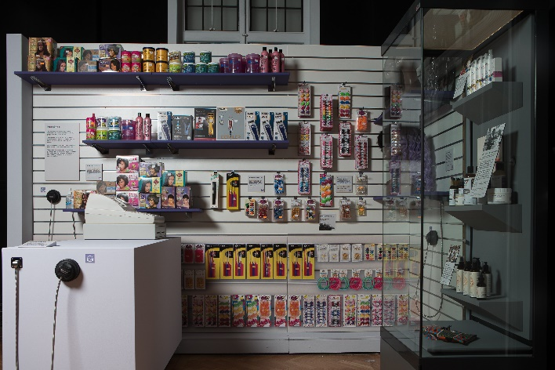 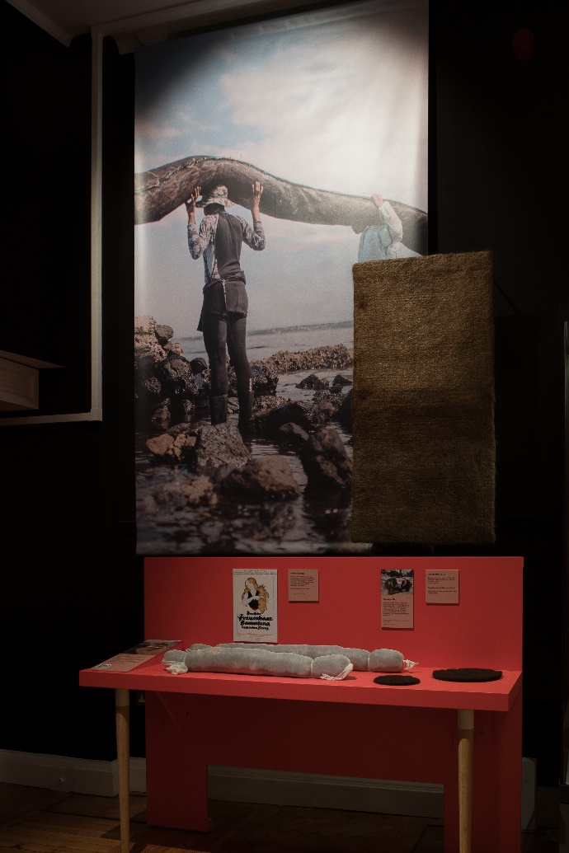

 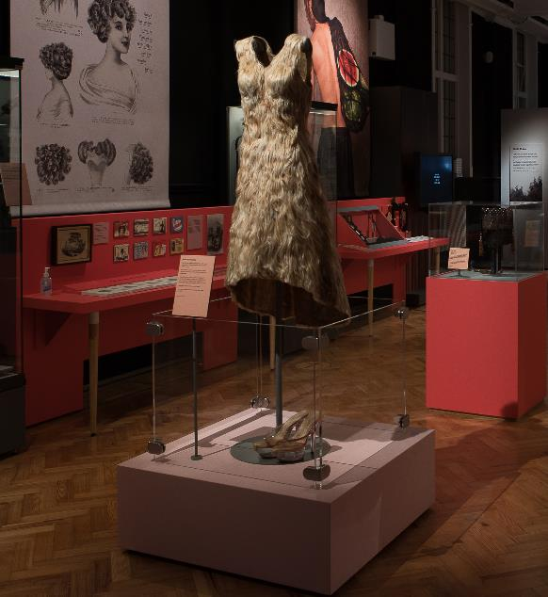

**Example of Slatwalls, Freestanding bench (HM1 - Oil booms bench), Intro panel stretched fabric and frame, and plinth and acrylic upstand (Hair dress) – all to be soft wrapped**

**Appendix 3: Cult Hair display**

Packing solution (crated, flight case or soft wrap) for the following display:

Photographs & intro panel

Dms:     H 750mm x w 600mm x 3mm Dibond (with aluminium rear split baton fixing to back)

QTY:     13

If there would be an additional cost of transporting Cult Hair with the Hair: Untold Stories Exhibition to Tullie House and Weston Park as part of the same tour, please specify additional fee.

**Appendix 4: Crate specifications**

Waterproof rigid case made from plywood (Far Eastern ply) strengthened with wooden battens. No particle board crates.

Wooden surfaces sealed inside and out, minimum of 3 coats Dacrylate or acrylic paint, or other sealing combination such as Marvelseal and water-based PU varnish layers.

Skids on bottom to allow for forklift access and flood protection. Skids to be at least 90mm high and where possible, be at least 550mm apart to allow pallet truck access.

All opening sides to be fully gasketed with inert foam strips adhered using inert double-sided tape or Conservation approved adhesive. Captive bolt closures in preference to screw closures for touring exhibition with multiple venues.

All exterior signage in permanent paint or ink to be spray-applied, or duplicate labels used if strong self-adhesive paper support used. Weight of crate to be indicated on exterior, as well as crate number as fraction of total group (e.g. 1/10, allocated by Horniman).

Principle of double container used, either drawers, trays or boxes; Plastazote cushioning foam and Ethafoam bracing material used where required. Hand spaces provided for top loaded containers.

Spring-loaded metal handles at comfortable carrying height on two sides and within the wooden batten area (or otherwise recessed) can be used on lightweight crates; wooden batten handles with sufficient gap or cut-out for hands can be provided on heavier crates.

In general, the most robust items need to be packed at lowest level of crate, in case of drop-shock.

All crates travel upright aligned in direction of vehicle. Crate dimensions to avoid risk of toppling (i.e. not too high and narrow).

48 hour acclimatisation period required before crates are unpacked and objects removed.

Need to specify where the crates will be stored for duration of tour exhibitions i.e. preferably in environment that meets exhibition specs. This is to avoid excessive absorption or desorption of moisture from wood which may affect internal crate conditions for re-packing of objects.