Joint Working Arrangements and Continuity of Care Principles (COCP)
for Psychiatric Intensive Care Units (PICU) Placements Framework

The purpose of this document is to outline the arrangements and procedures that will need to be in place for a previously inappropriate Out of Area Placement (OAP) to be deemed an appropriate OAP by NHS England & Improvement.

To ensure that patients needs are adequately served as part of the process of moving them into a PICU through the application of effective continuity of care principles, whilst at the same time giving systems some flexibility in approach when patients are moved across STP boundaries.

The aim of this process is to achieve a practical approach for Psychiatric Intensive Care Units (PICU) placements, whilst ensuring consistent care and support is in line with Continuity of Care Principles (COCP), as set out by the National Team (see below):

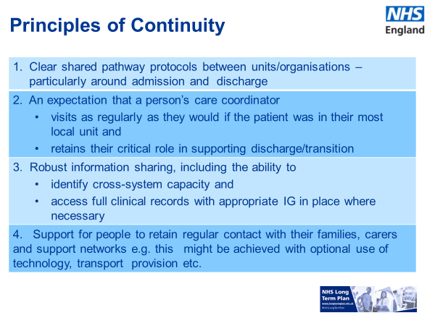

These Joint Working Arrangements only apply to PICU and are not applicable to Adult Acute mental health care. The premise of this arrangement is that a host Trust (local Trust within an STP) enters contractual agreements to implement COCP with other organisations (NHS or non-NHS) who are not the most local unit/within the CMHT catchment area. Without COCP, any placements with these other organisations would still be deemed inappropriate OAPs.

It is not intended that this will replace STP plans for ensuring sufficient PICU capacity is always available locally. Each STP must continue to work towards ensuring patients are cared for within their local boundaries by their local NHS Trust as soon as possible. However, recognising that in some cases achieving this may require longer term solutions, this framework has been developed to provide system flexibility during the interim period so that:
- where individuals can’t be access care in their own provider, they can still access appropriate care as close to home as possible;
- an inappropriate OAP (currently defined as red on the NHSE&I decision tree) can be reclassified as an appropriate OAP (defined as amber), with the ultimate goal being to move them to a green status, once STP plans for local PICU capacity have been implemented.

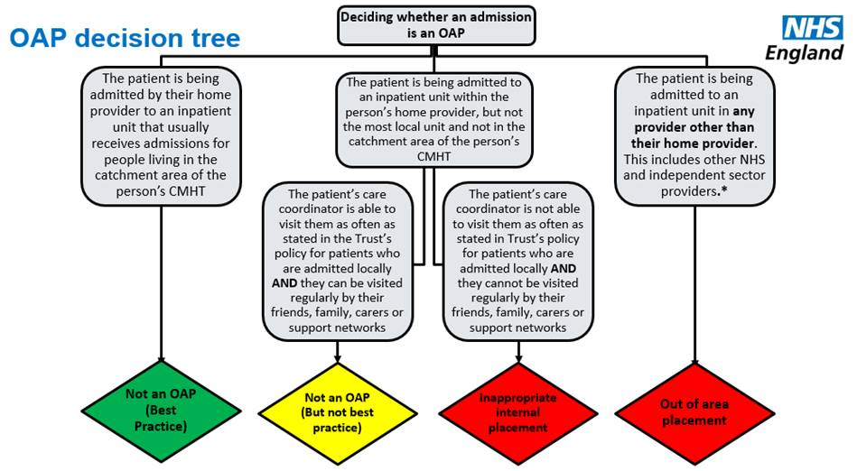

In order for a system to begin using a Joint Working Approach to PICU placements, it is proposed that first they must be able to demonstrate that all other options have been considered. A series of Key Lines of Enquiry (KLOE’s) are provided in Appendix A.

NHSE&I would work through the KLOE’s with their system, and if it is evidenced that all other options have been considered, agreement will be given to implement COCP’s with neighbouring STP’s (guidance in Appendix B). It is only when these arrangements are in place, with evidence of COCP’s, that a system can count their PICU OAP’s as appropriate.

Footprint for a Joint Working Arrangement

In order for STP’s to access more PICU placement options, they will need to have a wider footprint that just an individual STP.

It is proposed that each PICU footprint will look different for each STP, as it will be ideally limited to their neighbouring STP’s (so only where they share borders). This will limit the distance travelled for patients/family/friends and ensure that it is reasonable for clinical teams to still engage in relevant meetings and discussions e.g. discharge planning and maintaining continuity of care principles.

Distance will not, however, be the sole consideration. In some cases, it might be appropriate to have Joint Working Arrangements between non-neighbouring STP’s as the accessibility (e.g. the time it takes to get to the unit) is considerably better than to the units of neighbouring STP’s.

However, this does mean that the footprint will be different for every STP, some will cross the East and West Midlands divide, and some may even may branch outside of our Region e.g. Derbyshire could access Staffordshire (West footprint) and Sheffield (North East Region), as both border their STP. This could make getting agreement more challenging, especially with those STPs outside of our Region, but the underlying tenet of the approach should always be to deliver a pathway of care that is most appropriate for the people requiring support.

Appendix A

KLOE’s for agreeing Joint Working Arrangements for PICU placements

The purpose of these Key Lines of Enquiry (KLOE’s) is to guide NHSE&I colleagues in discussions with their STP’s, to gain assurance that a Joint Working Arrangement (JWA) is appropriate and that all other options/efficiencies have been explored/maximised first.

These KLOE’s should not just be given to the system to complete, rather they are to be used to focus conversations with STP’s.

Ideally, an STP would express a desire to use a Joint Working Arrangement and NHSE&I colleagues would then work through this checklist with the system to gain assurance that this would be an appropriate interim solution.

If through this process, NHSE&I colleagues do not agree a JWA, then STP’s can submit a recovery action plan (RAP) to address the areas of concern and ask to revisit at a later date, once the issues have been addressed (or are in the process of being resolved).

Once NHSE&I has reached an agreement for a JWA, a letter should be issued to the STP, summarising all information provided and detailing the reasoning for the decision.

Q1. Is the existing PICU capacity (local commissioned provision) sufficient for the demand within the STP?
Has the STP conducted analysis to evidence the capacity required? Is this robust? Are commissioners and providers in agreement about the findings of any capacity demand analysis? If there is insufficient capacity, what is the STP doing to address this shortfall in capacity in the longer term?
If the STP has sufficient existing PICU provision, why is a networked approach being considered? For example, if existing provision requires refurbishment to enable it to operate at full capacity (i.e. a number of beds won’t be available for a given time), it may be appropriate to grant a networked approach for a defined period of time.

Q2. Does the STP have male and female PICU provided by the local Mental Health Trust (or via a commissioned independent provider)?
Guidance: If an STP has some PICU in place e.g. female only, they can request to implement a Joint Working Arrangement for male PICU only. Consideration must be given to the specific situation of each STP on an individual basis.
If the STP has PICU provided in area but by an independent provider (non-NHS Trust), consideration must be given to the reasons for requiring a Joint Working Arrangement. Is it possible to deliver the continuity principles whilst subcontracting from the independent provider? Is the cost of the independent provider unmanageably high? Does the independent provider have a poor CQC rating/concerns have been raised about safety of patients? Does the independent provider have high length of stay? Has the system engaged with the independent provider to try to resolve these issues?

Q3. Is the average PICU length of stay (for local commissioned provision) equal to, or less than, the England National average?
If no, what is the system doing to address high LoS? If STP has high PICU length of stay, consider whether it is necessary for the STP to demonstrate improvements in this area before granting a Joint Working Arrangement Is there further work that is needed within the system e.g. improved crisis in-reach and support for discharge, better engagement with community services, etc?

Q4. Is there NHS PICU provision within the neighbouring STP’s?
If no, how far would a patient have to travel to access a PICU bed? Consider how far the patient/family/friends have to travel. This isn’t an opportunity to just stop counting inappropriate OAP’s, but rather, it still needs to be a reasonable option for people and their families.
If the neighbouring system is also experiencing challenges with low PICU capacity, is there a case for the systems working together to develop a shared PICU offer in geographical location which is mutually beneficial? E.g. Jointly subcontracting another provider or developing a joint business case to provide the service across both populations?

Q5. If exploring the option of independent providers within the STP geography, have other NHS provider options within the Network been sufficiently explored and discounted? On what grounds?

Guidance: NHS providers should be the preferred provider in terms of value for the public, particularly if continuity of care is well-maintained and distances are acceptable.

However, Local private providers may be the right choice based on the totality of considerations. If NHS providers have been discounted, are there independent Providers within the STP geography that do, or could, provide PICU capacity?

If yes, has this been explored and if it has been discounted, please provide the reason.
Has the STP explored opportunities with the independent sector? If not, should this be looked at before granting a Joint Working Arrangement?

Q6. Is the system confident that, having explored all other options, a networked approached would be the best interim solution for ensuring adequate PICU provision for their local population?
Is the system transparent about their existing issues/system developments? Is there a sense of confidence from the system that they have explored all other options? Are commissioners and providers ‘joined-up’ in their approach and future plans for their PICU provision?

Q7. Does the STP have plans in place to develop PICU provision in area, so that in the future, a Joint Working Arrangement would not be required?
It is essential that STP’s have agreed plans in place to address their lack of PICU provision. A Joint Working Arrangement is only an interim solution and systems must demonstrate a commitment to create PICU capacity within their STP by 2023/24.

This provision may also include a shared approach to PICU provision with a bordering STP where demand is not deemed clinically or financially viable to support two separate units. For example, building one new female unit to serve two systems populations.

Appendix B

Proposed Continuity of Care Principles (COCP) for Joint Working Arrangements for PICU placements

This section provides information on the Continuity of Care Principles (COCP) that need to be considered and adopted for a Joint Working Arrangement for PICU beds to apply.

NHSE&I have not stipulated how the COCP’s will be implemented, it is for each STP to determine how best to demonstrate these principles. A number of considerations have been suggested for each Principle. For example, care co-ordinators need to regular make contact with their patients in the inpatient facility, but it is for the STP’s to determine their frequency (in line with their Trust’s policy), and the best way to achieve this, be that face-to-face or via Skype.

This section also makes suggestions as to how the process should be monitored locally by Commissioners. The purpose of the COCP’s is to ensure that patients placed outside of the STP’s geography, have the same level of care and contact with community teams and support networks as those patients who are admitted to an inpatient bed provided by the STP’s local Mental Health Trust.

Principle | Considerations
Admission Process | Who conducts the assessment for admission to PICU? Is this in line with referring Trust’s policy?  What level of experience / staff are involved in the decision- making processes?  Is the clinical threshold for PICU patients consistent across all units?  What paperwork should be shared with the admitting ward? Is this consistent with the referring Trust’s policy?  What clinical handover will take place? Is this consistent for all patients referred to inpatient facilities?  What family/personal network conversations / considerations have been taken into account as part of the placement process?  Has the time for travel as well as the distance travelled been factored into decision making?  What measures/indicators do you have in place?  What is the minimum data set that you would expect to see/ have available as part of the handover process?
Patient Management System (IT) | Does the admitting ward have access to the referring Trust’s patient record system?  How will updates to patient records be shared?  How quickly will patient records be updated within the referring Trust?  What audit processes will be in place to ensure quality of records?  What resolution process is in place if information isn’t shared by the admitting ward?  Is there sufficient IG/data sharing agreements in place to support access of patient records?  How frequently will the patients records be reviewed/shared with the referring Trust?  What information should be available and who should it be available to?  Family?, Clinicians?, Commissioners etc?
Clinical Oversight | How frequent are review meetings? Is this in line with the referring Trust’s policy?  At what level are patient reviews being conducted?  How will clinical updates be conducted?(skype/site visit?)  Is there a minimum on how often a site should be visited for someone out of area?  How Will the care-coordinator for the referring Trust be involved in the review meetings? Is this in line with the referring Trust’s policy?  How satisfied are you that the receiving organisation is managing the person in a way that supports a timely return to their chosen locality?  Does the admitting ward have the same admission management processes in place as the referring Trust e.g. Red2Green? If not, what information would the referring Trust need in order to include these PICU patients in their systems?  How confident are you that the level of clinical oversight is sufficient to meet the needs of the patient?  How confident are you that the outcomes from clinical discussions are sufficient to drive effective decision making?
Care Planning | Is care planning undertaken in line with the referring Trust’s policy?  Is the referring Trust’s care co-ordinator involved in care planning, both the development of the care plan and subsequent reviews?  How are family/friends kept up to date with the persons progress?
Discharge  Planning | Does discharge planning in the admitting ward operate within the timescales set out in the referring Trust’s policy? E.g. commencing planning at the point of admission  How will the referring Trust be involved in discharge planning?  How will the referring Trust ensure that patients receive the same level of support in preparation for discharge and post discharge, as those discharged from local inpatient units?  Who will be responsible for 7-day follow up?  What is the process if readmission is required?  What processes are in place to support clinicians when there are differences of opinion between the admitting ward and referring trust?
Management Oversight | How will clinical and operational management within the referring Trust have oversight of the admitting ward?  How will issues be escalated so that they can be addressed and resolved as quickly as possible?  How will safeguarding issues be overseen?  What is the process if an admitting ward is deemed inappropriate/unsafe?  Is there a minimum on how often a site should be visited for someone out of area?
Visits to site | How often will the referring Trust visit the admitting ward for inspection?  Will these be announced/unannounced?  Who will conduct these visits?  How will clinicians be involved in the visit process?
Commissioning Oversight | How are commissioners monitoring adherence to these principles?  How are these principles and processes embedded into contracts with the referring Trust (local Trust to the STP)?  How will commissioners manage this if there are performance issues?  Are there contracts/memorandums of understanding (MOU) in place between the referring Trust and the admitting ward? Are regular contract monitoring mechanisms in place?  What patient / family factors are evidenced in the decision to admit out of area?

