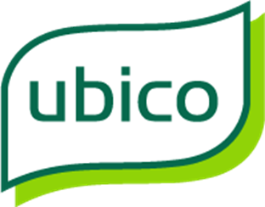

**Market Engagement**

**Fleet Procurement**

**This process is not a procurement and participation or non-participation in it will give neither advantage or disadvantage to any organisation, should Ubico Limited on behalf of its shareholding partners decide to proceed to a procurement exercise.**

**Market Engagement Events**

**11:00 hrs Thursday 27 April 2017**(for Cars and Light Commercial Vehicles)

**13:30 hrs Thursday 27 April 2017**(for Refuse, Road sweepers, specialist HGV’s and grounds vehicles)

**Venue: Cheltenham Park Hotel**

Cirencester Road, Charlton Kings, Cheltenham, Gloucestershire GL53 8EA.

**Response Form for completion by potential service providers – deadline 17:00 hours Friday 12 May 2017**

**Contents**

Part A – Introduction

Part B – Frequently asked questions and instructions to potential suppliers

Part C – Response / Feedback Form to be submitted by potential suppliers

**Part A – Introduction and existing service**

1. **Introduction**

**THIS IS NOT A CALL FOR COMPETITION**

### **Who we are and what we do**

Ubico control a rapidly growing fleet, currently in excess of 350 vehicles and plant items.

Our objective is to explore how we can establish and grow relationships with potential suppliers, with the aim of maximising our buying power. We anticipate being able to secure mutual benefits through improved purchasing terms, in return for offering restricted supplier status for a defined period, thus offering planned business volumes to our appointed suppliers.

Ubico is a local authority owned company set up to deliver environmental services to its primary shareholding Councils through service contracts. Our vehicles allow us to provide services to our shareholders who are currently:

|  |  |
| --- | --- |
| * Cheltenham Borough Council * Cotswold District Council * Tewkesbury Borough Council * West Oxfordshire District Council | * Forest of Dean District Council * Stroud District Council * Gloucestershire County Council |

Ubico operates out of a range of sites throughout Gloucestershire and Oxfordshire. The operational locations are:

CHELTENHAM and TEWKESBURY COTSWOLD DISTRICT COUNCIL CONTRACT  
CONTRACTS Packers Leaze  
Central Depot Off Broadway Lane  
Swindon Road South Cerney  
Cheltenham Cirencester  
GL51 9JZ GL7 5UJ

STROUD DISTRICT WEST OXFORDSHIRE  
COUNCIL CONTRACT DISTRICT COUNCIL CONTRACT  
Operating Centre The Depot  
Gossington Truckshop Avenue 4  
Cam Station Lane  
Dursley Witney  
GL11 5JA OX28 4XZ

FOREST OF DEAN DISTRICT  
COUNCIL CONTRACT  
Unit 1 & Unit 2  
Swan Road Depot  
Swan Road  
Lydney  
GL15 5RU

GLOUCESTERSHIRE COUNTY COUNCIL  
HOUSEHOLD WASTE RECYCLING CENTRES  
Sudmeadow Wingmoor Farm Pyke Quarry  
Hempsted Stoke Orchard Road The Street  
Hempsted Lane Bishops Cleeve Horsley  
GL2 5FR Cheltenham Nailswoth  
 GL52 7RS GL6 0QA

Oak Quarry Fosse Cross  
Broadwell Calmsden  
Coleford GL54 4NW  
GL16 7EG

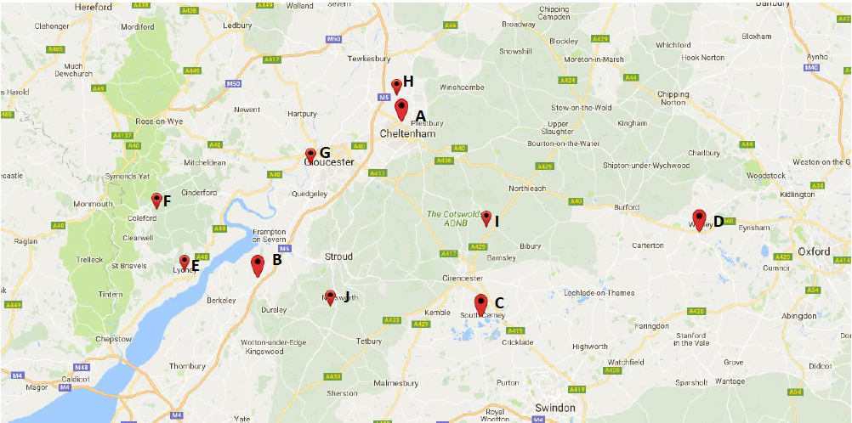

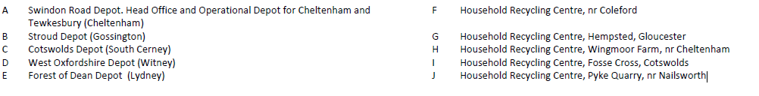The services provided by Ubico for its shareholders for the duration of this contract are;



**1.2 Our vision**

By 2021 Ubico Limited will have consolidated its position in the public sector as a provider of choice for sustainable, value for money services and will have built a solid reputation for business excellence.

In addition to securing new long term agreements with existing shareholders, the company will have further expanded partnership working and external sources of income by offering a wide range of competitively priced, reliable, integrated, environmental services.

We will have enhanced our ability to rapidly adapt to market and environmental circumstances and the challenge of constant change. We will also have a strong organisational culture that values and rewards customer focused, safety conscious, committed and productive staff.

### **Developing a resilient Fleet Programme**

Ubico are arranging a **Market Engagement event on 27 April 2017** at the Cheltenham Park Hotel to explain our company structure and explore ideas for a future procurement programme. There will be 2 sessions, as detailed below.

The objective of the event is to ascertain the feasibility of a different procurement approach and/or a potential reduction in the number of suppliers who could benefit from either a potential sole or dual supply arrangement that will ensure Ubico Limited obtain the maximum volume of vehicles over a four year period or longer.

We wish to establish relationships with potential future suppliers and to actively seek their input as to the best way to work through this process, for the mutual benefit of Ubico and its suppliers.

We will be holding 2 sessions on the 27 April 2017:

11:00 - 12:30 hours for Cars and Light Commercial Vehicles

13:30 - 15:00 hours for Refuse, Road sweepers, specialist HGV’s and grounds vehicles.

Suppliers are welcome to attend either or both sessions. However, attendance is restricted to 2 representatives from each organisation.

In order for us to explore all potential procurement approaches, We would like representatives from manufacturers, dealer groups, body manufacturers and specialist service providers who may be able to satisfy our purchasing requirements to attend this event where we will set out greater detail of how we intend to proceed, as well as seeking suppliers input and thoughts on the best way forward, with opportunity for questions and discussion.

If you would like to attend, please forward names of attendees, organisation and their job role to [claire.blizzard@ubico.co.uk](mailto:claire.blizzard@ubico.co.uk) (restricted to 2 attendees per organisation). To do this simply copy and paste the table below in to your email

|  |  |  |  |
| --- | --- | --- | --- |
| **Name** | **Job Title** | **Company** | **Time**  **(am/pm/both)** |
|  |  |  |  |
|  |  |  |  |

Our current thinking is that the Lot groupings noted below will maximise the potential business that a supplier can bid for on a potential restricted supplier basis. However, their composition is not intended to exclude suppliers who may not be able to provide the full range of vehicles within a lot.

The final Lot composition is not set in stone and through this early engagement process, we are actively seeking your input and advice as to how it should look

Our initial view for the Lot structure will be to segregate:

* Cars and Light Commercial Vehicles (c120 vehicles)
* Refuse Collection Vehicles, Road Sweepers and Specialist HGVs (c150)
* Grounds maintenance vehicles, tractors, trailers and equipment (c80)

Following the event there will be a two week period for feedback and recommendations from suppliers, which we will use to help to inform our future approach to fleet procurement.

**This market engagement feedback is required by 17:00 hours Friday 12 May 2017.**

**This process is not a procurement and participation or non-participation in it will give neither advantage or disadvantage to any organisation, should Ubico Limited decide to proceed to procure the service. You may complete and return part C response even if you are unable to attend on the day.**

**Part B – Frequently asked questions and instructions**

**1. What is the early market engagement process?**

Ubico Limited (the Company) is undertaking an early market engagement exercise which will assist its approach to future vehicle procurement.

This early market engagement exercise is for the purpose of gathering expressions of interest and ideas for future fleet procurement; it does not constitute a procurement process and participation does not guarantee or preclude any selection of a potential supplier in any procurement process. Responses may be used in the planning and conduct of any procurement. The Company may also approach and engage with others, such as independent experts and potential funders.

**2. Are Ubico serious about the potential to restrict suppliers to a single or dual supplier status and move away from the traditional framework structure?**

Yes, provided we can achieve and demonstrate mutual benefits for our shareholders and our suppliers we are prepared to change how we currently acquire vehicles and machinery .

**3. How does a potential supplier get involved in the market engagement process?**

Attend the Market Engagement Eventon Thursday 27 April 2017

Then complete and submit a Return Form Part C by 17:00 hours Friday 12 May 2017

**4. Why has the Company issued a call for market engagement at this stage and what is its intention?**

The Company is committed to following best practice so far as it applies to any procurement and, in particular, the principles of openness, non-discrimination, transparency and not distorting competition. Early market engagement, along with statutory consultation, is the first stage in taking forward the process of determining the future of our fleet procurement. It also allows the Company to prepare for any procurement and gauge the interest in the marketplace.

**5. If I do not reply to this call for early market engagement, is my organisation prevented from participating in any future procurement?**

No, the Company is not launching a call for competition at this stage and the call for market engagement does not constitute the start of a formal procurement process. Any potential supplier expressing an interest, at this stage, will not be treated any more or less favourably than another.

**6. What is the deadline for submitting a Return Form for this early market engagement process and how do I submit?**

Written returns – Part C in pdf format of the early market engagement process must be submitted by email by 17:00 hours Friday 12 May 2017 to [claire.blizzard@ubico.co.uk](mailto:claire.blizzard@ubico.co.uk) The Company will review all responses, engage in any meetings and then consider the appropriate next steps, which could include engaging the market through procurement.

**7. How will the Company carry through what it receives from the potential Service providers and what is the procurement and intention and timescale on the back of this process?**

The Company will review all of the responses it receives to the early market engagement exercise. Depending on the informationthe Company then has at its disposal it may commence a formal procurement process.

**8. How do we know the Company will take our views seriously?**

The Company has a commitment to ensuring that the fleet procurement on behalf of its shareholders continues to be provided and demonstrates best value for whole of life costs.

**9. Who should I contact with a question about the process and/or my Feedback Form?**

Questions relating to this process should be submitted by email to [claire.blizzard@ubico.co.uk](mailto:claire.blizzard@ubico.co.uk)

**10. How will I receive a response to my question?**

We will endeavour to acknowledge your Questions by email within 48 hours of receipt.

**11. How can I get additional information?**

The Company is committed to ensuring openness, non-discrimination, equal opportunity and equality of treatment. All necessary background material and technical information is provided in this document and at the Market Engagement Event on Thursday 27 April 2017 and additional information cannot be supplied exclusively to individual respondents.

**11. Can I arrange a meeting with the Company?**

No, this is the purpose of attending the Market Engagement Event on Thursday 27 April 2017.

**12. Can the Company assure me that my return will remain confidential?**

The Company will keep returns and feedback confidential unless otherwise agreed with the potential supplier concerned, but elements of the return feedback may form part of any procurement process or reports of the Company without being attributed to any one organisation.

**13. What happens at the end of the early market engagement process?**

Depending on the responses, the Company may begin a process of procurement or take what other steps it considers appropriate for the future of fleet procurement.

**Part C – Return / Feedback Form to be submitted by potential service providers -** Early Market Engagement – Ubico Limited Fleet Procurement

Please do not submit this Feedback Form until AFTER the Market Engagement Event on 27 April – with a deadline for submission of 17:00 hrs Friday 12 May 2017

**This process is not a procurement and participation or non-participation in it will give neither advantage or disadvantage to any organisation, should Ubico Limited decide to proceed to a procurement exercise.**

|  |  |  |  |  |
| --- | --- | --- | --- | --- |
| **1.1 Organisation details** | | **Response** | | |
| Full name of the organisation completing the response | |  | | |
| Registered company address | |  | | |
| Registered company number | |  | | |
| Registered charity number | |  | | |
| Name of immediate parent company | |  | | |
| Name of ultimate parent company | |  | | |
| Trading status  a) a public limited company  b) a limited company  c) a limited liability partnership  d) other partnership  e) sole trader  f) other (please specify your trading status) | |  | | |
| **1.2 Contact details** | | | | |
| Your organisation contact details for enquiries about this early market engagement: | | | | |
| Name |  | | | |
| Postal address |  | | | |
| Country |  | | | |
| Phone |  | | | |
| Mobile |  | | | |
| E-mail |  | | | |

**In the sections below please provide brief responses (limited to a maximum 100 words where possible) per question to inform us how the Ubico Fleet Procurement could be provided.**

|  |  |
| --- | --- |
| 1. **Supplier Feedback / Responses required by 17:00 hours Friday 12 May 2017** | |
| 2.1 | How should the Vehicle Lots be fairly structured?Please consider this for the Market Engagement Event on Thursday 27 April 2017 |
|  |  |
| 2.2 | Are you able to provide vehicles and equipment for one or more of the three basic categories we envisage?  Our initial Lot structure will be to segregate:   * Cars and Light Commercial Vehicles (c120 vehicles) * Refuse Collection Vehicles, Road Sweepers and Specialist HGVs (c150) * Grounds maintenance vehicles, tractors, trailers and equipment.(c80) |
|  |  |
| 2.3 | What industry and environmental issues should we be considering for our future acquisitions? |
|  |  |
| 2.4 | How will current and emerging technology help shape our procurement plans? |
|  |  |
| 2.5 | Do you believe that it will be attractive to your organisation if Ubico were to reduce number of qualifying suppliers for a defined period or framework; and would there be a potential benefit to Ubico for such an arrangement? |
|  |  |
| 2.6 | What other potential benefits could you provide to Ubico under such an arrangement? |
|  |  |
| 2.7 | What additional or alternative procurement approaches should Ubico consider to make this more attractive to potential suppliers? |
|  |  |
| 2.8 | What factors would encourage you to bid or discourage you from bidding for a contract for the procurement of vehicles? |
|  |  |
| 2.9 | If Ubico propose a procurement route, what timetable would you suggest is used for this and why? |
|  |  |
| 2.10 | What would be the most suitable contract duration, and why? |
|  |  |
| 2.11 | The Company has the following social value, sustainability and environmental objectives and would expect to see these replicated in any services provided:   * Ubico holds ISO 14001 certification; with any future procurement we would seek to support and enhance this status * We strive to support the local economy and communities in the areas in which we operate through providing employment opportunities and supporting community initiatives and priorities * We have an organisational culture that values and rewards customer focussed, safety conscious, committed and productive staff   How would you propose to deliver against and support these objectives? |
|  |  |
| 2.12 | Please use the space below to provide any further comments which are not covered by the above questions (maximum 300 words) |
|  |  |