Invitation to Tender:

Conversion of LMPC streetlights to LED
Version 1.0

Invitation to Tender | Supply of goods works and services to convert 36 residential streetlights to LED and to adapt 3 LED streetlights to support requirements.  Maintenance of streetlights for a period of three years.
Buyer | Little Marlow Parish Council
Address | The Pavilion Church Road, Little Marlow, Marlow SL7 3RS
Contact | clerk@littlemarlowparishcouncil.org.uk
Invitation Date | 1st December 2022
Close Date | 23rd February 2023
Decision Date | 7th March 2023
Installation Date | April 2023

Contents
1. Scope of Work 2
2. Requirements & Objectives 3
3. Tender Instructions 6
4. Annexe A: Form of Tender 8
5. Annexe B: Streetlight Inventory 9
6. Annexe C: Spreadsheet 10

Scope of Work
Little Marlow Parish Council (LMPC) plans to convert 36 legacy residential streetlights to LED and convert 3 LED streetlights to comply with the requirements and objectives specified in this ITT.
The project will involve the replacement of columns, brackets, lanterns, LED engines, drivers and electrical parts. Responsibilities will include
- Removal and disposal of redundant streetlight parts
- Installation of new streetlight parts
- Electrical works
- Configuration of streetlights to comply with the specified requirements
- Compliance testing & certification
- Maintenance
Applicants are invited to tender for the following
- Contract for the supply of all goods, works and services
- Contract for the maintenance of all LMPC streetlights

Existing Streetlights
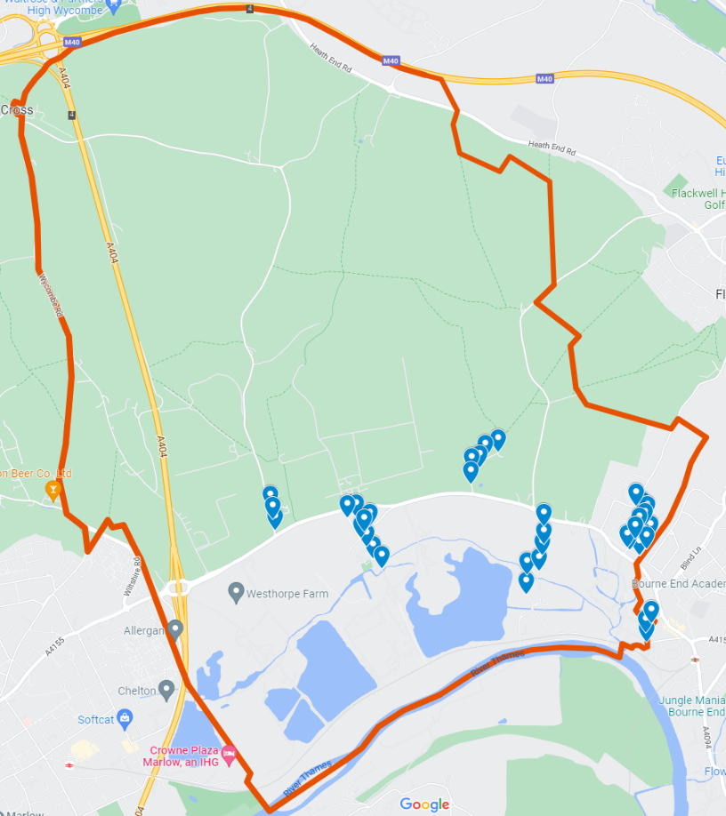
The 39 LMPC streetlights are located in the parish of Little Marlow (SL7) on the following roads.
- Burroughs Crescent
- Church Road
- Coldmoorholme Lane
- Fern Lane
- Oakfield Road
- School Lane
- The Moor
- Wendover Road
- Winchbottom Lane
A map showing approximate locations is provided to the right and can be found at https://tinyurl.com/29jrcxuh
An inventory is provided in Annexe B.
The current annual energy consumption is 12,675.7 kWh.
Energy is supplied by SSE on a variable, unmetered Dusk to Dawn tariff (Profile B) according to published “Deemed Contract Rates”. The MPAN number is
S 01 859 501
20 0002 7522 173

The current maintenance contract is approximately £2,000 per annum.
Little Marlow Parish Council resolved in favour of a proposal recommending the conversion of its streetlights to LED at a meeting of full council on 8th November 2022. A copy of the proposal can be found on the LMPC website http://www.littlemarlowparishcouncil.org.uk.

Requirements & Objectives
The requirements and objectives for the conversion of LMPC streetlights to LED are provided below
- “Shall” = Requirement
- “Should” = Objective

General

Energy consumption should be reduced by more than 75% per annum

The payback period should be less than 3 years

All necessary information shall be obtained by survey and from LMPC, SSE or other bodies such that proposed specification of goods and works will fully satisfy the requirements and objectives stated in this ITT.

Lighting Performance

The brightness, distribution and uniformity of illumination provided by each converted streetlight shall be suitable for its location according to the following recommendations

British Standards BS 5489-1 & BS EN 13201-2

ILP Guidance Note 01/21 “The Reduction of Obtrusive Light” – Environmental Zone E2

Shields shall be installed if required to prevent residential light intrusion

Lantern Housing

Existing lanterns that are unable to accommodate the retrofitting of an appropriate LED engine, driver or PECU shall be replaced

Replacement lanterns should be of a modular design

Tool-free access should be supported

Inclination angle shall be adjustable

Ingress Protection shall be IP66 or better

Impact Protection shall be IK10

LED Engine

The Colour temperature shall be 3,000K

The Colour Rendering Index shall be ≥ 70

The Luminous Efficiency shall be ≥ 135 lm/W

L90B10 rating shall be ≥ 100,000 hours

LED Engines should be replaceable

LED Driver

Drivers shall be configured for Constant Light Output

Drivers shall have a 90% survival rate lifetime ≥ 100,000 hours

Drivers should support the DALI-2 protocol

Drivers should be replaceable

Control

DALI-2 should be used for streetlight configuration & control

Photocells shall be either integrated within the lantern housing or fitted as a plug-in PECU

Plug-in PECUs shall use either NEMA or ZHAGA connectors

Ambient light switching levels shall be: On at 35 lux, Off at 18 lux. Part-Night Switching should be configurable in situ and shall be set to: Off at 0030, On at 0530 (assumed to correspond to Elexon Regime Code 769)

Part-Night Dimming shall not be implemented

Columns & Brackets

Existing columns and brackets that are unable to support LED lanterns, that are non-compliant or that are in poor condition (ie are unsafe or likely to fail within 5 years) shall be replaced or adapted.

Replacement columns and brackets shall be manufactured from galvanised steel or galvanised aluminium and shall comply with BS EN40.

Replacement columns and brackets shall be installed in the same location, shall be similarly mounted and shall be of approximately the same dimensions and painted the same colour as those they replace unless changes are necessary to meet lighting performance requirements.

Replacement columns and brackets shall be installed according to the manufacturer’s instructions and in compliance with BS EN40.

All removed parts shall be legally disposed of.

Any street furniture attached to existing columns (eg dog waste bins) shall be removed and attached to the replacement column.

Each column and bracket shall be clearly labelled with a unique identification number.

Electrical Works

Compliant isolators, cut-outs, switches and fuses shall be used to connect streetlights to the electricity distribution network.

Electrical installation and testing shall comply with BS 7671:2018

Contestable works on the electricity distribution network shall comply with the ENA EREC G39 and all relevant SSEN standards and guidelines.

Certification

Electrical test certificates shall be provided to LMPC upon completion of the works

An inventory according to MUESLI 1.1 shall be provided to LMPC upon completion of the works.

Written confirmation that all components comply with the SSEN adoption standards shall be provided.

Contract Terms

The selected tenderer shall be responsible for the supply of goods, works and services using its own employees or those of an approved subcontractor.

The selected tenderer shall be responsible for all contestable works on the electricity distribution network and shall obtain all necessary authorisations from SSEN and shall pay all associated fees.

The selected tenderer shall be responsible for the payment of all permit fees, consents and licenses required for the works.

The selected tenderer shall be responsible for any traffic management measures deemed necessary by survey.

The selected tenderer shall be liable for the acts and omissions of any subcontractor as if those were the acts or omissions of the tenderer under the contract.

Maintenance Terms
The tenderer shall provide a proposal for the terms of a streetlight maintenance contract including

Services provided under contract

Condition reporting schedule

Cleaning and maintenance schedule

Electrical testing schedule

Turnaround time for the repair of faults

Annual fee for years 1, 2 & 3

The tenderer shall provide a schedule of Rechargeable Repairs for maintenance and repair works excluded from the contract.

Tender Instructions

Process

The tendering process shall be performed in accordance with LMPC STANDING ORDERS - FINANCIAL REGULATIONS (http://www.littlemarlowparishcouncil.org.uk/)

The ITT is issued directly to invited tenderers. Invited tenderers may forward the ITT to 3rd parties that will (i) respond to the ITT on its behalf (ii) provide subcontracted services.

Tenderers shall provide written confirmation of their intention to tender within 10 working days of the issuance of the ITT whereupon ITT spreadsheet will be provided by email. The confirmation letter shall nominate a single point of contact for all matters that may arise until completion of the project.

All questions from tenderers shall be submitted by email to the LMPC clerk not later than 5 working days before the tender close date. LMPC answers to any tenderer’s questions shall be provided to all tenderers.

Tenderers shall not directly contact LMPC parish councillors during the tendering process.

Tenders shall be delivered to LMPC by registered mail no later than 12 noon on the tender close date. Tenders received after the tender close date shall be rejected.

Electronic versions of the tender shall be submitted by email to the LMPC clerk no later than 48 hours after the tender close time

The tender shall be open for acceptance for a period of 40 days following the tender close date and all quoted prices and rates shall remain fixed.

Tenderers shall answer any question related to their proposal and shall meet members of LMPC at its offices and present their proposal if invited to do so.

Tenders for the conversion of streetlights and for the maintenance of the streetlights shall be awarded based on a consideration of the following factors

Total cost of ownership over 3 years

Compliance with requirements

Capabilities and Experience

LMPC shall not be obliged to (i) select the lowest priced tender, (i) select any tender or (iii) purchase all parts of the selected tender.

LMPC shall provide the selected tenderer with a letter of provisional acceptance whereupon terms shall be agreed and the contract documentation shall be executed.

LMPC shall not be liable for any expenses or costs incurred by tenderers in the preparation of tender proposals.

Tender
The tender shall contain the following information

Company profile of the tenderer and of any subcontractors that will perform works for the tenderer

Completed Form of Tender

Completed ITT spreadsheet

Specification and warranty of all proposed parts

Warranty of all proposed works

Outline project plan stating the estimated lead-time, earliest start date and estimated project duration.

Proposed contract for the supply of works

Proposed maintenance contract

Details of the tenderer’s (and subcontractors’) NERS accreditation

Details of the tenderer’s (and subcontractors’) NICIEC accreditation or equivalent

Details of the tenderer’s (and subcontractors’) HEA membership

A copy of the tenderer’s (and subcontractors’) Public Liability Insurance

A copy of the tenderer’s (and subcontractors’) Health and Safety policy

A copy of the tenderer’s (and subcontractors’) Waste Disposal Policy

Two customer references for similar projects performed by the tenderer
If tenderers wish to propose multiple options (eg lanterns from different manufacturers) then a fully completed set of spreadsheets shall be provided for each option.

Annexe A: Form of Tender

Conversion of LMPC Streetlights to LED

To Little Marlow Parish Council
The Pavilion Church Road, Little Marlow, Marlow SL7 3RS

Date ______________

We, ______________________________________________________________________________________, have examined and understood the contents of this ITT and hereby offer to tender goods, works and services as described in the documents attached to this form (listed below) that fully meet the stated requirements.

“Compliance” spreadsheet

“Goods & Works” spreadsheet

“Maintenance” spreadsheet

Specification and warranty of all proposed parts

Warranty of all proposed works

Outline project plan stating the estimated lead-time, earliest start date and estimated project duration
We confirm that the tender shall be open for acceptance for a period of 40 days following the tender close date and that all quoted prices and rates shall remain fixed.

We confirm the undersigned is authorised to submit this tender

Signature ___________________________________

Name ___________________________________

Position ___________________________________

Annexe B: Streetlight Inventory
Road Name | Location | Ref | Mounting | Type | W
Burroughs Crescent | Nr sub station | 49 | Column | SON | 70
Burroughs Crescent | By Footpath | 50 | Column | SON | 70
Burroughs Crescent | opp no. 20 | 51 | Column | LED | 25
Burroughs Crescent | o/s no. 13 | 52 | Column | LED | 25
Burroughs Crescent | Nr no. 2 | 53 | Column | SON | 80
Burroughs Crescent | 1st in Alleyway to Chalklands | X | Column | SON | 20
Burroughs Crescent | 2nd in Alleyway to Chalklands | XX | Column | SON | 20
Church Road | o/s Kings Head Pub | 1 | Bracket | SON | 70
Church Road | o/s The Bramleys | 2 | Bracket | SON | 70
Church Road | o/s The Old Cottage | 3 | Bracket | SON | 70
Church Road | o/s Manaton | 4 | Bracket | SON | 70
Church Road | o/s Manor Farmhouse | 5 | Bracket | SON | 70
Coldmoorholme Lane | Nr Cedar lodge | 20 | Bracket | SON | 70
Coldmoorholme Lane | o/s sub station | 21 | Bracket | SON | 70
Coldmoorholme Lane | o/s Coldmoorholme Cottage | 22 | Bracket | SON | 70
Coldmoorholme Lane | Junc Spade Oak Meadows | 23 | Column | SON | 80
Coldmoorholme Lane | opp New Lodge | 24 | Column | SON | 70
Coldmoorholme Lane | Nr Spade Oak Pub | 25 | Bracket | SON | 70
Fern Lane | o/s Two Oaks | 15 | Bracket | SON | 70
Fern Lane | o/s Brambles | 16 | Bracket | SON | 70
Fern Lane | by post box | 17 | Bracket | SON | 70
Fern Lane | adj Fern House | 18 | Bracket | SON | 70
Fern Lane | o/s Broadhaven | 19 | Bracket | SON | 70
Oakfield Road | o/s Abbotts Mead | 58 | Column | SON | 35
Oakfield Road | o/s The Chuntry | 59 | Column | SON | 35
Oakfield Road | o/s Firtrees | 406 | Column | SON | 70
School Lane | o/s Garden Cottage | 6 | Bracket | SON | 70
School Lane | opp Meadow Cottage | 7 | Bracket | SON | 70
The Moor | Nr bridge over stream | 1 | Column | SON | 70
Wendover Road | o/s no. 5 | 61 | Column | SON | 70
Wendover Road | o/s no. 14 | 62 | Column | SON | 80
Wendover Road | o/s Claytons County Primary School | 63 | Column | SON | 70
Wendover Road | o/s no. 32 | 64 | Column | SON | 70
Wendover Road | o/s Thames Water | 65 | Column | SON | 70
Wendover Road | o/s School Playing Field | 66 | Column | LED | 29
Wendover Road | o/s Conkers | 67 | Column | SON | 70
Winchbottom Lane | o/s Lawnswood | 1 | Column | SON | 70
Winchbottom Lane | o/s Redroofs | 2 | Column | SON | 45
Winchbottom Lane | o/s Kantarra | 3 | Column | SON | 45

Annexe C: Spreadsheet
- The tenderer shall complete all green coloured cells in the tender spreadsheet.
- A separate spreadsheet shall be submitted for each proposal (if a tenderer wishes to submit multiple proposals for different product options)
- The spreadsheet contains example entries for illustration. These entries do not indicate LMPC preferences or assumptions.
- One of the following versions of Excel is required: Excel 2021 or later (PC and Mac), Excel for Microsoft 365 Subscriptions (PC and Mac), Excel Online

“Information” Tab
- All fields are to be completed
- A brief description of the proposal, or other information, may be included in the Comments box

“Compliance” Tab
- For each of the stated requirements the tenderer should select either “Comply”, “Not Comply” or “Partially Comply” from the pull-down menu. Explanations shall be provided for each non-compliance (eg cost-reduction, practically).
- General comments about the requirements may be made in the Comments box

“Products” Tab
- Details for each product used in the proposal shall be identified in the appropriate section.
“Lantern Assemblies” consist of the housing (except where a retrofit lamp will be installed), LED Engine and Photocell (if integrated in the lantern).
“Plugin Controllers” are for lantern assemblies that do not include an integrated photocell.
“Columns” should list replacement columns or “slip-over” column components
“Ancillary Parts” should identify the proposed components and provided appropriate details. The level of detail provided is for the discretion of the tenderer. Bundles of unspecified components may be listed (eg Isolator, fuse & termination block) for commodity items.

“Materials” Tab
- For each streetlight listed, the tenderer shall select the reference number of each product (from the product tab) required for its conversion to LED.
- Materials that cannot be specified on a per streetlamp basis should be listed in the “Project Materials” section

Works Tab
- For each streetlight listed, the tenderer shall specify the price of installation works, contestable electrical works or any other works required for its conversion to LED.
- Works pricing that cannot be specified on a per streetlight basis should be entered into the “Project Works and Services” section.

Maintenance Tab
- Maintenance pricing for Years 1,2 and 3 should be provide

Summary Tab
- The tenderer may enter absolute or percentage discounts if applicable (and terms associated with discounts should be specified in the “Information” tab)

SON, SOX etc
Financial calculations should assume the current electricity tariff stated in 1.1 will be fixed for 3 years.
i.e., supports the requirements stated in 2.2, 2.4, 2.5 and 2.6
LMPC’s preferred setting is: Off at 0100, On at 0500. However, no such Regime Code appears to exist.

