Hethersett Memorial Playing Field Pavilion
Architects Invitation to Tender

Introduction
Hethersett Parish Council is seeking to appoint a qualified architect to meet the Council’s Design Brief to replace the existing changing block with a fit for purpose multi-use pavilion together with extending the current car parking arrangements at the Memorial Playing Field in Hethersett.

Background
- Hethersett Parish Council are the Custodian Trustees of the Memorial Playing Field. The day to day management of the site is the responsibility of the Trustees of the Memorial Playing Field Committee which is a registered charity.
- Hethersett Parish Council assumed responsibility for the project in June 2019 and will be working closely with the Management Trustees and members of the user groups including football, bowls and cycle speedway.
- The Hethersett Memorial Playing Field Trustees had previously run the project and applied for planning permission from South Norfolk Council in 2013 (planning application number 2013/1048). A copy of the planning application together with plans of the proposed extension can be found at https://info.south-norfolk.gov.uk/online-applications/applicationDetails.do?activeTab=documents&keyVal=MOBQE2OQ2O000
- The existing changing block, pictured below, is believed to have been built during the 1980’s:

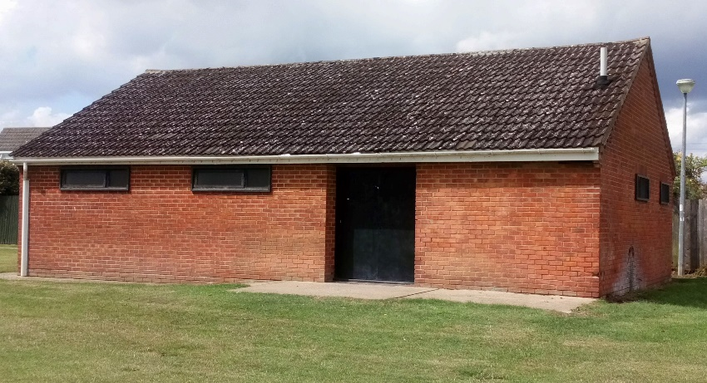

It is in poor condition and requires replacement. The Parish Council’s preference is to demolish the existing building and replace with a new build. Significant fundraising will be required and discussions are already ongoing with the Football Foundation.
Design Brief Requirements
The Parish Council are seeking a well-designed building for the use of existing user groups (football, bowls and cycle speedway) and community groups (birthday parties, fitness classes, mother & toddler groups). It is envisaged that the construction will be brick but we are open to other forms of construction that are economic and energy efficient. The area has previously been subject to anti-social behaviour and consideration should therefore be given to graffiti and vandalism to ensure that the building can be cleaned/maintained easily. We would hope that the design would incorporate a number of energy efficient features such as energy efficient fabric, heating system; green water systems to make the building environmentally friendly, but these need to be kept within a reasonable budget. The building must also be fully accessible for disabled users. For ease of reference the Design Brief requirements are broken down into four sections:

Section 1:
- 2 changing rooms built to FA specification
- A minimum of 40 lockers
- 2 officials/referees changing rooms built to FA specification
Section 2:
- A basic kitchenette area (to allow for fridge, microwave, water heater and 2 burner cooker)
- Meeting room (approximate size 1000 square foot) which may include a sprung floor
- Toilet facilities (male/female/disabled/baby changing)
- Self-contained/lockable from Section 1 (to allow both areas to be hired out separately)
Section 3:
- 2 x storage rooms (one must be a minimum of 8m x 2m to allow for storage of football goalposts)
- Plant room
- CCTV room/secure cupboard (it is hoped that this could be accommodated within one of the storage rooms)
Section 4 (Exterior):
- Window hatch to kitchenette with steel grill to protect building
- External toilets with door (overlooking field or towards Park Drive)
- Water fountain/bottle refill station
- Veranda with bench seating (pavilion will be a boot free zone)
- Exterior PIR lights
- CCTV
- Existing car park to be extended to include at least ten additional spaces including disabled spaces
Contract Details
- The contract will be with Hethersett Parish Council, who will act as Employer and Client. The Parish Council will work closely with the Management Trustees and other groups as required.
- The successful architect will be expected to liaise with the Local Planning Authority (South Norfolk Council) and other appropriate statutory bodies.
- The successful architect will be expected to have a key role in community consultation by preparing consultation material, explaining the design proposals and making amendments, where appropriate. This is likely to involve attending an exhibition/public meeting.
Fees
The Parish Council expects the successful Architect to organise all required members of their project team to obtain all Statutory Approvals and Consultations including Football Association. To be responsible for managing all works on site whilst liaising with the Parish Council, from demolition through to completion with all necessary Certification including for all Professional Fees and Statutory Charges. Please provide a full breakdown of costs associated with each element of the work in the Fee Bid.

Response
Response to this tender should include:
- Your proposed approach
- Quotation for the work
- Details of key personnel who will work on the project including a summary of how they have the required skills, technical expertise and experience to deliver the work to a high standard on time and within budget
- Examples of similar work undertaken and references (if available)
Assessment of tenders received
The Parish Council will assess tenders against the following criteria:
- Your ideas for the design
- Relevant experience/expertise
- Value for money
Timetable
- This tender document has been issued on 6th November 2019
- Tender submissions should be submitted by 5pm on Friday 6th December 2019 in a sealed envelope, marked Private & Confidential to:
The Parish Clerk
Hethersett Parish Council
Village Hall
Back Lane
Hethersett
Norwich
NR9 3JJ
Any questions or requests for further information relating to the tender must be submitted to the Clerk by email at hethersett.pc@tiscali.co.uk. Contact with Parish Councillors or non-Council members of the Pavilion Development Committee to discuss, encourage or request support of a tender is strictly prohibited.
- All tenders will be opened by the Clerk in the presence of the Chairman of the Parish Council and discussed at the following meeting of the Parish Council’s Pavilion Development Committee.

