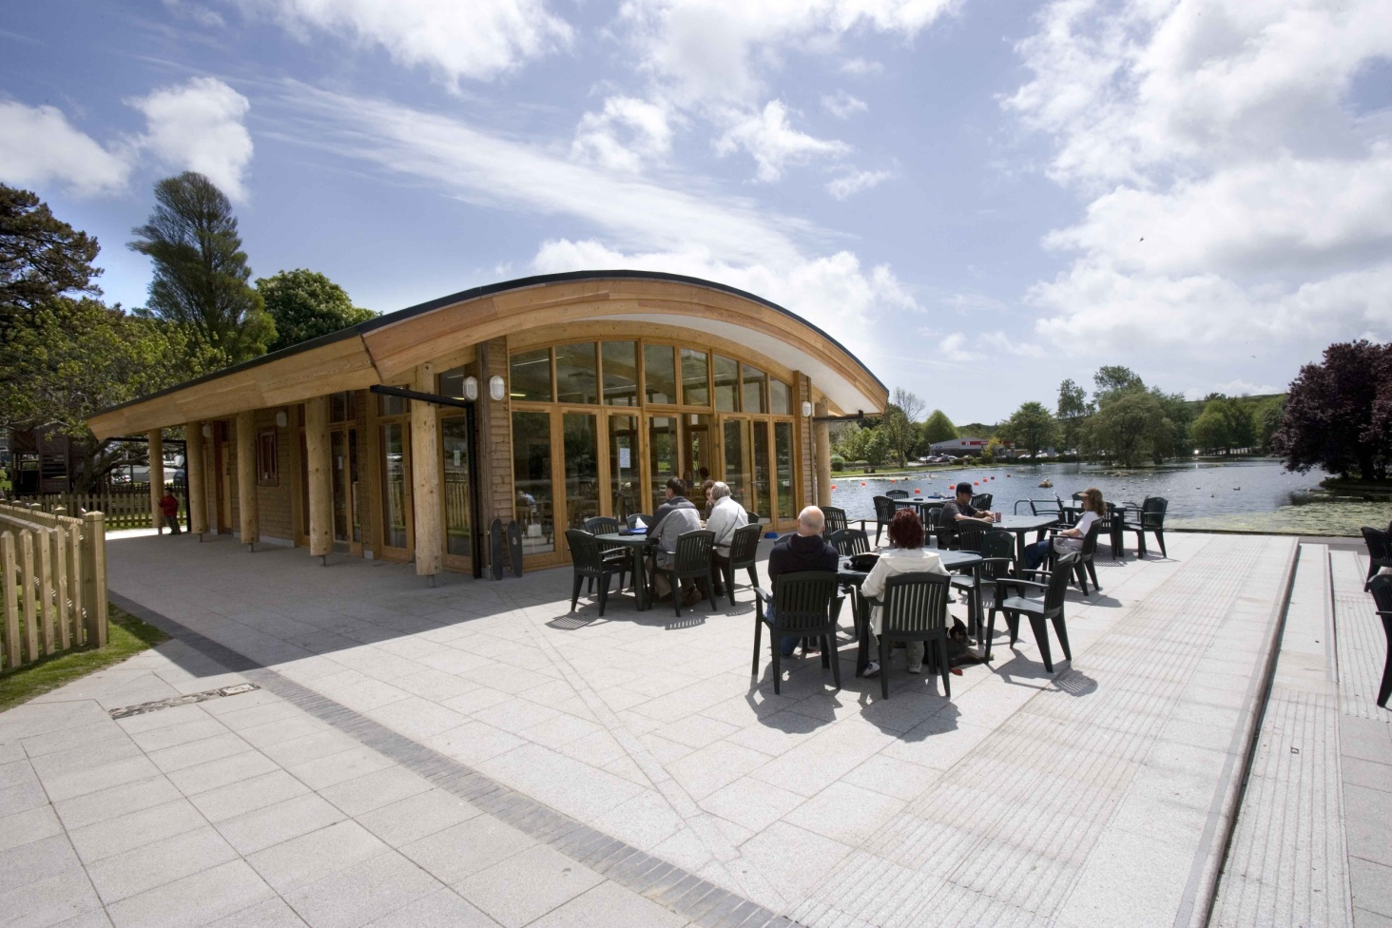

Information Pack for Coronation Lake and Park, Helston 2016

June 2016
V5
Information Pack for Coronation Lake & Park, Helston

Introduction
Cornwall Council wishes to explore well considered opportunities for enhancing and maintaining the flagship park at Coronation Lake, Helston.
The Council is seeking a suitably experienced organisation to develop project proposals to source and secure capital funding to invest in the facilities, implement the agreed works and manage the enhanced asset in a financially sustainable manner, delivering high quality services to the public.
The site will be transferred by way of lease to the successful organisation, the duration is 99 years but alternative lease length may be considered by the Council. The intention will be to commence the new lease by Winter 2016/ Spring 2017.
The Site
Coronation Lake and Park is a popular public open space within Helston, Cornwall. It forms the most northern section of a chain of greenspaces which link Helston, via Penrose Amenity Area and the National Trust owned Penrose estate, to the coast at Loe Bar and Porthleven.
Site Address- Coronation Park, Porthleven Road, Helston, TR13 0SR
Map Base- Ordnance Survey 1:25,000 Explorer 103
Grid Reference- SW 654 272
It has a total area of 6 hectares
The central focus of the park is a 210m long historic boating lake with resident wildfowl, surrounded by seats, shelters a circular footpath and a water-wheel. At the town centre end there are formal play facilities (including a skate park), a café, public toilets, an events space, avenues and car parking. These were re-configured in 2007, when the park was extended into the site of the former Helston Cattle Market, which had become derelict since ceasing business during the 2001 Foot and Mouth outbreak. The café is open daily serving a wide variety of refreshments. The new building, which also houses the toilets, was created using sustainable building materials such as recycled insulation, timber and a living sedum roof. Avenues of trees lead to an all-weather events space, where unique benches allow visitors to enjoy the special views and where a variety of entertainments and fairs can be held.
The play areas incorporating modern and environmental play opportunities have been developed in a number of phases along with a relocated skate park. The space is fully accessible for wheelchair users and people with visual impairment. There is a pay & display car park with over 30 spaces (including a number reserved for disabled visitors). Pedestrians can easily access the site from the north via the St John's/Penzance Road crossing and a crossing point has been created across the Porthleven Road to access for walks through Penrose Amenity Area and along the Loe Valley.
The café is leased with exclusivity for the sale of refreshments, along with a boating concession. The lease incorporates responsibility to maintain & make available the 4 public toilets to all users of the space daily. These are accessed externally without the need to enter the café. The tenant has gained planning approval to introduce a cycle hire facility near the northern corner of the lake, which has been added as a concession to the existing lease.
Habitat conservation is an important consideration, as the site forms the start of the Penrose to Loe Pool natural green corridor that follows the river 2 miles to the sea, which comprises a Site of Special Scientific Interest.
Close to the north/ north western perimeter of the site runs the River Cober. The Park is located close to Helston town centre and there is car parking and sufficient turning space for coaches. There is good public access to the site from the town onto the amenity area.
Ownership
The site area shown on Plan 1 is owned freehold by Cornwall Council, the current Cornwall Council property reference number is 13324. There are two separate existing lease arrangements within the site area listed below;
The café and events square which, along with public toilets and boat/ cycle hire franchise, are leased out via commercial leases, these will form part of the agreement and taking on landlord role for the existing sub tenants will form part of the agreement. Specific details of income and duration of these leases are shown in the accompanying draft Heads of Terms.
At the northern point of the site, adjacent Penzance Road is a new community building, on land leased out to South Kerrier Community Alliance, this falls outside the agreement area.

Map 1. Location

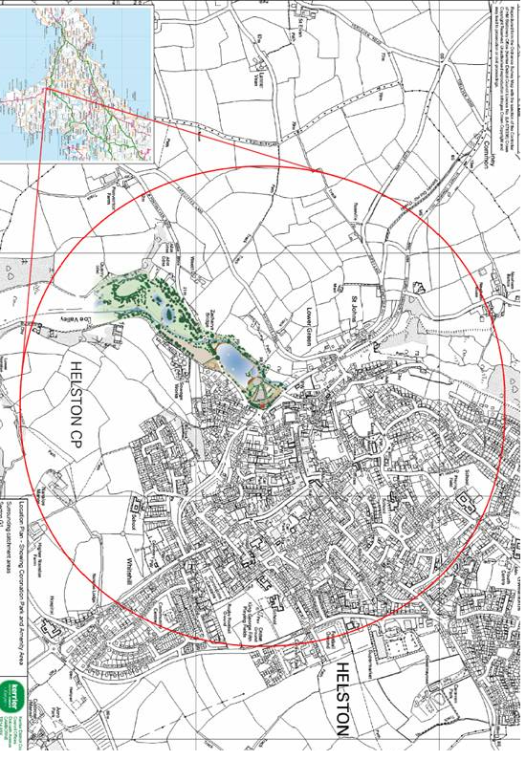
Map 2. Site Boundaries/ Inclusions and Exclusions

The extent of the land included in the lease is shown below. It includes the park, lake, river cober, café (with existing tenant) and all associated infrastructure including the former cattle market car park. The extent is shown in red and green (leased out building).

It excludes the cattle market building, Castle Green car park and fairground car park/ Penrose Amenity Area. These areas are shown in blue.

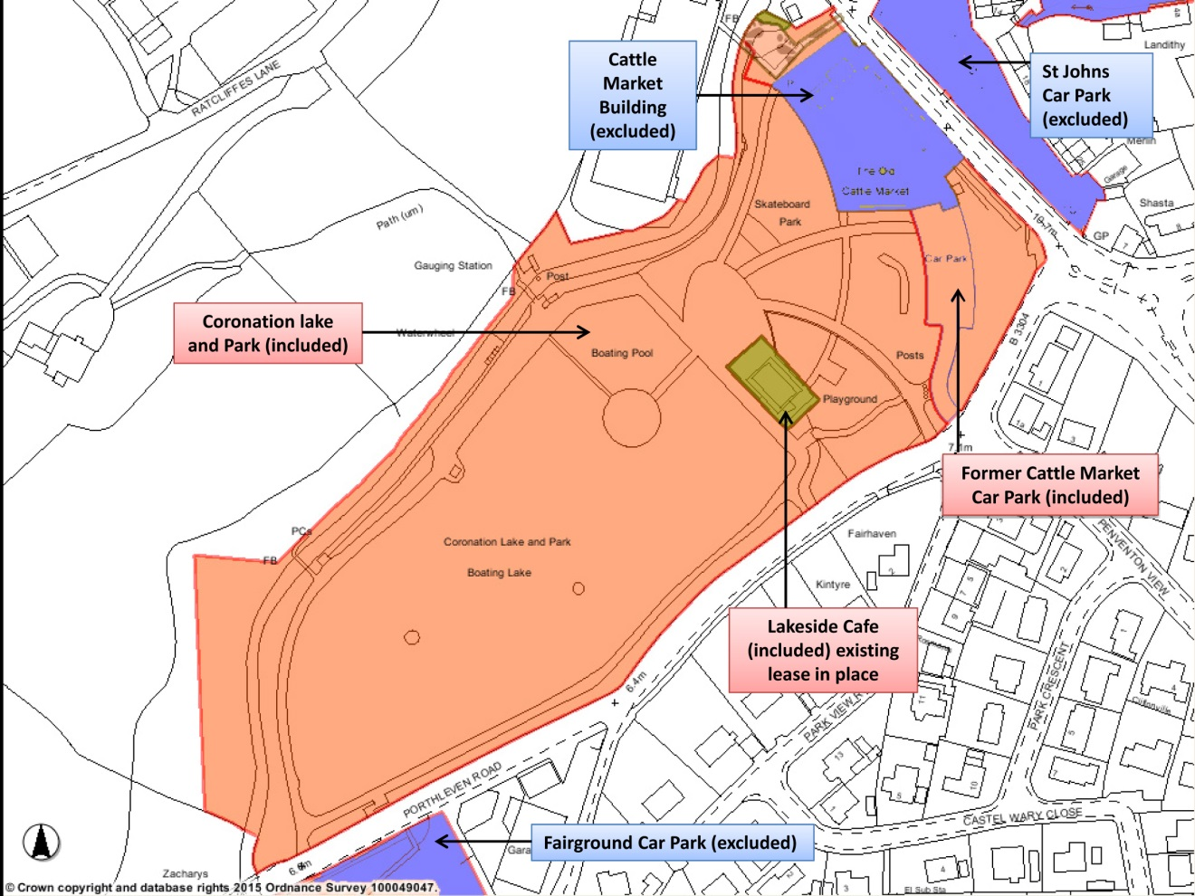

Designations and conditions
Coronation Park falls within the Environment Agency’s Fluvial Floodplain area for the River Cober. The site borders both an SSSI and a County Wildlife site to the south.
Influencing designations, strategies and groups
There are a number of groups, management strategies and designations that influence the management of the Cober valley and Loe Pool catchment area. Although none directly affect Coronation Park their influence should be noted.

- Loe Pool Forum
The Loe Pool Forum was set up in 1996 to look at ways of reversing the process of eutrophication that has been adversely affecting Loe Pool since the mid 1970s. It is made up of organisations and individuals with a particular interest in Loe Pool and who are committed to making changes. Some of the objectives set out by the forum for Loe Pool are:
- To make the most of the wildlife value of Loe Pool and its catchment
- To make Loe Pool and its catchment a place that is attractive and well used by the local community and visitors alike.
- The Loe pool forum also aim to control invasive species such as Parrots Feather and reduce the amount of litter entering the pool from Helston
b. Site of Special Scientific Interest
Loe Pool is Cornwall’s largest natural lake, separated from the sea by a shingle bar. The site is designated as a SSSI and is owned by the National Trust. An SSSI is given certain protection against damaging operations. There is a list of operations that would require English Nature consultation.
c. County Nature Reserve
The County Wildlife Site boundary follows closely the boundary of the SSSI. This is a non-statutory designation identifying sites that are important at a County level. These sites are identified by Cornwall Wildlife Trust.
d. South Kerrier Alliance
South Kerrier Alliance Community Interest Company (SKA CIC) is a social enterprise, formed by volunteers, to address the needs and aspirations of the people of South Kerrier, Helston and its surrounding parishes. Their plan focuses on the long term issues and challenges that will affect our environment, local economy, people and communities of South Kerrier.
They manage The Old Cattle Market project which is housed in a two storey multi-use building within the site.
River Cober Responsibilities
Coronation Park sits in Flood Zones 2, 3 and 3b and is close to but not quite affected by a Critical Drainage Area designation. As such the tenant should not make any material changes to potential flood storage capacity (e.g. by walling off areas, creating mounds by importing material or buildings) without discussing with the Environment Agency in advance. The tenant shall take on the inherent responsibilities as a Riparian Owner (see attached Environment Agency guidance document Living on the Edge).

Recent investment in the park
£888,000 – 2005/07 – West Cornwall Liveability Project – redevelopment of town end of park.
£116,000 – 2009 – Playbuilder Project – new tower play units within play area.
£12,024 – 2012 – Tree works, skate ramp repairs, lake repairs and survey report.
£10,000 – 2013/14 – Improvements to play area.
£7,573 – 2014 – Repairs to steel skate ramps.
The tenant of the café has invested in the café facilities & boating concession, and continues to undertake improvements such as the cycle hire.
Future investment in the park
A report has been prepared on the condition of the lake, both structurally and in terms of the build-up of nutrient rich silt, which result in annual algal blooms.
The very popular skate park comprises a number of old steel ramps that suffer from wear and corrosion, and consequently require regular repairs. The eventual replacement of the ramps with a more sustainable, low noise and hard wearing alternative needs to be considered. A number of measures have been introduced to tackle problems with surface water within the play area. Additional land remodelling and the introduction appropriate vegetation may require investigation.
Reports on these structures are available.

Annual Income
The annual income generated by the café lease is in the region of £16,000, the former cattle market car park generates a similar figure, combined the average annual income is £32,000.

Annual Costs
The programmed maintenance works to the site cost in the region of £16,000 per annum. It is envisaged that there are no TUPE implications associated with the agreement, this will be confirmed formally.

It should be noted that the successful tenderer will take on all maintenance responsibilities for the park, which includes waste management. The accompanying Code of Practice for Litter and Refuse should be used as a guide to the level of service expected for this site to ensure appropriate cleanliness. https://www.gov.uk/government/uploads/system/uploads/attachment_data/file/221087/pb11577b-cop-litter.pdf

Car Park Management
The approach to future car park management is dependent upon whether the successful tenderer is another Local Authority. If so, the latest guidance from the Department of Transport is that the car park should be operated under the Traffic Management Act 2004, as it is now. Cornwall Council may be able to provide enforcement services to the tenderer, under a Service Level Agreement.

If a private entity takes on the management of the former cattle market car park, this could be operated under contract law, employing the services of a private car park operator to enable enforcement. The council already has pay and display machines at the site. If the successful tender does wish to retain car parking charges at the site then these machines will be transferred across to the tenant as part of the lease. Ongoing maintenance of the equipment will transfer to the tenant.

Thank you for expressing an interest and we look forward to your submission.
General Views across the site

