ESSEX COUNTY COUNCIL

Leadership & Management Development Framework

SPECIFICATION

Issued 15th March 2021

Procurement Project CO0076

- Essex County Council

  - Essex County Council is dedicated to improving Essex and the lives of our residents. Our ambition is to deliver the best quality of life in Britain. We will achieve this by providing high-quality, targeted services that deliver real value for money.

- Our vision

  - The current Essex Organisation Strategy sets out our aims and priorities for the period 2017-21, please note that a revised strategy is being developed and is likely to contain a similar direction of travel and emphasis. It articulates how we will achieve better outcomes for Essex and secure the ambitions set out in the Vision for Essex. Our ambition, at the end of this period, is for Essex to be the best local authority in the country.

  - At ECC we are passionate about better lives for people in Essex. We believe prosperity is the best route to achieve that – so people can help each other, and themselves. We are also ready to step in – to protect vulnerable children, to help care for older people and to support our economy to flourish. As a public body it is important we spend taxpayers’ money wisely, on the issues that matter to our residents. To offset reductions in government funding, we must constantly manage demand, reshape and re-imagine services and look for opportunities to generate income. It is also important we work tirelessly to secure investment into the county that can help make Essex an even better place to live and work.

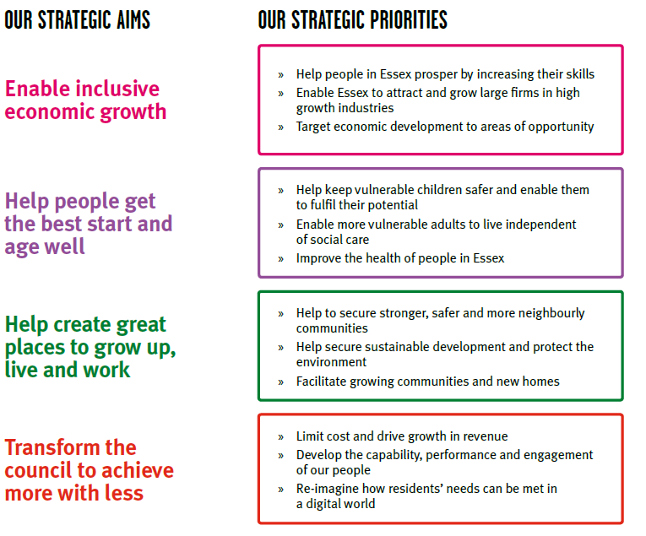
  - Further information can be found on the ECC website.

- Delivering the vision

  - If we are to succeed through these testing times, we must maintain a focus on our core purpose. The challenge ahead strengthens our resolve to:

- increase educational achievement and enhance skills
- develop and maintain the infrastructure that enables our residents to travel and our businesses to grow
- support employment and entrepreneurship across our economy
- improve public health and wellbeing across Essex
- safeguard vulnerable people of all ages
- keep our communities safe and build community resilience
- respect Essex’s environment

  - Our Corporate Outcomes Framework translates our Cabinet’s political ambitions – outlined in their Vision for Essex – into a set of outcomes and supporting indicators that can guide the work of commissioners across ECC. The consolidation of outcomes into a single, authoritative, framework for ECC is designed to:

- provide a clear foundation for the development of our commissioning strategy and plans;
- provide a clear framework for assessing progress – allowing ECC to understand its impact on residents and communities in Essex; and
- and allow for the analysis of ECC resources, assets, contracts etc, against a consistent set of outcomes.

  - The Corporate Outcomes Framework embeds the principles of Outcomes Based Accountability (OBA) within ECC. OBA is an established and effective approach for expressing, operationalising and ensuring accountability for outcomes. It provides a simple, common sense, low bureaucracy planning model supported by clear terminology.

Essex: a  county where innovation brings prosperity | Children in Essex get the best start in life | People in Essex enjoy good health and wellbeing | People have aspiration and achieve their ambitions through education, training and lifelong-learning
 | - Percentage of children ready for school  - Percentage of children achieving a good level of development by the age of five  - Percentage of families living in temporary accommodation  - Percentage of children living in non-working households | - People in Essex have a healthy life expectancy  - Reduced differential in life expectancy across different areas of Essex  - Percentage of children achieving at school [measured at foundation stage, KS2 and KS4]  - Percentage of working age people in employment  - Prevalence of healthy lifestyles  - Prevalence of mental health disorders among children and adults  - Percentage of Essex residents who consider themselves to be in good health  - Percentage of families living in safe and suitable housing  - Percentage of households living in fuel poverty  - Teenage pregnancy rates  - Life satisfaction rates (ONS condition of wellbeing) | - Rates of literacy and numeracy at all ages  - Percentage of children achieving at school  - Percentage of adults participating in lifelong learning  - Percentage of working age people in employment  - Percentage of people participating in further education/higher education/vocational learning  - Percentage of young people aged 16-19 not in education, employment & training  - Rates of volunteering  - Percentage of children attending a good school

People in Essex live in safe communities and are protected from harm | Sustainable economic growth for Essex communities and businesses | People in Essex experience a high quality and sustainable environment | People in Essex can live independently and exercise control over their lives
- Level of crime in Essex  - Number of children subject to protection plans  - Number of children in care  - Rate of anti-social behaviour in Essex  - Number of people killed or seriously injured on Essex roads  - Percentage of residents who feel that Essex roads are safe  - Hospital admissions caused by injuries to children and young people  - Hospital admissions caused by injuries to adults  - Incidents of domestic abuse  - Percentage of residents who feel safe  - Rates of re-offending | - Job growth in key locations and key sectors  - Housing growth in key locations  - Supply of fit for purpose business premises  - Increased connectivity and journey time reliability on priority route network (PR1)  - Number of bus and/or community transport journeys  - Median earnings  - Coverage of superfast broadband services  - Sustainable business start-up rates  - Percentage of Essex businesses who think they can recruit suitable people  - Percentage of working age people in employment  - Business rates growth | - Residual waste volumes  - Cost of energy to households  - Preventable flooding incidents  - Level of pollution  - Condition of roads and footways  - Access to valuable open spaces  - Perception of the quality of the environment in Essex’s cities, towns and villages | - Proportion of people who live independently  - Percentage of people who regain or increase their level of independence following hospital admissions  - Access to end of life care in their preferred placement of choice  - Number of children and adults who receive social care support  - Number of people with personal budgets

- Introduction and Aim

  - People are our most important asset and everyone is crucial to the successful delivery of our services. Our people plan (which is being renewed alongside the Corporate Strategy) forms our current workforce strategy which clearly defines the capabilities, skills and culture we need for future success. The public sector workforce is facing uncertain times and in four years’ time will look very different from today and will require us to work in different ways to continue to serve our residents.

  - The summary of our current workforce strategy (below) is made up of strategic themes
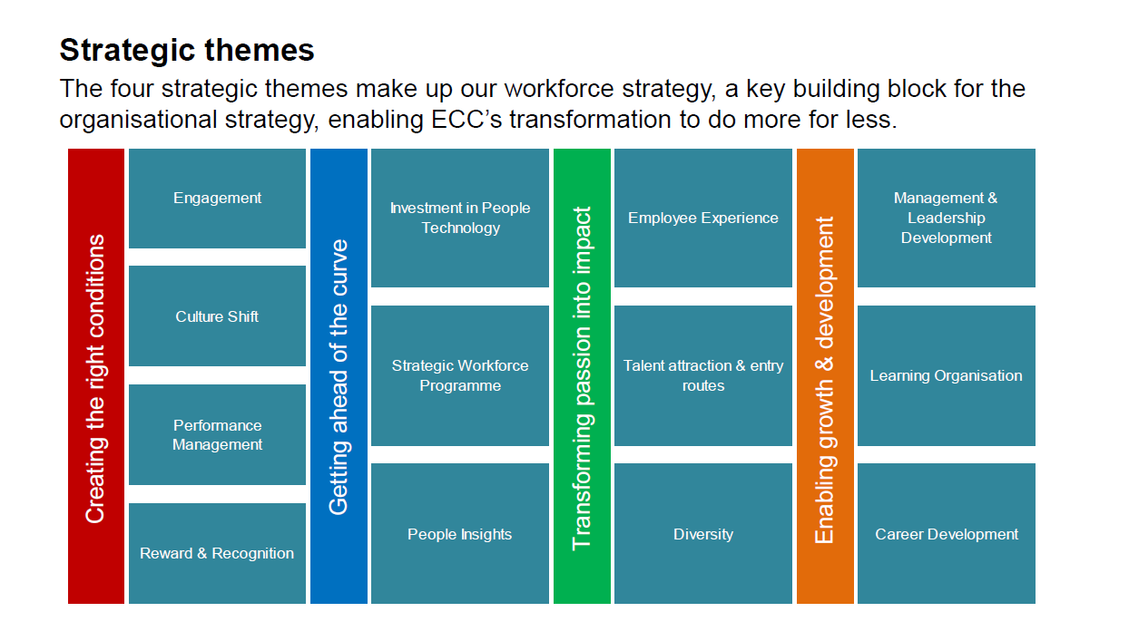
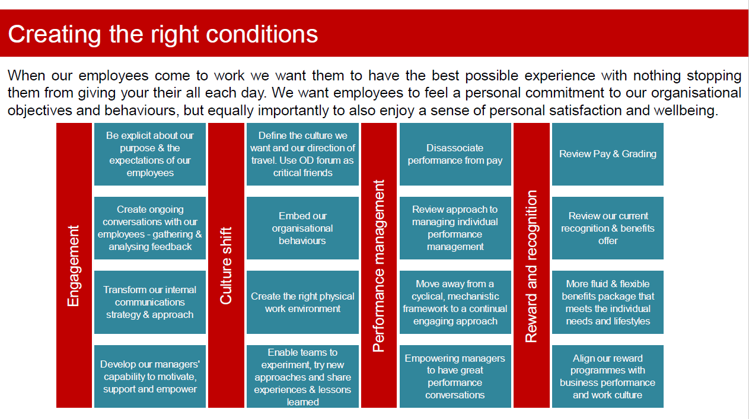

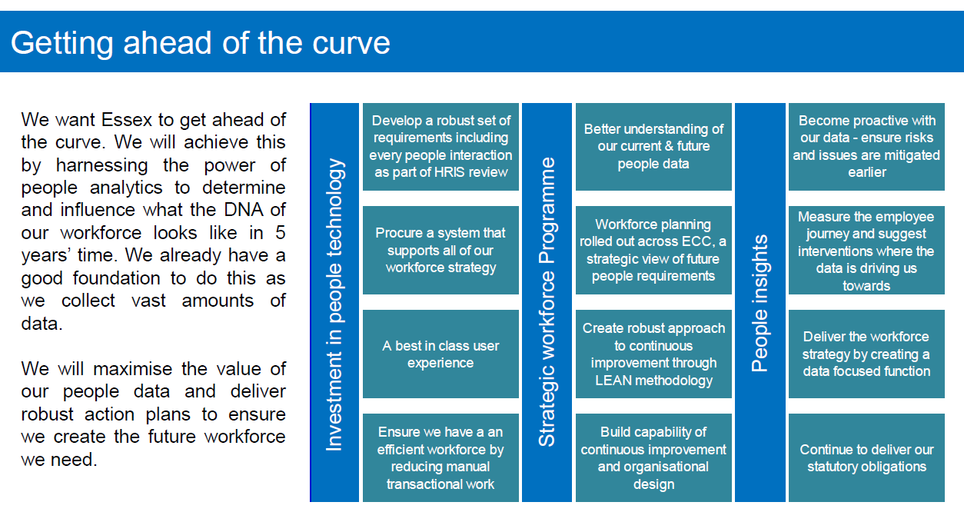
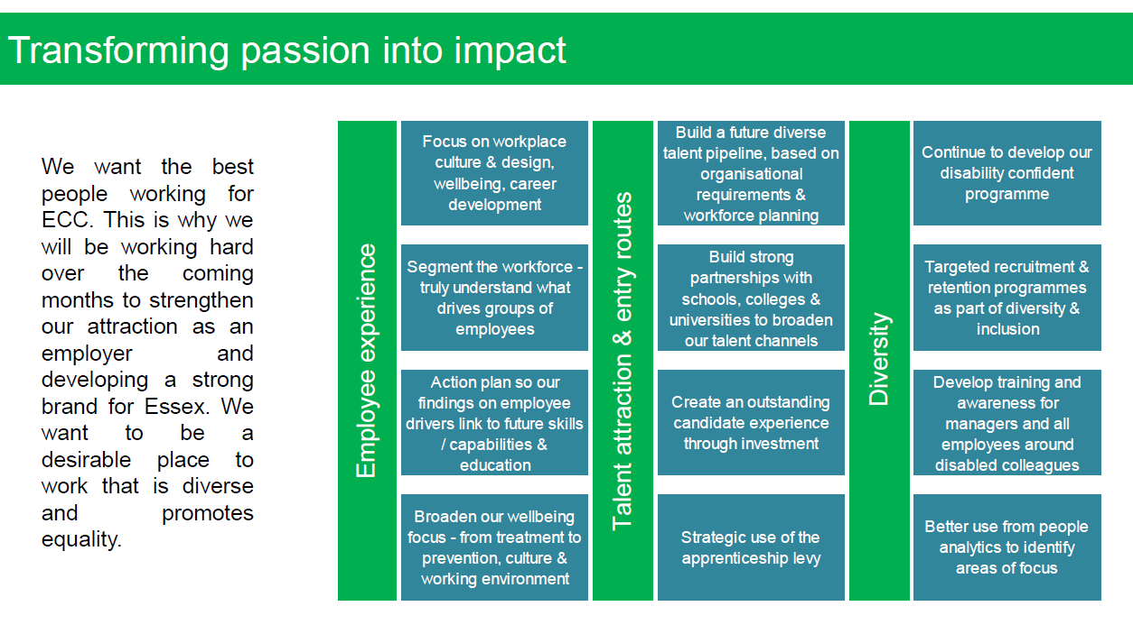

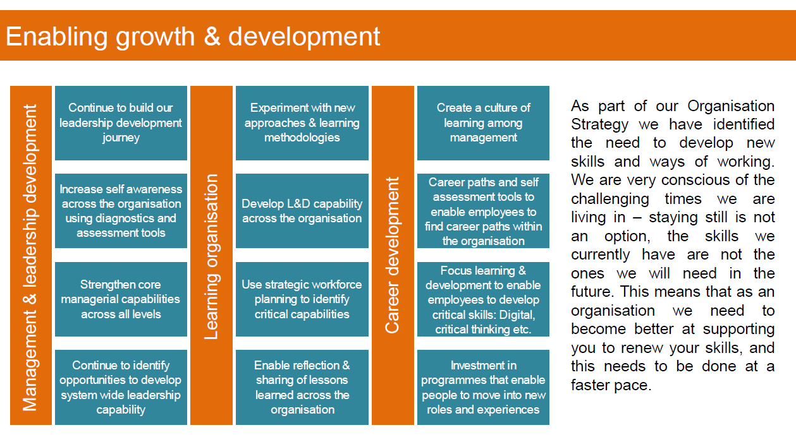
  - The landscape of local Government is changing; recent changes have been made to Essex County Council’s organisational structure in line with the new collective ambition to make significant improvements to the way that services are delivered. This has resulted in a greater need of, and an increased focus on, developing excellent leadership & management capabilities to embed a ‘fit for purpose’ strategy.
  - The purpose of this procurement is to ensure that there is a process to; Discover, scope, design, develop, facilitate and deliver a range of interventions to develop and enhance the skills and capabilities of the leadership & management population through the provision of a multi-supplier Framework based on the Lots described in Section 6.
  - As we move to a Hybrid way of working, based on functional and individual requirements, we will also require a hybrid approach to our development provision. This may mean that suppliers may be asked to undertake the whole of a solution (from discovery through to delivery) or alternatively, only part of the provision (e,g scoping a solution, designing an intervention or facilitation). They would be expected to work alongside and collaborate with other providers as required (ECC would project manage such occasions).
- Background
  - As part of the 2017 – 2021 Organisational Strategy, ECC introduced an extensive organisational re-design programme, which will continue as required in order to meet the requirements of the citizens of Essex. This period also saw the introduction of a set of organisational behaviours, which have been further developed and translated into our leadership behaviours as follows:

    - Inspires: Displays a passion for making a difference. Creates and shares an ideal image of what we can become and motivates others to see exciting opportunities for the future.

    - Innovates: Thinks radically, take risks and is prepared to make mistakes when looking for new ways to improve services. Sees disappointments as learning opportunities. Seeks opportunities to challenge and change the status quo.

    - Enables: Builds energised teams and recognises contribution. Creates an atmosphere of trust, respect and dignity so others feel able to experiment with new or innovative ways of working.

    - Collaborates: Creates and develops networks and involves others to first understand their point of view and then join together in a common purpose. Crosses internal and external organisational boundaries to improve and deliver shared solutions and services in ways that achieve mutual gain.

    - Delivers: Develops a quality service by valuing and modelling professional excellence and expertise to enable the delivery of commercially, financially viable services. Takes into account diverse customer needs and requirements.

  - These behaviours form the foundation of our ‘Leadership and Management Development Roadmap’, which will be a structured, common and consistent approach that is applicable across the leadership & management population of the organisation.

  - The key purpose of the Leadership and Management Development Roadmap is to clarify what the organisation’s expectations are from our managers, and in the same spirit, what our managers can expect from the organisation, in terms of support and resources to enable them to deliver in their roles and at each stage of their careers.

  - The aim of the ‘Leadership & Management Development Framework’ is to ensure that the call off orders for specific and detailed work packages can be expedited to ensure timely delivery of the agreed solutions. As such, we are looking for organisations that are agile, can respond to work packages, work in partnership and deliver services within agreed timescales.

  - These requirements will be met by the placing of call-off agreements (work packages) with the framework suppliers via one of the following methods;
    - Direct Award to a single supplier against specific criteria.
    - Further competition – Buyers will run a mini-competition with all service providers in the Lot chosen.
  - The expectation is that the leadership & management population, through the implemented solutions, will have sufficient self and situational awareness, guidance and tools to ensure effectiveness, efficiency, productivity and performance are significantly and continually improved.

- Scope

  - Appendix A provides a representation of the Leadership & Management Development Journey, from Aspiring/New Manager through to Functional Leader.

  - There are 2 key areas of focus for the Leadership & Management Development Framework:

    - Management Skills & Capabilities, which currently sit within our Management Acceleration Programme, are broken down into five key domains (split into Lots of work covered in section 6.4). They cover; Managing Yourself, Managing Others, Managing Resources, Managing in The System and Managing for Continuous Improvement. These skills and capabilities are listed indicatively in Appendix B, however, more detailed requirements will be identified from a needs analysis which is currently underway and will continue to develop in response to emerging needs throughout the period of the contract.

    - Leadership Behaviours and Capabilities, which currently sit within our Leadership Development Offer are broken down into three key domains (also split into Lots of work covered in section 6.4). They are Leading Self, Leading Others (and other Managers) and Leading the Function (and Organisation). These capabilities and behaviours are listed indicatively in Appendix B, however, more detailed requirements will continue to be identified in response to changing requirements throughout the life of the contract.

  - The key outcome of this tender is to ensure that there is a process to design, develop and deliver a range of interventions to grow and enhance the core skills of the management population. As such, we are seeking organisations that can support us through the delivery of services as set out in the Lots below. Interested Bidders are required to highlight which Lot(s) of work they are bidding for and is clearly marked when completing the Bidder questionnaire.
    - Lot 1 – People Management (capable of constructively building, effectively managing and developing high performing teams).
    - Lot 2 – Managing Resources (capable of productively and efficiently utilising resources to best advantage).
    - Lot 3 – Managing in the System (collaboratively working across boundaries of the Council, partner organisations & stakeholders in a positive & collective goal orientated way).
    - Lot 4 – Managing for Continuous Improvement (embed and implement a culture of constantly doing better).

    - Lot 5 – Managing yourself (assessing and improving leadership performance through self-awareness, feedback and critical thinking).
    - Lot 6 – Leading Self (being more aware of ourselves, our influence and the need to flex styles and approaches. Leadership at all levels, starts with people choosing to lead themselves)
    - Lot 7 – Leading Others & Other Managers (seeking out and integrating Multiple perspectives, building strong and productive relationships in order to get things done and the ability to bridge the gap between operational and strategic focus as the context requires)
    - Lot 8 – Leading the Function & the Organisation (setting the organisational purpose and alignment for implementation of the organisational strategy

  - The management population in scope of this tender includes junior, middle and senior managers; line managers, operational/service managers and strategic/heads of service respectively.

  - Executive coaching for our Senior Leadership (heads of service/strategic managers) is out of scope.

  - Technical and professional pathways are not within scope of this tender.

  - The potential volumes would be in the region of 240 strategic managers/heads of service and 2000 operational/service managers. These numbers are only indicative and those that require interventions will be confirmed when detailed work packages are released.

  - The main location of the management population has traditionally been County Hall, Chelmsford, Essex. However, the move towards Hybrid ways of working (incorporating working from other locations, alongside working from the office as required) means delivery of development services will need to be truly blended, including some virtual and some on-site face to face delivery (at Council sites across the County) for the duration of this contract. Our channel of choice for virtual delivery is Microsoft Teams (though staff can also access other platforms).

  - The duration of this Procurement Framework Agreement for a 2 year period; however, there may be an option at the end of this 2 year period to extend by up to a further 2 years – one year at a time (so a 2 +1 +1 arrangement). It must be noted that even if successful vendors have established themselves on the preferred supplier list and signed the Procurement Framework Agreement, there will be no guarantees of work packages being awarded.

  - There could be potential for the range of services, volumes of the management population as well as the scope of work to expand or reduce; furthermore, the range of materials could increase or decrease or for new products to be included or substituted as technology develops.

  - In the event of any digital or technology solutions to be offered as part of any proposals, these must be compliant with ECC’s IT policies and be compatible to interface seamlessly.

- Key Dates
Commencement date – 1st July 2021
Completion date – 30th June 2023
Duration - 24 months
  - Required delivery dates/milestones, content and quality will be agreed within each work package contracted for.

- Statement of Requirements

  - Within each of the 8 key domain headings and summaries, there are a number of skills and competencies (see appendices A & B). These tables are not a complete and final list and as such will give the range of skills and competencies (which could change on the outcomes of any training needs analysis) specific to any department or function. However, the indicative requirements would be to assess, design, develop, deliver and evaluate interventions and solutions to meet identified leadership & management development needs across the organisation.

  - Successful bidders could be required to complete all, or part, of these stages i.e. to assess, scope, design, develop, deliver, facilitate and evaluate a complete intervention, or to undertake a single element (e.g. facilitation). Appendix C provides examples of Development Solutions.

  - The expectation is that bidders will clearly articulate their skills, competencies and experience in a range of delivery techniques, use of industry best practice tools and models, fit for purpose methodologies, bring innovation and what they have learned during the pandemic to bear, whilst incorporating technology to demonstrate their suitability as well as to quote affordable rates to maximise the return on investment.

  - Continuous improvement – it is the expectation that bidders will endeavour to continually improve their services in line with feedback, new technologies, research, or latest thinking and aim to be ‘best in class’ for what solutions they are designing and delivering.

  - Performance, targets, and monitoring arrangements – Metrics will be agreed for each work package and these would be built into each contract along with milestones and deliverables.

  - A programme of delivery may consist of a number of concurrent work packages delivered by different suppliers. It is therefore essential that suppliers allow the Authority to be able to use those outcomes in the delivery of the next phase albeit, potentially with a different supplier.
  - It is also essential that they are willing to work in collaborative partnership with Essex County Council and other suppliers in the design and delivery of development services as required.

  - Business Continuity – Successful bidders may be required to provide a business continuity plan following award of contract.

- Authorities policies
  - ECC’s Information Handling Schedule for Contracts - http://www.essex.gov.uk/Business-Partners/Supplying-Council/Documents/Information_handling_schedule.docx
  - ECC's Information Policy Requirements for Suppliers – http://www.essex.gov.uk/Business-Partners/Supplying-Council/Documents/Information-Policy-Requirements-Suppliers.pdf
  - Supplier Charter - http://www.essex.gov.uk/Business-Partners/Supplying-Council/Documents/Appendix_D_Supplier_Charter.pdf

- Insurance and warranties

  - Employer’s liability insurance - £5 million.

  - Public liability insurance - £10 million.

  - Professional indemnity insurance - £5 million.
- E-Procurement Requirements

  - Overview

  - Essex County Council has implemented a fully automated Purchase to Pay system. Purchase to Pay enables the full purchasing and payment process to be carried out on-line, from order creation and authorisation to receipting and invoice matching. It is easier, faster and more efficient than conventional purchasing processes.

  - Marketplace is a Proactis Solution. It is a web based system used by Essex County Council to submit purchase orders electronically and receive and process e-invoices and e-credits.

  - The Marketplace supplier interface is both simple and secure. All the successful bidders will need to access Marketplace is an Internet browser. Marketplace supports the latest release of web browser technologies, for example, Internet Explorer, Firefox, Safari etc.

  - Electronic Ordering

    - A record on Marketplace will be created for the successful bidder and a user ID and password will be issued via e-mail.

    - The user ID and password will allow the successful bidder to:

- View their purchase orders online
- Update their status
- Notify delivery
- Submit and monitor the status of electronic invoices and credits, once they have been submitted.

    - Purchase orders will be sent electronically to the successful bidder’s central e-mail address

  - Emailed Purchase Orders

    - Orders will be sent electronically, via Marketplace, to the successful bidder’s preferred central e-mail address from the contract start date. To ensure continuity of service, the successful bidder will be responsible for ensuring that orders are processed quickly and efficiently. It is therefore not advisable to provide individual e-mail addresses unless appropriate access is available, to ensure that orders are still processed if the main contact is unavailable. There is no transaction charge for e-mail orders which are sent to a preferred central e-mail address, via Marketplace.

  - Electronic Invoicing

    - The successful bidder will be expected to submit electronic invoices and credit notes via Marketplace by utilising the PO Flip method from the contract start date. On approval of the electronic invoice an automatic payment will be made via BACS, direct to the successful bidder’s bank account, in line with Essex County Council’s contracted payment terms. In addition to the above, the successful bidder will be able to view the status of their invoices, via the Marketplace system.

  - Purchase Order Flip (PO Flip)

    - The successful bidder will be able to gain access to the Marketplace system via a web browser, to view their Purchase Orders and turn any outstanding Purchase Orders into electronic invoices, by choosing the PO Flip method. There is no charge for this method.
Further information about all of the above can be found on ECC’s website: http://www.essex.gov.uk/Business-Partners/Supplying-Council/Pages/IDeA-Marketplace.aspx
  - Please be aware, the successful bidder will also be registered onto ECC’s Finance system, Oracle. They will in turn receive a registration email to activate their iSupplier portal account. This account is used to:

- View the status of invoice payments
- Amend your supplier details e.g. address, contact details, bank details
- Create additional user accounts

  - E-Procurement Terms of Trading

    - A preferred central e-mail address, (where orders will be sent electronically via Marketplace) must be provided. It is the responsibility of the supplier/ successful bidder to ensure that they can provide a central e-mail address for orders sent electronically via Marketplace from the contract start date. The Successful Bidder/ Supplier/ Contractor will be asked to submit this e-mail address. It is also the supplier’s/ successful bidder’s responsibility to ensure that continuity of service is maintained at all times and that orders are processed promptly.

    - All invoices and credit notes must be submitted electronically by the supplier/ successful bidder to Essex County Council and as a minimum must be raised using the PO Flip method via Marketplace from the contract start date.

    - Goods/Services should only be provided/carried out on receipt of an Official Purchase Order which has been issued via Marketplace by the Authority.

    - The Successful Bidder assumes full responsibility for ensuring that programs or other data downloaded uploaded or in any way transmitted electronically to the Authority are free from viruses, or any other items of a destructive nature whatsoever. The Authority makes every effort to virus check information made available for download from Marketplace. The Authority cannot accept any responsibility for any loss, disruption or damage to your data or your computer system which may occur whilst using material derived from Marketplace. The Authority recommends that users recheck all downloaded material with their own virus check software.
- Agreement term

  - The Agreement term for this agreement with be 2 year(s) with an option to extend for a period of up to 24 (2x12) month(s). The decision to extend the Agreement with is at the sole discretion of Essex County Council.

- Payment

  - The Authority will pay any invoice issued by the Supplier within 30 days of receipt of a valid invoice following the delivery of the Good(s) and/or service(s). On the thirtieth day the payment will leave the account of the Authority

  - The rates/prices stated on the invoice must be those specified under this Agreement.

- Commercial Response

  - The Tenderer is to complete the commercial response detailed within the E-sourcing portal

Appendix A – Leadership and Management Development Journey
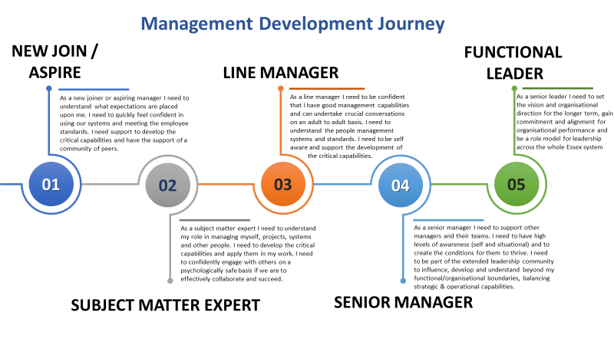

Appendix B Key Management Skills and Competencies
Operational/Service Manager | Strategic Management/Head of Service
Managing People
Capable of constructively building, effectively managing & developing high performing teams
Communication & engagement | Workforce Planning
Team development | Leads a high performance culture
Leading through change | Creates an inclusive and engaging culture
Performance & Delivery | Talent management
People Management (including Matrix Mgt) | Enables a learning and development environment
Managing Resources
Capable of productively and efficiently utilising resources to best advantage
Short to medium term business planning | Resource integration / alignment
Project & Delivery management | Programme and portfolio management
Financial management | Entrepreneurial and commercially minded
Decision making | Strategic financial planning
Procurement & contract management | Strategic business planning
Managing in the System
Collaboratively working across boundaries of organisations/stakeholders in a positive & a collective goal
Systems thinking | Systems leadership
Developing shared outcomes | Builds a shared vision
Knowledge sharing | Builds multi-disciplinary teams
Collaborative problem solving | Creates an inclusive and collaborative culture
Organisational context | Understands the market, policies & changes in the political landscape
Managing for Continuous Improvement
Embed and implement a culture of constantly doing better
Continuous improvement planning | Develop continuous improvement strategies
Analysis and data insights | Innovative thinking
Championing continuous improvement | Create a culture of experimentation
Demonstrate citizen/service user centric approach | Digital Leadership
Implement lean tools and techniques | Enables a continuous learning culture
Managing Yourself
Assessing and improving leadership performance through self-awareness, feedback and critical thinking
Self-awareness | Self-awareness
Resilience | Resilience
Manage complexity, ambiguity and uncertainty | Manage complexity, ambiguity and uncertainty
Emotional & social intelligence, empathy and compassion | Emotional & social intelligence, empathy and compassion
Personal accountability & reflection | Personal accountability & reflection

Leadership Capabilities & Behaviours
Leading Self | - Understanding Leadership Styles & Effective Application  - Influence Without Authority  - Self and Digital Awareness
Leading Others | - Seek and Integrate Cross-functional perspectives in decisions  - Build relationships to get things done  - Bridge the gap between operational and strategic Leadership in the digital age
Leading Functions | - Set the vision for digital & organisational direction  - Redefine the purpose of the organisation  - Prepare and align organisation for strategy implementation

Appendix C - Example Stages of Development Solutions
This is provided to give a flavour of the elements which may be required for development interventions. It is not an exhaustive list and is offered simply as an example, providers will have their own methods of scoping, designing delivering etc..

Successful bidders could be asked to undertake whole development projects end to end or potentially just one of the stages. They could also be asked to collaborate with others in the delivery of development programmes.

Example Stage | Example Activities
Scope | Initial clarification of requirements, learning objectives, size target population, timescales, links to other initiatives, stakeholder expectations, issues/risks etc. role clarification.
Discovery | Data analysis, stakeholder discussions, assumption testing, approach verification etc..
Design | Planning, theory, models, application, contextualisation, channel selection, experiential, social, flow/sequencing, scheduling, templates etc.. communication.
Delivery | Deliver the intervention and gather immediate feedback, rapidly respond to suggested improvements etc.
Facilitate | Focus groups, action learning, development meeting/discussions, away days.
Review/Evaluate | Critically consider feedback, review outcomes against objectives, consider potential next steps, impacts and lessons learned.

