Service Specifications

Service Specification No. | v1.8
Service | Discharge To Assess Bed Primary Care Cover
Commissioner Lead | Tom Ham – Commissioning Manager
Provider Lead | TBC
Period | 01/04/2024 – 31/03/2026, with the potential for a further 2 years (2 + 2)
Date of Review | TBC

1. Population Needs
  - National/local context and evidence base
Older people with frailty are at higher risk of adverse health outcomes in hospital, particularly deconditioning and delirium. These conditions are significant; delirium is associated with a one-year mortality of around 30% and deconditioning leads to loss of independence and falls. Each fall carries a 1 in 20 chance of fracture and if an older person fractures their hip the one-year mortality is 30-50%. It’s also worth noting that 50% of patients over 85 with an unplanned hospital admission die within six months. Furthermore, the National Audit of Intermediate care (NAIC) has demonstrated that a delay in discharge of longer than two days negates the rehabilitation benefits that intermediate care can offer.
It could therefore be argued that there are two medical emergencies when older people are admitted. The first is treating their acute medical needs. The second involves supporting timely discharge as soon as medically fit to minimise the risk of hospital-associated complications and maximise the probability of getting them back to how they were. Studies in the Plymouth locality show that a Comprehensive Geriatric Assessment (CGA) delivered by a joint workforce comprised of primary care and community services offer the dual win of improved patient health and more time spent at home, out of hospital. It would therefore be logical to extend this model of care to intermediate care and include those where people have their care managed in a care home to prevent admission as well.
This service has been designed to link directly to and compliment the commissioning intention to co-locate people in specialist services enabling more join up in the wrap around support they require and move away from bed-based care where appropriate and having a higher utilisation of services such as home first.
Pathway 2 patients are defined as: Likely to be maximum of 4% of people discharged: recovery, rehabilitation, assessment, care planning or short-term intensive support in a 24-hour bed-based setting, ideally before returning home.
2. Outcomes
2.1 NHS Outcomes Framework Domains & Indicators

Domain 1 | Preventing people from dying prematurely | x
Domain 2 | Enhancing quality of life for people with long-term conditions | x
Domain 3 | Helping people to recover from episodes of ill-health or following injury | x
Domain 4 | Ensuring people have a positive experience of care | x
Domain 5 | Treating and caring for people in safe environment and protecting them from avoidable harm | x

2.2 Local defined outcomes

The commissioner wants to receive the following information in relation to the use of the scheme:

Indicator | Any clarification | Frequency
New patients per month | Covering Placement location | Monthly
Discharges per month | Split to show disposition  - Usual home  - Long term care  - RIP  - Admission to hospital | Monthly
Average length of stay on scheme | Crude average but also median and mode | Monthly average but also rolling average
Number of new patient assessments undertaken within the 24hour timescale (unless weekend or BH) | Total number, total number within timeframe and percentage. Type of evaluation; (face to face visit, phone or video) undertaken | Monthly
Completion of CGA for all patients,  Target 100% started within 7 days of joining the service | Number of patients who receive CGA while in care of the service compared to number on case load | Monthly
Total number of calls to service | Calls received | Monthly
Total number and percentage of calls abandoned after 30 secs.  *<5% of calls abandoned |  | Monthly
Average time to call answer  *95% of calls answered in 90 Second requirement |  | Monthly
Average time to call back  *2-hour requirement 95% | Where a patient requires advice from a GP, what is the average time from the end of the originating call to when the GP calls back or first failed attempt | Monthly
Call arrival patterns | Average arrival pattern of calls (day of week, hour of day) | Monthly and rolling average
Number of complaints/SIRI’s |  | Monthly
Types of consultation | Visits, telephone calls etc | Monthly
Average time to home visit  *2 hour requirement (urgent)  4-hour requirement (non-urgent)  95% | Time from end of consultation when visit is decided as required to onsite arrival | Average
GP rota fill  *100% fill rate requirement | Breakdown of filled and vacant shifts | Monthly

We do want to monitor the numbers of people who may end up being readmitted to hospital but recognise that in some instances where this happens after discharge from the scheme there may be a need to liaise with other providers to obtain this information. The ICB would expect service to work with other providers to ensure the information needed to triangulate this data is shared safely and without obstacles.

3. Scope
3.1 Aims and objectives of service

To provide safe, effective and agile care to patients who are discharged under the Discharge to Assess (D2A) scheme and are admitted into a bedded placement.

The care provided will be to the same level as would be provided by a patient’s own GP, this care should include but not be limited to:

- the personal, primary and continuing nature of the care of individuals
- the physical, psychological and social aspects of diagnosis
- the early diagnosis, initial decisions and continuing management of problems
- current, chronic and terminal types of illness
- treatment, prevention and education for promoting health

The provider should have a good knowledge of local health and care system.

3.2 Service description/care pathway

Referral of the Admission Avoidance/D2A patient to the service.

The patient will be referred to the service via a dedicated telephone line. As part of the referral, the provider will receive a written discharge summary for the patient.

Call operator
The Provider will then ask for the following information:
- Patient name
- Contact details
- Confirmation that this is a new admission avoidance/D2A referral, that the discharge summary is with the patient and date the patient will be discharged to the bedded setting
- Add in the read code “provision of intermediate care” SNOMED 287601000000101
- If the patient needs registering as a TR this will also be done.

Call operator to contact the registered GP practice via telephone and the dedicated email address to inform them that the patient is now on the scheme.

New Patient Assessment

New referrals will be automatically booked in for a ‘new patient’ evaluation within 24hrs. The method of evaluation (face to face visit, phone, or video) will be determined by the clinician depending on clinical need. If the referral is made on a Friday, the visit date will be the following Monday, or Tuesday if it is bank holiday.

Intermediate Care Commissioning Transformation and Best Practice

The Plymouth system has undertaken a review of Intermediate Care commissioning and set out a plan for transforming our delivery over the next 12 months to ensure we meet best practice models and maximise improvement opportunities in outcomes for individuals. This will mean the following changes:

- We will increase the proportion of people who are discharged back home (DTA pathway 1)
- For those who require a pathway 2 bed, we will co-locate people in a smaller number of specialist services with environment and staffing to maximise reablement opportunities
- We will ensure a clear wrap around support offer across this service and community service provision

We will reduce the average length of stay to ensure people are able to return back home at the optimum point in their recover.
The provider will play an essential role in our transformation programme and will be required to support us in delivering the ambitions we have set up through working as part of the wider MDT in the coordinated delivery of goal orientated personalised care.

The provider will be required to have strong communication between community/acute providers and then with patient’s registered GP practice to support decisions of intermediate care whilst a patient is in a bed covered by this service, and for onward care arrangements. Acute provider should also engage in this process.

Follow-up / advice / delivery of the CGA

If there is a request from the bedded placement provider for a follow up visit or advice, a telephone appointment will be scheduled. If the triaging GP deems it appropriate to visit, the GP will book a visit.

Following discharge from hospital to a D2A bed the service will commence a CGA assessment for every patient, outlined in figure 1 below:

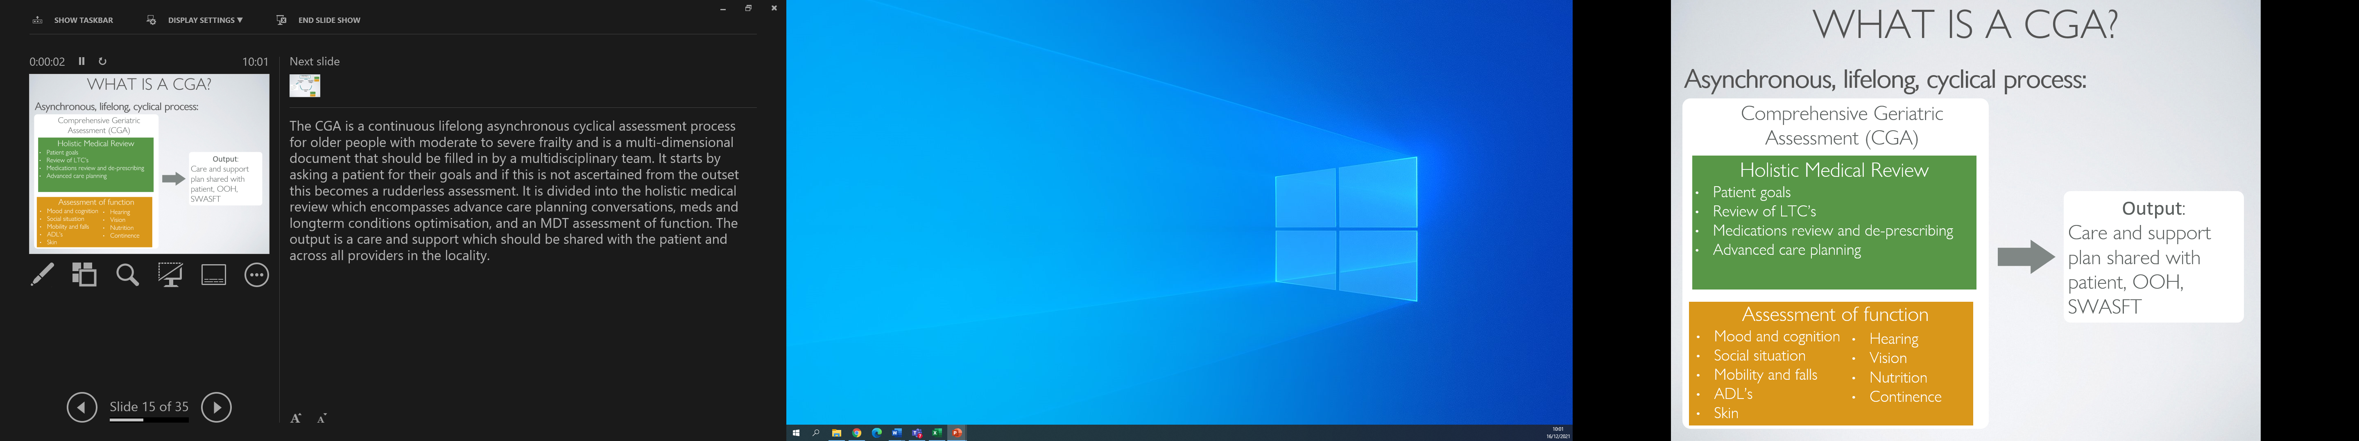

Figure 1: components of a CGA.
The CGA is a continuous lifelong asynchronous cyclical assessment process for older people with moderate to severe frailty and is a multi-dimensional document that should be filled in by a multidisciplinary team. It starts by asking a patient for their goals and if this is not ascertained from the outset this becomes a rudderless assessment. It is divided into the holistic medical review which encompasses advance care planning conversations, meds and long-term conditions optimisation, and an MDT assessment of function. The output is a care and support which should be shared with the patient and across all providers in the locality.

A CGA cycle is outlined in figure 2 below:

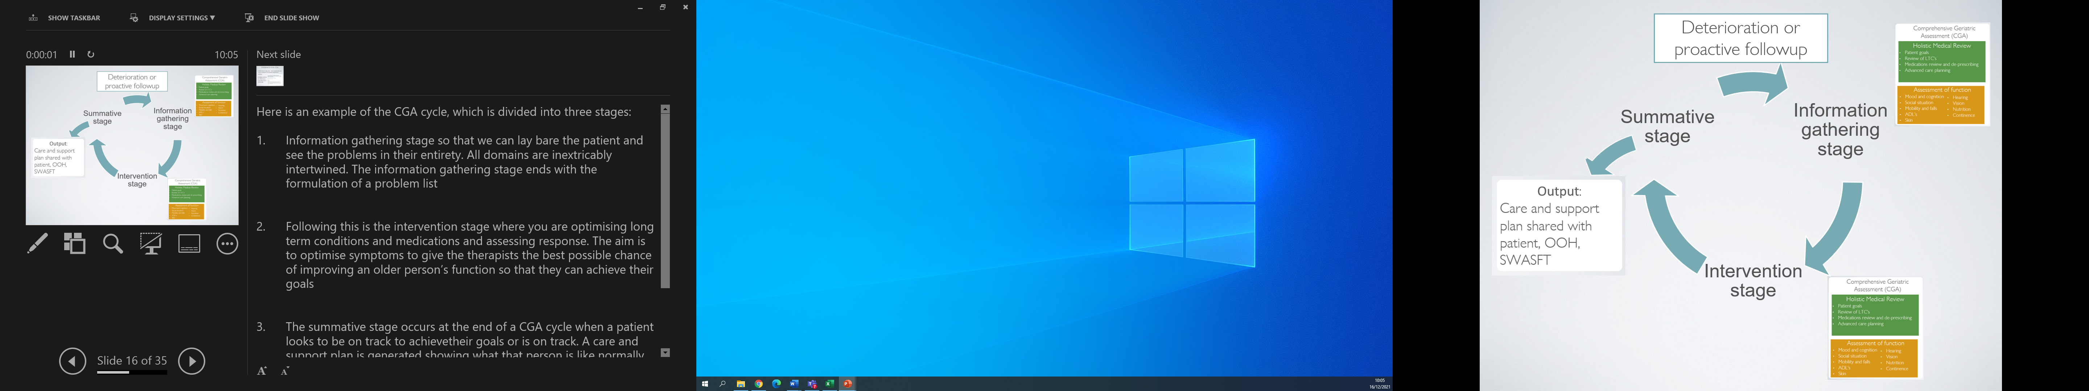
Figure 2: a CGA cycle

The CGA cycle is divided into three stages:
- Information gathering stage: where information is gathered in each of the domains so that the issues in each domain can be seen in their entirety. All domains are inextricably intertwined. The information gathering stage ends with the formulation of a problem list, which are the areas to address in the next stage
- Intervention stage: this is where long term conditions and medications are optimised, and response is assessed. The aim is to optimise symptoms to give the therapists the best possible chance of improving an older person’s function so that they can achieve their goals
- The summative stage: occurs at the end of a CGA cycle when a patient looks to be on track to achieve their goals or is on track. A care and support plan are generated showing what that person is like normally and this is shared with the individual and organisations across the locality.

If the patient deteriorates or at a suitable time interval the assessment process re-commences.

This assessment should be jointly delivered jointly between Livewell, the bedded care provider, and the provider. Providers may choose to make use of their Ageing Well MDTs, EHCH home rounds, and other develop other methods to facilitate this.

Read-coding activity:

The service delivering D2A will record the following read codes when undertaking a CGA:

Read code to add: | Rationale
Medication optimisation read codes:  Structured medication review (1239511000000100)  AND  Review of medication (182836005) | Denotes that a medication review has been completed.  Both read codes must be added on completion
Advance care planning read codes:  Treatment escalation plan (735324008) AND ONE OF:  - If patient does not want resuscitation use read code “Not for resuscitation (304253006)”  - If patient wishes resuscitation use read code “For resuscitation (304252001)”  - If patient is undecided about resuscitation use read code “Discussion about resuscitation (873341000000100)” | All Arden’s and THS templates use these read codes. These read codes are automatically seen by Livewell, St Luke’s, Derriford hospital, Ambulance Services.  This enables outstanding levels of informational continuity across the locality
Consent to share read codes:  If express consent use read code “Express consent for core and additional Summary Care Record dataset upload (773051000000102)”  If patient lacks capacity use read code “Best interest decision made on behalf of patient (Mental Capacity Act 2005) (765141000000105)” | Allows visibility to Summary Care Record
Completion of a CGA cycle:  On completion of a CGA the following read codes must go into the record:  'Subject of comprehensive geriatric assessment plan (XaZIv)'.  'Personalised Care and Support Plan agreed (Y281e)'  Sharing advance care planning decisions with out of hours service (922301000000104) | Denotes patient has completed a CGA assessment cycle.  Denotes patient has received a care and support plan at end of CGA cycle  Denotes patient has had their care plan shared with provider through a special patient note
D2A metrics:  All patients in D2A2 beds to have “provision of intermediate care” SNOMED 287601000000101 | Allows evaluation of patients admitted to D2A2 beds

It is recognised that on occasions, a patient will be discharged from the care home before their CGA cycle is complete. If the patient is going home, it is strongly advised that the CGA cycle is completed in a manner best determined by the service, the patient’s own GP and Livewell. If the patient is temporarily registered with the service, a handover to the patients registered GP surgery should occur (see below).

Discharge from the scheme for TR patients

At the point the patient is discharged from the scheme, the registered GP practice will be informed that they are now discharged back to their care.

If person is likely to remain in the care homes for their future care – i.e., long stay resident, over 12 weeks, the sensible approach would be to start to make plans to transfer care to a permanent GP, this is particularly important if there are delays in relation to completion of assessments etc.

If the discussion suggests the person is likely to take longer than 6 weeks but the intention is to continue with a plan for discharge it would be sensible to retain the person as a temporary resident for as long as practically possible. The numbers are small but should be considered individually.

Operational Times/Days

09.00 – 1800 Monday to Friday (excluding Bank Holidays)

Risk Management
Robust risk management processes and support and training for staff should be in place to ensure that staff are knowledgeable and skilled to recognise risk, to understand what constitutes acceptable risks for individuals and to know what action to take to support Individuals to mitigate risk.

Population covered

Any acceptance and exclusion criteria and thresholds

Patients in Plymouth admitted into a bedded setting on an admission avoidance/ D2A scheme.

The bedded settings covered will include Care Home beds, The Short Term Care Centre (27 beds) and Discharge Assessment Unit (40 beds, only P2 patients)

The expectation is that the average length of stay on the service will be 6 weeks.

Exclusions
Those patients who are expected to have a long length of stay over 12 weeks as primary care guidance suggests that at 12 weeks a person should be registered permanently with a GP practice.

Own GP Responsibility

There will be no specific responsibility for the patients own GP while a patient of theirs is registered on this scheme (same as acute care). All responsibilities for the patients care that would have normally provided by the surgery will now be provided by the provider.

Interoperability/ Data Sharing

The provider must ensure that the service is using a computer system which is capable of sharing pertinent information with all relevant services, such as, out of hours services and the patients own GP, around care given and future plans.

Additional Bedded Capacity

This service will also be responsible for the Primary Care provision of any additional bedded capacity (such as a Care Hotel or other setting) which is stood up during the contract term. The service will provide the same service as described above to all the beds in the care setting.

This will attract an addition payment of £200 per bed per month.
Demand

Full information around the current demand for the service including seasonal variation and call arrival profiles can be found in appendix 1.

Intermediate Care Review

The demand and capacity work that has been undertaken as part of the Intermediate Care Review uses the IPACS model to map demand for Intermediate Care Services. SUS data was used and input into the IPACS model, using a high-level summary of John Bolton Model outputs to determine activity split between P1-P3 pathways. We have used data relating to all discharges over the age of 59 (and not 65 plus) as part of localising the best practice model; this is related to deprivation and lower healthy life expectancy and therefore need appears at an earlier point.

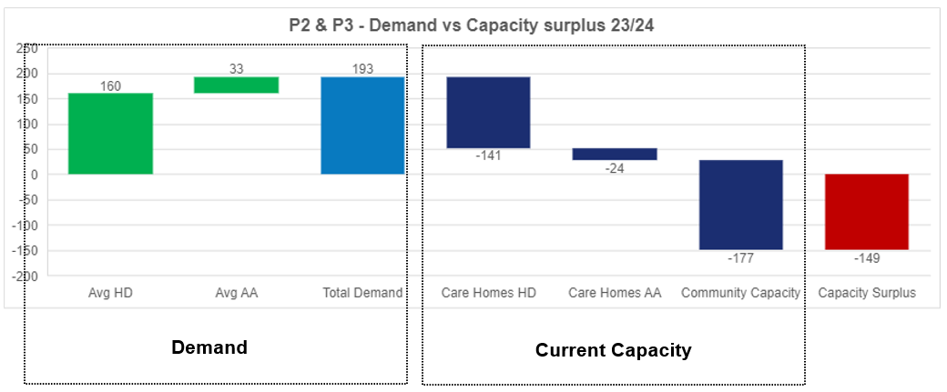
This work shows that a shift to the John Bolton model would require a 44% reduction in Pathway 2 & 3 placements.

The ambition is that this will be delivered within the first year of the contract and as such Devon ICB will be looking to review the demand levels on a yearly basis. Therefore, a review of demand would need to be undertake during Q3 of 2024.

4. Applicable Service Standards
4.1 Applicable national standards (e.g., NICE)

4.2 Applicable standards set out in Guidance and/or issued by a competent body (e.g., Royal Colleges)

4.3 Applicable local standards

5. Applicable quality requirements and CQUIN goals
  - Applicable Quality Requirements (See Schedule 4A-C)

  - Applicable CQUIN goals (See Schedule 3E)
6. Location of Provider Premises
6.1 The Provider’s Premises are located at:

7. Individual Service User Placement
NA

8. Applicable Personalised Care Requirements
8.1 Applicable requirements, by reference to Schedule 2M where appropriate

Appendix 1

