Project Name: | Southern Windermere Trails Section 3) | 
Location: | Southern Windermere Basin –  Windermere and Coniston Valleys
Document: | Heritage, Design and Access Statement  (Part 4) Trail route Images

Section 3C – View N
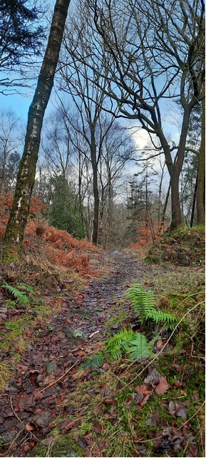

Section 3C – View N
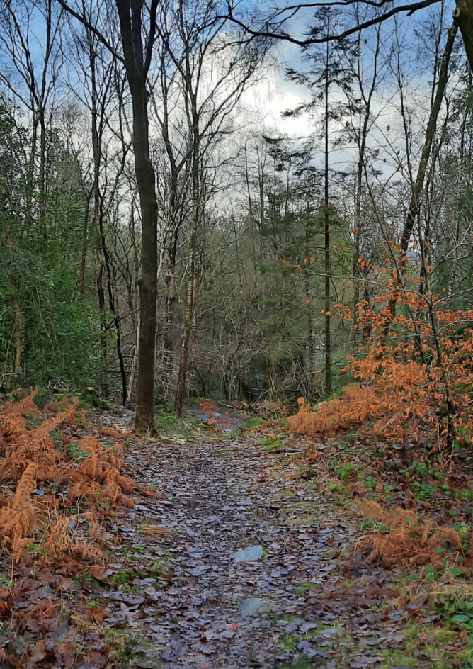

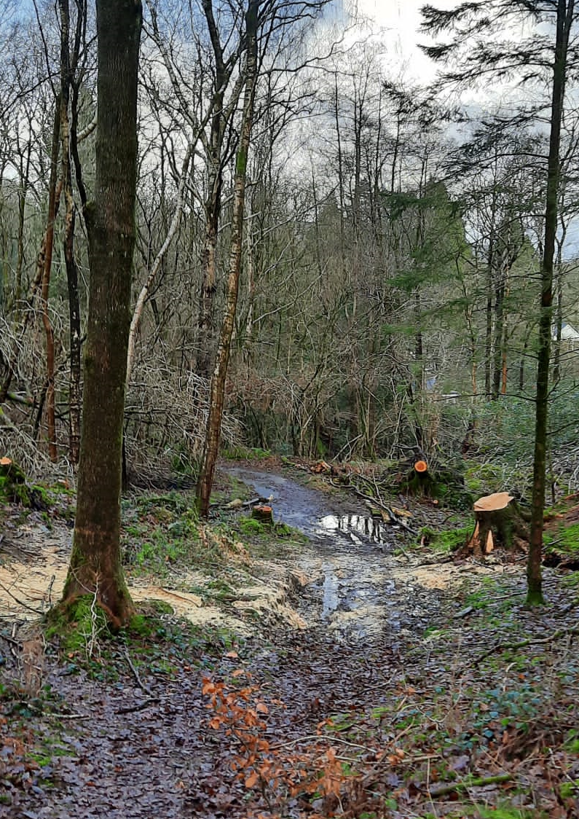

Section 3C View N
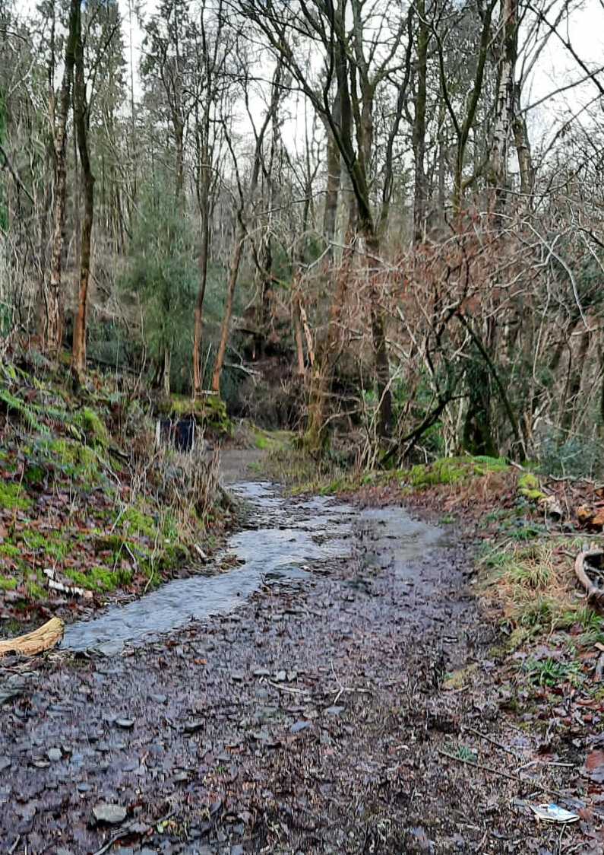

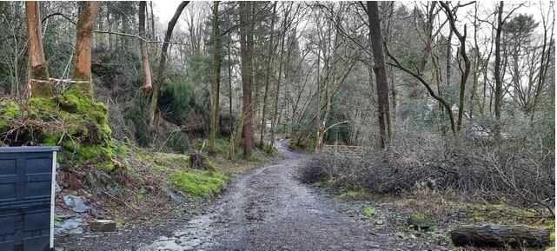

Section 3D 445 – View N; Start of Section
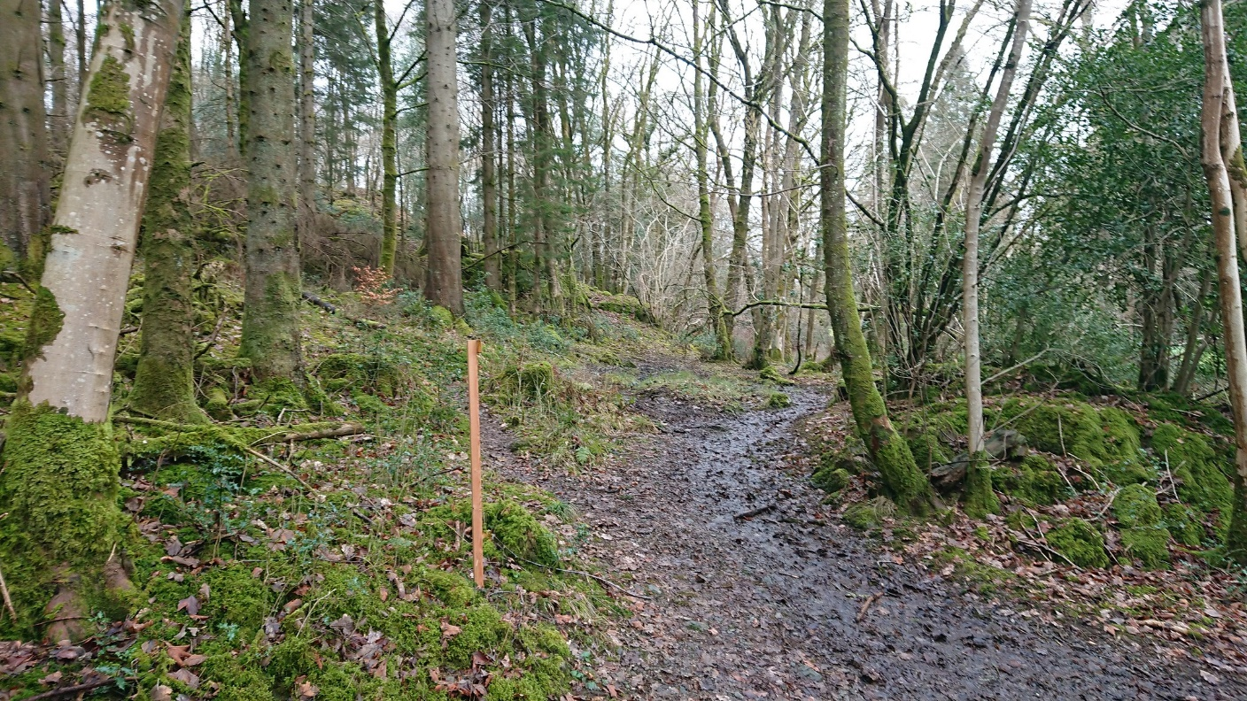
Section 3D – View N
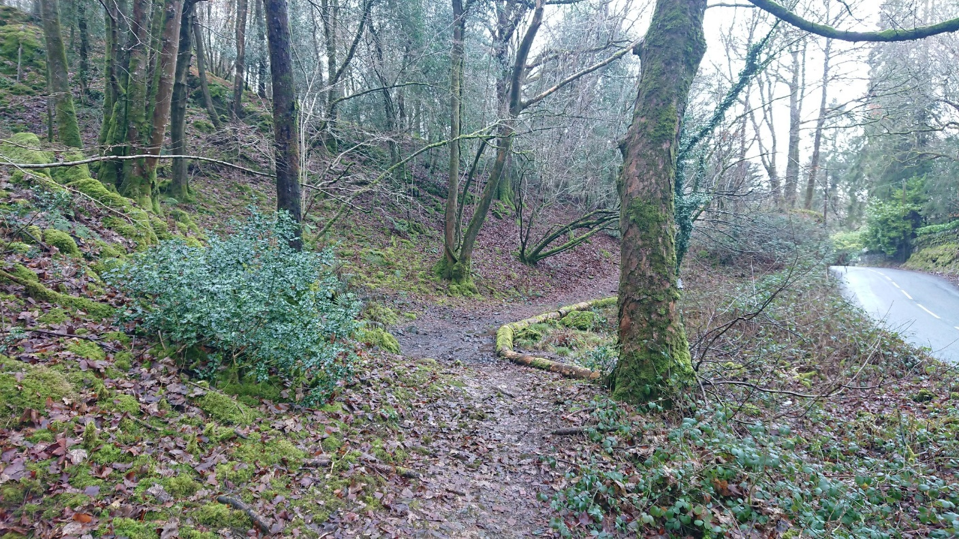

Section 3D 545 – end of section
