A Partnership Opportunity

**Town Centre Regeneration**

A Partnership Opportunity

Empty Unit – Find Out More

Invitation for Expression of Interest

25th May 2021

Contents

1 Introduction 3

2 The future of Southend High Street 4

3 The challenge 5

4 Southend Town Centre Intervention Project (STCIP) 7

5 Providing activities in an empty unit 8

6 The opportunity 10

7 Mood Board - Potential Deliverables 11

8 Programme 12

Expression of Interest 13

# Introduction

The Council has been successful in securing Local Growth Funding (LGF) for the Southend Town Centre Intervention Project (STCIP). The LGF STCIP aims to reinvigorate the town centre through several planned initiatives. One of these is to reduce the number of empty units on the High Street and to increase both footfall and dwell time.

As part of this recovery plan, we are committing funds to acquire a significant lease holding of a prominent empty unit in the heart of the town centre and use it to provide a range of events and activities.

To help create the best opportunities for Southend-on-Sea we are looking to attract a ‘can do’ *Delivery Partner* that is interested in managing the unit on the Council’s behalf. The *Delivery Partner* can be an individual organisation or consortia who have experience in providing and coordinating a programme of town centre events and activities.

We would very much like to focus on creative, cultural and community type activities; working with local people, local businesses, perhaps with an appropriate food and beverage offer.

This document provides some background on plans for the economic recovery and regeneration of the Town Centre and welcomes formal Expression of Interest for that *Delivery Partner*.

|  |  |
| --- | --- |
|  |  |
|  |  |
|  |  |

# The future of Southend High Street

Southend-on-Sea has long been a travel destination for shoppers and seaside day-trippers. With the High Street and the seafront so closely linked, many visitors combine retail therapy with seaside relaxation.

The mile of shops, bars, restaurants and cafes means there is much to offer. However, the national decline of the High Street, the rise in internet shopping and the restrictions of the Covid-19 pandemic have all had an impact.

In 2018/19 the Place Scrutiny Committee, in the context of Southend 2050, established a working group to undertake a detailed review to reimagine and explore what the future of the town centre might be. The working group has therefore agreed on a set of outcomes for a reimagined town centre and a number of recommended actions to help achieve these which have been mapped against the five Southend 2050 Ambition themes and divided into short and medium-long term actions:

[(Public Pack)Agenda Document for Place Scrutiny Committee, 08/04/2019 18:30 (southend.gov.uk)](https://democracy.southend.gov.uk/documents/g3144/Public%20reports%20pack%2008th-Apr-2019%2018.30%20Place%20Scrutiny%20Committee.pdf?T=10)

This study has provided the strategic context for much of the current and planned activity in the town centre.

There are many projects and schemes taking place to improve Southend High Street and encourage shoppers and visitors to return. You can find out more about those projects and schemes, how other schemes nearby will have a positive impact on the High Street and what our ambitions are for the future at:

[The Future of Southend High Street – Southend-on-Sea Borough Council](https://www.southend.gov.uk/homepage/447/the-future-of-southend-high-street)

Projects include:

* Works to improve the public realm in and around the town centre.
* Project Sunrise, an extensive public consultation to inform the nature and design of works in the town centre.
* Cool Towns bringing more plants, trees and greenery into the town centre.
* Modernisation and improvement of Victoria Circus.
* Southend Town Centre Intervention Project
* Upgrade of CCTV

There are also ambitious plans for the future with Better Queensway receiving planning permission in March 2021 and the proposed development at Seaways.

# The challenge

Falling footfall and rising vacancy rates in town centres are a national problem, and Southend is no different. These issues have been exacerbated by the COVID 19 restrictions and various lockdowns. In the case of Southend, CoStar vacancy rates for Southend town centre rose by 3 percentage points over the 5 years 2011-2016.

The role of the High Street is changing - creative leadership is necessary for the physical aspects of our town centres to adapt to the massive changes in shopping habits, global trends and what attracts people to town centres.



Town centre revitalisation requires big thinking and success requires many factors if they are to remain successful. Many town centres are now diversifying their offer– a rebalancing of the functions they serve to include, leisure, culture, creativity and community which should come as no surprise considering each year at least £856 million of spending by tourists visiting the UK can be attributed directly to arts and culture.

The Institute of Place Management’s high street UK2020 study24 identified twenty-five priorities for local action which ranked cultural and community factors such as entertainment and leisure, multifunctionality and recreational space for places wanting to increase footfall, alongside issues such as the retail/services mix and accessibility.

In its report on driving growth through the arts, the LGA provides a reference point for the ways that councils can lead local growth through investment in arts and culture including town and city centres.

Such investments help boost local economies by attracting visitors, creating jobs, boosting businesses, revitalising places, and developing talent. Cultural anchors such as libraries, theatres or museums can play a key role in hosting events and attracting additional footfall.

The joint LGA and Chief Cultural and Leisure Officers Association publication on the role of culture in placemaking puts a strong emphasis on the community benefits. By creating vibrant events and experiences in town centre locations, areas can boost wellbeing, improve mental health and tackle isolation as well as underpinning regeneration and boosting the economy.

# Southend Town Centre Intervention Project (STCIP)

The STCIP project aims to reduce the number of empty units on the High Street and to increase both footfall and dwell time. It will look at ways in which the High Street is used as a destination to dwell and its integration with the wider public realm. There are five strands of activity that will be delivered by the project:

* Creating a welcoming and attractive place in the Forum Square with improved wayfinding promoting improved connectivity between venues and places of interest.
* Providing 0% loans to encourage owners, landlords and businesses to take up vacant ground floor units and redevelop and repurpose vacant upper floor units.
* Providing shop front grants to encourage businesses to invest in external shop renovations in terms of design, cleanliness and safety.
* Support our ambition to become a leading Digital Smart City by implementing a footfall and performance data solution across the town centre to provide insights about town centre performance.
* Investing in a vacant retail space and introducing business-led activities in the town centre. More information on this workstream is provided below.

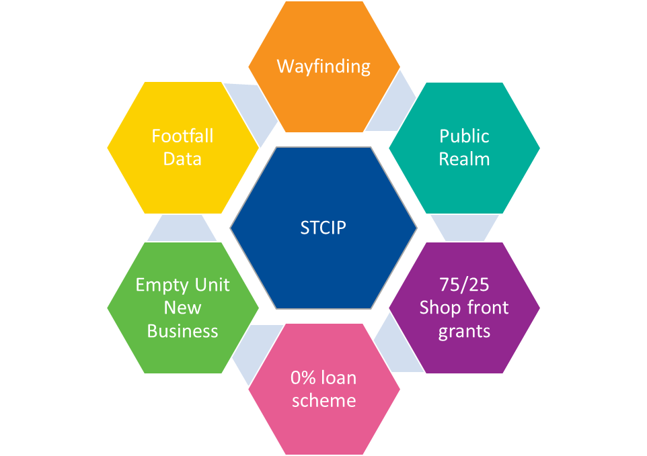

# Providing activities in an empty unit

Of the money secured from the LGF, an allocation has been ring-fenced to “introduce business-led activities in vacant units in the town centre to increase activation and utilisation along the High Street.” Specifically, the project is looking to secure a prominent town-centre premises, on a 5-year lease, to support a series of ‘pop up’ events and activities on the High Street.

Pop up events tend to capture people’s attention by capitalising on a FOMO (Fear Of Missing Out) and form a positive narrative about the area in which they are happening. These temporary “blink and you’ll miss it” type of events make it an exciting necessity for people to venture into town to experience an event that has an almost exclusive status due to its limited run.



We intend to provide a wide range of focused events and activities for diverse communities in Southend. That the empty shop unit will become a thriving artistic hub of activity – a place where people can create, make, sell, trade, share, and meet together. A functional, professional space for local performers, artists and other creative businesses. We will prioritise initiatives that show expertise and the ability to attract a wide range of people throughout the seasons and each year. The types of potential events and activities that have been suggested include:

* Comedy and performance – a venue for comedy and performance events linking to Southend festivals and events.
* Intergenerational arts events – to encourage residents and visitors of different generations to spend time together and encourage well-being. Local artists could lead and run workshops and activities.
* Exhibition space – to extend local exhibitions.
* Support for the Southend Festival and other similar events.
* Christmas - Evening craft workshops e.g. wreath making, bauble decoration, jewellery,
* Makers Festival/workshops - The crafts industry is continuing to build on a solid and consistent growth rate in sales of craftworks of approximately 5% year on year.
* Markets - ATCM published recent research that markets at Christmas boosted the HS. “47% of respondents said the main reason for their visit to the town was to attend the Christmas Market…. the average dwell time of over two hours.”
* Immersive Events – such as Bingo Bongo.

This list is simply illustrative of the type of activities that have been suggested, prospective *Delivery Partner* will be free to identify their own programmes.

Depending on the nature of the space and the partnership that we perform consideration may also be given to the possibility of locating the night-time community hub in the space. This service is currently looking at the Forum as a short-term solution until a hub space can be secured on the high street. The night-time hub comprises the street pastors, first aid volunteers, police and other services and provides a safe haven in the late evening.

# The opportunity

The Council is entering into a five-year lease for premises in the Heart of Southend Town Centre with:

* Open plan space circa 280 sq.m.
* Good frontage and rear access
* Separate ‘Back of House’ space and basement (for storage circa 370 sq.m.)

There is a rent guarantee for the first 24 months with a break clause in the lease at that point. Using the LGF grant the Council will also cover the cost of business rates for those 24 months. All business-related costs (fit-out (you know best what you need) utilities, licence fees etc) will be the responsibility of the *Delivery Partner.*

We are seeking a *Delivery Partner* (an organisation or collaborative consortia) to manage the premises on our behalf and co-ordinate a range of activities which increase footfall and dwell time in a key location on the High Street.

These activities should also support our aim of creative and cultural led regeneration for the town centre. We would also expect that our *Delivery Partner* will look to engage with and give an opportunity to the local creative and cultural sector.

The initial rent-free period is intended to provide our *Delivery Partner* with an opportunity to test a concept which hopefully gives rise to a commercial town centre business that can be sustained into the future. Full access will be provided to business support services to help achieve this.

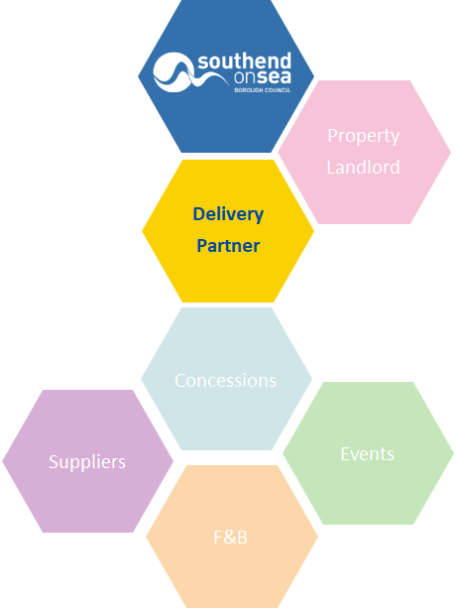

# Mood Board - Potential Deliverables

|  |  |  |  |
| --- | --- | --- | --- |
|  |  |  |  |
|  |  |  |  |
|  |  |  |  |
|  |  |  |  |

# Programme

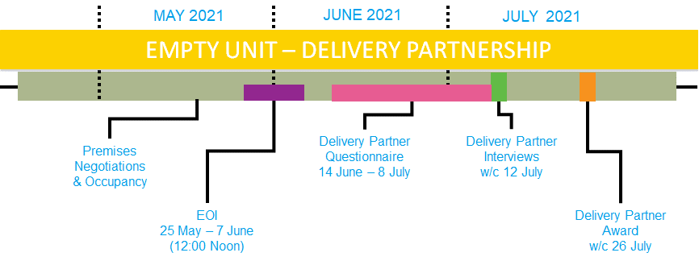

# Expression of Interest

# 



A Partnership Opportunity

**Empty Unit – Find Out More**

**Invitation for Expression of Interest**

# The EOI Process

Southend Borough Council is carrying out this procurement exercise in the form of an open expression of interest for a *Delivery* *Partner* to present a proposition to kick-start empty unit regeneration in the heart of Southend Town Centre. Your interest, in being our *Delivery Partner* and in taking part in this process must be by responding to our EOI.

1. **Stage 1: Respond to EOI using:**

* Email: [capitalprogramme@southend.gov.uk](mailto:capitalprogramme@southend.gov.uk)
* As part of the EOI, please answer the following questions.

Each question must be answered in no more than 500 words (additionally graphics and charts can be provided)

(NB: no web links, associated information or appendices will not be read or reviewed)

1a Your Organisation. Please describe your organisation or consortium (your skills and experience, key personnel, any appropriate licences you already hold or state your willingness to apply for licences)

1b Your Experience. Please demonstrate the experience you have of managing a commercial and professional town centre space for retail, social, creative and cultural activities.

Decision-making process: A review Panel set up by Southend on Sea Borough Council will decide which EOI’s will be allowed to progress to Stage 2 of this selection process. The shortlisted EOIs will receive further instructions on submission to Stage 2. The review panel’s decisions at Stage 1 and Stage 2 will be final and at the discretion of the Council.

1. **Stage 2: Delivery Partner Questionnaire**
   * Successful EOI’s will be sent a Questionnaire.

A selection of scored questions for evaluation.

1. **Delivery Partner Panel Review**
   * Assessment of submissions

NB: The Panel’s decision is final, and the funding is awarded at the discretion of the Council.

1. **Operator Interview**
   * Interviews with a maximum of the top three ranking Delivery Partners will be held via teleconference.
2. **Partnership Agreement**
   * Following evaluation of the submissions, the Council will make a decision on which, if any, shall be accepted.
   * Any acceptance of a submission by the Council shall be in writing and shall be communicated to the Delivery Partner.
   * Upon such acceptance the Council and Delivery Partner shall become binding contractual parties, and, notwithstanding that, the appointed Delivery Partner shall execute a formal contract in writing upon request of the Council.

If you have any questions about this opportunity (and note that the responses to these will be shared with all interested parties), please **Email:** [capitalprogramme@southend.gov.uk](mailto:capitalprogramme@southend.gov.uk)

For the avoidance of doubt, any submissions received after **12.00 noon on Monday 7th June 2021** will be regarded as a late submission. Late submissions will NOT be considered. All Expressions of Interest and responses must be sent to [capitalprogramme@southend.gov.uk](mailto:capitalprogramme@southend.gov.uk)

Southend-on-Sea Borough Council

Civic Centre, Victoria Avenue

Southend-on-Sea SS2 6ER[www.southend.gov.uk](http://www.southend.gov.uk/)

Email: capitalprogramme@southend.gov.uk

  [twitter@southendbc](https://twitter.com/southendbc)  
  [Facebook.com/SouthendBCOfficial](https://www.facebook.com/SouthendBCOfficial)   
  [Flickr.com/southendbc](https://www.flickr.com/photos/southendbc)  
  [Instargram.com/southendbc](https://www.instagram.com/southendbc/)

3