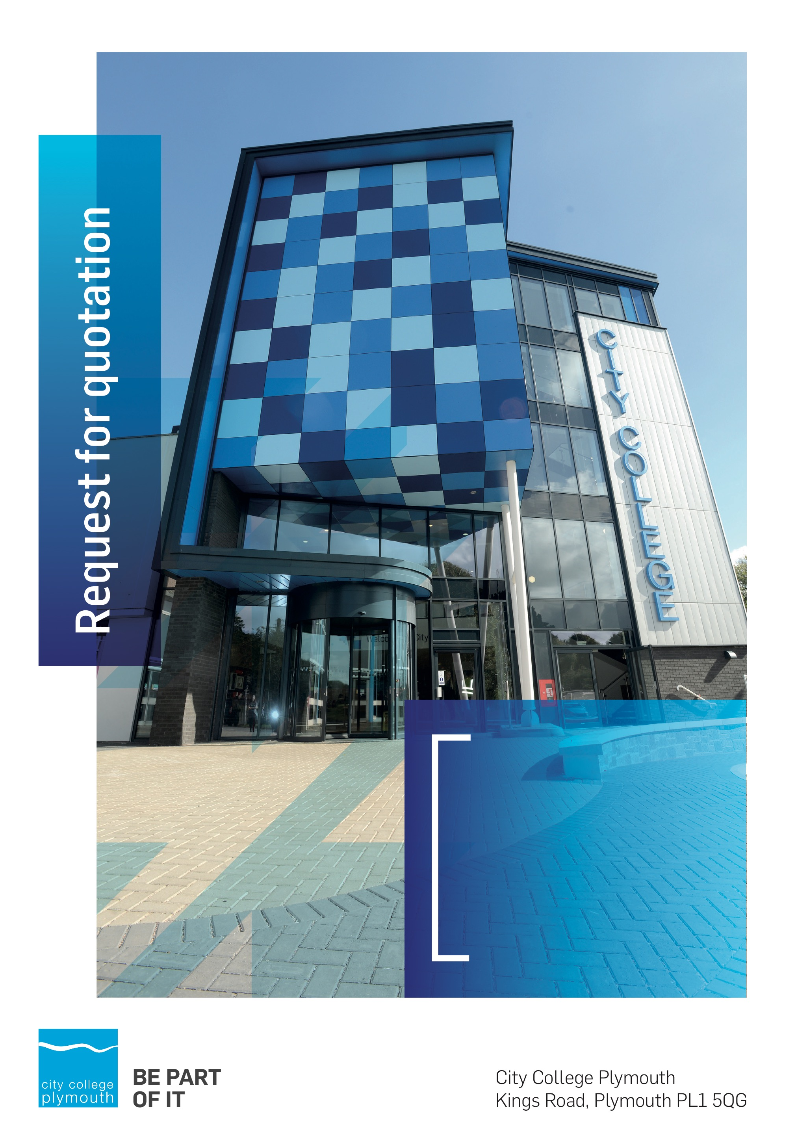

Request for Quotation
RFQ185
Cloud back up services
Issued 20/10/2021

Table of Contents
Table of Contents……………………………………………………………………………2
Table of Contents 2
Confidentiality Statement 3
Open Procedure 4
Submission Details 4
Submission Deadlines 4
Submission Questions and Clarifications 4
Electronic Submissions 5
Introduction and Executive Summary 5
Business Overview & Background 6
Our Guiding principle 6
Our Vision 6
Our CORE VALUES 6
Our CULTURE 7
The Way Forward - our Priorities 7
Detailed Requirement 7
Timescales 7
Written Submission 8
Required Affiliations 8
Safeguarding 8
Pricing 8
Terms and Conditions 9
Validity 9
Selection Criteria 9
Award Price 10
Written submission 10
Assessment of Quotations 10
Freedom of Information Act 2000 11
General Data Protection Regulation (GDPR) 2018 11
Agreement Conditions Acceptance and Declaration 11
Supporting Documentation 11

Confidentiality Statement
This document, and any attachments thereto, regardless of form or medium, is intended only for use by the addressee(s) and may contain legally privileged and/or confidential, copyrighted, trademarked, patented or otherwise restricted information viewable by the intended recipient only. If you are not the intended recipient of this document (or the person responsible for delivering this document to the intended recipient), you are hereby notified that any dissemination, distribution, printing or copying of this document, and any attachment thereto, is strictly prohibited and violation of this condition may infringe upon copyright, trademark, patent, or other laws protecting proprietary and, or, intellectual property. In no event shall this document be delivered to anyone other than the intended recipient or original sender and violation may be considered a breach of law fully punishable by various domestic and international courts. If you have received this document in error, please respond to the originator of this message or email him/her at the address below and permanently delete and/or shred the original and any copies and any electronic form this document, and any attachments thereto and do not disseminate further.
Thank you for your consideration, City College Plymouth.
Where no notice is given, all information contained herein is Copyright 2021 City College Plymouth.

Open Procedure
The College fully adheres to the requirements of the Public Contracts Regulations 2015, including for opportunities which are under threshold amounts.
Any Contractor who directly or indirectly canvasses any Member or Officer of the Institution, or advisor concerning the award of the contract for the provision of the services, or who directly or indirectly obtains or attempts to obtain information from any such member or Officer concerning any Tender or proposed Tender for the service will be disqualified from having his/her Tender considered.

Submission Details

Submission Deadlines
All submissions for responding to this Request for Quote must be submitted electronically as stated below, no later than:
2nd November 2021
12:00 Noon
Any submissions received after this date will not be considered.

Submission Questions and Clarifications
You may contact the following person if you have any questions or require clarification on any topics covered in this Request for Quotation: 26th October 2021.
Adam Baker
Procurement Officer
Phone: 01752 505313
Email: tenders@cityplym.ac.uk
All correspondence during the Tender should be channeled via the Procurement Officer using the above details only. Bidders found to have gained an unfair advantage shall be disqualified from the current opportunity and future opportunities with the College for a minimum of four (4) years.

Electronic Submissions
Electronic submissions in response to this Request for Quotation are required and must meet the following criteria:
Sent via email to: tenders@cityplym.ac.uk
Document standards:
- Text must be in Microsoft Word format;
- Price tables must be in Microsoft Excel format (using pricing schedule in Appendix A);
- Supportive evidence may additionally be submitted in PDF format;
- Images, Designs, and other supporting evidence may be in either JPEG or PDF format
- Completed Appendix C Suitability Assessment & Selection Questionnaire (Including Mandatory & Discretionary Exclusions) Parts 1, 2 and 3. - Please note this suitability assessment will not be viewed unless you are the winning tenderer. Failure at this stage may prevent the contract from being awarded.
- Signed Agreement Acceptance and Declaration.

Please note that the College is able to accept submissions sent in a compressed or “.zip” file format, so long as the files contained meet the standards described above.

WARRANTY:
By submitting your tender bid, you are warrantying to the College that you have not breached our canvassing or soliciting clause.

If any successful tenderer awarded a contract is found to have provided an inaccurate warranty, then the College reserves the right to terminate the awarded contract with immediate effect and re-tender the contract from which the successful tenderer will be excluded from re-bidding and shall be disqualified from any future opportunities for a period of four years.

Introduction and Executive Summary
In order to meet our requirements of having one copy of our backup files stored off site City College Plymouth is looking to procure cloud backup services. The goal is to use a cloud service that is tightly integrated into VEEAM as this our preferred backup solution. This will allow automation and hand-off operation of off-site backups along with automated reporting of our cloud usage
The anticipated value of the supply contract could exceed £25,000. Therefore, as per the Public contracts Regulations 2015 the opportunity will be advertised on the government portal ‘Contracts Finder’.

Business Overview & Background
City College Plymouth has a learning environment and organisational culture that impacts positively on the health, wellbeing and sustainability of our community and enables all of our students and staff to achieve their full potential.
City College Plymouth is one of the largest providers of innovative, technical and professional, education in the South West with a national reputation for promoting enterprise, employability and science, technology, engineering and mathematics (STEM). The College plays a central role in the educational, cultural and economic life of the region and works with strategic partners to facilitate growth, raise aspirations and foster wealth creation.
The College was awarded the Teaching Excellence Framework (TEF) Gold award for its university-level provision and its most recent Ofsted inspection confirmed that the College continues to be ‘Good’ with many outstanding features. The College was rated first in the South West and second nationally for student satisfaction in the latest FE Choices student satisfaction survey.
City College Plymouth is also one of the first Institutes of technology in the UK Working in collaboration with education providers and employers across the South West to improve the training in science, technology, engineering and maths in order to address skills gaps within these industries and support regional growth.
City College supports the region’s employers with their award-winning Apprenticeship provision, as well as providing a range of courses and bespoke training programmes which enable employees to upskill or retrain to better support their business’ requirements.
The College operates on two main sites within the city, serving 12,500 students and employing over 650 staff. The College operates year round, with opening times from 0800-2100 on some days.

Our Guiding principle
City College Plymouth has a learning environment and organisational culture that impacts positively on the health, wellbeing and sustainability of our community and enables all of our students and staff to achieve their full potential.

Our Vision
To be the learning destination of choice

Our CORE VALUES
Respect, ownership, integrity for all

Our CULTURE
Nurturing a passion for teaching and learning
Enriching our community through knowledge, experience and skills
Enabling every student to be the best that they can be

The Way Forward - our Priorities
• Staff - our most important investment
• Students - our purpose
• Community - making a difference
• Achievement - reputation for success
• Wellbeing - infusing health into every day

Detailed Requirement
The estimated budget is around £25,000
Please see appendix B for a full detailed specification of the requirements, the detail has been produced by the Colleges Senior Network Engineer.
City College Plymouth is looking to appoint a provider on an a 3 year contract with a break clause after the first year.
If you require any more information please contact us on the email address provided within this document.

Timescales

Action | Date
Tender Issued | 19/10/2021
Deadline for Queries | 26/10/2021
Tender Response Date | 02/11/2021
Award Date | 12/11/2021

Written Submission
We also require a written document which details your company offer with particular interest to the following areas. This submitted document will be scored as per the table on page 10.
- The solution you would offer, including how you meet the technical requirements as outlined in appendix B
- The support you would offer throughout the contract including response times to any requests.
- Sustainability, the Environment and Corporate Social Responsibility including Modern Slavery
- Potential partnering arrangements with regard to student work experience, apprenticeships and working partnerships.

Required Affiliations
We require you to be a VEEAM platinum partner to engage with this bid.

Safeguarding

The College requires that all contractors, prior to undertaking work on the College site, will have been subject to a (DBS) English Disclosure Barring and Services check. You will be required to provide evidence of compliance before commencing work. This requirement may be suspended where works are undertaken during the college holiday breaks or outside of the main school week, providing the College is satisfied any risk to students who may be on site for revision or taster sessions is adequately managed.
All staff on site will be required to comply with health and safety requirements at all times and to wear appropriate identification.
All staff will be required to sign in and sign out when on College premises.

Pricing
Bidders should provide their pricing for the service as per Appendix A.
Prices should be firm and valid for at least the initial contract period (12 months) and not subject to increase or escalation of any kind throughout the contract.

Terms and Conditions
The College’s normal business terms are 1-2 months from the date of invoice. Payment will become due subject to the above upon the College’s full acceptance of the goods/services. This Request for Quotation and any resulting purchase order will be subject to the College’s General Terms and Conditions of Purchase of Goods/Services – see Appendix B.

Validity
Bidder’s offers should be open and valid for acceptance for a period of no less than ninety [90] days from the date of submission.

Selection Criteria
The successful supplier will have provided the Most Economically Advantageous Tender (MEAT) to the college. It should be noted that the bidder with the lowest submitted prices will not necessarily be down-selected. All bidders will be notified via email of the results of the outcome no later than 90 days from the date of submission. The date of contract award will be provided within that email.
The marking criteria follows:
Category | Weight
Price | 50%
Ability to Satisfy the technical requirement | 25%
Support, maintenance and response to problems | 25%
Pass / Fail Criteria
VEEAM Platinum partner | Pass/ Fail

Please see table below for more details on the scoring method.

Award Price
Lowest quote price divided by quote price multiplied by 100

Written submission
Assessment | Score | Interpretation
Excellent | 4 | Comprehensive response supported by examples  Description fully supported by details that demonstrate the applicant’s ability to provide the required services.
Good | 3 | Broad response supported by relevant examples.  Description well supported by details that demonstrate the applicant’s ability to provide the required services.
Satisfactory | 2 | Reasonable response supported by some evidence.  Description adequately supported by details that demonstrate the applicant’s ability to provide the required services.
Poor | 1 | Limited response not well supported by evidence.  Description inadequately supported by details that demonstrate the applicant’s ability to provide the required services.
Unacceptable | 0 | No response or insufficient information provided.

Assessment of Quotations
Bidders must ensure that their quotation fully addresses all information requested within this RFQ document. Bidders must ensure that any quotation fully meets the specification required. The College reserves the right to discount any quotation which does not fully meet the specification.
The College reserves the right to seek clarification with bidders upon receipt of quotations.

Freedom of Information Act 2000
Under the Freedom of Information Act 2000 the College cannot guarantee that information provided by bidders during the course of this RFQ procedure or any resulting contract will be held a confidential. The College will not routinely release information to interested parties unless required to do so in order to meet our statutory obligations.

General Data Protection Regulation (GDPR) 2018
All bidders must comply with the General Data Protection Regulation (GDPR) 2018 in respect of using and processing personal information. Bidders must have in place technical and organisational safeguards to protect personal data from unauthorised use, disclosure or loss.
The College reserves the right to request a copy of your privacy statement if you are the successful bidder.

Agreement Conditions Acceptance and Declaration
Bidders are required to sign and return the attached Agreement Conditions Acceptance and Declaration. Appendix D

Supporting Documentation
Appendix A: Pricing Schedule
Appendix B: Technical Specification
Appendix C: City College Plymouth Standard Terms & Conditions
Appendix D: Agreement Conditions Acceptance and Declaration

